UNITED STATES
SECURITIES AND EXCHANGE COMMISSION
Washington, D.C. 20549
FORM |  |  | 8-K
CURRENT REPORT
Pursuant to Section 13 or 15(d) of the
Securities Exchange Act of 1934
Date of Report (Date of earliest event reported): |  |  | February 19, 2026
Shutterstock, Inc.
(Exact name of registrant as specified in its charter)
Delaware |  |  |  |  |  | 001-35669 |  |  |  |  |  | 80-0812659
(State or other jurisdiction of incorporation) |  |  |  |  |  | (Commission File Number) |  |  |  |  |  | (IRS Employer Identification No.)
350 Fifth Avenue, 20th Floor
New York, NY 10118
(Address of principal executive offices, including zip code)
(646) 710-3417
(Registrant’s telephone number, including area code)
Not applicable
(Former name, former address and former fiscal year, if changed since last report)
Check the appropriate box below if the Form 8-K filing is intended to simultaneously satisfy the filing obligation of the registrant under any of the following provisions:
☒ |  |  | Written communications pursuant to Rule 425 under the Securities Act (17 CFR 230.425)
☐ |  |  | Soliciting material pursuant to Rule 14a-12 under the Exchange Act (17 CFR 240.14a-12)
☐ |  |  | Pre-commencement communications pursuant to Rule 14d-2(b) under the Exchange Act (17 CFR 240.14d-2(b))
☐ |  |  | Pre-commencement communications pursuant to Rule 13e-4(c) under the Exchange Act (17 CFR 240.13e-4(c))
Securities registered pursuant to Section 12(b) of the Act:
Class |  |  | Trading symbol |  |  | Name of each exchange on which registered
Common Stock, $0.01 par value per share |  |  | SSTK |  |  | New York Stock Exchange
 |  |  | Indicate by check mark whether the registrant is an emerging growth company as defined in Rule 405 of the Securities Act of 1933 (§230.405 of this chapter) or Rule 12b-2 of the Securities Exchange Act of 1934 (§240.12b-2 of this chapter).
☐ |  |  | Emerging growth company
☐ |  |  | If an emerging growth company, indicate by check mark if the registrant has elected not to use the extended transition period for complying with any new or revised financial accounting standards provided pursuant to Section 13(a) of the Exchange Act.

Item 8.01 |  |  | Other Events.
On February 19, 2026, Shutterstock, Inc. (the “Company”) issued a press release (“Press Release”) with a statement on the UK Competition and Markets Authority’s provisional finding with respect to the previously announced merger with Getty Images Holdings, Inc.
A copy of the Press Release is attached as Exhibit 99.1 hereto and is incorporated herein by reference.
Item 9.01 |  |  | Financial Statements and Exhibits.
(d) Exhibits.
Exhibit No. |  |  |  |  |  | Exhibit Description
99.1 |  |  |  |  |  | Press Release issued by Shutterstock, Inc., dated February 19, 2026.
104 |  |  |  |  |  | Cover Page Interactive Data File (formatted as Inline XBRL).
Cautionary Note Regarding Forward-Looking Statements
The statements in this document, and any related oral statements, include forward-looking statements concerning Getty Images, Shutterstock, the proposed transaction described herein and other matters. All statements, other than historical facts, are forward-looking statements. Forward-looking statements may discuss goals, intentions and expectations as to future plans, trends, events, results of operations or financial condition, financings or otherwise, based on current beliefs and involve numerous risks and uncertainties that could cause actual results to differ materially from expectations. Forward-looking statements speak only as of the date they are made or as of the dates indicated in the statements and should not be relied upon as predictions of future events, as there can be no assurance that the events or circumstances reflected in these statements will be achieved or will occur or the timing thereof. Forward-looking statements can often, but not always, be identified by the use of forward-looking terminology including “believes,” “expects,” “may,” “will,” “should,” “could,” “might,” “seeks,” “intends,” “plans,” “pro forma,” “estimates,” “anticipates,” “designed,” or the negative of these words and phrases, other variations of these words and phrases or comparable terminology, but not all forward-looking statements include such identifying words. Forward-looking statements are based upon current plans, estimates and expectations that are subject to risks, uncertainties and assumptions. Should one or more of these risks or uncertainties materialize, or should underlying assumptions prove incorrect, actual results may vary. The forward-looking statements in this document relate to, among other things, obtaining applicable regulatory approvals on a timely basis or otherwise. A more fulsome discussion of the risks related to the proposed transaction has been included in the information statement and proxy statement/prospectus. For a discussion of factors that could cause actual results to differ materially from those contemplated by forward-looking statements, see the section captioned “Risk Factors” in each of Getty Images’ and Shutterstock’s Annual Report on Form 10-K for the fiscal year ended December 31, 2024 and other filings with the SEC. Should one or more of these risks or uncertainties materialize, or should underlying assumptions prove incorrect, actual results may vary materially from those indicated or anticipated by such forward looking statements. While the list of factors presented here is, and the list of factors presented in the information statement and proxy statement/prospectus is, considered representative, no such list should be considered to be a complete statement of all potential risks and uncertainties. Unlisted factors may present significant additional obstacles to the realization of forward looking statements. Neither Getty Images nor Shutterstock assumes, and each hereby disclaims, any obligation to update forward-looking statements, except as may be required by law.
Additional Information about the Merger and Where to Find It
In connection with the proposed transaction, on March 31, 2025, Getty Images filed with the Securities and Exchange Commission (the "SEC") a preliminary registration statement on Form S-4 that includes an information statement of Getty Images and a proxy statement of Shutterstock and that also constitutes a prospectus with respect to shares of Getty Images' common stock to be issued in the proposed transaction (the "information statement and proxy statement/prospectus"). The registration statement was amended in a pre-effective amendment on Form S-4/A on April 28, 2025. The registration statement, as amended, was declared effective on April 30, 2025, and Getty Images filed a final prospectus on April 30, 2025. Each of Getty Images and Shutterstock may also file with or furnish to the SEC other relevant documents regarding the proposed transaction. This communication is not a substitute for the information statement and proxy statement/prospectus or any other document that Getty Images or Shutterstock has filed or may file with or furnish to the SEC. BEFORE MAKING ANY VOTING OR INVESTMENT DECISION, INVESTORS AND SECURITY HOLDERS ARE URGED TO READ THE INFORMATION STATEMENT AND PROXY STATEMENT/PROSPECTUS AND ALL OTHER RELEVANT DOCUMENTS THAT ARE OR WILL BE FILED WITH OR FURNISHED TO THE SEC, AS WELL AS ANY AMENDMENTS OR SUPPLEMENTS TO THESE DOCUMENTS, CAREFULLY AND IN THEIR ENTIRETY BECAUSE THEY CONTAIN OR WILL CONTAIN IMPORTANT INFORMATION ABOUT THE PROPOSED TRANSACTION AND RELATED MATTERS. Investors and security holders may obtain free copies of the information statement and definitive proxy statement/prospectus and other documents containing important information about Getty Images, Shutterstock and the proposed transaction through the website maintained by the SEC
2

at www.sec.gov. Copies of the documents filed with or furnished to the SEC by Getty Images are available free of charge on Getty Images' website at investors.gettyimages.com or by contacting Getty Images' Investor Relations department by email at investorrelations@gettyimages.com. Copies of the documents filed with or furnished to the SEC by Shutterstock are available free of charge on the Company's website at investor.shutterstock.com or by contacting Shutterstock's Investor Relations department by email at IR@shutterstock.com.

3

SIGNATURE
Pursuant to the requirements of the Securities Exchange Act of 1934, the registrant has duly caused this report to be signed on its behalf by the undersigned hereunto duly authorized.
 |  |  | SHUTTERSTOCK, INC.
Dated: February 19, 2026 |  |  | By: |  |  | /s/ Rik Powell
 |  |  |  |  |  | Rik Powell
 |  |  |  |  |  | Chief Financial Officer
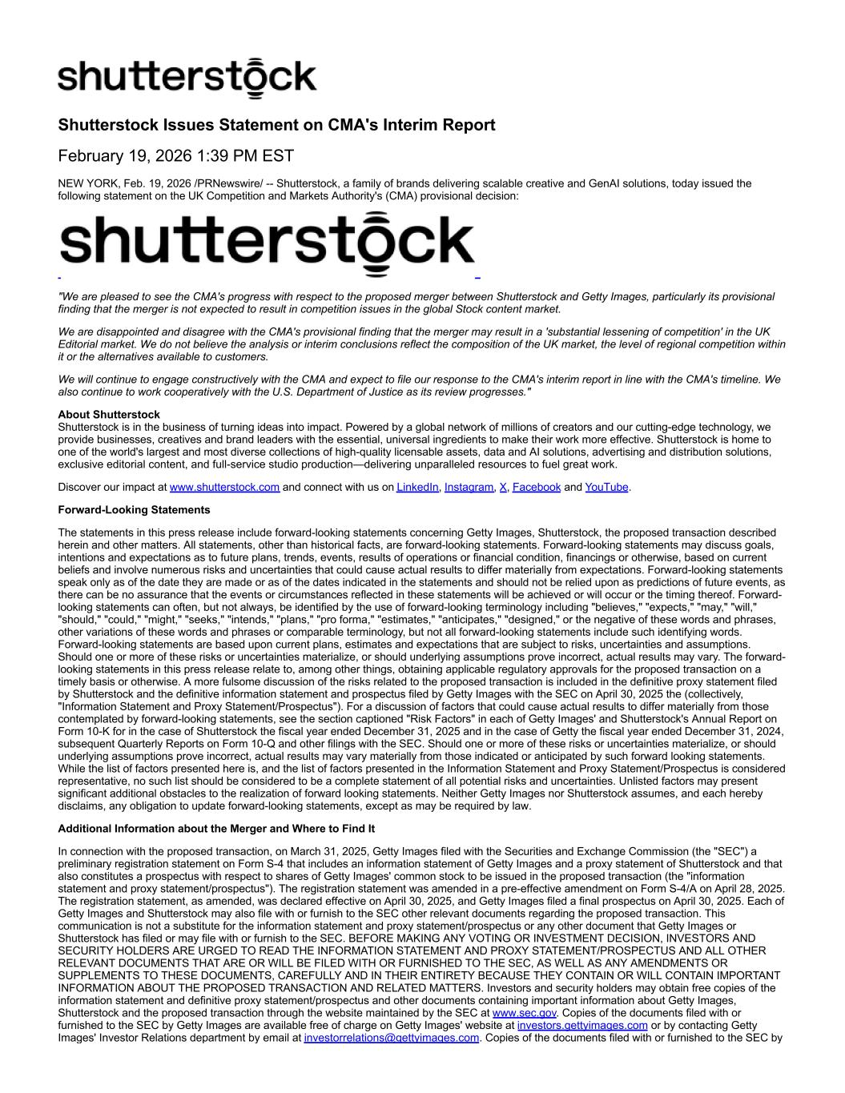
4
Shutterstock Issues Statement on CMA's Interim Report February 19, 2026 1:39 PM EST NEW YORK, Feb. 19, 2026 /PRNewswire/ -- Shutterstock, a family of brands delivering scalable creative and GenAI solutions, today issued the following statement on the UK Competition and Markets Authority's (CMA) provisional decision: "We are pleased to see the CMA's progress with respect to the proposed merger between Shutterstock and Getty Images, particularly its provisional finding that the merger is not expected to result in competition issues in the global Stock content market. We are disappointed and disagree with the CMA's provisional finding that the merger may result in a 'substantial lessening of competition' in the UK Editorial market. We do not believe the analysis or interim conclusions reflect the composition of the UK market, the level of regional competition within it or the alternatives available to customers. We will continue to engage constructively with the CMA and expect to file our response to the CMA's interim report in line with the CMA's timeline. We also continue to work cooperatively with the U.S. Department of Justice as its review progresses." About Shutterstock Shutterstock is in the business of turning ideas into impact. Powered by a global network of millions of creators and our cutting-edge technology, we provide businesses, creatives and brand leaders with the essential, universal ingredients to make their work more effective. Shutterstock is home to one of the world's largest and most diverse collections of high-quality licensable assets, data and AI solutions, advertising and distribution solutions, exclusive editorial content, and full-service studio production—delivering unparalleled resources to fuel great work. Discover our impact at www.shutterstock.com and connect with us on LinkedIn, Instagram, X, Facebook and YouTube. Forward-Looking Statements The statements in this press release include forward-looking statements concerning Getty Images, Shutterstock, the proposed transaction described herein and other matters. All statements, other than historical facts, are forward-looking statements. Forward-looking statements may discuss goals, intentions and expectations as to future plans, trends, events, results of operations or financial condition, financings or otherwise, based on current beliefs and involve numerous risks and uncertainties that could cause actual results to differ materially from expectations. Forward-looking statements speak only as of the date they are made or as of the dates indicated in the statements and should not be relied upon as predictions of future events, as there can be no assurance that the events or circumstances reflected in these statements will be achieved or will occur or the timing thereof. Forward- looking statements can often, but not always, be identified by the use of forward-looking terminology including "believes," "expects," "may," "will," "should," "could," "might," "seeks," "intends," "plans," "pro forma," "estimates," "anticipates," "designed," or the negative of these words and phrases, other variations of these words and phrases or comparable terminology, but not all forward-looking statements include such identifying words. Forward-looking statements are based upon current plans, estimates and expectations that are subject to risks, uncertainties and assumptions. Should one or more of these risks or uncertainties materialize, or should underlying assumptions prove incorrect, actual results may vary. The forward- looking statements in this press release relate to, among other things, obtaining applicable regulatory approvals for the proposed transaction on a timely basis or otherwise. A more fulsome discussion of the risks related to the proposed transaction is included in the definitive proxy statement filed by Shutterstock and the definitive information statement and prospectus filed by Getty Images with the SEC on April 30, 2025 the (collectively, "Information Statement and Proxy Statement/Prospectus"). For a discussion of factors that could cause actual results to differ materially from those contemplated by forward-looking statements, see the section captioned "Risk Factors" in each of Getty Images' and Shutterstock's Annual Report on Form 10-K for in the case of Shutterstock the fiscal year ended December 31, 2025 and in the case of Getty the fiscal year ended December 31, 2024, subsequent Quarterly Reports on Form 10-Q and other filings with the SEC. Should one or more of these risks or uncertainties materialize, or should underlying assumptions prove incorrect, actual results may vary materially from those indicated or anticipated by such forward looking statements. While the list of factors presented here is, and the list of factors presented in the Information Statement and Proxy Statement/Prospectus is considered representative, no such list should be considered to be a complete statement of all potential risks and uncertainties. Unlisted factors may present significant additional obstacles to the realization of forward looking statements. Neither Getty Images nor Shutterstock assumes, and each hereby disclaims, any obligation to update forward-looking statements, except as may be required by law. Additional Information about the Merger and Where to Find It In connection with the proposed transaction, on March 31, 2025, Getty Images filed with the Securities and Exchange Commission (the "SEC") a preliminary registration statement on Form S-4 that includes an information statement of Getty Images and a proxy statement of Shutterstock and that also constitutes a prospectus with respect to shares of Getty Images' common stock to be issued in the proposed transaction (the "information statement and proxy statement/prospectus"). The registration statement was amended in a pre-effective amendment on Form S-4/A on April 28, 2025. The registration statement, as amended, was declared effective on April 30, 2025, and Getty Images filed a final prospectus on April 30, 2025. Each of Getty Images and Shutterstock may also file with or furnish to the SEC other relevant documents regarding the proposed transaction. This communication is not a substitute for the information statement and proxy statement/prospectus or any other document that Getty Images or Shutterstock has filed or may file with or furnish to the SEC. BEFORE MAKING ANY VOTING OR INVESTMENT DECISION, INVESTORS AND SECURITY HOLDERS ARE URGED TO READ THE INFORMATION STATEMENT AND PROXY STATEMENT/PROSPECTUS AND ALL OTHER RELEVANT DOCUMENTS THAT ARE OR WILL BE FILED WITH OR FURNISHED TO THE SEC, AS WELL AS ANY AMENDMENTS OR SUPPLEMENTS TO THESE DOCUMENTS, CAREFULLY AND IN THEIR ENTIRETY BECAUSE THEY CONTAIN OR WILL CONTAIN IMPORTANT INFORMATION ABOUT THE PROPOSED TRANSACTION AND RELATED MATTERS. Investors and security holders may obtain free copies of the information statement and definitive proxy statement/prospectus and other documents containing important information about Getty Images, Shutterstock and the proposed transaction through the website maintained by the SEC at www.sec.gov. Copies of the documents filed with or furnished to the SEC by Getty Images are available free of charge on Getty Images' website at investors.gettyimages.com or by contacting Getty Images' Investor Relations department by email at investorrelations@gettyimages.com. Copies of the documents filed with or furnished to the SEC by

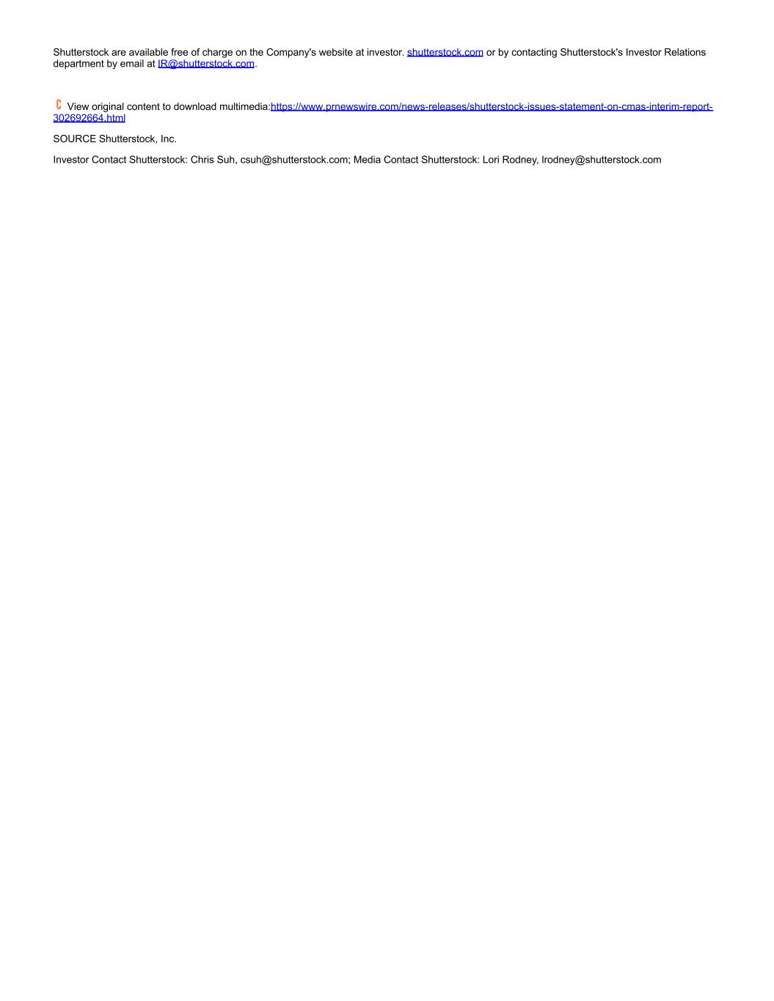
Shutterstock are available free of charge on the Company's website at investor. shutterstock.com or by contacting Shutterstock's Investor Relations department by email at IR@shutterstock.com. View original content to download multimedia:https://www.prnewswire.com/news-releases/shutterstock-issues-statement-on-cmas-interim-report- 302692664.html SOURCE Shutterstock, Inc. Investor Contact Shutterstock: Chris Suh, csuh@shutterstock.com; Media Contact Shutterstock: Lori Rodney, lrodney@shutterstock.com

