UNITED STATES

SECURITIES AND EXCHANGE COMMISSION

Washington, D.C. 20549

FORM8-K

CURRENT REPORT

Pursuant to Section 13 or 15(d) of the

Securities Exchange Act of 1934

Date of Report (Date of earliest event reported): March 28, 2025

Shutterstock, Inc.

(Exact name of registrant as specified in its charter)

Delaware

001-35669

80-0812659

(State or other jurisdiction

of incorporation)

(Commission

File Number)

(IRS Employer

Identification No.)

350 Fifth Avenue, 20th Floor

New York, NY 10118

(Address of principal executive offices, including zip code)

(646) 710-3417

(Registrant’s telephone number, including area code)

Not applicable

(Former name, former address and former fiscal year, if changed since last report)

Check the appropriate box below if the Form 8-K filing is intended to simultaneously satisfy the filing obligation of the registrant under any of the following provisions:

- Written communications pursuant to Rule 425 under the Securities Act (17 CFR 230.425) ☐ Soliciting material pursuant to Rule 14a-12 under the Exchange Act (17 CFR 240.14a-12)

☐ Pre-commencement communications pursuant to Rule 14d-2(b) under the Exchange Act (17 CFR 240.14d-2(b)) ☐ Pre-commencement communications pursuant to Rule 13e-4(c) under the Exchange Act (17 CFR 240.13e-4(c))

Securities registered pursuant to Section 12(b) of the Act:

Class | Trading symbol | Name of each exchange on which registered
Common Stock, $0.01 par value per share | SSTK | New York Stock Exchange

Indicate by check mark whether the registrant is an emerging growth company as defined in Rule 405 of the Securities Act of 1933 (§230.405 of this chapter) or Rule 12b-2 of the Securit Exchange Act of 1934 (§240.12b-2 of this chapter).

- Emerging growth company

- If an emerging growth company, indicate by check mark if the registrant has elected not to use the extended transition period for complying with any new or revised financial accounting standards provided pursuant to Section 13(a) of the Exchange Act.

Item 8.01 Other Events.

As previously disclosed in the Current Report on Form 8-K filed with the U.S. Securities and Exchange Commission (the “SEC”) by Shutterstock, Inc. (the “Company” or “Shutterstock”) on July 22, 2024 (the “Original Form 8-K”), the Company consummated its previously announced acquisition of Envato Pty Ltd. (“Envato”) on July 22, 2024 pursuant to the Share Purchase Agreement, dated as of May 1, 2024, by and among the Company, Shutterstock AUS EMU Pty Ltd., Envato, the shareholders of Envato named thereto and their representative (the “Purchase Agreement”). The aggregate consideration payable by the Company in connection with the acquisition, after customary working capital and other adjustments in accordance with the terms of the Purchase Agreement, was approximately $250 million.

On October 3, 2024, the Company amended the Original Form 8-K to include the financial statements required to be filed under Item 9.01(a) of Form 8-K and the pro forma financial information required to be filed under Item 9.01(b) of Form 8-K (the “Form 8-K/A”).

In connection with the filing of a Registration Statement on Form S-4 on or about the date hereof (the “Form S-4”) contemplated by the previously announced Agreement and Plan of Merger (the “Merger Agreement”), by and among Shutterstock, Getty Images Holdings, Inc. (“Getty Images”), and the other parties thereto, dated as of January 6, 2025, that provides for the combination of the two companies, this Current Report on Form 8-K is being filed to provide the following information related to the Company’s acquisition of Envato that will be incorporated by reference into the Form S-4: (i) Envato’s audited consolidated financial statements as of and for the year ended June 30, 2024 (the “Updated Audited Financial Statements”) and (ii) the Company’s unaudited pro forma condensed combined financial information for the year ended December 31, 2024 (the “Updated Pro Forma Financial Information” together with the Updated Audited Financial Statements, the “Updated Financial Information”). The Updated Financial Information updates and supplements the audited consolidated financial statements of Envato and unaudited pro forma condensed combined financial information of the Company and related disclosures contained in Exhibits 99.1 and 99.2 to the Form 8-K/A. To the extent that information in this Current Report on Form 8-K differs from or updates information contained in the Form 8-K/A, the information in this Current Report on Form 8-K shall supersede or supplement the information in the Form 8-K/A.

The Updated Financial Information included in this Current Report on Form 8-K has been presented for informational purposes only, as required by the Form S-4. It does not purport to represent the actual results or project future operating results of the Company following the acquisition of Envato.

Additional Information about the Acquisition and Where to Find It

In connection with the proposed transaction, Shutterstock intends to file a proxy statement with the Securities and Exchange Commission (the “SEC”), which will be included in the Form S-4 intended to be filed by Getty Images and that also will include an information statement of Getty Images and constitute a prospectus with respect to shares of Getty Images’ common stock to be issued in the transactions contemplated by the Merger Agreement (the “information statement and proxy statement/prospectus”). Each of Getty Images and Shutterstock may also file with or furnish to the SEC other relevant documents regarding the proposed transactions. This filing is not a substitute for the information statement and proxy statement/prospectus or any other document that Getty Images or Shutterstock may file with or furnish to the SEC. The definitive information statement and proxy statement/prospectus (if and when available) will be mailed to stockholders of Getty Images and Shutterstock. BEFORE MAKING ANY VOTING OR INVESTMENT DECISION, INVESTORS AND SECURITY HOLDERS ARE URGED TO READ THE INFORMATION STATEMENT AND PROXY STATEMENT/PROSPECTUS (WHEN AVAILABLE) AND ALL OTHER RELEVANT DOCUMENTS THAT ARE OR WILL BE FILED WITH OR FURNISHED TO THE SEC, AS WELL AS ANY AMENDMENTS OR SUPPLEMENTS TO THESE DOCUMENTS, CAREFULLY AND IN THEIR ENTIRETY BECAUSE THEY CONTAIN OR WILL CONTAIN IMPORTANT INFORMATION ABOUT THE PROPOSED TRANSACTIONS AND RELATED MATTERS. Investors and security holders will be able to obtain free copies of the information statement and proxy statement/prospectus (if and when available) and other documents containing important information about Getty Images, Shutterstock and the proposed transactions, once such documents are filed with or furnished to the SEC through the website maintained by the SEC at www.sec.gov. Copies of the documents filed with or furnished to the SEC by Getty Images will be available free of charge on Getty Images’ website at investors.gettyimages.com. Copies of the documents filed with or furnished to the SEC by Shutterstock will be available free of charge on Shutterstock’s website at investor.shutterstock.com.

2

Participants in the Solicitation

This Form 8-K is not a solicitation of proxies in connection with the proposed transactions. Getty Images, Shutterstock and certain of their respective directors and executive officers and other members of their respective management and employees may be deemed to be participants in the solicitation of proxies in respect of the proposed transactions. Information about the directors and executive officers of Getty Images, including a description of their direct or indirect interests, by security holdings or otherwise, is set forth in Getty Images’ Form 10-K for the year ended December 31, 2024, which was filed with the SEC on March 17, 2025. Information about the directors and executive officers of Shutterstock, including a description of their direct or indirect interests, by security holdings or otherwise, is set forth in Shutterstock’s Form 10-K/A for the year ended December 31, 2024 which was filed with the SEC on March 28, 2025. Other information regarding the participants in the proxy solicitations and a description of their direct and indirect interests, by security holdings or otherwise, will be contained in the information statement and proxy statement/prospectus and other relevant materials to be filed with or furnished to the SEC regarding the proposed transactions. You may obtain free copies of these documents using the sources indicated above.

No Offer or Solicitation

This Form 8-K is not intended to and shall not constitute an offer to buy or sell or the solicitation of an offer to buy or sell any securities, or a solicitation of any vote or approval, nor shall there be any sale of securities in any jurisdiction in which such offer, solicitation or sale would be unlawful prior to registration or qualification under the securities laws of any such jurisdiction. No offer of securities shall be made, except by means of a prospectus meeting the requirements of Section 10 of the Securities Act of 1933, as amended.

Forward-Looking Statements

The statements in this Form 8-K include forward-looking statements concerning Getty Images, Shutterstock, the proposed transactions described herein and other matters. All statements, other than historical facts, are forward-looking statements. Forward-looking statements may discuss goals, intentions and expectations as to future plans, trends, events, results of operations or financial condition, financings or otherwise, based on current beliefs and involve numerous risks and uncertainties that could cause actual results to differ materially from expectations. Forward-looking statements speak only as of the date they are made or as of the dates indicated in the statements and should not be relied upon as predictions of future events, as there can be no assurance that the events or circumstances reflected in these statements will be achieved or will occur or the timing thereof. Forward-looking statements can often, but not always, be identified by the use of forward-looking terminology including “believes,” “expects,” “may,” “will,” “should,” “could,” “might,” “seeks,” “intends,” “plans,” “pro forma,” “estimates,” “anticipates,” “designed,” or the negative of these words and phrases, other variations of these words and phrases or comparable terminology, but not all forward-looking statements include such identifying words. Forward-looking statements are based upon current plans, estimates and expectations that are subject to risks, uncertainties and assumptions. Should one or more of these risks or uncertainties materialize, or should underlying assumptions prove incorrect, actual results may vary. The forward-looking statements in this Form 8-K relate to, among other things, filing of the Form S-4 with the SEC. Important factors that could cause actual results to differ materially from such forward-looking statements include, among other things: failure to file the Form S-4 with the SEC. A more fulsome discussion of the risks related to the proposed transactions contemplated by the Merger Agreement will be included in the information statement and proxy statement/prospectus. For a discussion of factors that could cause actual results to differ materially from those contemplated by forward-looking statements, see the section captioned “Risk Factors” in each of Getty Images’ and Shutterstock’s Annual Report on Form 10-K for the fiscal year ended December 31, 2024 and other filings with the SEC. Should one or more of these risks or uncertainties materialize, or should underlying assumptions prove incorrect, actual results may vary materially from those indicated or anticipated by such forward looking statements. While the list of factors presented here is, and the list of factors presented in the information statement and proxy statement/prospectus will be, considered representative, no such list should be considered to be a complete statement of all potential risks and uncertainties. Unlisted factors may present significant additional obstacles to the realization of forward looking statements. Neither Getty Images nor Shutterstock assumes, and each hereby disclaims, any obligation to update forward-looking statements, except as may be required by law.

3

Item 9.01 Financial Statements and Exhibits.

- Financial statements of businesses or funds acquired.

Envato’s audited consolidated financial statements as of and for the year ended June 30, 2024 and unaudited condensed consolidated financial statements as of December 31, 2023 and for the six-month periods ended December 31, 2023 and 2022 are attached as Exhibits 99.1 and 99.2, respectively, to this Form 8-K and incorporated herein by reference. Such financial statements of Envato were prepared in accordance with International Financial Reporting Standards as issued by the International Accounting Standards Board.

- Pro forma financial information.

The unaudited pro forma condensed combined financial information for the year ended December 31, 2024, related to the Company’s acquisition of Envato is attached as Exhibit 99.3 to this Form 8-K and incorporated herein by reference.

(d) Exhibits.

Exhibit No. |  |  |  | Exhibit Description
23.1 |  | Consent of PricewaterhouseCoopers
99.1 |  | Envato Pty Ltd audited consolidated financial statements as of and for the year ended June 30, 2024
99.2 |  | Envato Pty Ltd unaudited condensed consolidated financial statements as of December 31, 2023 and for the six-month periods ended December 31, 2023 and
 |  | 2022
99.3 |  | Shutterstock, Inc. Unaudited pro forma condensed combined financial information for the year ended December 31, 2024
104 |  | Cover Page Interactive Data File - The cover page XBRL tags are embedded within the Inline XBRL document.

4

SIGNATURE

Pursuant to the requirements of the Securities Exchange Act of 1934, the registrant has duly caused this report to be signed on its behalf by the undersigned hereunto duly authorized.

 | SHUTTERSTOCK, INC.
Dated: March 28, 2025 | By: | /s/ Rik Powell
 |  | Rik Powell
 |  | Chief Financial Officer

5

Exhibit 23.1

CONSENT OF INDEPENDENT AUDITORS

We hereby consent to the incorporation by reference in the Registration Statements on Form S-8 (Nos. 333-184371, 333-184544, 333-202395, 333-268480 and 333-280093) and Form S-3 (No.

333-276203) of Shutterstock, Inc. of our report dated March 14, 2025 relating to the financial statements of Envato Pty Ltd, which appears in this Current Report on Form 8-K.

/s/ PricewaterhouseCoopers

Melbourne, Australia

March 28, 2025



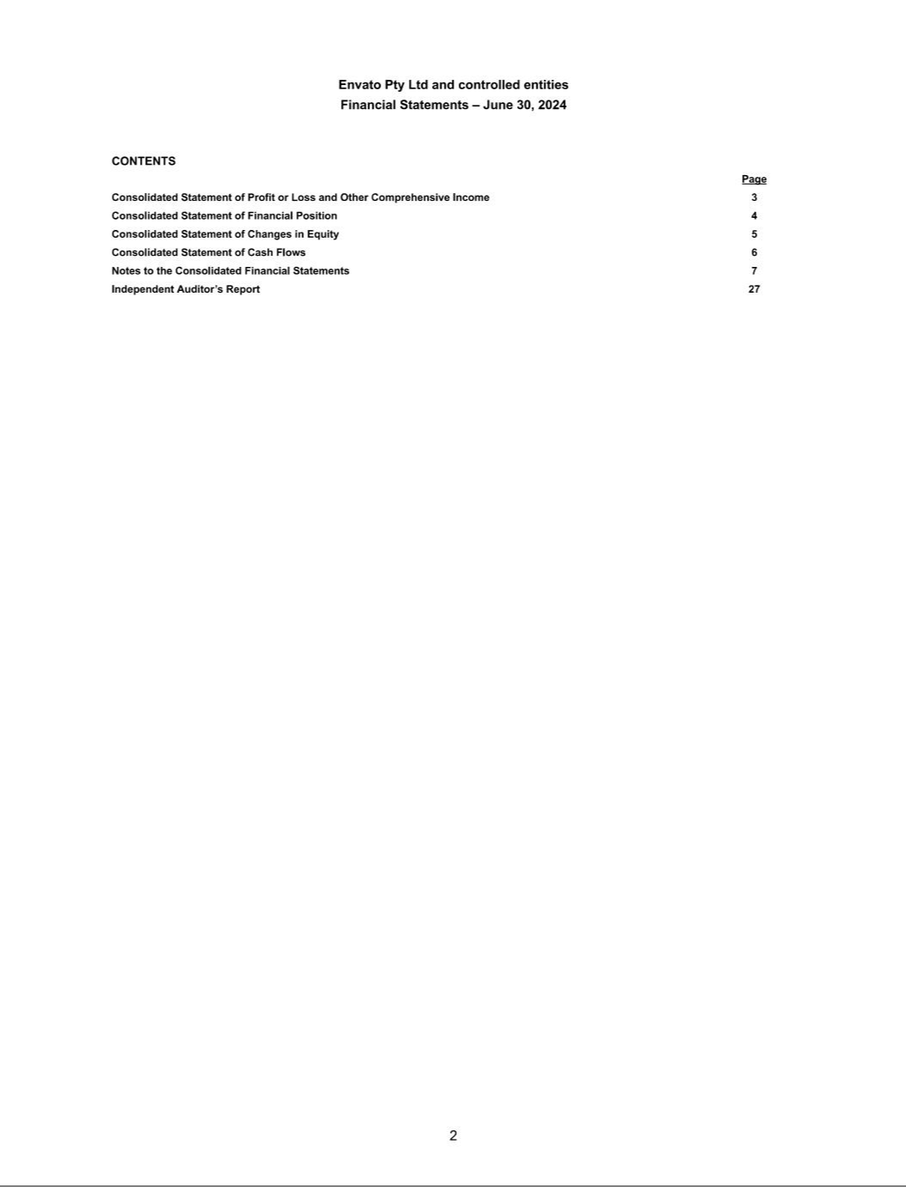

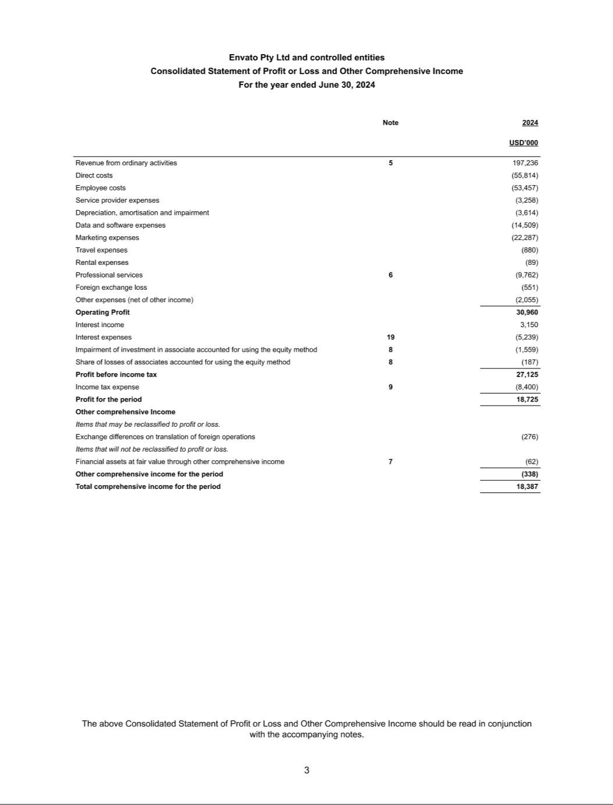

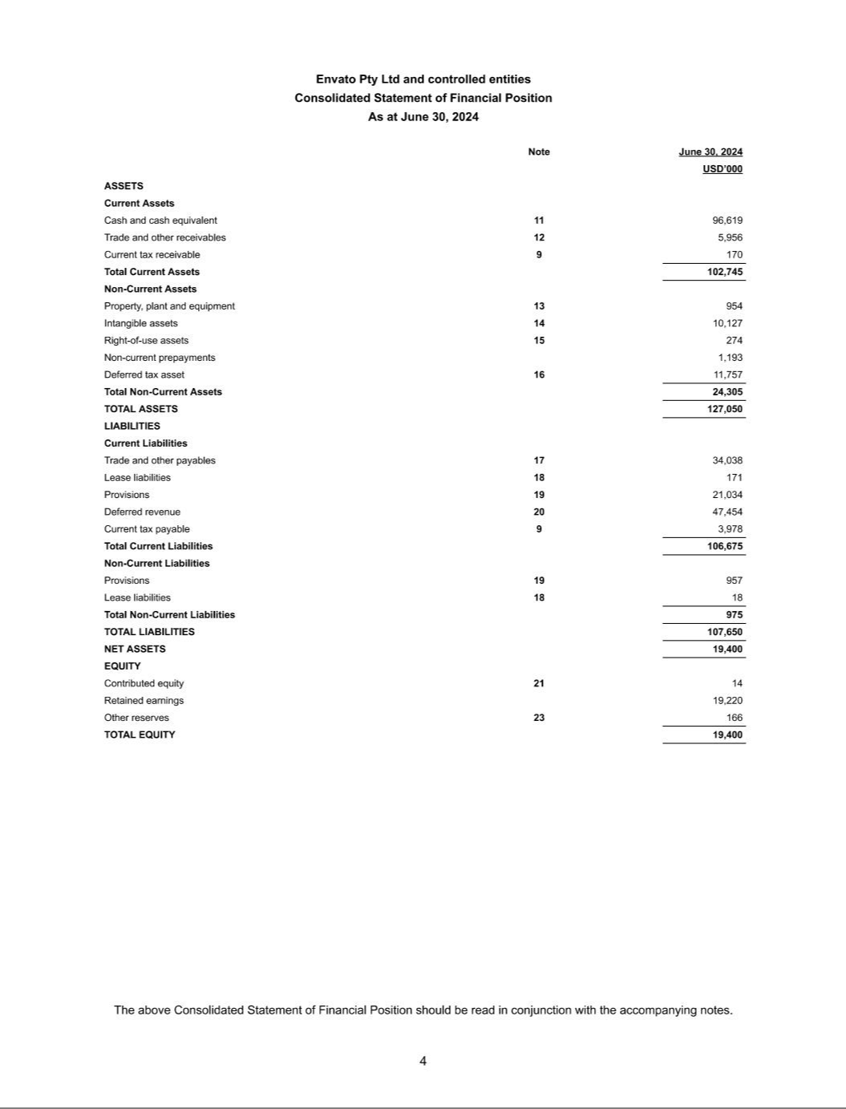

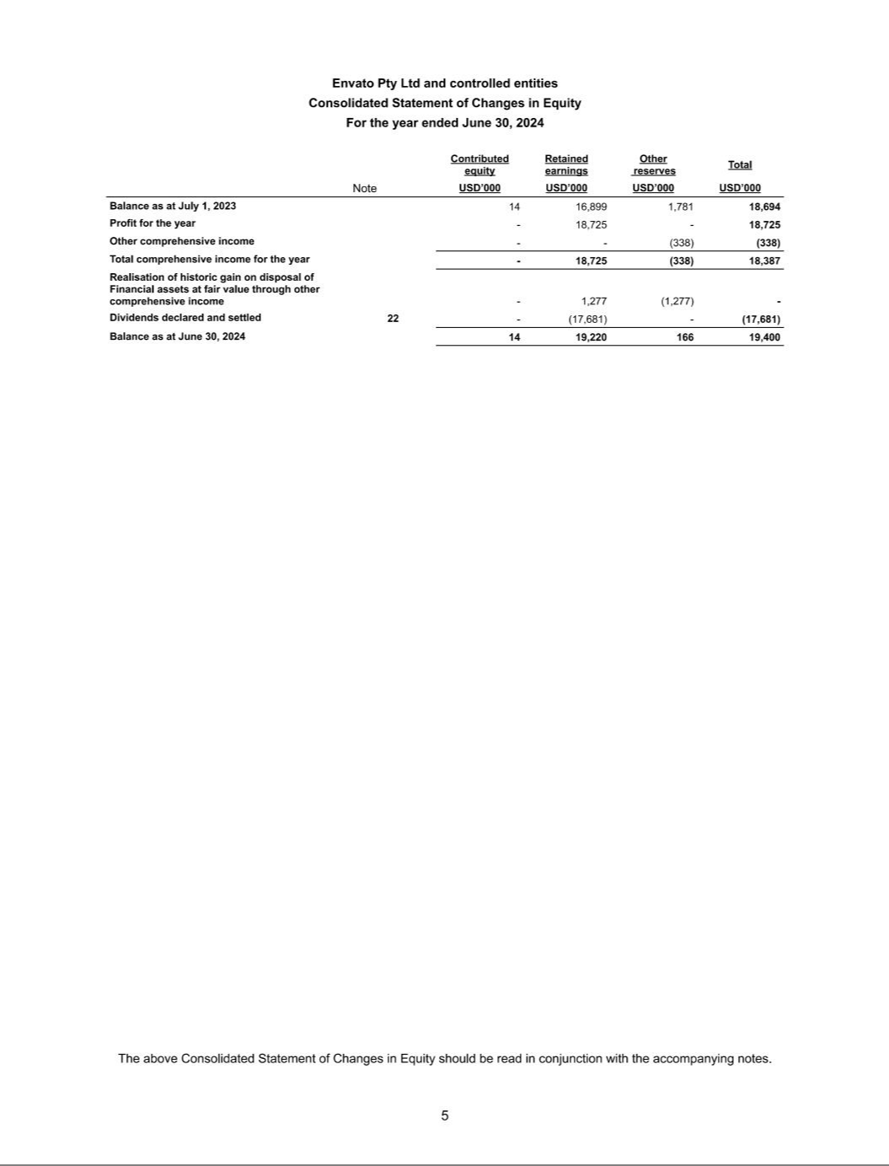

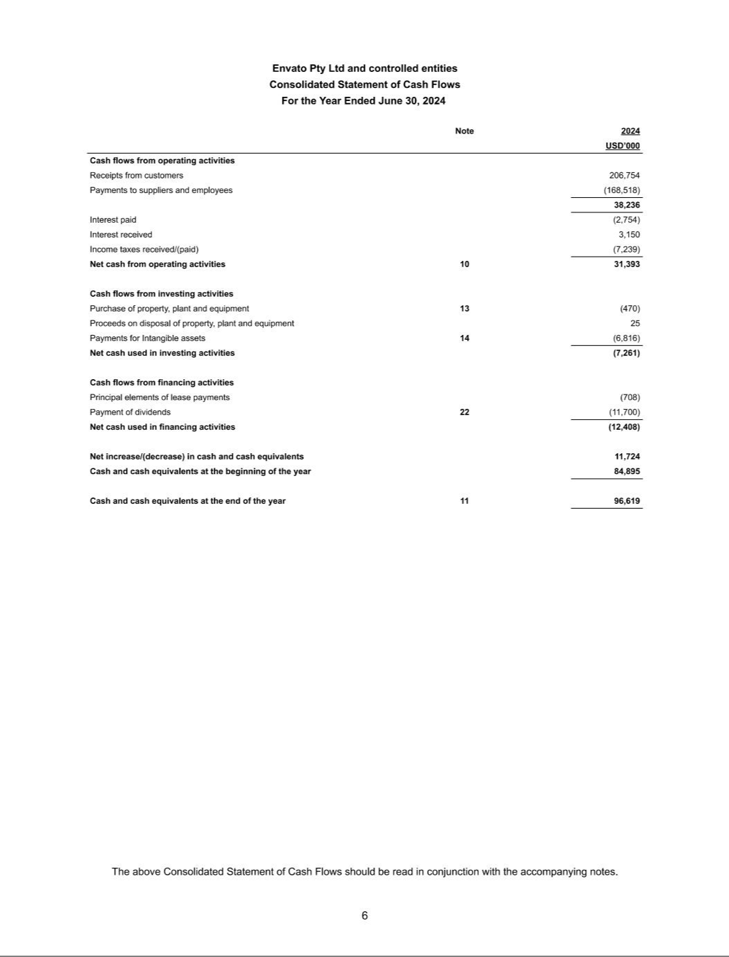

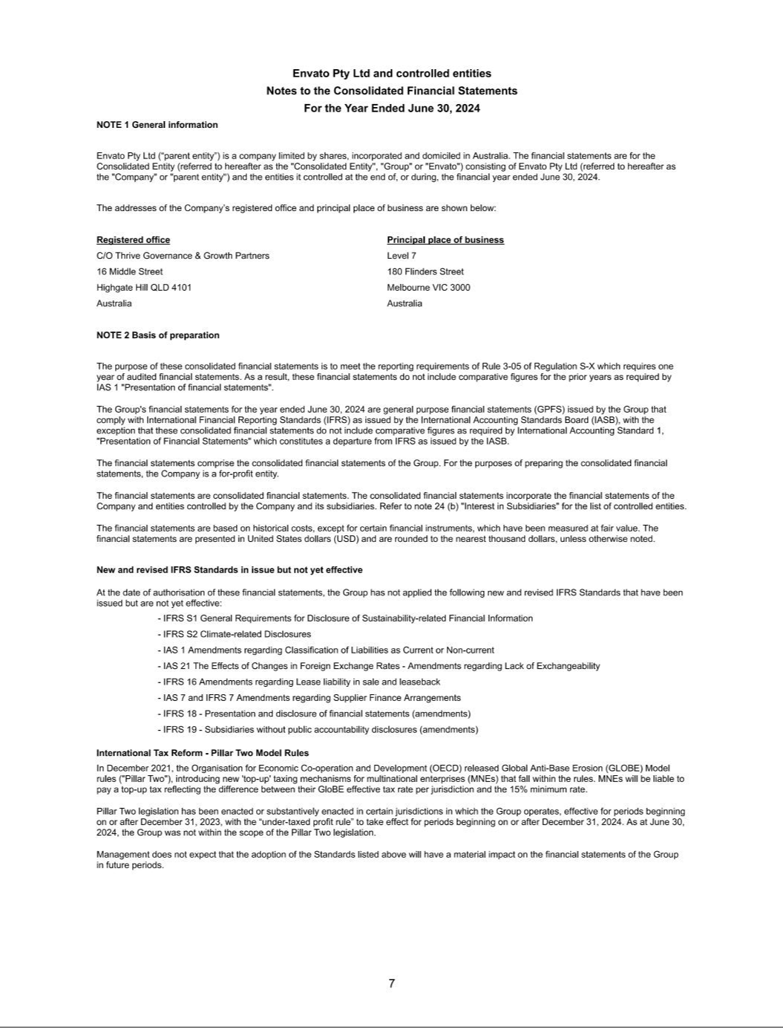

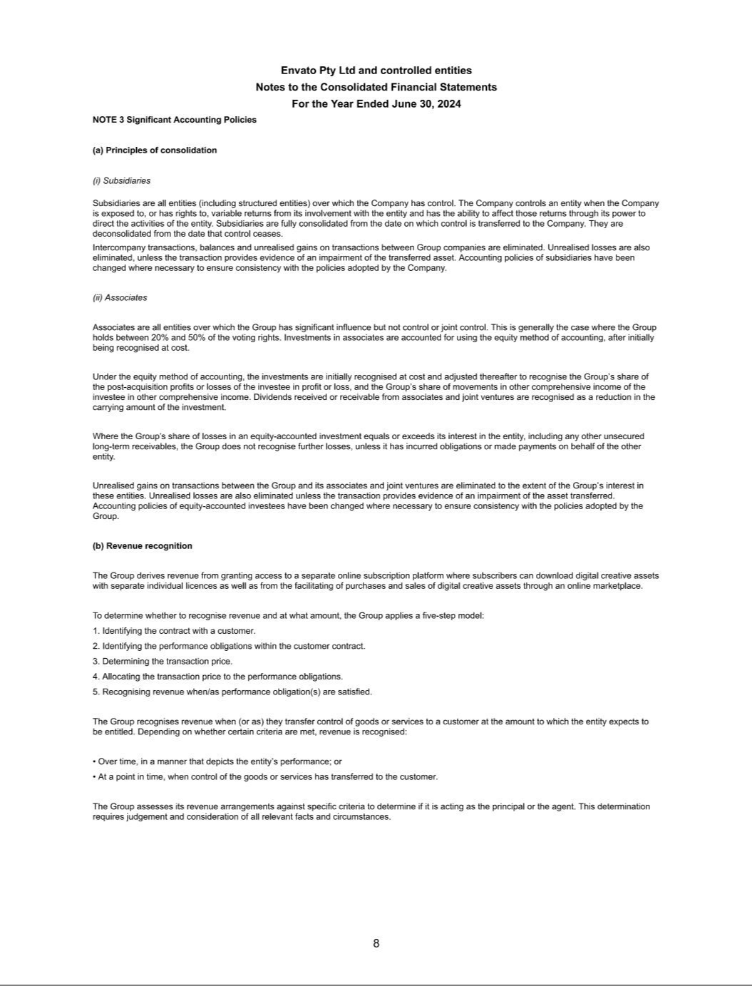

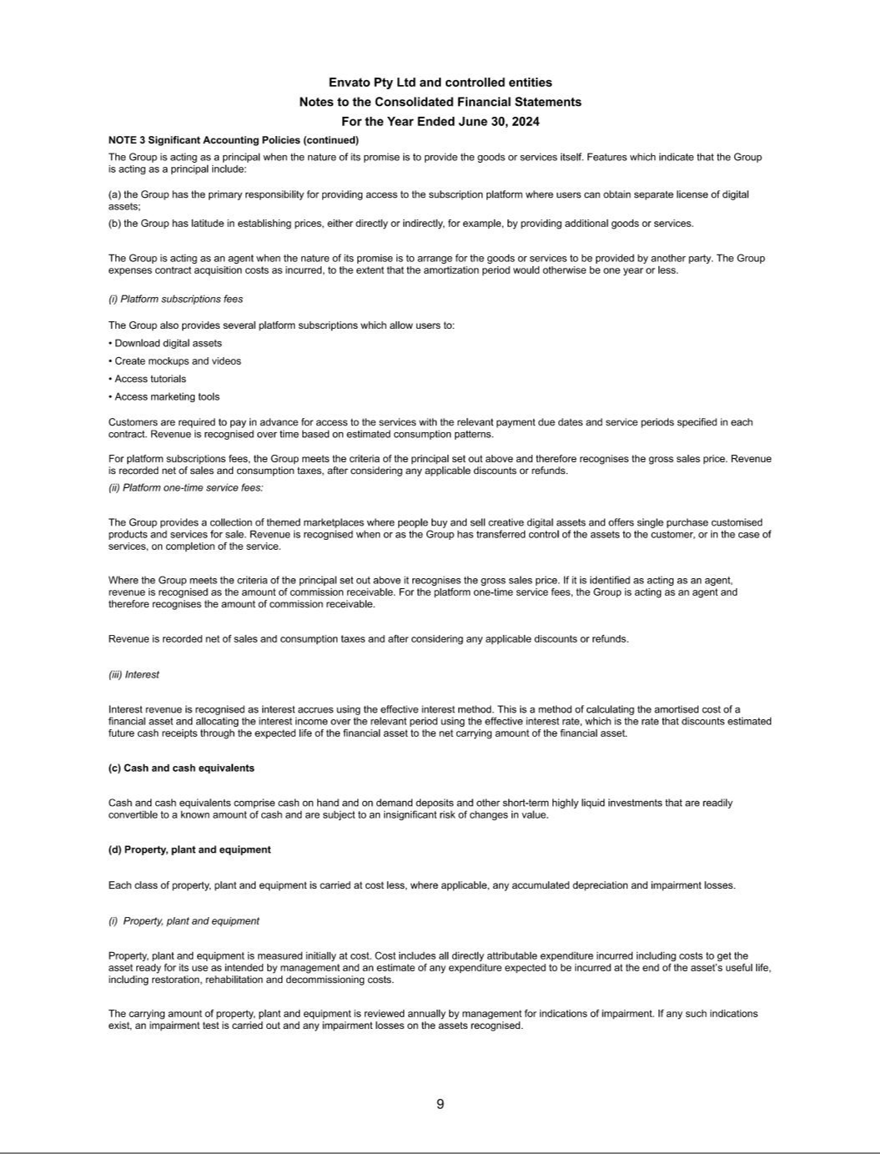

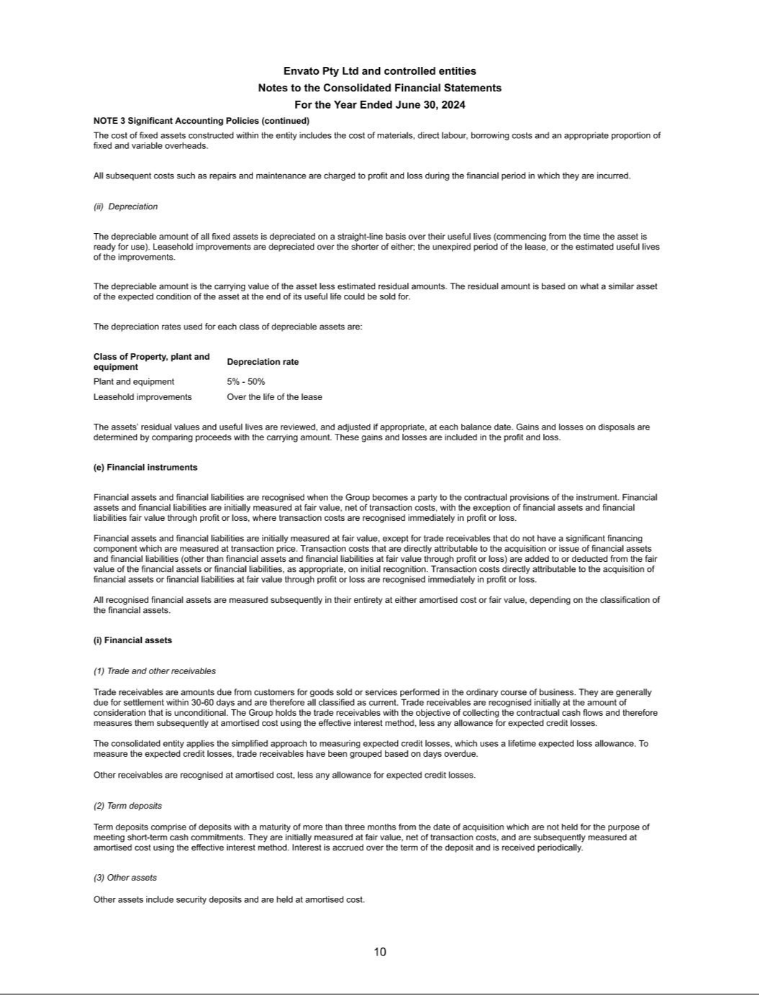

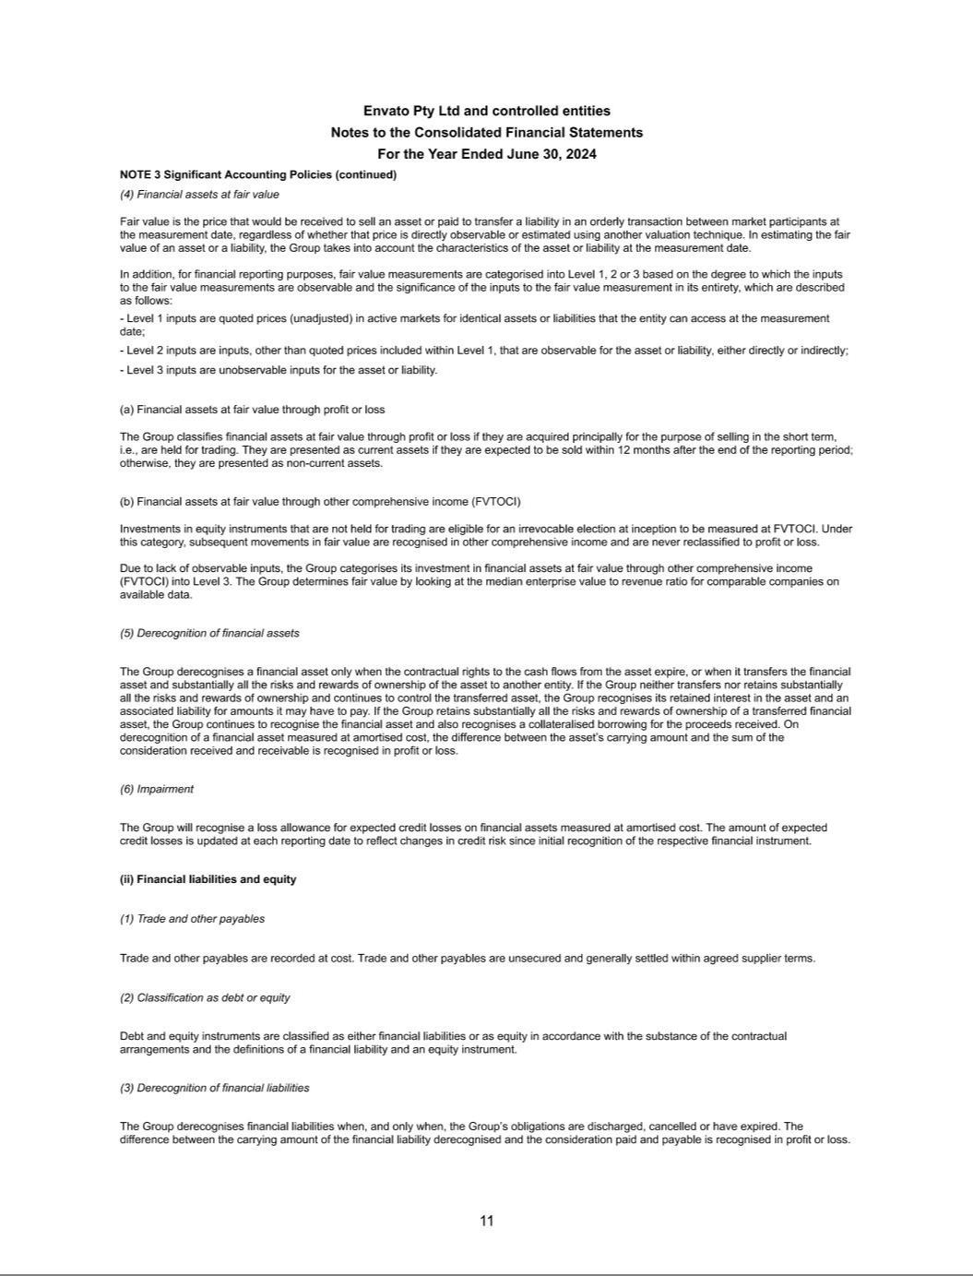

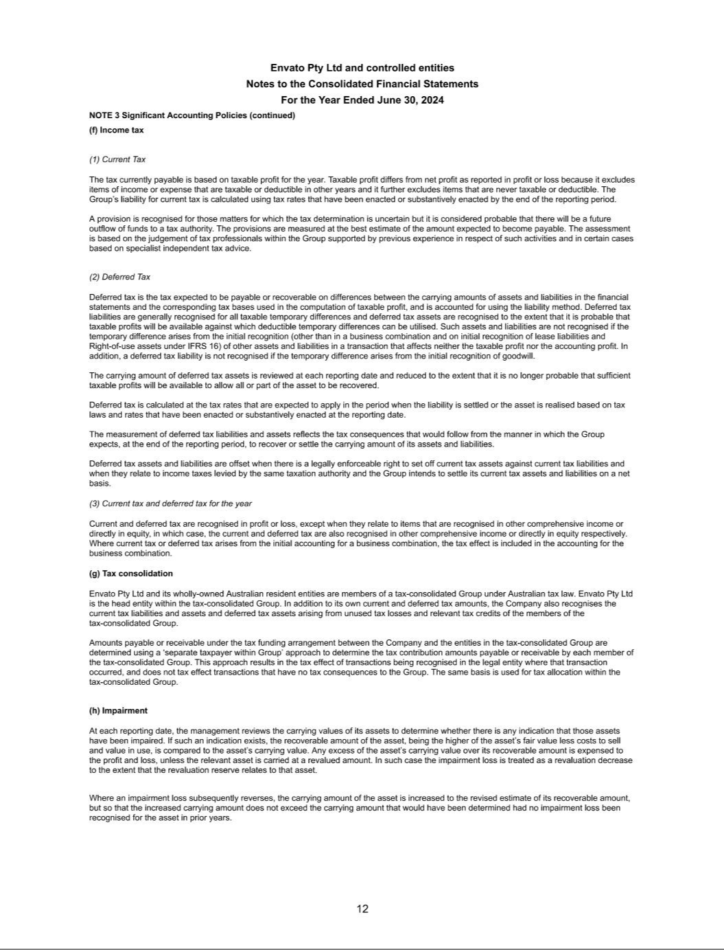

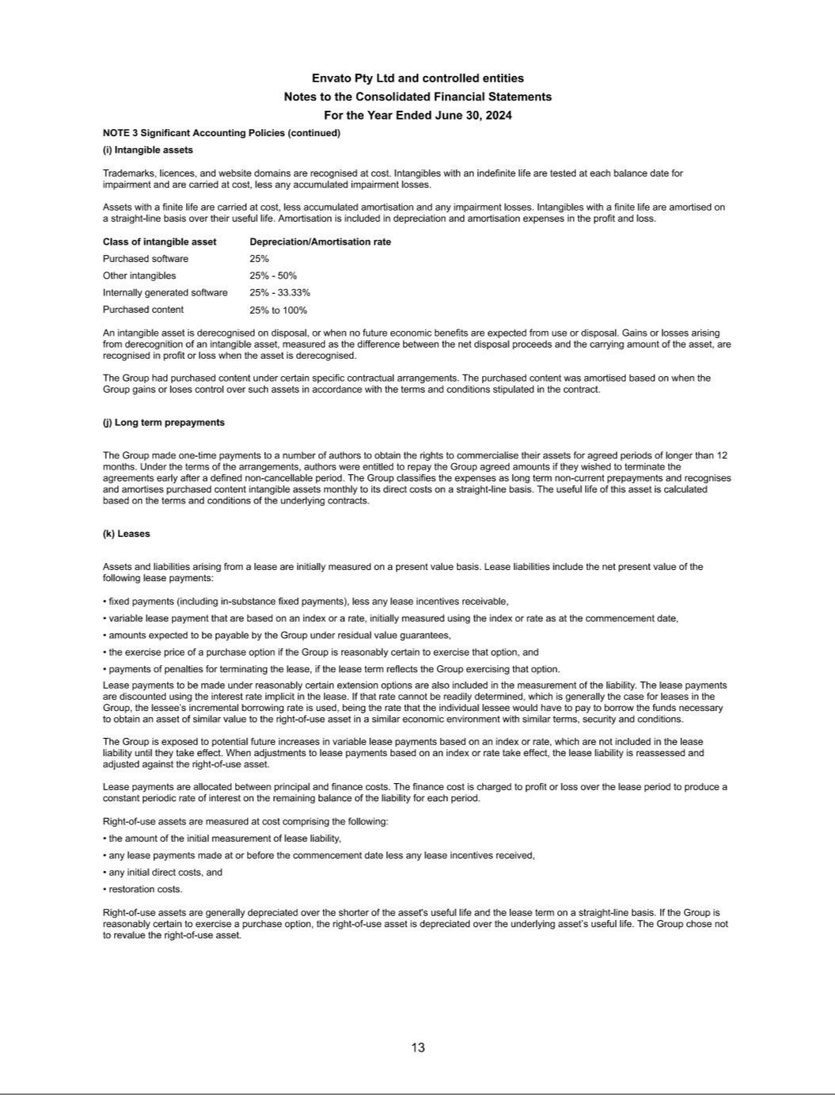

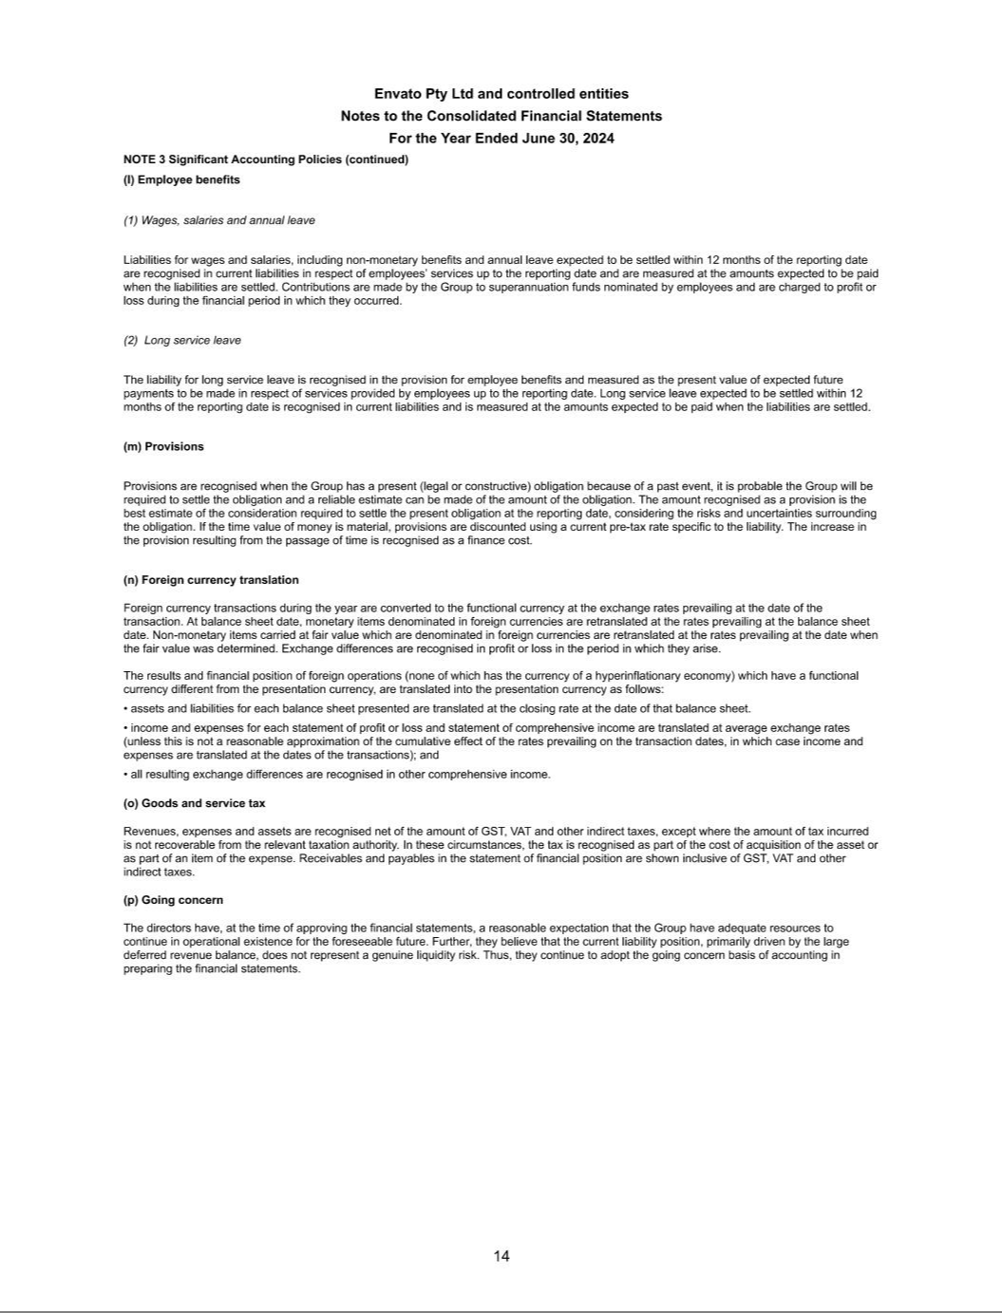

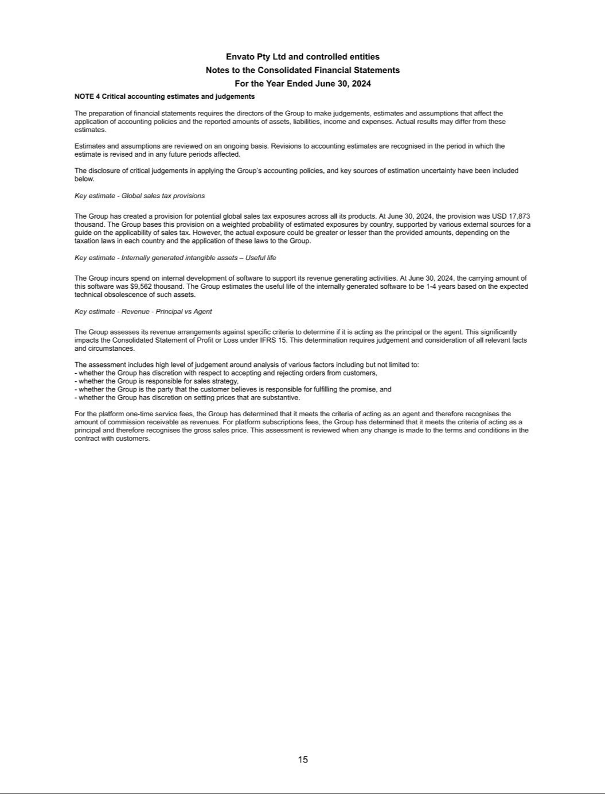

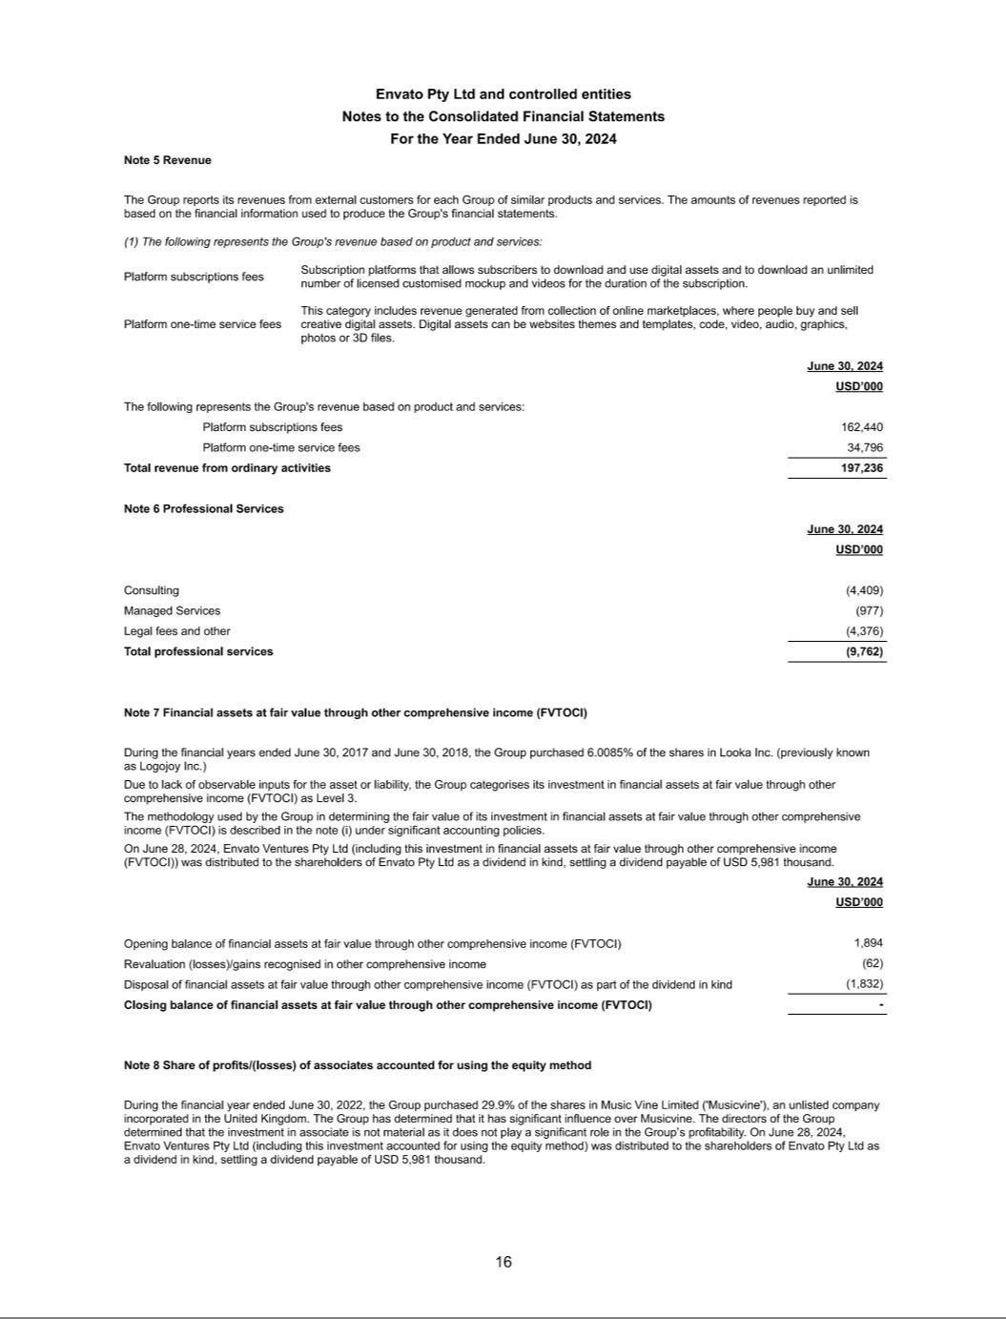

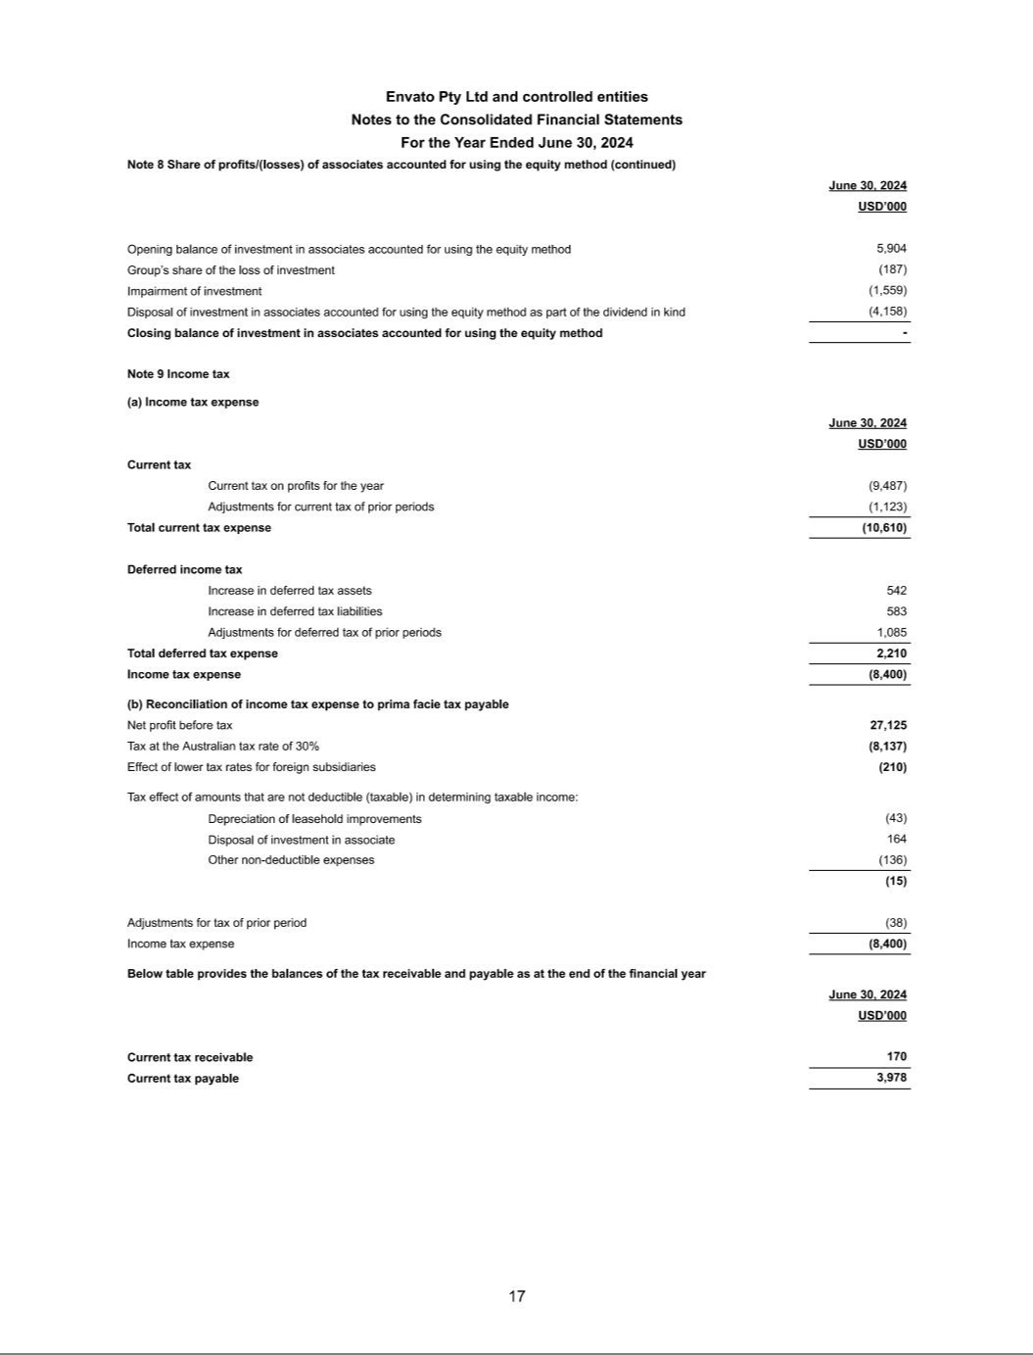

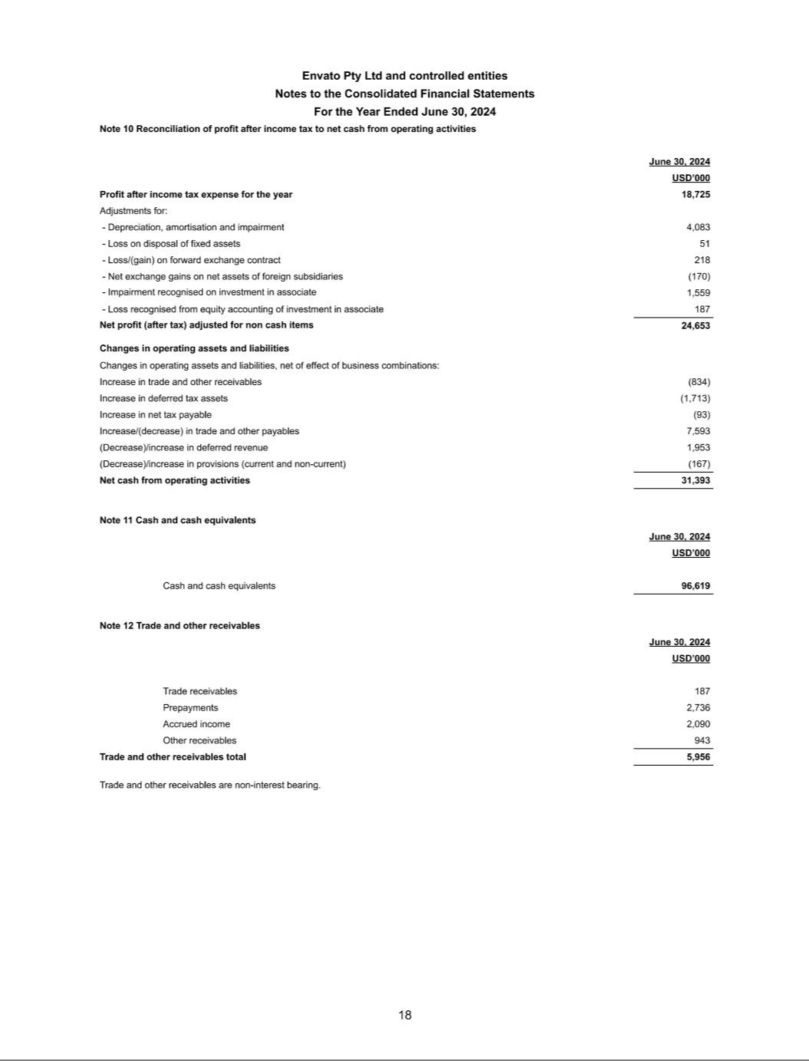

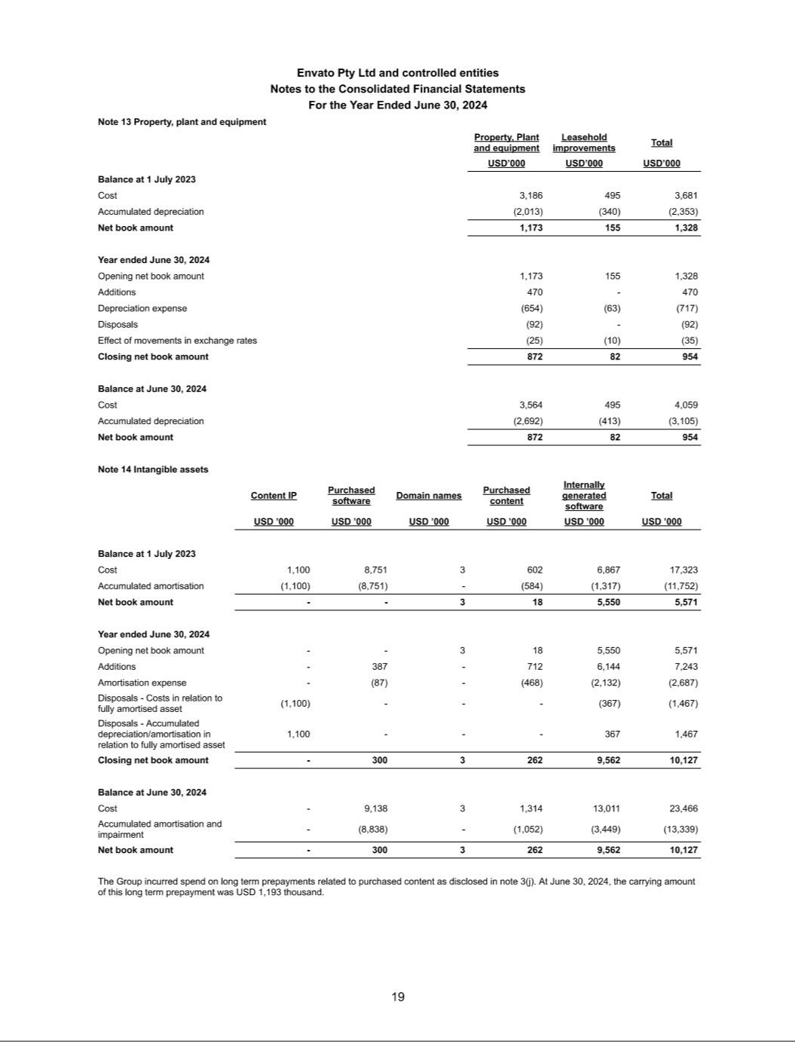

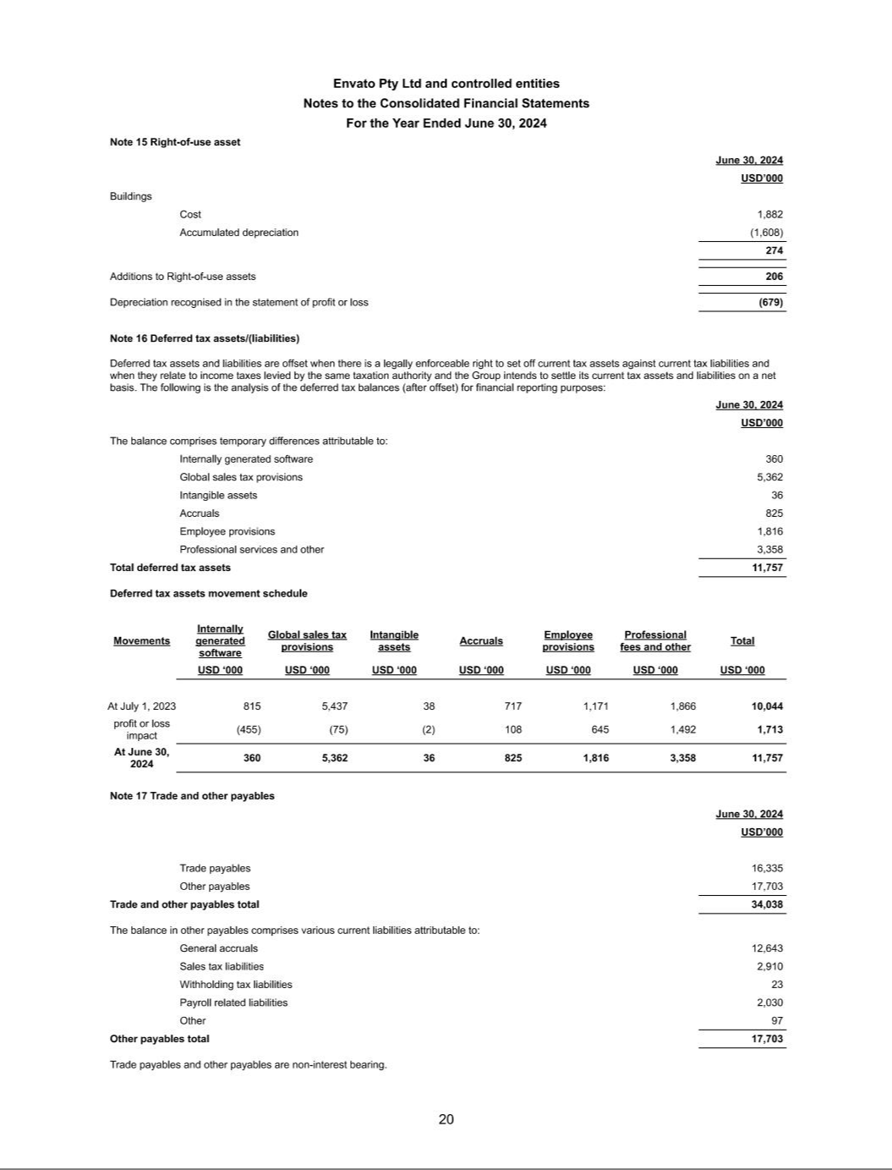

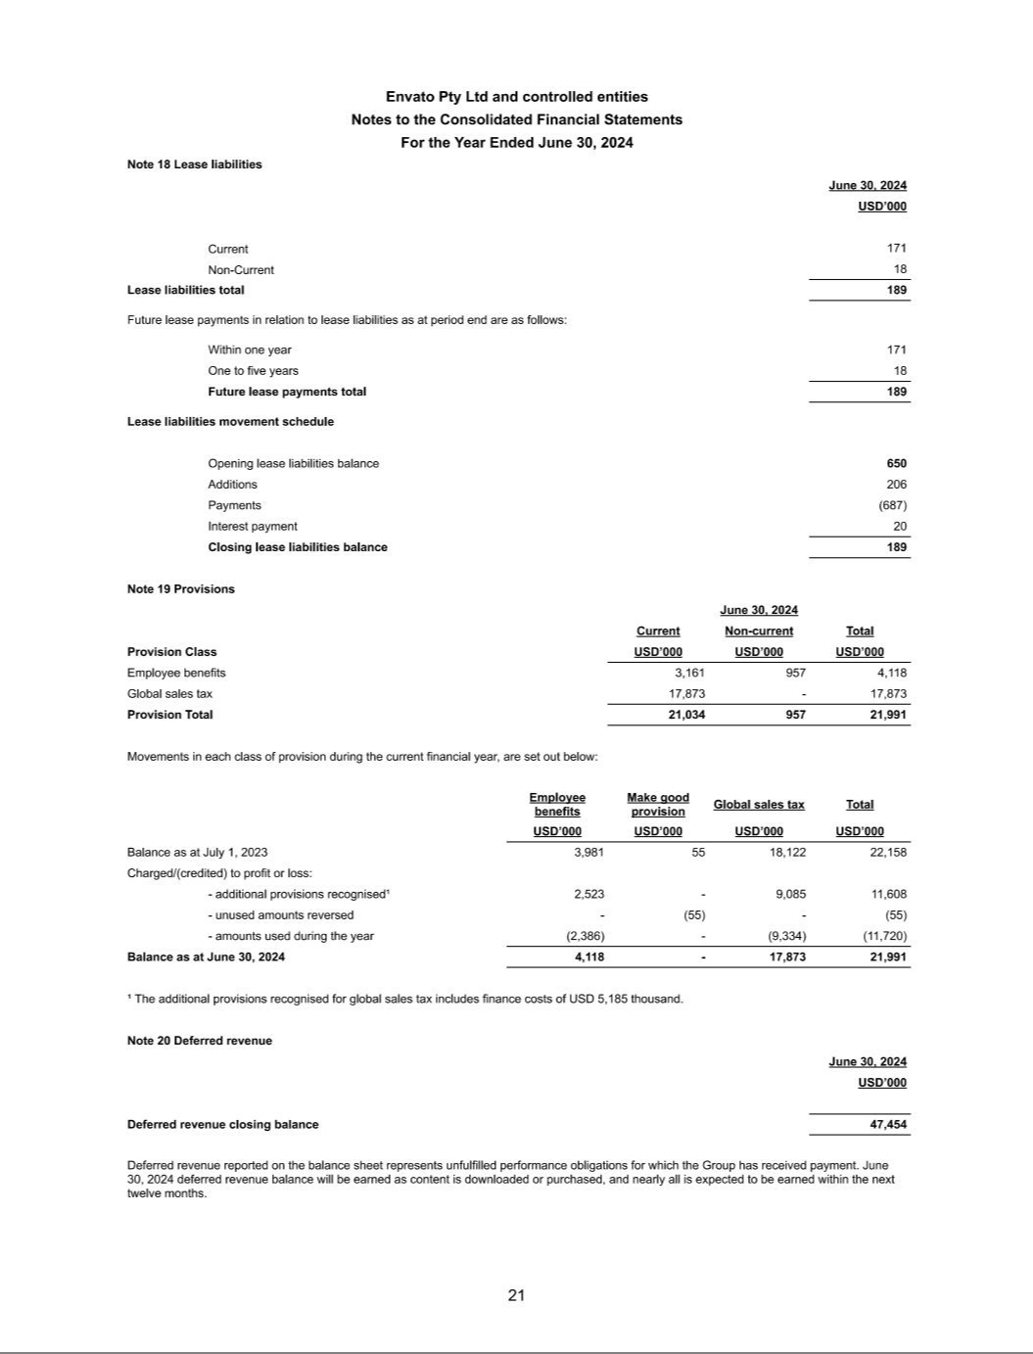

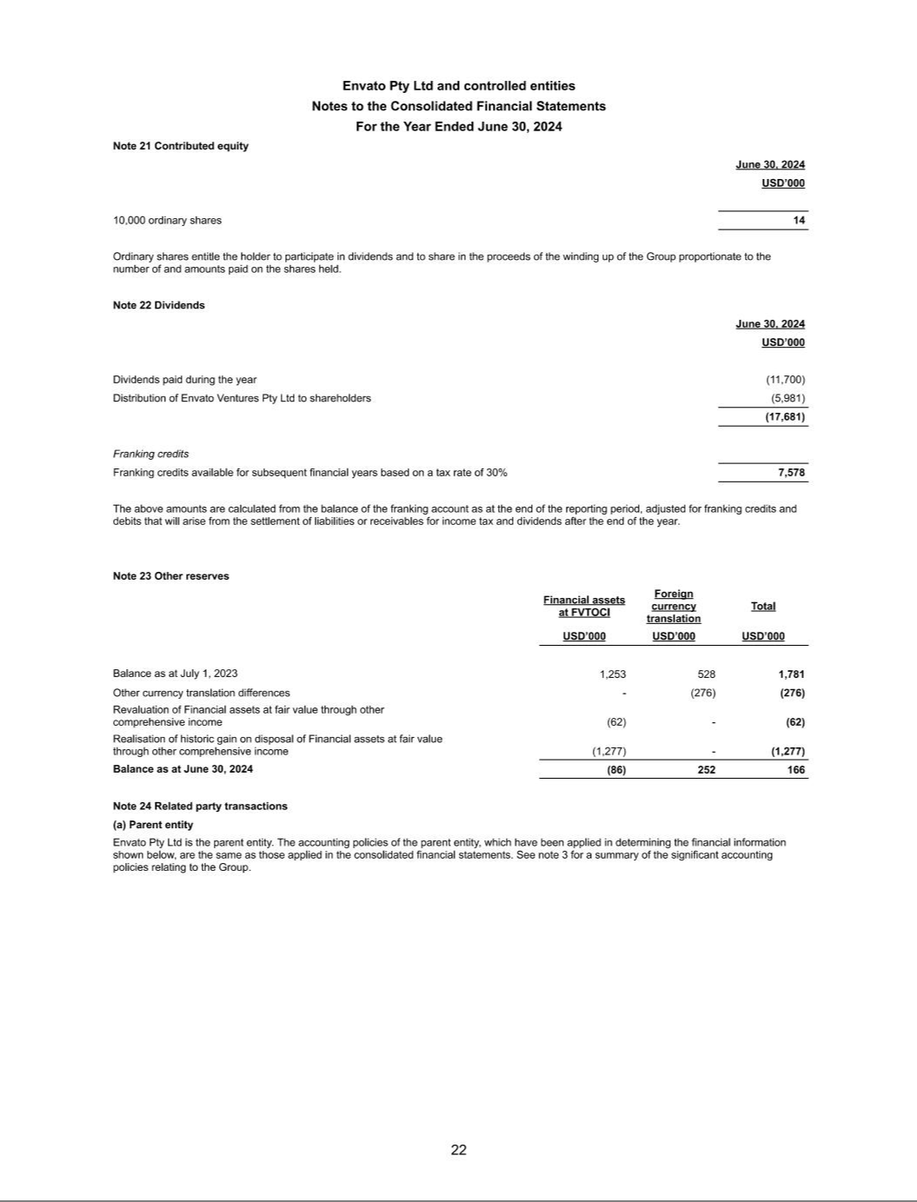

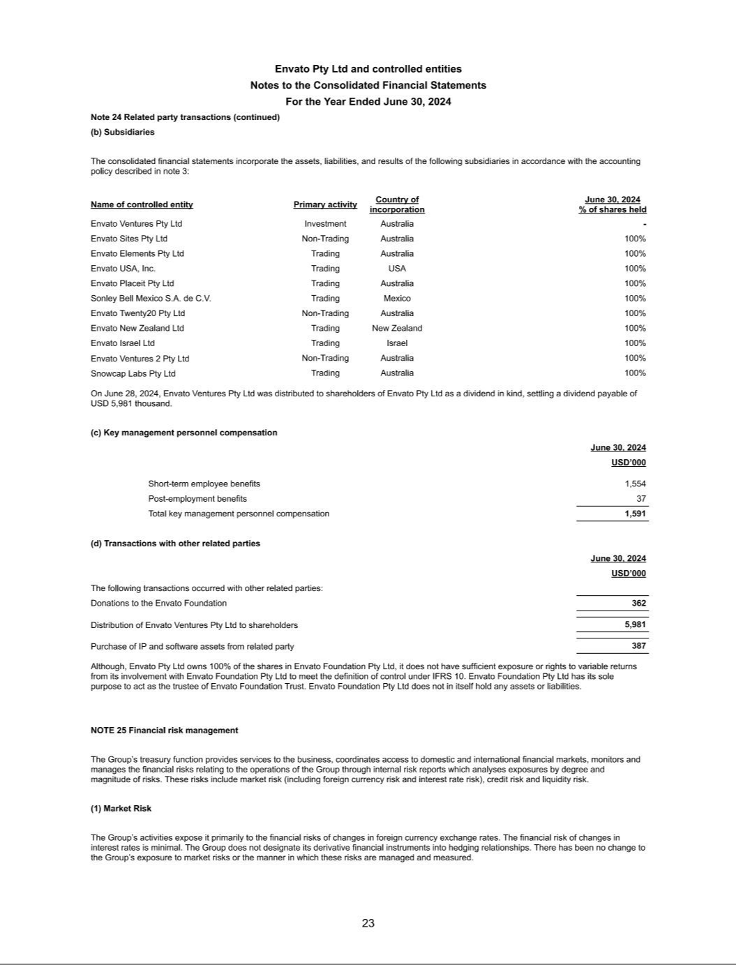

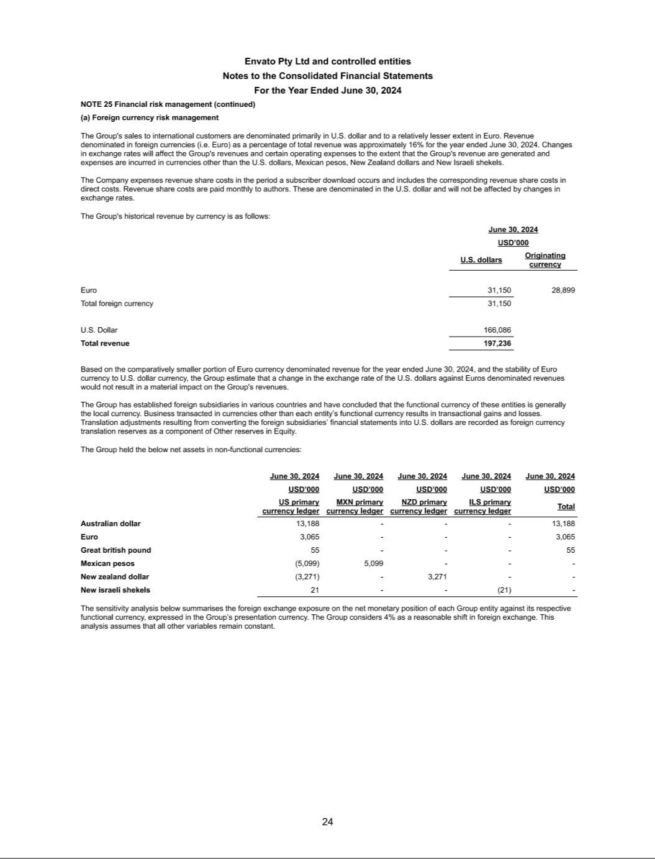

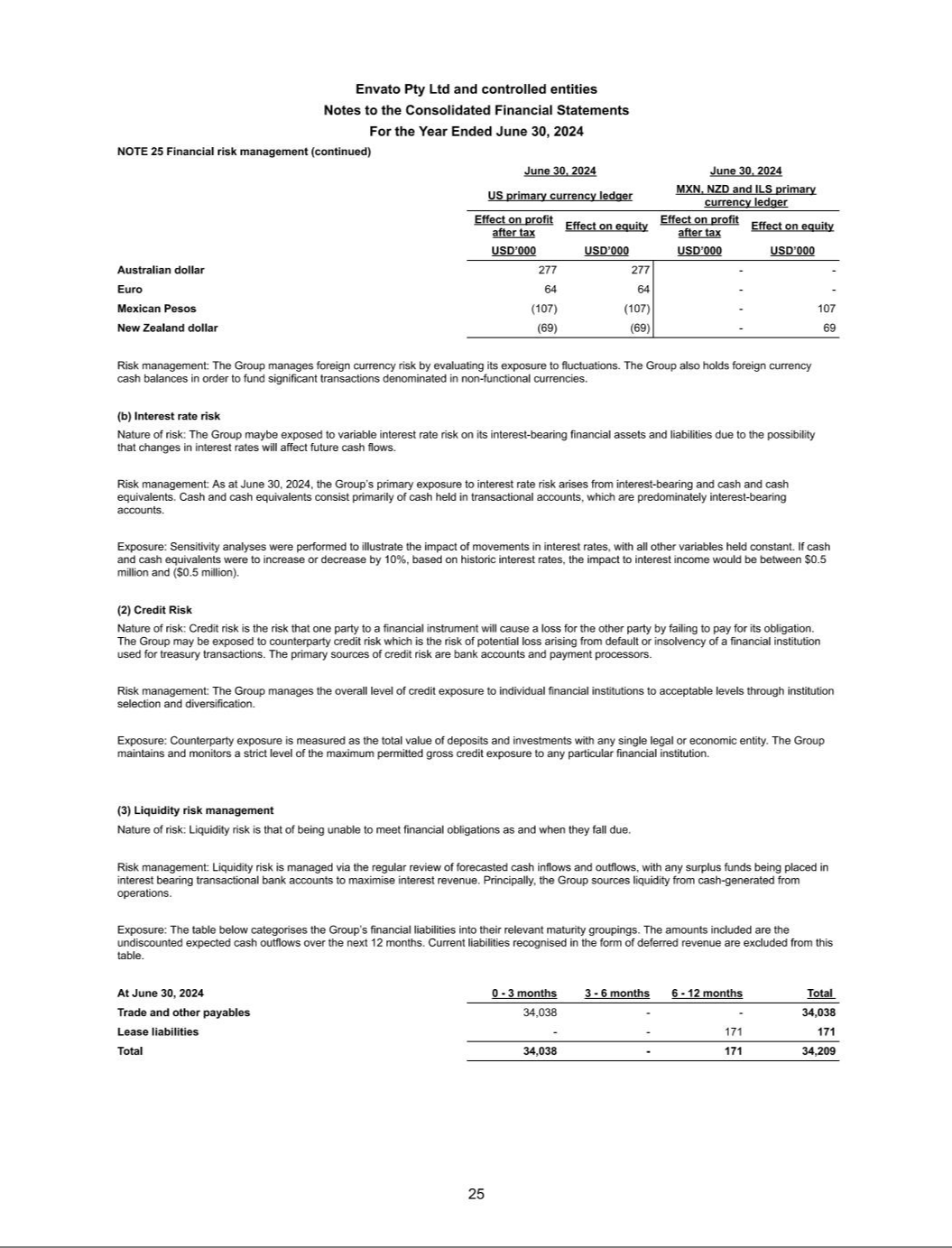

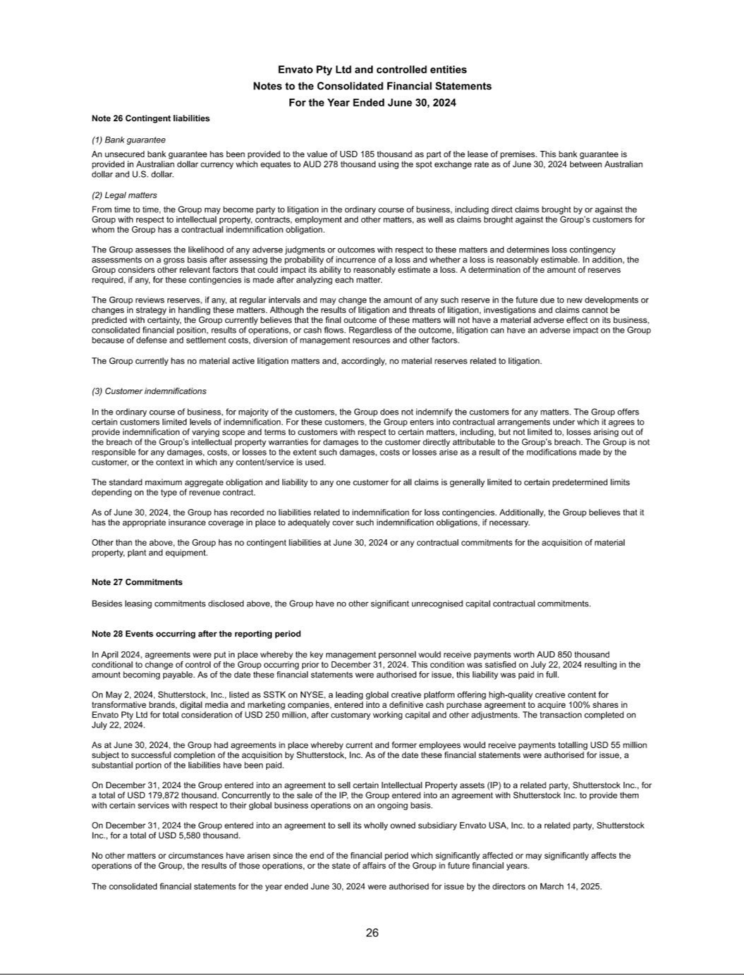

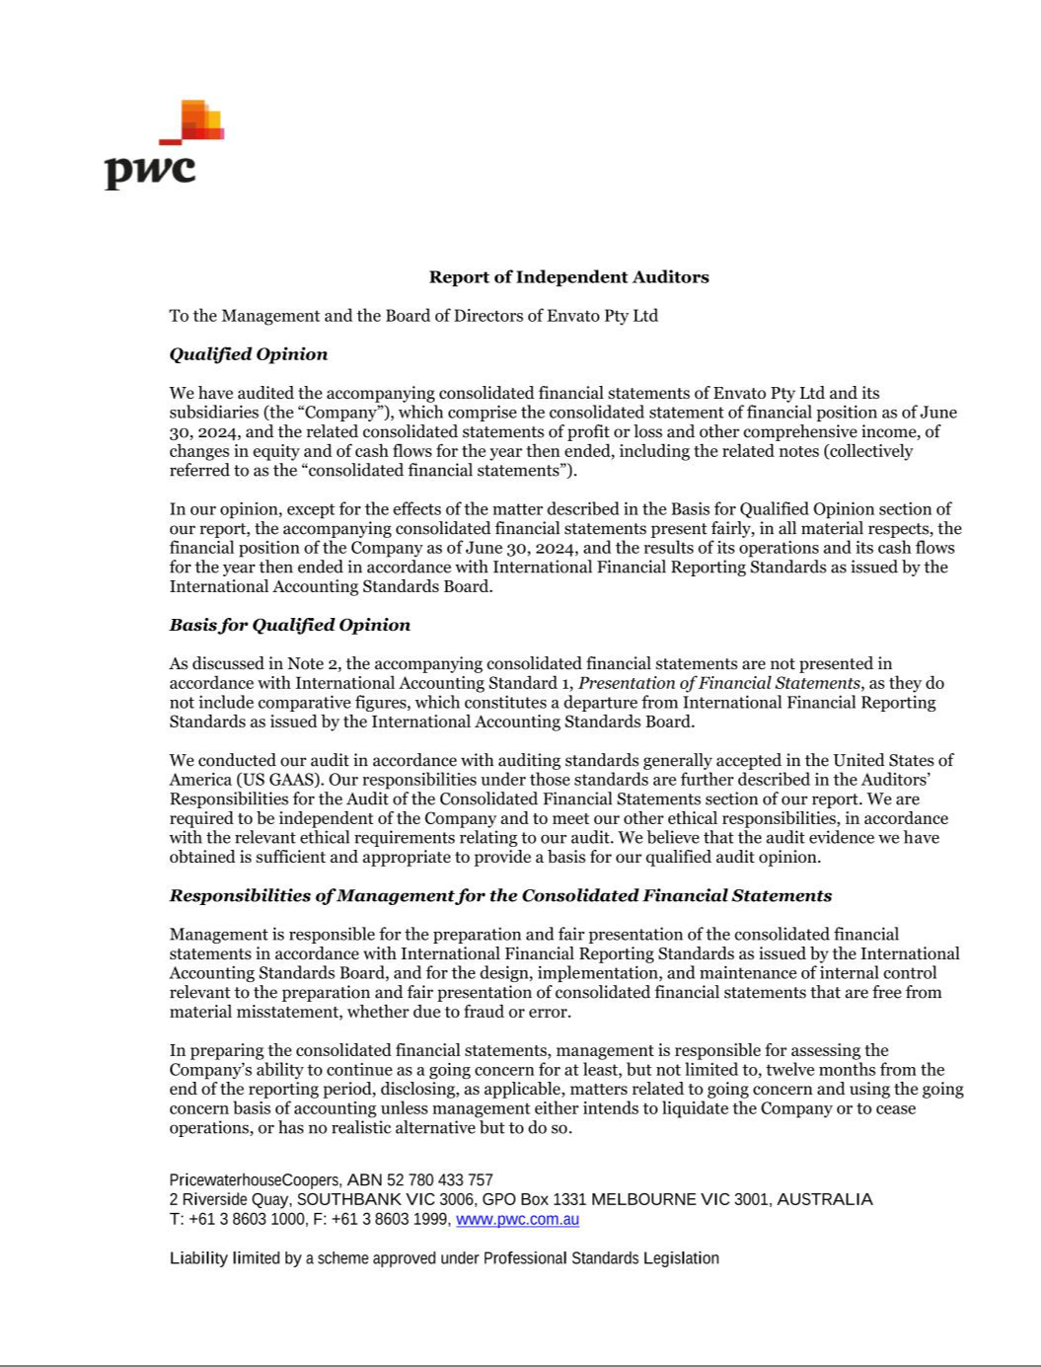

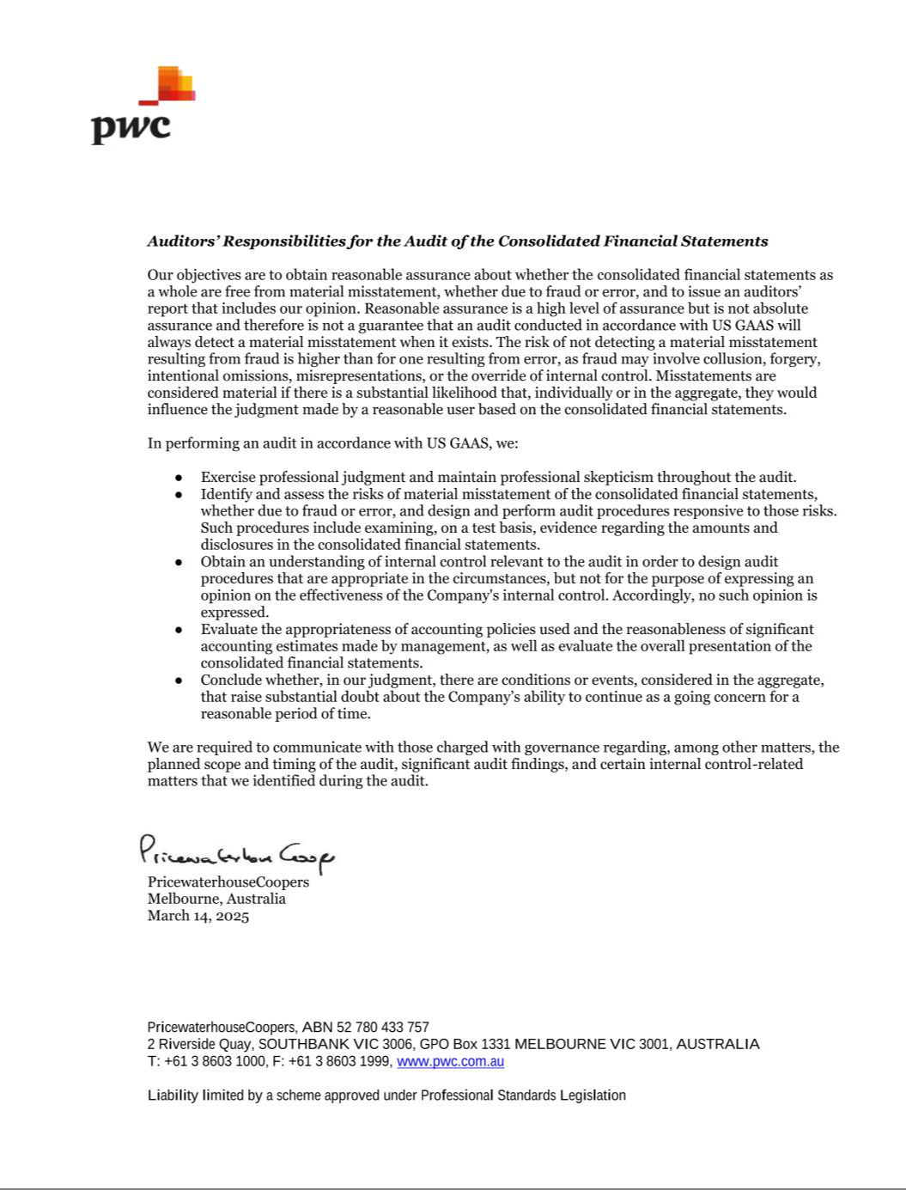

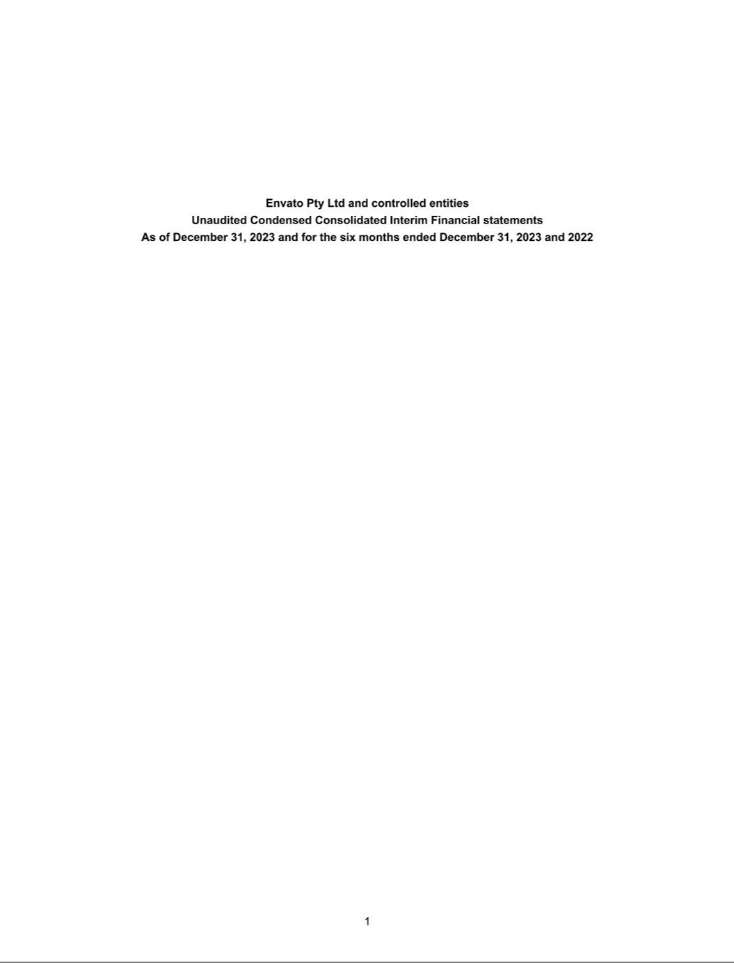

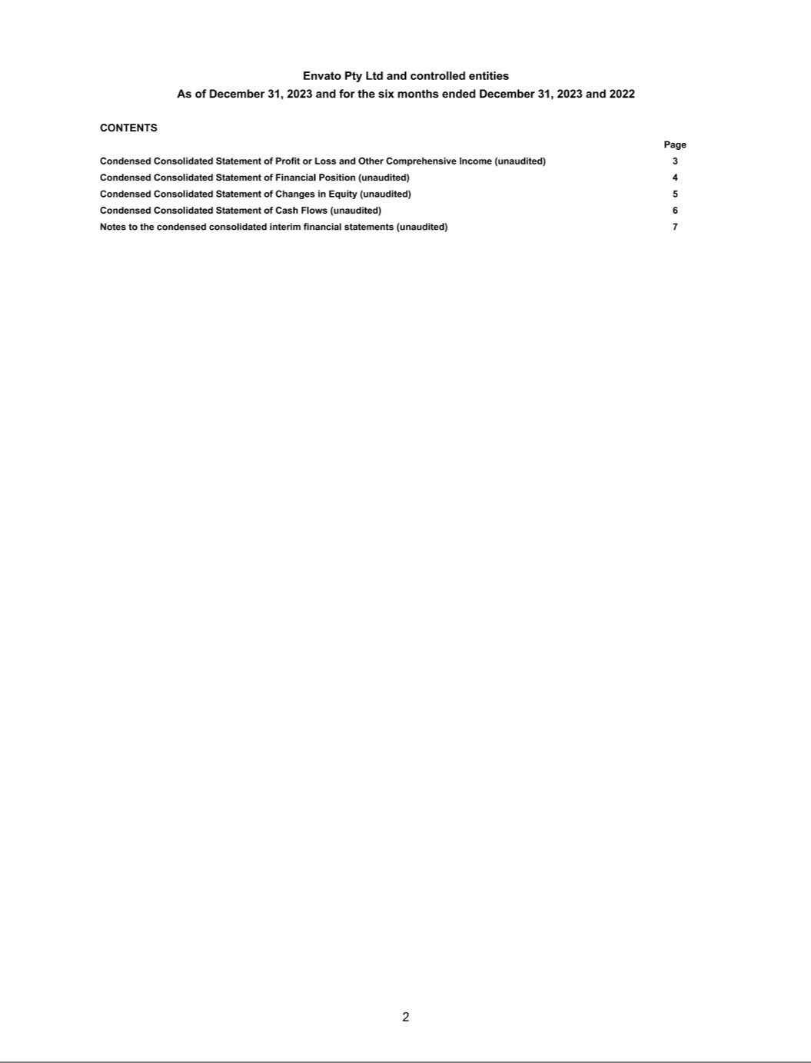

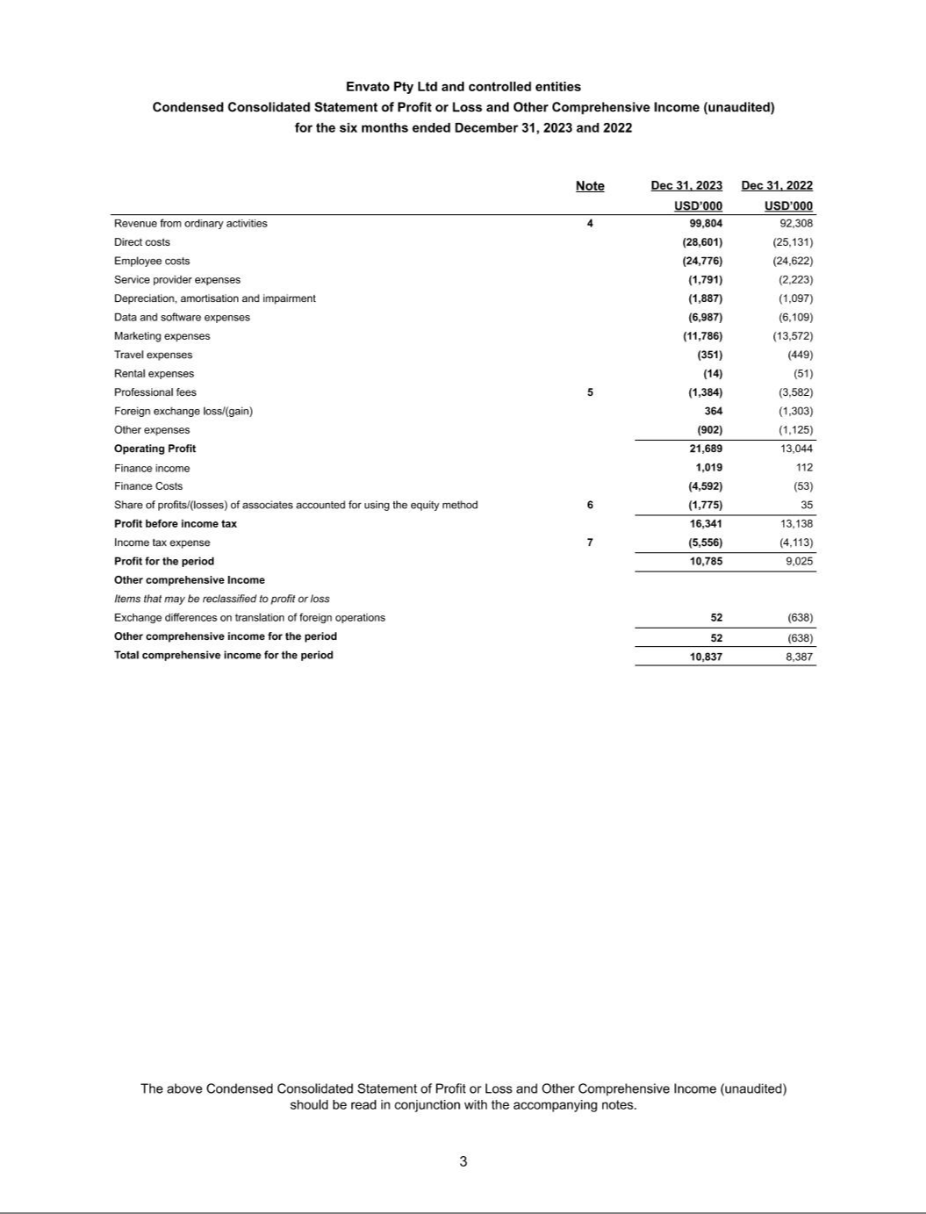

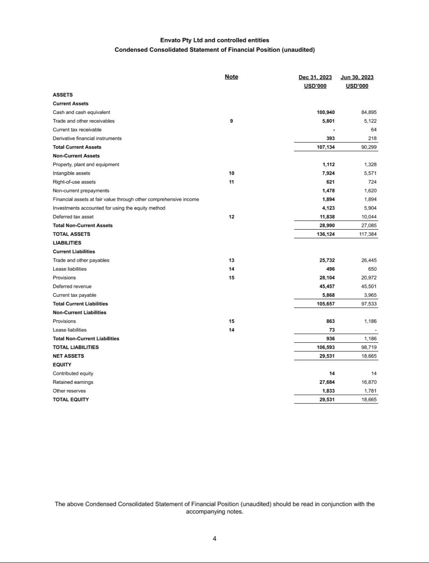

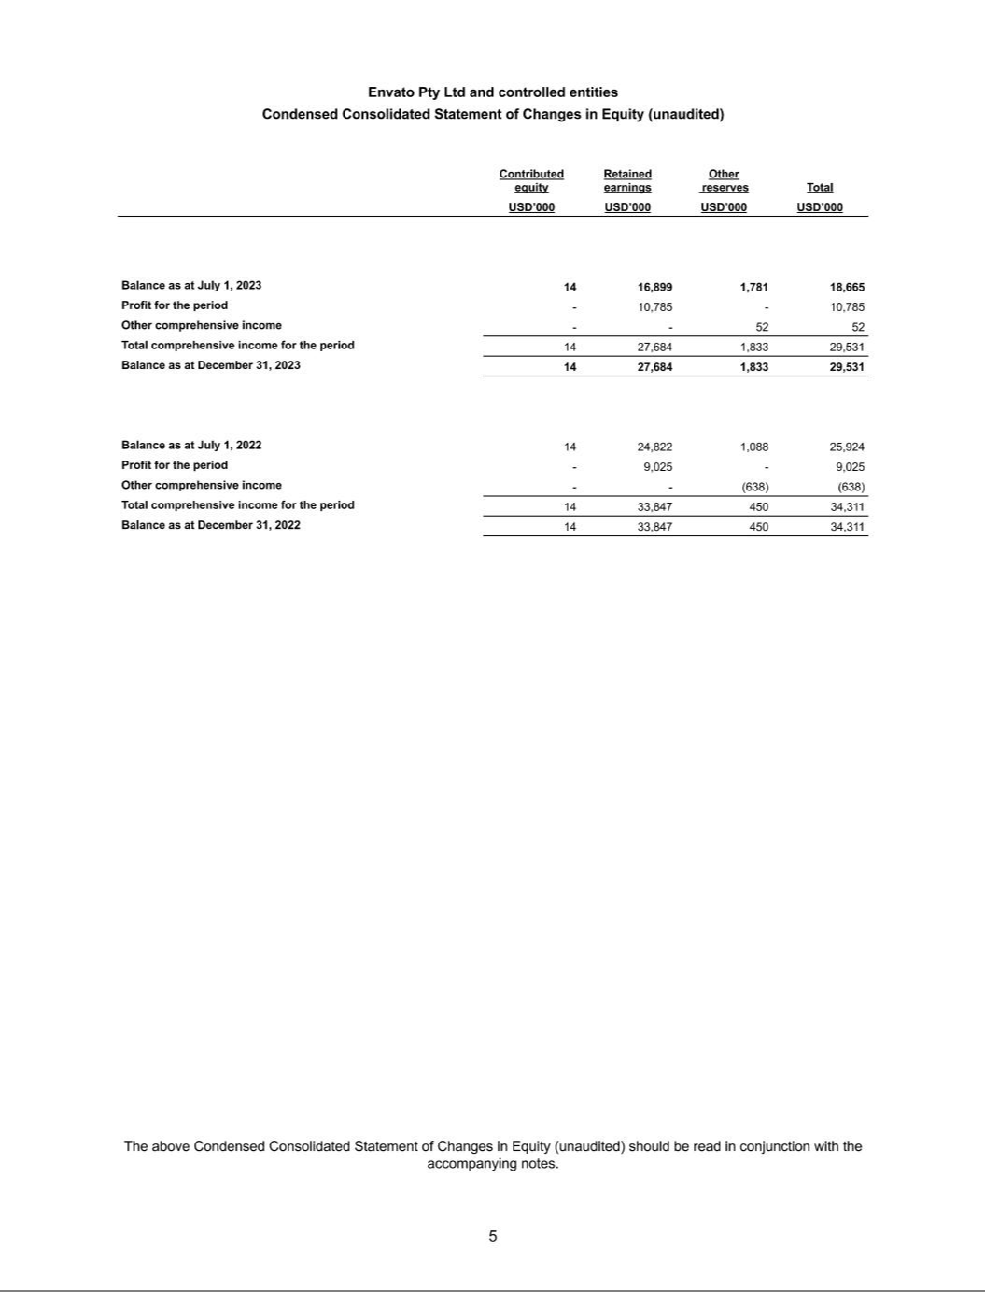

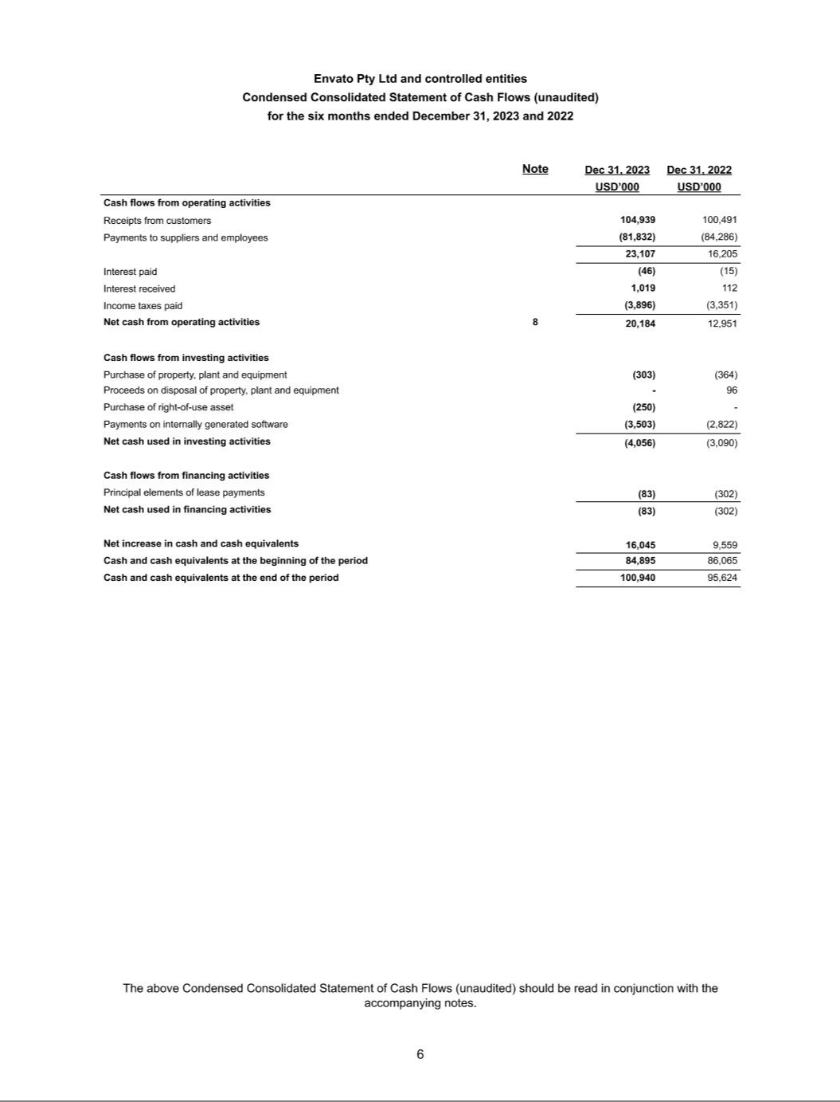

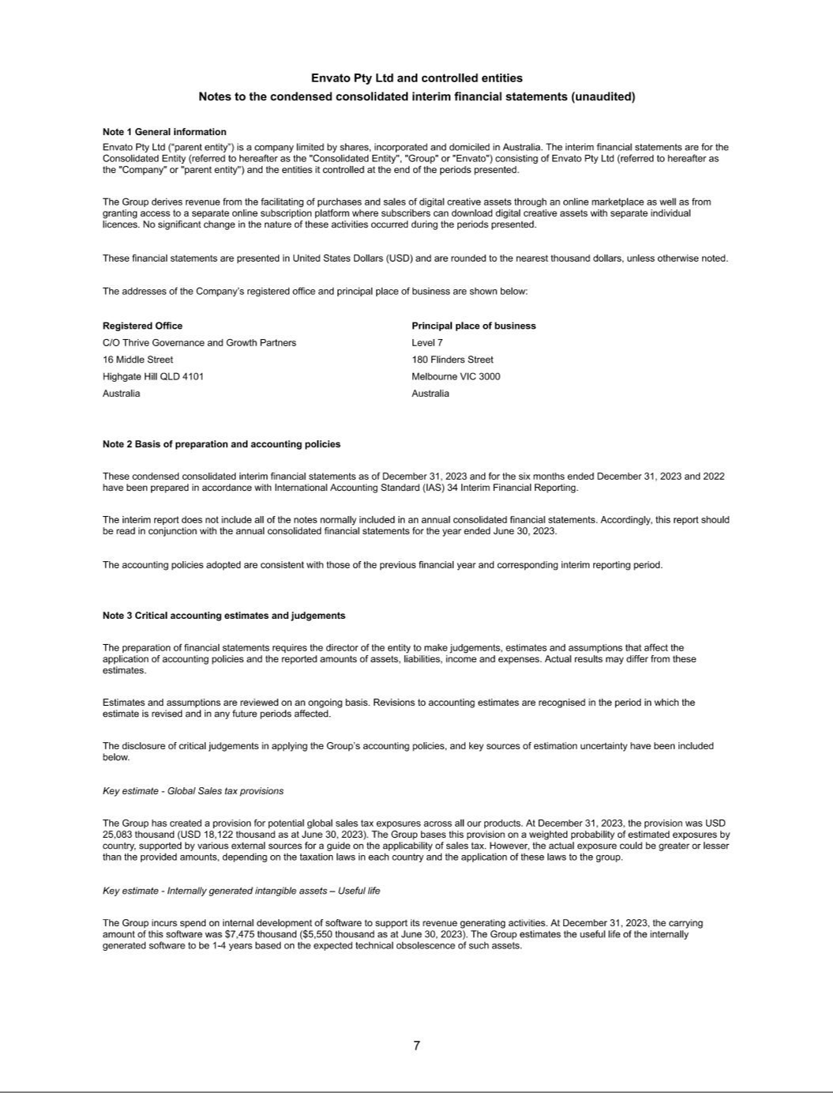

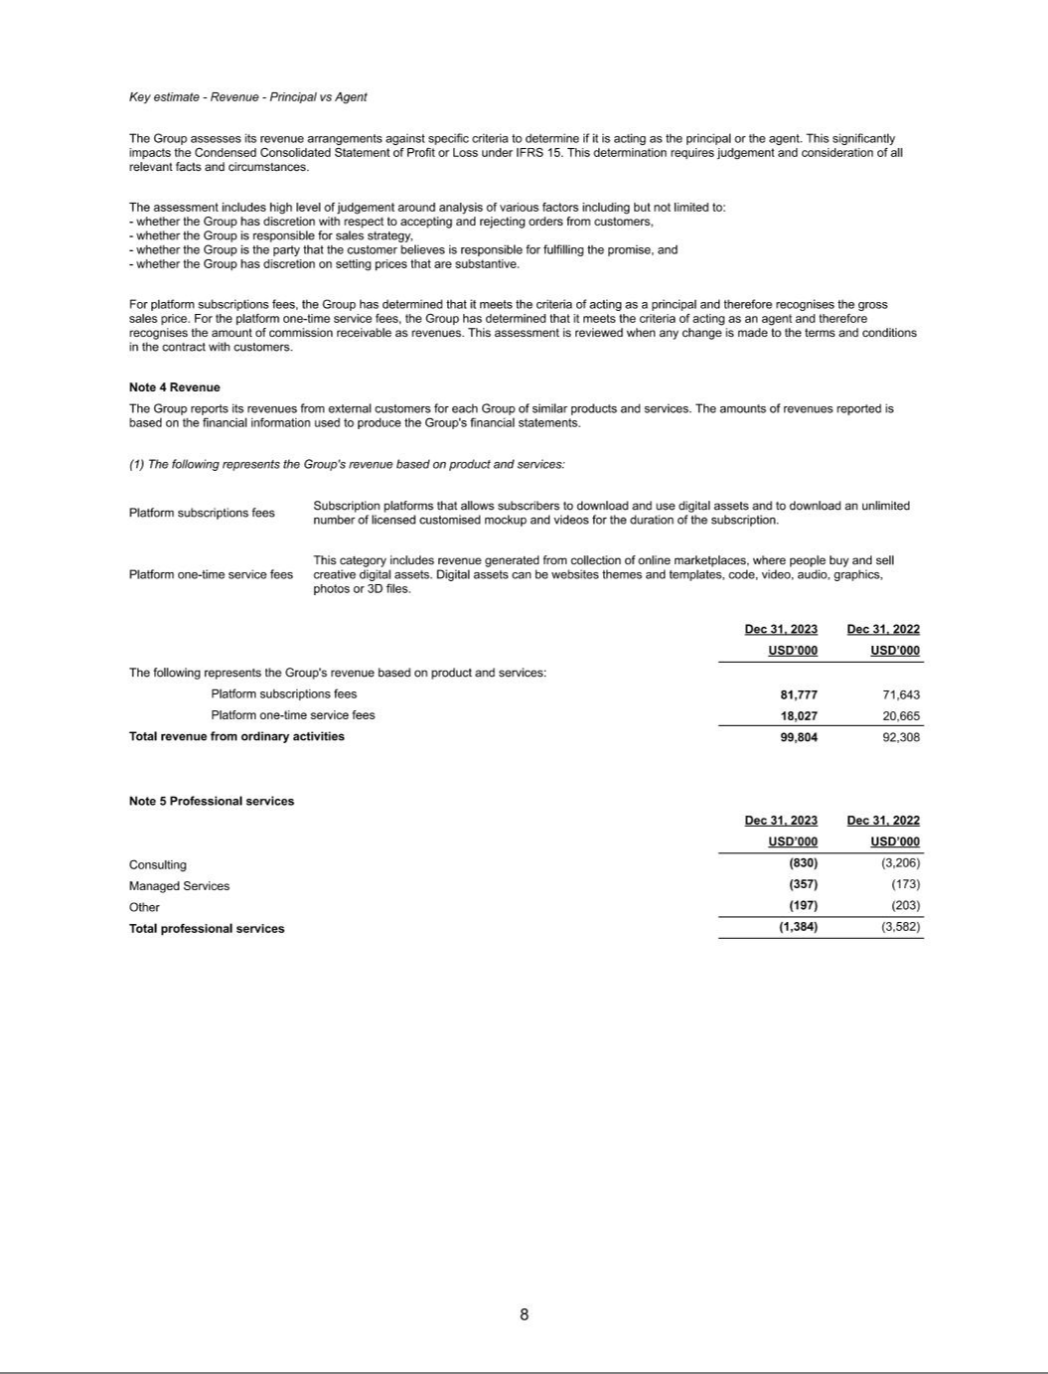

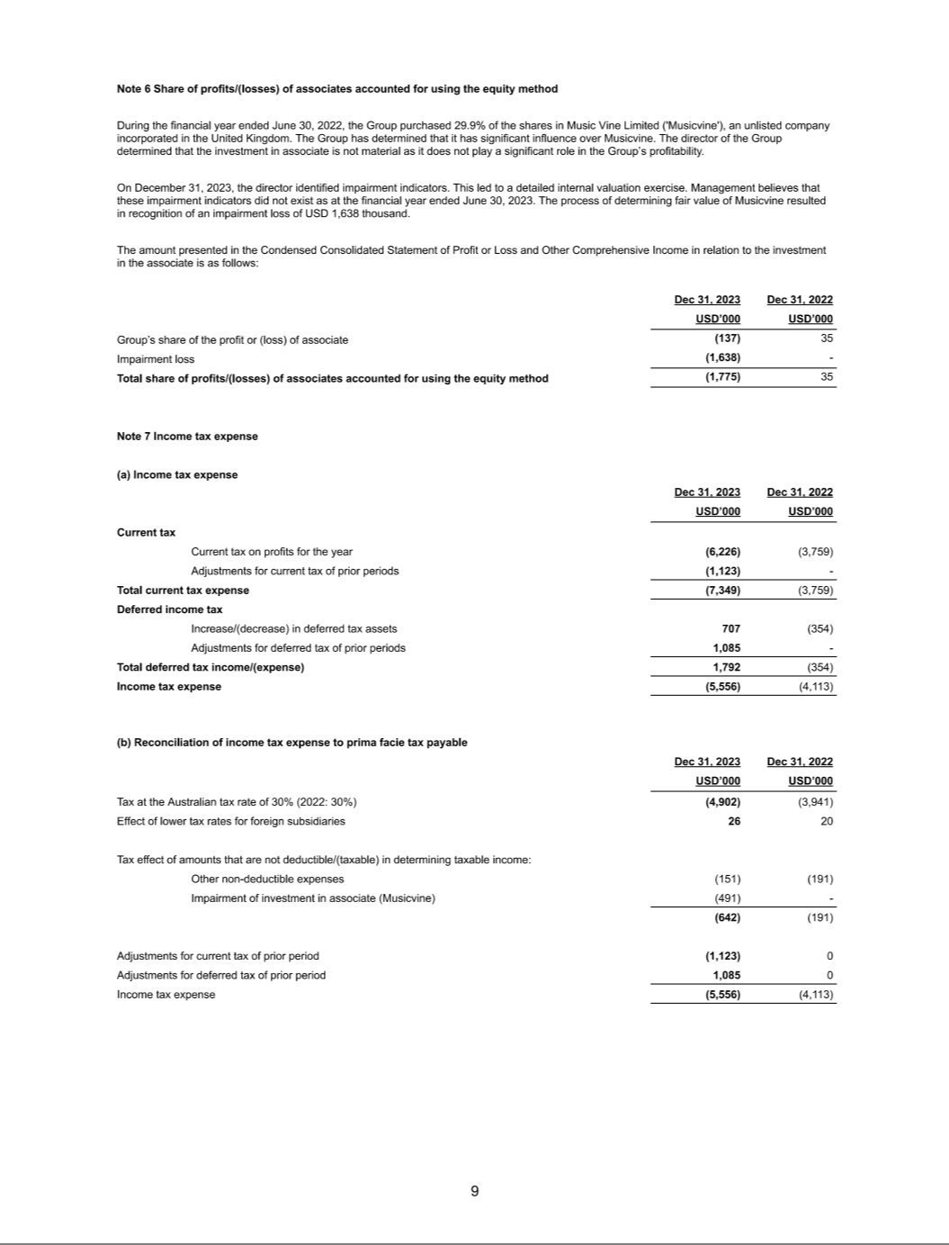

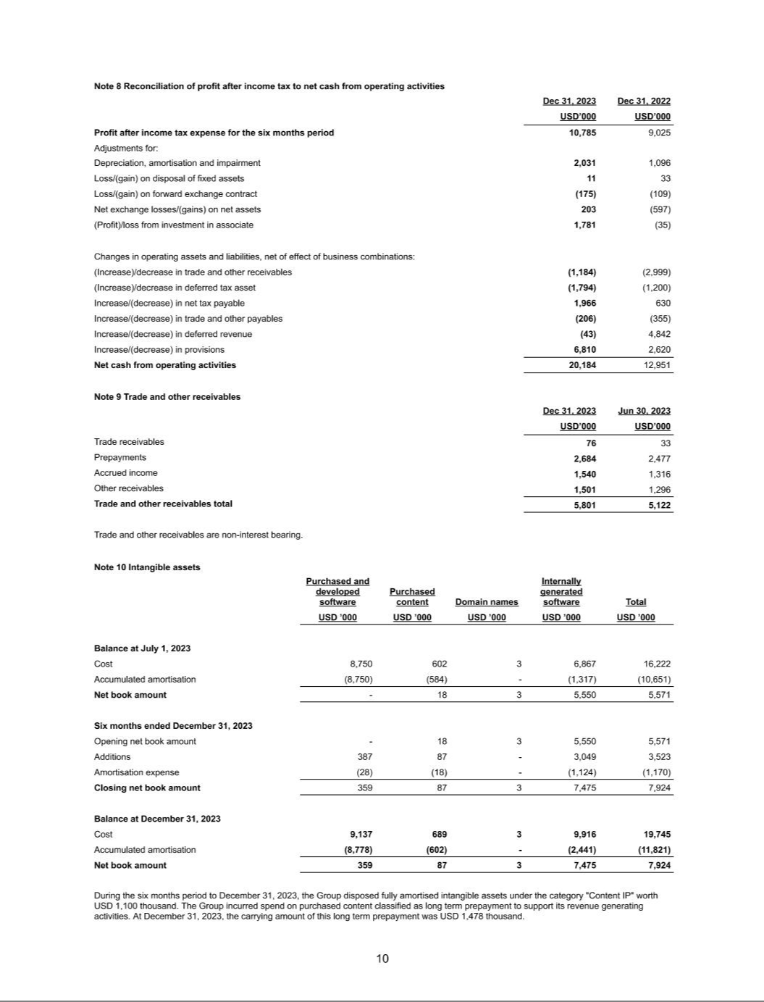

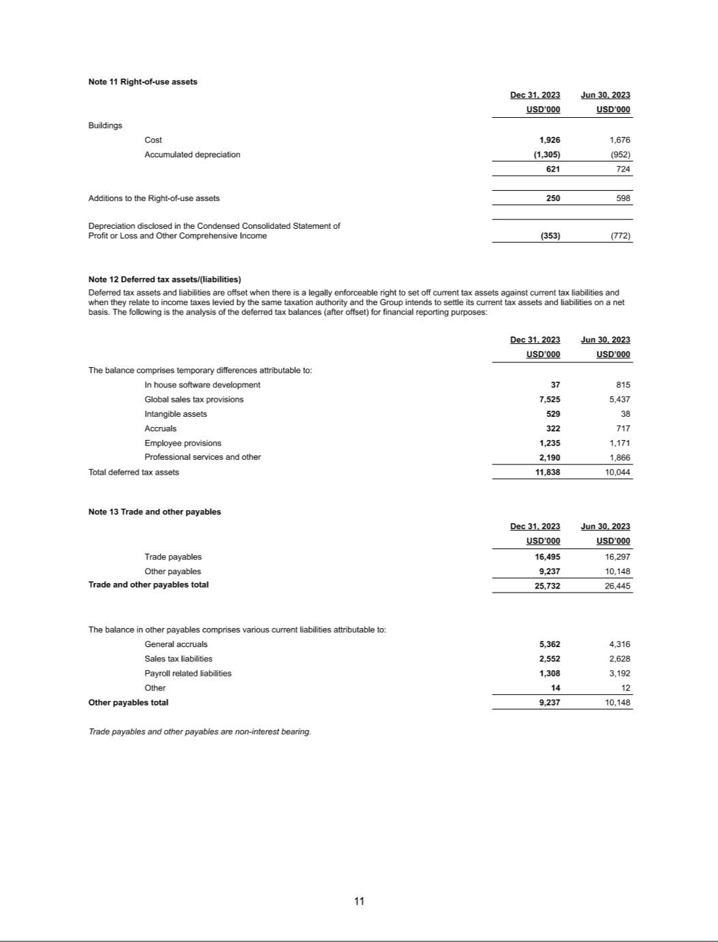

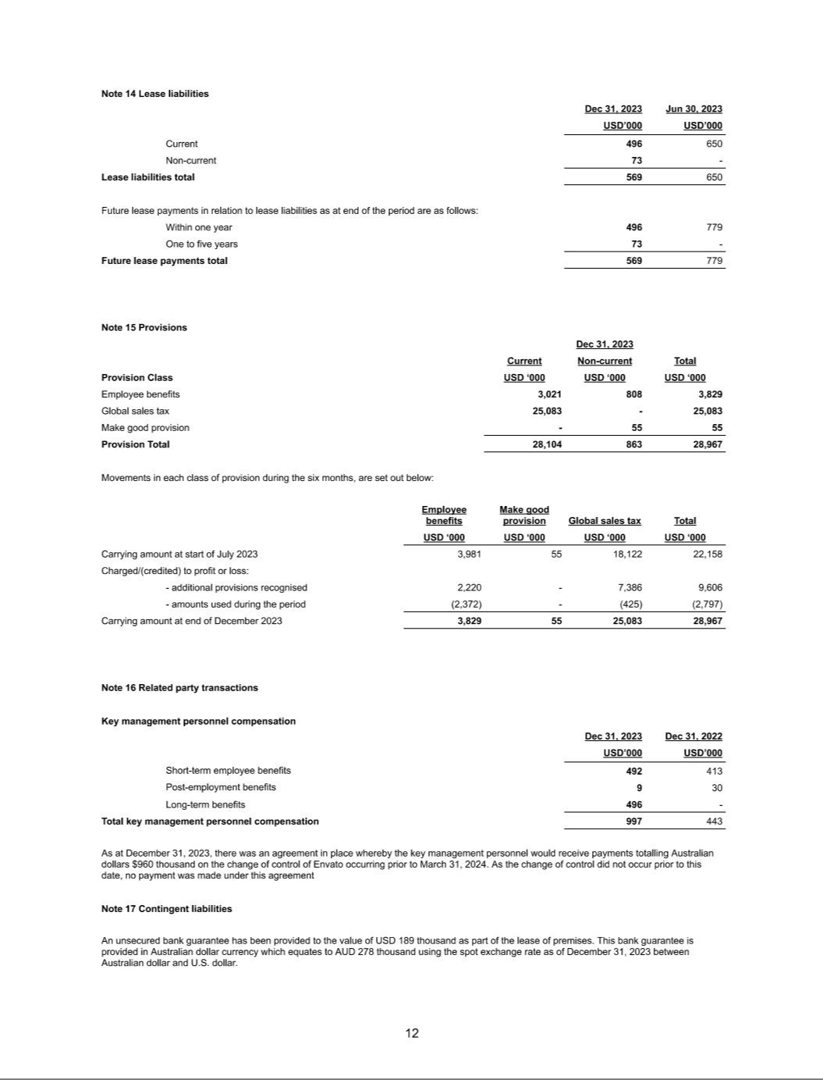

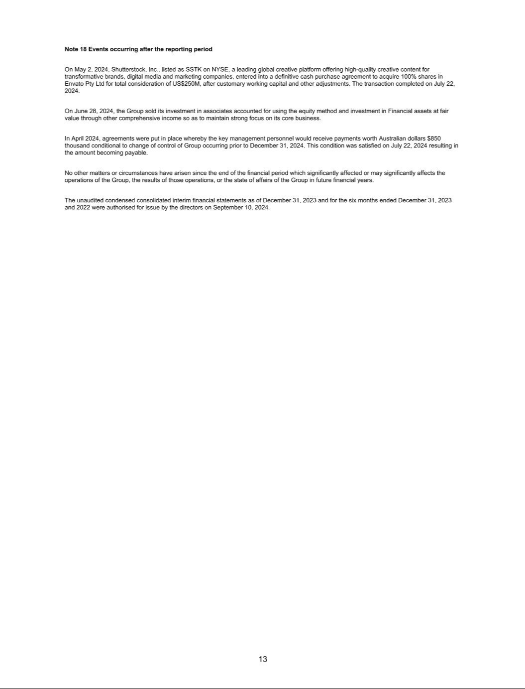

EXHIBIT 99.3

UNAUDITED PRO FORMA CONDENSED COMBINED FINANCIAL INFORMATION

On July 22, 2024, the Company completed its previously announced acquisition of Envato Pty Ltd. (“Envato”) pursuant to a Share Purchase Agreement (the “Purchase Agreement”) entered into on May 1, 2024, to acquire all of the issued and outstanding capital stock of Envato (the "Envato Acquisition"). The aggregate consideration paid by the Company, after customary working capital and other adjustments in accordance with the terms of the Purchase Agreement, was $250 million.

The Envato acquisition was funded through an amended and restated credit agreement (the “A&R Credit Agreement”), which was entered into among the Company, as borrower, certain direct and indirect subsidiaries of the Company as guarantors, the lenders party thereto, and Bank of America, N.A., as Administrative Agent for the lenders. The A&R Credit Agreement provides for a five-year (i) senior unsecured term loan facility (the “Term Loan”) in an aggregate principal amount of $125 million and (ii) senior unsecured revolving credit facility (the “Revolver”) in an aggregate principal amount of $250 million. The A&R Credit Agreement provides for a letter of credit subfacility and a swingline facility.

The Envato Acquisition was accounted for using the acquisition method of accounting for business combinations under the provisions of Financial Accounting Standards Board (“FASB”) Accounting Standard Codification (“ASC”) Topic 805, Business Combinations (“ASC 805”).

The unaudited pro forma condensed combined financial statements were prepared in accordance with Article 11 of Regulation S-X, as amended by SEC Final Rule Release No. 33-10786, Amendments to Financial Disclosures About Acquired and Disposed Businesses and are presented to illustrate the estimated effects of the Envato Acquisition.

The unaudited pro forma condensed combined statement of operations for the year ended December 31, 2024, was prepared as if the Envato Acquisition had occurred on January 1, 2024. The following unaudited pro forma condensed combined financial information is derived from the historical financial statements of Shutterstock and Envato, and should be read in conjunction

with:

- Shutterstock, Inc.’s consolidated financial statements included in its Annual Report on Form 10-K filed with the Securities and Exchange Commission (“SEC”) on February 25, 2025, and incorporated herein by reference.
- Envato’s audited consolidated financial statements as of and for the year ended June 30, 2024, that are included as Exhibit 99.1 in the Company’s Report on Form 8-K filed with the SEC on March 28, 2025 to which this unaudited pro forma condensed combined financial information is being filed as an exhibit.
- Envato’s unaudited condensed consolidated financial statements as of December 31, 2023 and for the six months ended December 31, 2023 and 2022, that are included as Exhibit 99.2 in the Company’s Report on Form 8-K filed with the SEC on March 28, 2025 to which this unaudited pro forma condensed combined financial information is being filed as an exhibit.
- Envato's statement of profit or loss from July 1, 2024 to July 22, 2024, the date of consummation of the Envato Acquisition, derived from the books and records of Envato.

The unaudited pro forma condensed combined financial information has been prepared for illustrative purposes only and are not necessarily indicative of the financial condition or results of operations of future periods or the financial condition or results of operations that would have been realized had the entities been a single entity as of or for the periods presented.

Assumptions underlying the pro forma adjustments are described in the accompanying notes, which should be read in conjunction with the unaudited pro forma condensed combined financial information. The transaction accounting adjustments are based on available information and assumptions that the Company’s management believes are reasonable. Such adjustments are estimates and actual experience may differ from expectations.

1

UNAUDITED PRO FORMA CONDENSED COMBINED STATEMENT OF OPERATIONS FOR THE YEAR ENDED DECEMBER 31, 2024

(In thousands, except per share data)

 |  | Historical
 |  |  |  |  |  |  |  | Envato Acquisition
 |  |  |  |  |  |  |  | Transaction |  |  | Debt Financing
 |  |  |  |  | Envato |  |  | Accounting |  |  | Transaction |  |  | Pro Forma
 |  | Shutterstock |  |  | (Note 4) |  |  | Adjustments | Note |  | Adjustments | Note |  | Combined
Revenue | $ | 935,262 | $ |  | 108,988 |  | $ | — | $ |  | — | $ |  | 1,044,250
Operating expenses:
Cost of revenue |  | 396,297 |  |  | 42,117 |  |  | 8,042 | 5A |  | — |  |  | 446,456
Sales and marketing |  | 222,704 |  |  | 15,969 |  |  | — |  |  | — |  |  | 238,673
Product development |  | 88,417 |  |  | 13,686 |  |  | — |  |  | — |  |  | 102,103
General and administrative |  | 159,136 |  |  | 24,607 |  |  | 142 | 5A |  | — |  |  | 183,885
Total operating expenses |  | 866,554 |  |  | 96,379 |  |  | 8,184 |  |  | — |  |  | 971,117
Income / (loss) from operations |  | 68,708 |  |  | 12,609 |  |  | (8,184) |  |  | — |  |  | 73,133
Interest expense |  | (10,561) |  |  | (662) |  |  | — |  |  | (11,696) | 5B |  | (22,919)
Other income / (expense), net |  | 4,401 |  |  | 1,276 |  |  | — |  |  | — |  |  | 5,677
Income / (loss) before income taxes |  | 62,548 |  |  | 13,223 |  |  | (8,184) |  |  | (11,696) |  |  | 55,891
Provision (benefit) for income taxes |  | 26,616 |  |  | 3,097 |  |  | (2,455) | 5A |  | (2,924) | 5C |  | 24,334
Net income / (loss) | $ | 35,932 | $ |  | 10,126 |  | $ | (5,729) | $ |  | (8,772) | $ |  | 31,557
Earnings per share:
Basic | $ | 1.02 |  |  |  |  |  |  |  |  |  |  | $ | 0.89
Diluted | $ | 1.01 |  |  |  |  |  |  |  |  |  | $ |  | 0.89
Weighted average shares outstanding:
Basic |  | 35,330 |  |  |  |  |  |  |  |  |  |  |  | 35,330
Diluted |  | 35,658 |  |  |  |  |  |  |  |  |  |  |  | 35,658

2

Notes to Unaudited Pro Forma Condensed Combined Financial Information

Note 1 – Basis of Pro Forma Presentation

On July 22, 2024, the Company completed its previously announced acquisition of Envato Pty Ltd. (“Envato”) pursuant to a Share Purchase Agreement (the “Purchase Agreement”) entered into on May 1, 2024, to acquire all of the issued and outstanding capital stock of Envato (the "Envato Acquisition"). The aggregate consideration paid by the Company, after customary working capital and other adjustments in accordance with the terms of the Purchase Agreement, was $250 million.

The Envato acquisition was funded through an amended and restated credit agreement (the “A&R Credit Agreement”), which was entered into among the Company, as borrower, certain direct and indirect subsidiaries of the Company as guarantors, the lenders party thereto, and Bank of America, N.A., as Administrative Agent for the lenders. The A&R Credit Agreement provides for a five-year (i) senior unsecured term loan facility (the “Term Loan”) in an aggregate principal amount of $125 million and (ii) senior unsecured revolving credit facility (the “Revolver”) in an aggregate principal amount of $250 million. The A&R Credit Agreement provides for a letter of credit subfacility and a swingline facility.

The Envato Acquisition was accounted for using the acquisition method of accounting for business combinations under the provisions of Financial Accounting Standards Board (“FASB”) Accounting Standard Codification (“ASC”) Topic 805, Business Combinations (“ASC 805”).

The unaudited pro forma condensed combined financial statements were prepared in accordance with Article 11 of Regulation S-X, as amended by SEC Final Rule Release No. 33-10786, Amendments to Financial Disclosures About Acquired and Disposed Businesses and are presented to illustrate the estimated effects of the Envato Acquisition.

The unaudited pro forma condensed combined statement of operations for the year ended December 31, 2024, was prepared as if the Envato Acquisition had occurred on January 1, 2024. The following unaudited pro forma condensed combined financial information is derived from the historical financial statements of Shutterstock and Envato, and should be read in conjunction

with:

- Shutterstock, Inc.’s consolidated financial statements included in its Annual Report on Form 10-K filed with the Securities and Exchange Commission (“SEC”) on February 25, 2025, and incorporated herein by reference.
- Envato’s audited consolidated financial statements for the year ended June 30, 2024, that are included as Exhibit 99.1 in the Company’s Report on Form 8-K filed with the SEC on March 28, 2025 to which this unaudited pro forma condensed combined financial information is being filed as an exhibit.
- Envato’s unaudited condensed consolidated financial statements for the six months ended December 31, 2023 and 2022, that are included as Exhibit 99.2 in the Company’s Report on Form 8-K filed with the SEC on March 28, 2025 to which this unaudited pro forma condensed combined financial information is being filed as an exhibit.
- Envato's statement of profit or loss from July 1, 2024 to July 22, 2024, the date of consummation of the Envato Acquisition, derived from the books and records of Envato.

The unaudited pro forma condensed combined financial information is not necessarily indicative of what Shutterstock’s results of operations would have been had the Envato Acquisition occurred on the date indicated, nor is it necessarily indicative of what the financial position or results of operations of the combined company will be in future periods. The historical financial information has been adjusted to reflect transaction related adjustments that management believes are necessary to present fairly Shutterstock’s pro forma results of operations following the closing of the Envato Acquisition for the period indicated. Additionally, the unaudited pro forma condensed combined statement of operations does not reflect any benefits that may result from potential revenue enhancements, anticipated cost savings and expense efficiencies or other synergies that may be achieved from the transaction.

3

Envato's financial statements were prepared in accordance with International Financial Reporting Standards ("IFRS") issued by the International Accounting Standards Board ("IASB"). There were no material adjustments required to convert these financial statements to United States generally accepted accounting principles (“U.S. GAAP”). The pro forma adjustments include certain reclassifications to conform Envato’s historical accounting presentation to Shutterstock’s accounting presentation. Shutterstock’s management believes that its assumptions provide a reasonable basis for presenting all of the significant effects of the transactions and that the pro forma adjustments give appropriate effect to those assumptions and are properly applied in the unaudited pro forma condensed combined financial information.

Note 2 – Preliminary Fair Value Allocation of Assets Acquired and Liabilities Assumed

The allocation of the purchase price to assets acquired and liabilities assumed is as follows (in thousands):

Assets acquired and liabilities assumed: |  | As of July 22, 2024
Cash and cash equivalents1 | $ | 90,591
Accounts receivable |  | 6,818
Other assets |  | 5,404
Right of use assets |  | 273
Fixed assets |  | 895
Intangible assets:
Trademark |  | 31,000
Developed technology |  | 61,000
Customer relationships |  | 14,200
Intangible assets, net |  | 106,200
Deferred tax asset |  | 37,350
Total assets acquired |  | 247,531
Accounts payable |  | 4,173
Contributor royalties payable |  | 11,917
Accrued expenses |  | 30,233
Deferred revenue |  | 46,888
Other liabilities1 |  | 71,487
Lease liability |  | 190
Total liabilities assumed |  | 164,888
Net assets acquired |  | 82,643
Purchase consideration |  | 250,215
Goodwill |  | 167,572

1Envato’s cash includes $63.4 million for the funding of Envato obligations that were triggered upon the closing of the acquisition (the “Envato Seller Obligations”). These obligations are also reported as assumed liabilities within Other liabilities. The Envato Obligations would not have been incurred had the acquisition not closed, and are presented “on-the-line” because they are not reflected in either the acquirer’s or acquiree’s statement of operations.

The purchased assets included identifiable intangible assets, comprised of trademark, developed technology and customer relationships, which have weighted average useful lives of approximately 10 years, 5 years and 6 years, respectively. Fair values of the trademark and developed technology were determined using the relief-from-royalty method, and the fair value of the customer relationships was determined using the excess of earnings method. Determining the fair value requires management to use significant judgement and estimates, including revenue growth rates, the royalty rate and the discount rate, and the economic life related to developed technology and revenue growth rates, the royalty rate, and the discount rate related to the trademark, among others. The goodwill arising from the transaction is primarily attributable to expected operational synergies and is not deductible for income tax purposes.

4

Note 3 – Envato’s Statement of Operations Reconciliation for period from January 1, 2024 to July 22, 2024

For purposes of preparing Shutterstock (as adjusted), presented in the pro forma condensed combined statement of operations for the year ended December 31, 2024, Envato's historical audited statement of profit and loss for the twelve months ended June 30, 2024 was adjusted by deducting Envato's unaudited statement of profit and loss for the six months ended December 31, 2023, and adding the unaudited results for Envato from July 1, 2024 to July 22, 2024, the date of consummation of the Envato Acquisition.

The following presents a reconciliation of Envato's statement of operations for the period from January 1, 2024 to July 22, 2024:

 |  |  |  |  |  |  |  | Period from
 |  | Twelve months ended |  |  | Six months ended December 31, |  |  | July 1, 2024 to |  |  | Period from
 |  | June 30, 2024 |  |  | 2023 |  |  | July 22, 2024 |  | January 1, 2024 to July 22, 2024
(in thousands) |  | (A) |  |  | (B) |  |  | (C) |  |  | (A - B + C)
Revenue from ordinary activities | $ | 197,236 |  | $ | 99,804 |  | $ | 11,556 |  | $ | 108,988
Direct costs |  | 55,814 |  |  | 28,601 |  |  | 3,423 |  |  | 30,636
Employee costs |  | 53,457 |  |  | 24,776 |  |  | 3,225 |  |  | 31,906
Service provider expenses |  | 3,258 |  |  | 1,791 |  |  | 392 |  |  | 1,859
Depreciation, amortization and impairment |  | 3,614 |  |  | 1,887 |  |  | 162 |  |  | 1,889
Data and software expenses |  | 14,509 |  |  | 6,987 |  |  | 571 |  |  | 8,093
Marketing expenses |  | 22,287 |  |  | 11,786 |  |  | 699 |  |  | 11,200
Travel expenses |  | 880 |  |  | 351 |  |  | 44 |  |  | 573
Rental expenses |  | 89 |  |  | 14 |  |  | 24 |  |  | 99
Professional fees |  | 9,762 |  |  | 1,384 |  |  | 578 |  |  | 8,956
Foreign exchange loss / (gain) |  | 551 |  |  | (364) |  |  | 87 |  |  | 1,002
Other expenses |  | 2,055 |  |  | 902 |  |  | 15 |  |  | 1,168
Operating profit |  | 30,960 |  |  | 21,689 |  |  | 2,336 |  |  | 11,607
Finance income |  | 3,150 |  |  | 1,019 |  |  | 147 |  |  | 2,278
Finance costs |  | (5,239) |  |  | (4,592) |  |  | (15) |  |  | (662)
Impairment of investment in associate account for using the equity method |  | (1,559) |  |  | — |  |  | — |  |  | (1,559)
Share of losses of associates accounted for using the equity method |  | (187) |  |  | (1,775) |  |  | — |  |  | 1,588
Profit before income tax |  | 27,125 |  |  | 16,341 |  |  | 2,468 |  |  | 13,252
Income tax expense |  | 8,400 |  |  | 5,556 |  |  | 253 |  |  | 3,097
Profit for the period |  | 18,725 |  |  | 10,785 |  |  | 2,215 |  |  | 10,155

5

Note 4 – Envato Statement of Profit or Loss Adjustments and Reclassification

Certain pre-acquisition adjustments and reclassifications for the period from January 1, 2024 to July 22, 2024 have been made in the historical presentation of Envato's statement of operations, as follows.

 |  |  |  |  |  | For the period from January 1, 2024 to July 22, 2024
 |  |  |  |  |  |  | (In thousands)
 |  | Envato Historical |  |  |  | Pre-acquisition
Envato caption | Shutterstock caption |  | (Note 3) |  |  | adjustments | Ref. |  | Reclassification | Ref. | Envato As Reclassified
Revenue from ordinary activities | Revenue | $ | 108,988 |  | $ | — | $ |  | — |  | $ | 108,988
Direct costs | Cost of revenue |  | 30,636 |  |  | — |  |  | — |  |  | 30,636
Employee costs |  |  | 31,906 |  |  | — |  |  | (31,906) | (ii) |  | —
 | Cost of revenue |  |  |  |  | — |  |  | 5,313 | (ii) |  | 5,313
 | Sales and marketing |  |  |  |  | — |  |  | 4,389 | (ii) |  | 4,389
 | Product development |  |  |  |  | — |  |  | 12,031 | (ii) |  | 12,031
 | General and administrative |  |  |  |  | — |  |  | 10,173 | (ii) |  | 10,173
Service provider expenses |  |  | 1,859 |  |  | — |  |  | (1,859) | (iii) |  | —
 | Cost of revenue |  |  |  |  | — |  |  | 711 | (iii) |  | 711
 | Sales and marketing |  |  |  |  | — |  |  | 32 | (iii) |  | 32
 | Product development |  |  |  |  | — |  |  | 542 | (iii) |  | 542
 | General and administrative |  |  |  |  | — |  |  | 574 | (iii) |  | 574
Depreciation, amortization and impairment |  |  | 1,889 |  |  | — |  |  | (1,889) | (iv) |  | —
 | Cost of revenue |  |  |  |  | — |  |  | 86 | (iv) |  | 86
 | General and administrative |  |  |  |  | — |  |  | 1,803 | (iv) |  | 1,803
Data and software expenses |  |  | 8,093 |  |  | — |  |  | (8,093) | (v) |  | —
 | Cost of revenue |  |  |  |  | — |  |  | 5,371 | (v) |  | 5,371
 | Sales and marketing |  |  |  |  | — |  |  | 348 | (v) |  | 348
 | Product development |  |  |  |  | — |  |  | 1,113 | (v) |  | 1,113
 | General and administrative |  |  |  |  | — |  |  | 1,261 | (v) |  | 1,261
Marketing expenses | Sales and marketing |  | 11,200 |  |  | — |  |  | — |  |  | 11,200
Travel expenses | General and administrative |  | 573 |  |  | — |  |  | — |  |  | 573
Rental expenses | General and administrative |  | 99 |  |  | — |  |  | — |  |  | 99
Professional fees | General and administrative |  | 8,956 |  |  | — |  |  | — |  |  | 8,956
Foreign exchange loss / (gain) | Other income / (expense), net |  | 1,002 |  |  | — |  |  | — |  |  | 1,002
Other expenses | General and administrative |  | 1,168 |  |  | — |  |  | — |  |  | 1,168
Operating profit | Income before income taxes |  | 11,607 |  |  | — |  |  | — |  |  | 11,607
Finance income | Other income / (expense), net |  | 2,278 |  |  | — |  |  | — |  |  | 2,278
Finance costs |  |  | (662) |  |  | — |  |  | 662 | (vi) |  | —
 | Interest expense |  | — |  |  | — |  |  | (662) | (vi) |  | (662)
Impairment of investment in associate account for using the equity method |  |  | (1,559) |  |  | 1,559 | (i) |  | — |  |  | —
Share of losses of associates accounted for using the equity method |  |  | 1,588 |  |  | (1,588) | (i) |  | — |  |  | —
Profit before income tax | Income before income taxes |  | 13,252 |  |  | (29) |  |  | — |  |  | 13,223
Income tax expense | Provision (benefit) for income taxes |  | 3,097 |  |  | — |  |  | — |  |  | 3,097
Profit for the period | Net income | $ | 10,155 |  | $ | (29) | $ |  | — |  | $ | 10,126

- Adjustment reflecting the change in the fair value of equity method investment that was disposed of prior to Shutterstock's acquisition of Envato.

- Represents the reclassification of "Employee cost" on Envato's statement of profit or loss into "Cost of revenue", "Sales and marketing", "Product development" and "General and administrative" to conform to the Company's statement of operations presentation.
- Represents the reclassification of "Service provider expenses" on Envato's statement of profit or loss into "Cost of revenue", "Sales and marketing", "Product development" and "General and administrative" to conform to the Company's statement of operations presentation.
- Represents the reclassification of "Depreciation, amortization and impairment" on Envato's statement of profit or loss into "Cost of revenue" and "General and administrative" to conform to the Company's statement of operations presentation.
- Represents the reclassification of "Data and software expenses" on Envato's statement of profit or loss into "Cost of revenue", "Sales and marketing", "Product development" and "General and administrative" to conform to the Company's statement of operations presentation.
- Represents the reclassification of "Finance costs" on Envato's statement of profit or loss into "Interest expense" to conform to the Company's statement of operations presentation.

6

Note 5 – Envato Acquisition Pro Forma Adjustments

A. Amortization of intangible assets recorded in connection with purchase accounting adjustments.

(in thousands) | Period from January 1, 2024 to July 22, 2024
Cost of revenue | 8,042
General and administrative | 142
Provision (benefit) for income taxes | (2,455)

Fair value of intangible assets acquired are as follows:

(in thousands) | Useful Life (in years) |  | Amount
Trademark | 10 | $ | 31,000
Developed technology | 5 |  | 61,000
Customer relationships | 6 |  | 14,200
Total |  |  | 106,200

- The adjustment to record interest expense and issuance costs amortization assumes the loans were obtained on January 1, 2024. The interest rate for this pro forma adjustment is 7.07% for the Senior Term Loan and 7.07% for Revolving Credit Facility. An increase or decrease in the interest rate on loans of one-eighth of one percent would result in a change in interest expense of approximately $0.4 million for the year ended December 31, 2024.

(in thousands) | Period from January 1, 2024 to July 22, 2024
Interest expense | (11,229)
Amortization of deferred issuance cost | (468)

- Estimated income tax impact of the Debt Financing Transaction Adjustments, using the statutory tax rate.

7

