UNITED STATES

SECURITIES AND EXCHANGE COMMISSION

Washington, D.C. 20549

FORM8-K/A

Amendment No. 1

CURRENT REPORT

Pursuant to Section 13 or 15(d) of the

Securities Exchange Act of 1934

Date of Report (Date of earliest event reported): ^{July 26, 2024}

Shutterstock, Inc.

(Exact name of registrant as specified in its charter)

Delaware

001-35669

80-0812659

(State or other jurisdiction

of incorporation)

(Commission

File Number)

(IRS Employer

Identification No.)

350 Fifth Avenue, 20th Floor

New York, NY 10118

(Address of principal executive offices, including zip code)

(646) 710-3417

(Registrant’s telephone number, including area code)

Not applicable

(Former name, former address and former fiscal year, if changed since last report)

Check the appropriate box below if the Form 8-K filing is intended to simultaneously satisfy the filing obligation of the registrant under any of the following provisions:

- Written communications pursuant to Rule 425 under the Securities Act (17 CFR 230.425)

- Soliciting material pursuant to Rule 14a-12 under the Exchange Act (17 CFR 240.14a-12)

- Pre-commencement communications pursuant to Rule 14d-2(b) under the Exchange Act (17 CFR 240.14d-2(b))

- Pre-commencement communications pursuant to Rule 13e-4(c) under the Exchange Act (17 CFR 240.13e-4(c))

Securities registered pursuant to Section 12(b) of the Act:

Class | Trading symbol | Name of each exchange on which registered
Common Stock, $0.01 par value per share | SSTK | New York Stock Exchange

Indicate by check mark whether the registrant is an emerging growth company as defined in Rule 405 of the Securities Act of 1933 (§230.405 of this chapter) or Rule 12b-2 of the Securit Exchange Act of 1934 (§240.12b-2 of this chapter).

- Emerging growth company

- If an emerging growth company, indicate by check mark if the registrant has elected not to use the extended transition period for complying with any new or revised financial accounting standards provided pursuant to Section 13(a) of the Exchange Act.

Item 2.01 Completion of Acquisition or Disposition of Assets.

As previously disclosed in the Current Report on Form 8-K filed with the U.S. Securities and Exchange Commission (the “SEC”) by Shutterstock, Inc. (the “Company”) on July 22, 2024 (the “Original Form 8-K”), the Company consummated its previously announced acquisition of Envato Pty Ltd. (“Envato”) on July 22, 2024 pursuant to the Share Purchase Agreement (the “Purchase Agreement”), whereby Garnett-Saunders Pty Ltd, Draconis Holdings Pty Ltd and Ta’eed Felah Pty Ltd (collectively, the “Sellers”) sold, and Shutterstock AUS EMU Pty Ltd., a wholly owned indirect subsidiary of the Company (“Purchaser”) purchased, all of the issued and outstanding capital stock of Envato. The consideration payable by the Company pursuant to the Purchase Agreement, after customary working capital and other adjustments in accordance with the terms of the Purchase Agreement, was approximately $250 million.

This Form 8-K/A has been filed to amend and supplement the Original Form 8-K to provide the financial statements described in Item 9.01 below, which are permitted to be filed by amendment not later than 71 calendar days after the date that the Original Form 8-K was required to be filed with the SEC.

Item 9.01 Financial Statements and Exhibits.

- Financial statements of businesses or funds acquired.

Envato’s audited consolidated financial statements as of and for the year ended June 30, 2023 and unaudited condensed consolidated financial statements for the six-month periods ended December 31, 2023 and 2022 are attached as Exhibits 99.1 and 99.2, respectively, to this Form 8-K/A and incorporated herein by reference. Such financial statements of Envato were prepared in accordance with International Financial Reporting Standards as issued by the International Accounting Standards Board.

- Pro forma financial information.

The unaudited pro forma condensed combined financial information as of and for the three months ended March 31, 2024, and for the year ended December 31, 2023, related to the Company’s acquisition of Envato are attached as Exhibit 99.3 to this Form 8-K/A and incorporated herein by reference.

- Exhibits.

 | Exhibit No. |  |  |  |  | Exhibit Description
23.1 |  |  |  | Consent of PricewaterhouseCoopers
99.1 |  |  |  | Envato Pty Ltd audited consolidated financial statements as of and for the year ended June 30, 2023
99.2 |  |  |  | Envato Pty Ltd unaudited condensed consolidated financial statements for the six-month periods ended December 31, 2023 and 2022
99.3 |  |  |  | Shutterstock, Inc. Unaudited pro forma condensed combined financial information as of and for the three months ended March 31, 2024 and for the year ended
 |  |  |  | December 31, 2023
104 |  |  |  | Cover Page Interactive Data File - The cover page XBRL tags are embedded within the Inline XBRL document.

SIGNATURE

Pursuant to the requirements of the Securities Exchange Act of 1934, the registrant has duly caused this report to be signed on its behalf by the undersigned hereunto duly authorized.

 | SHUTTERSTOCK, INC.
Dated: October 3, 2024 | By: | /s/ Jarrod Yahes
 |  | Jarrod Yahes
 |  | Chief Financial Officer

3

Exhibit 23.1

CONSENT OF INDEPENDENT AUDITORS

We hereby consent to the incorporation by reference in the Registration Statements on Form S-3 (No. 333-276203) and on Form S-8 (Nos. 333-184371, 333-184544, 333-202395, 333-268480 and 333-280093) of Shutterstock, Inc. of our report dated September 10, 2024 relating to the financial statements of Envato Pty Ltd, which appears in this Current Report on Form 8-K/A.

/s/ PricewaterhouseCoopers

Melbourne, Australia

October 3, 2024



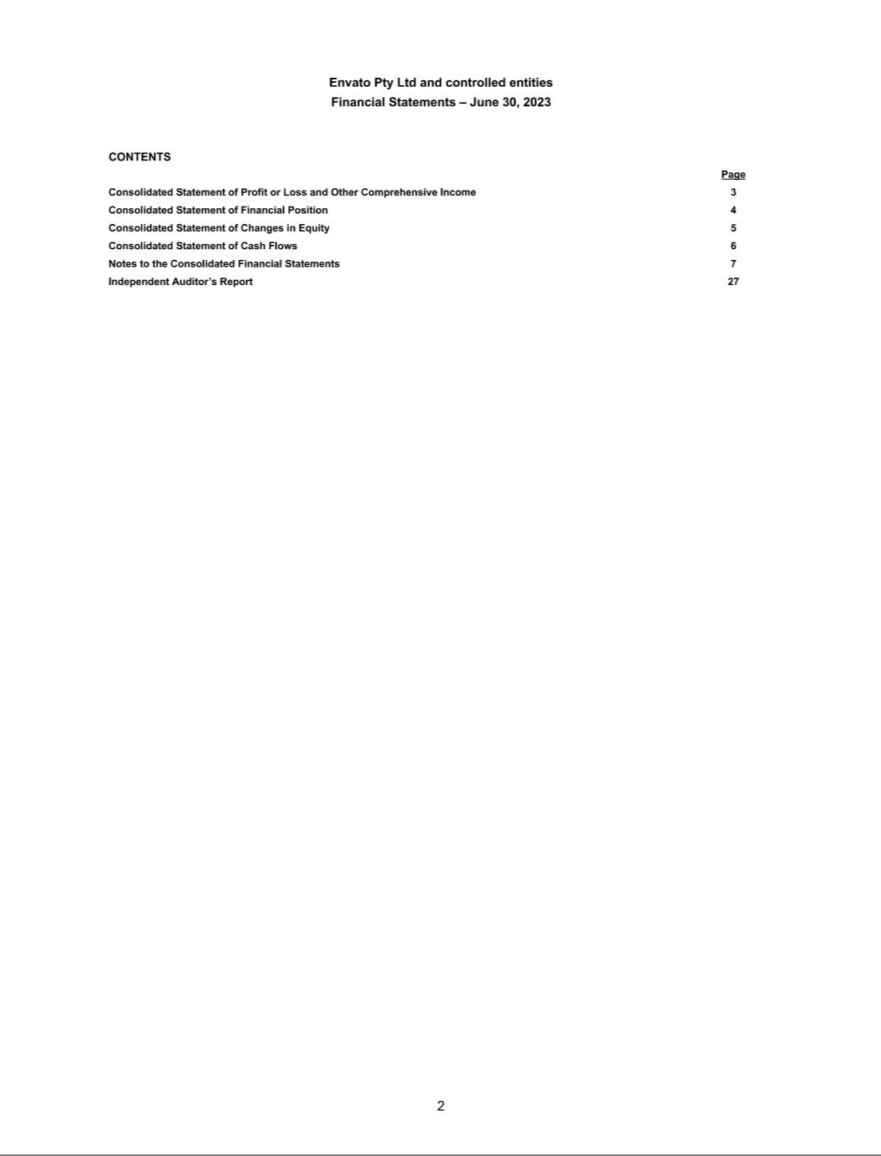

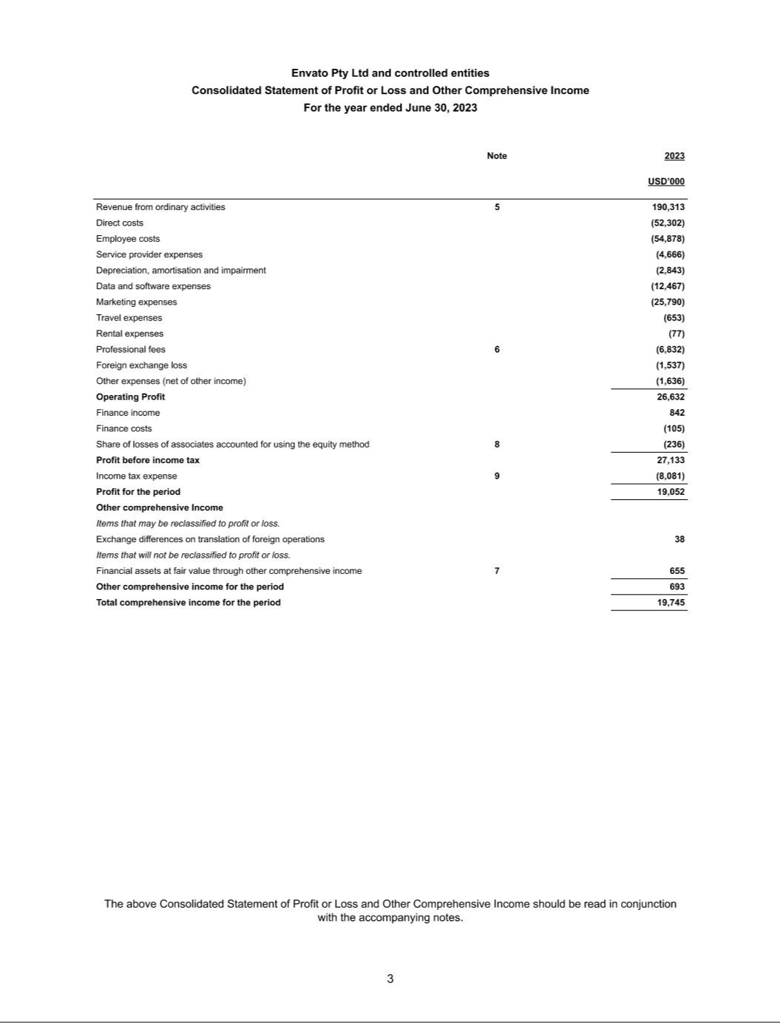

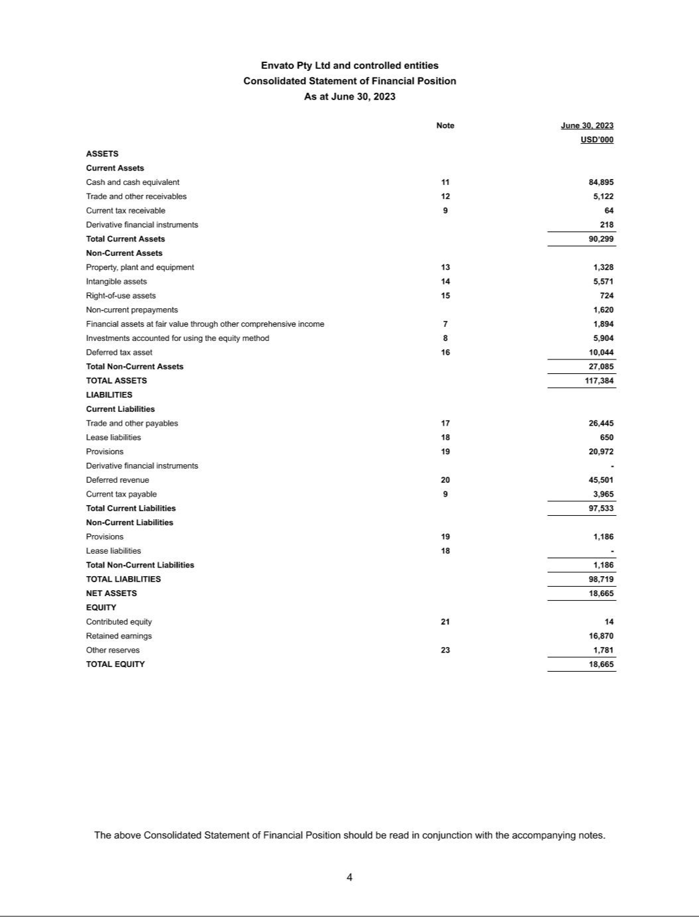

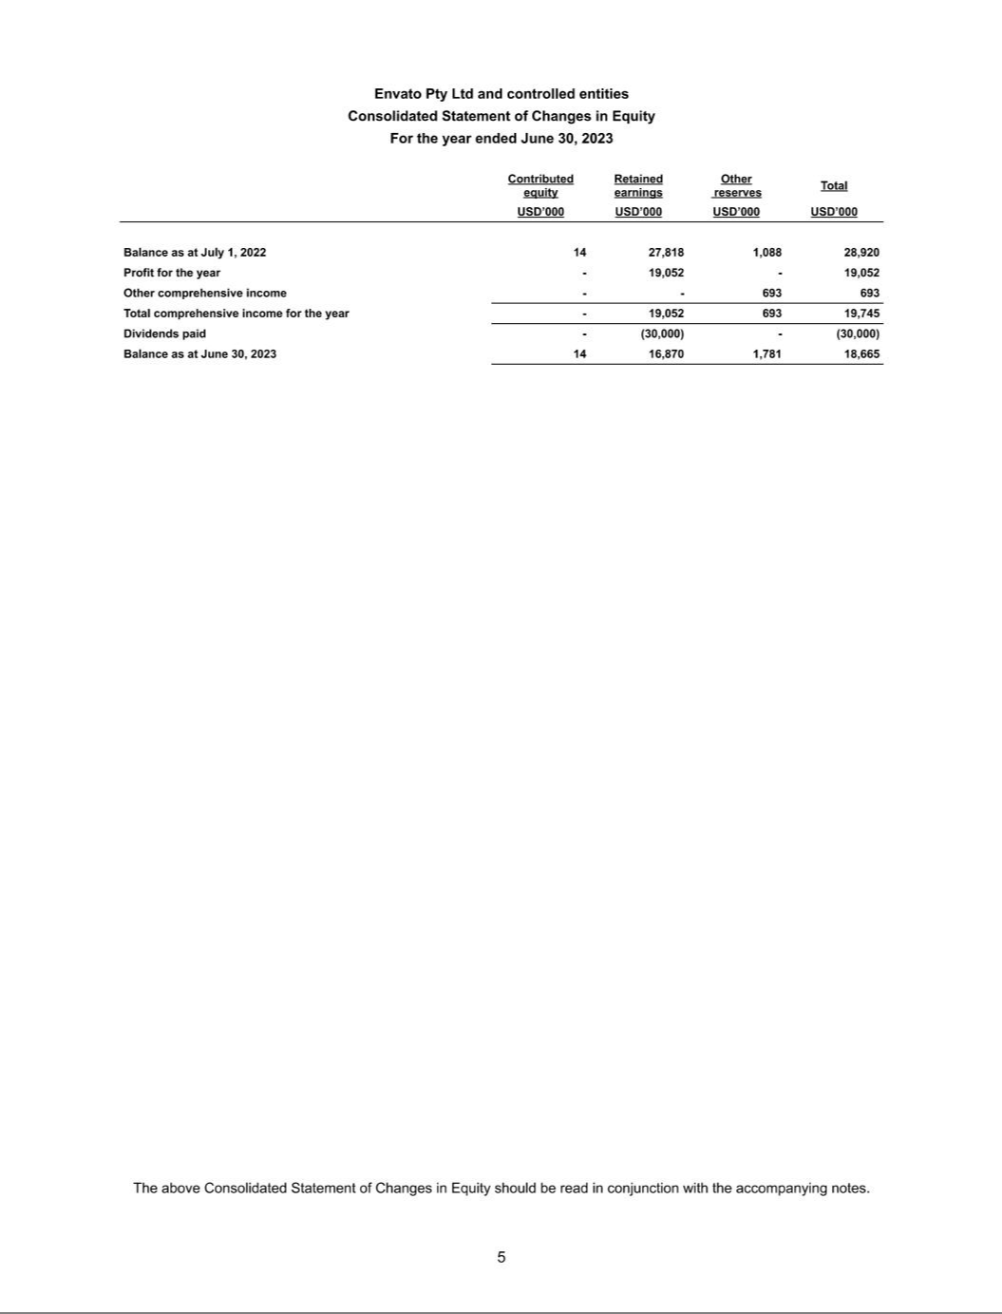

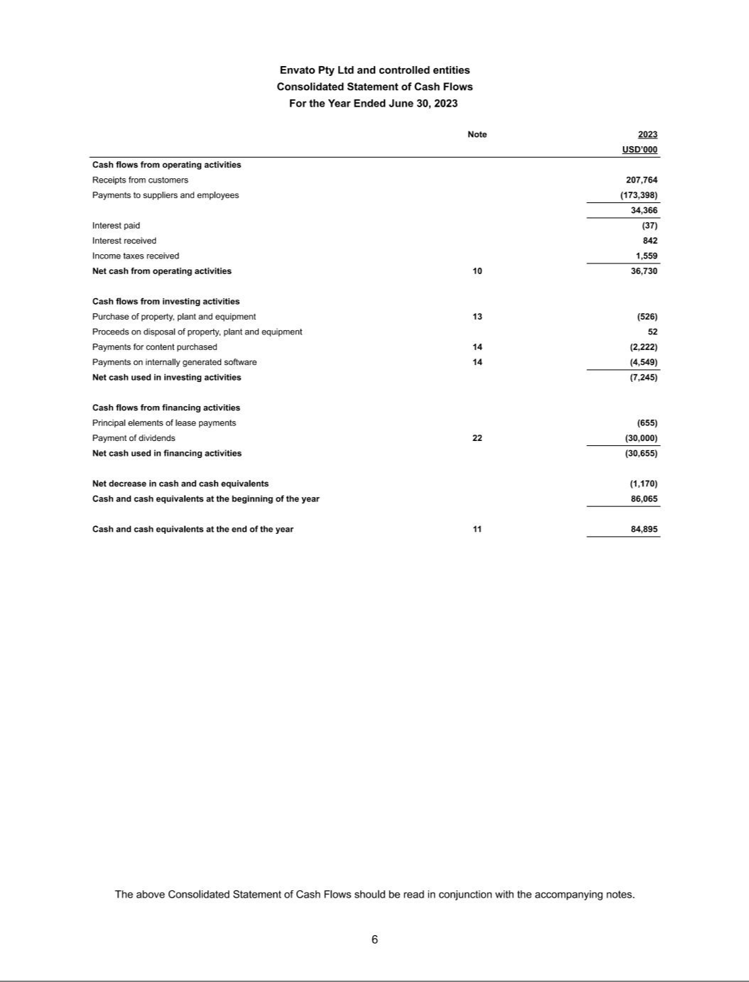

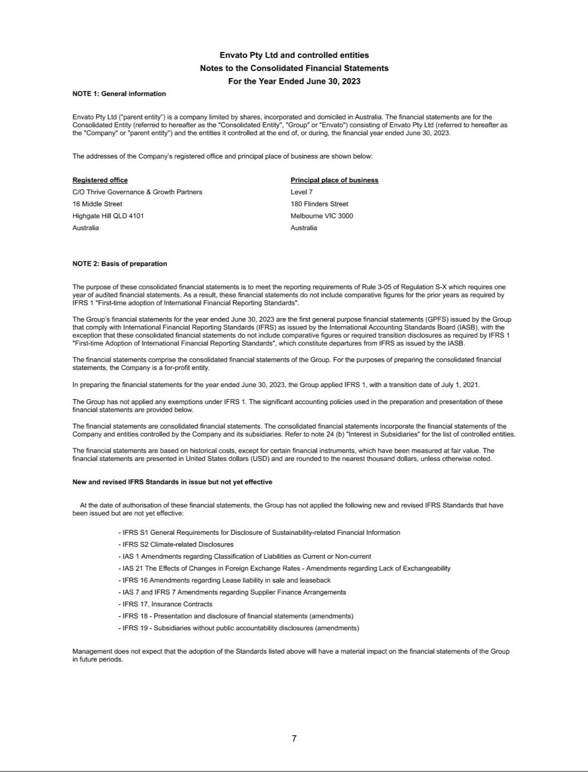

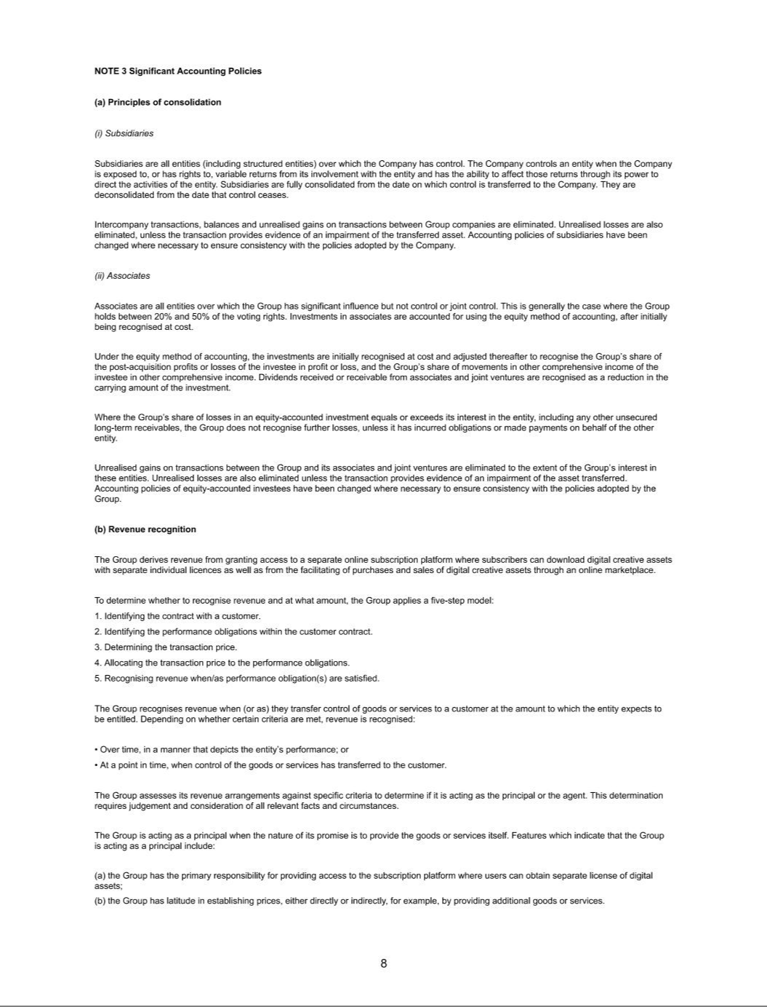

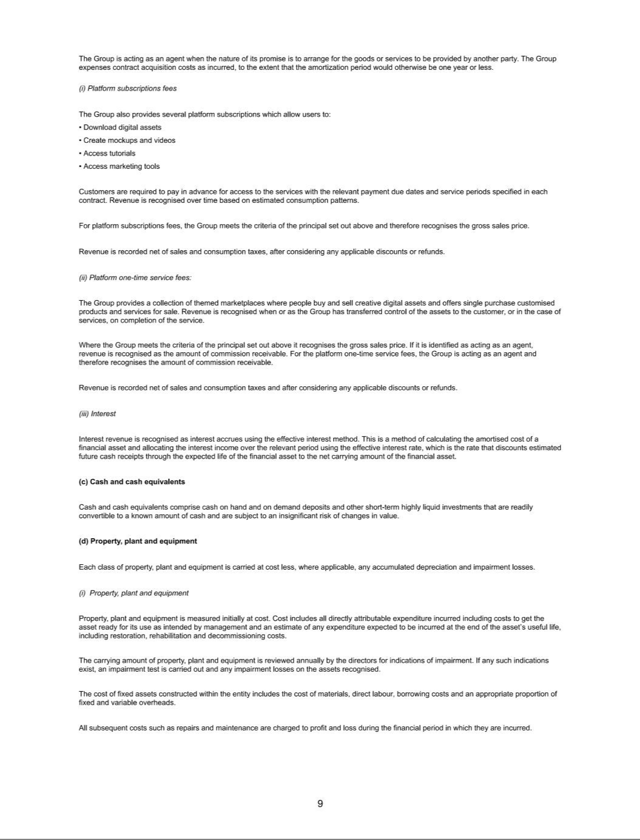

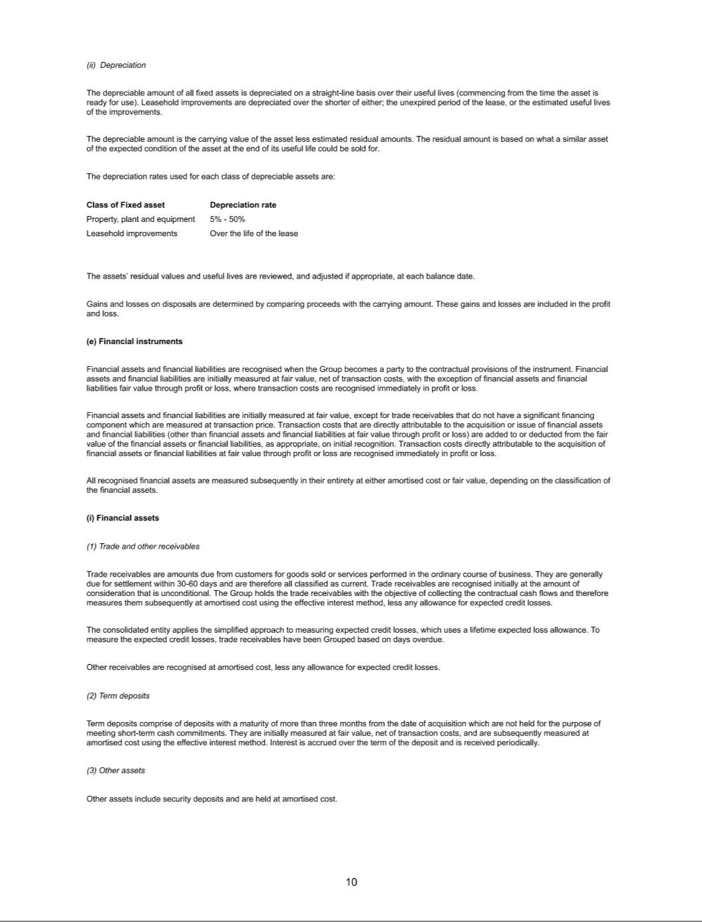

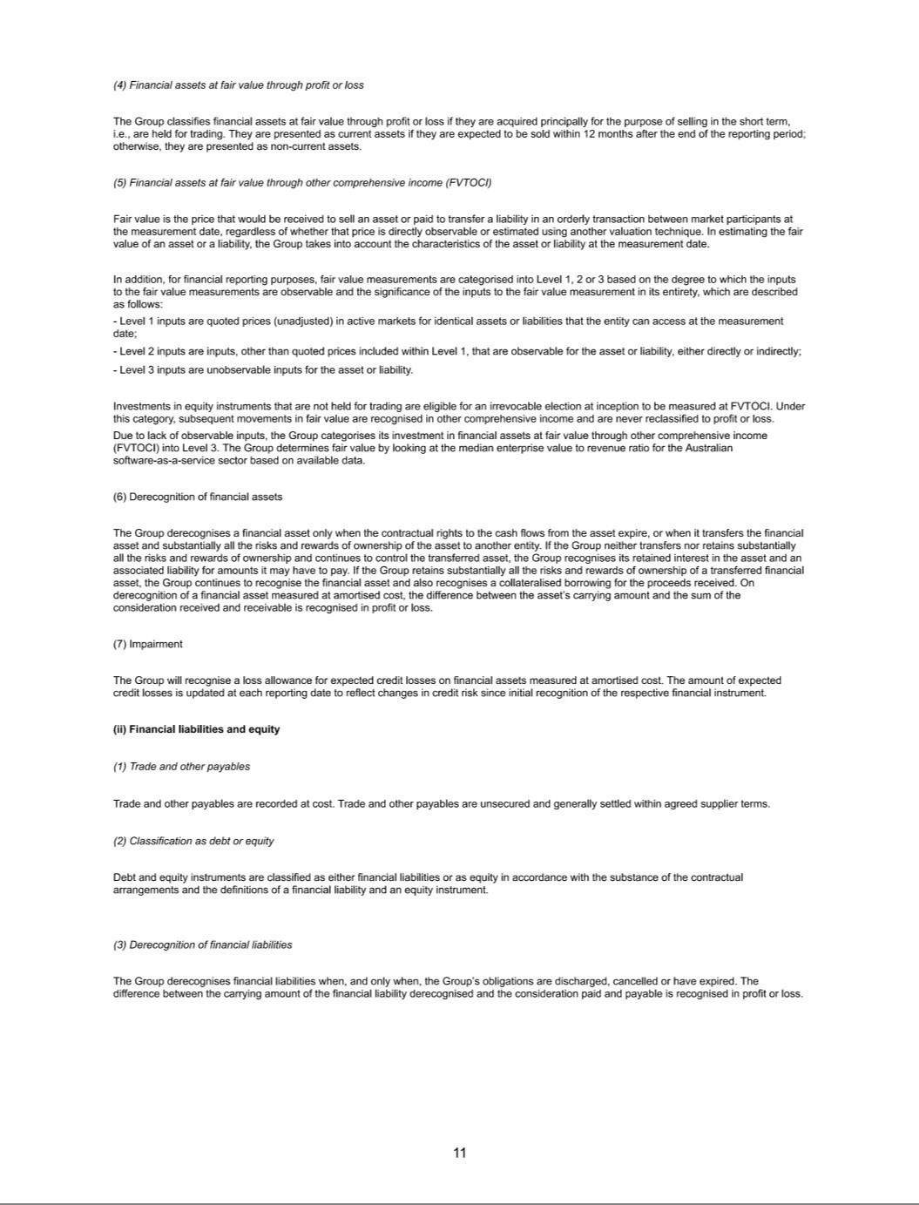

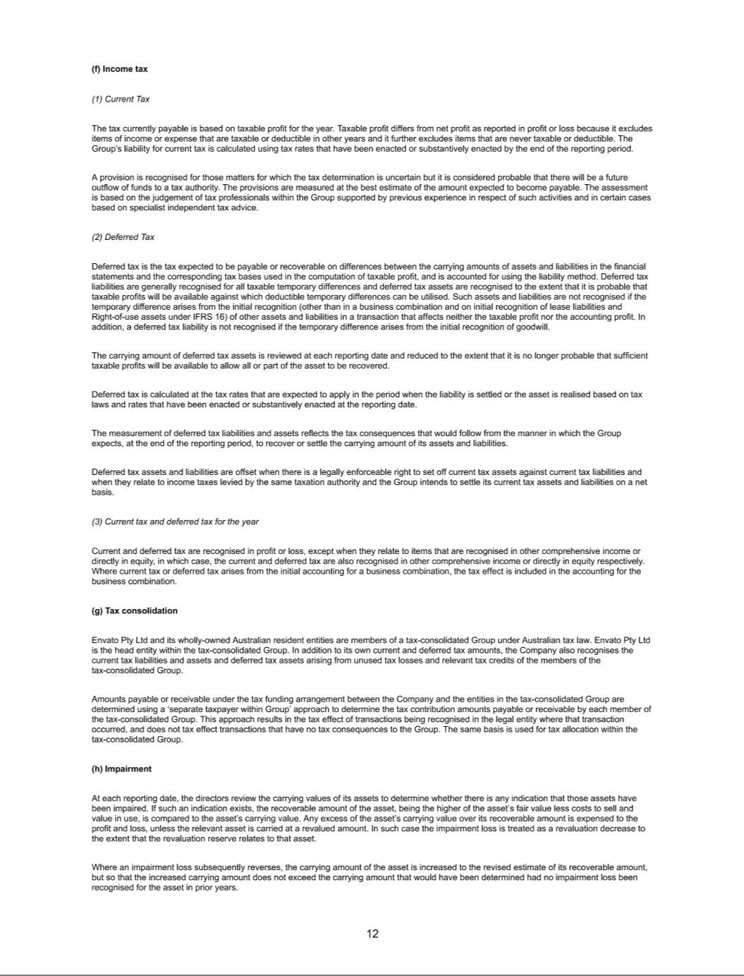

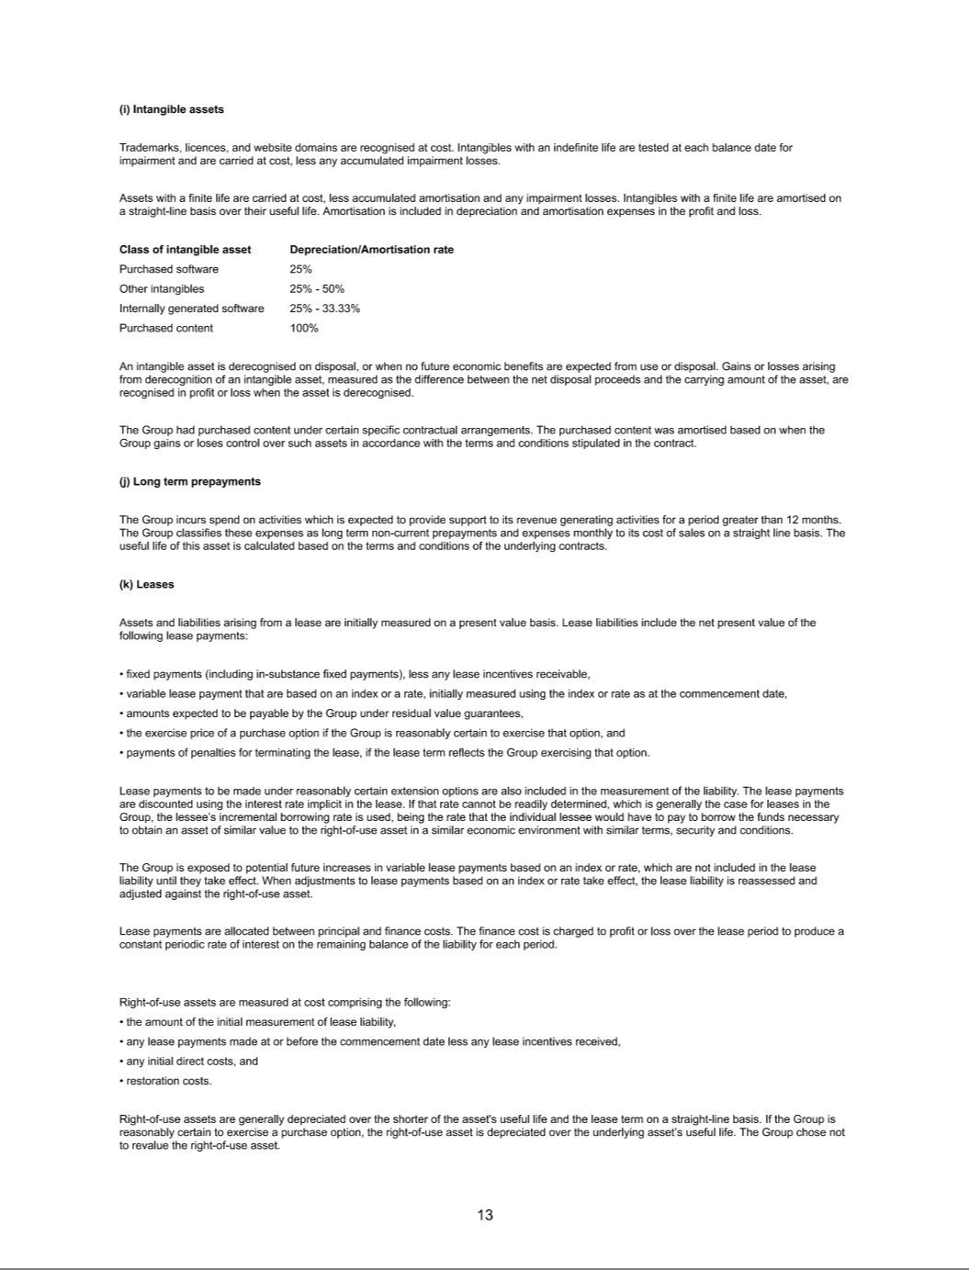

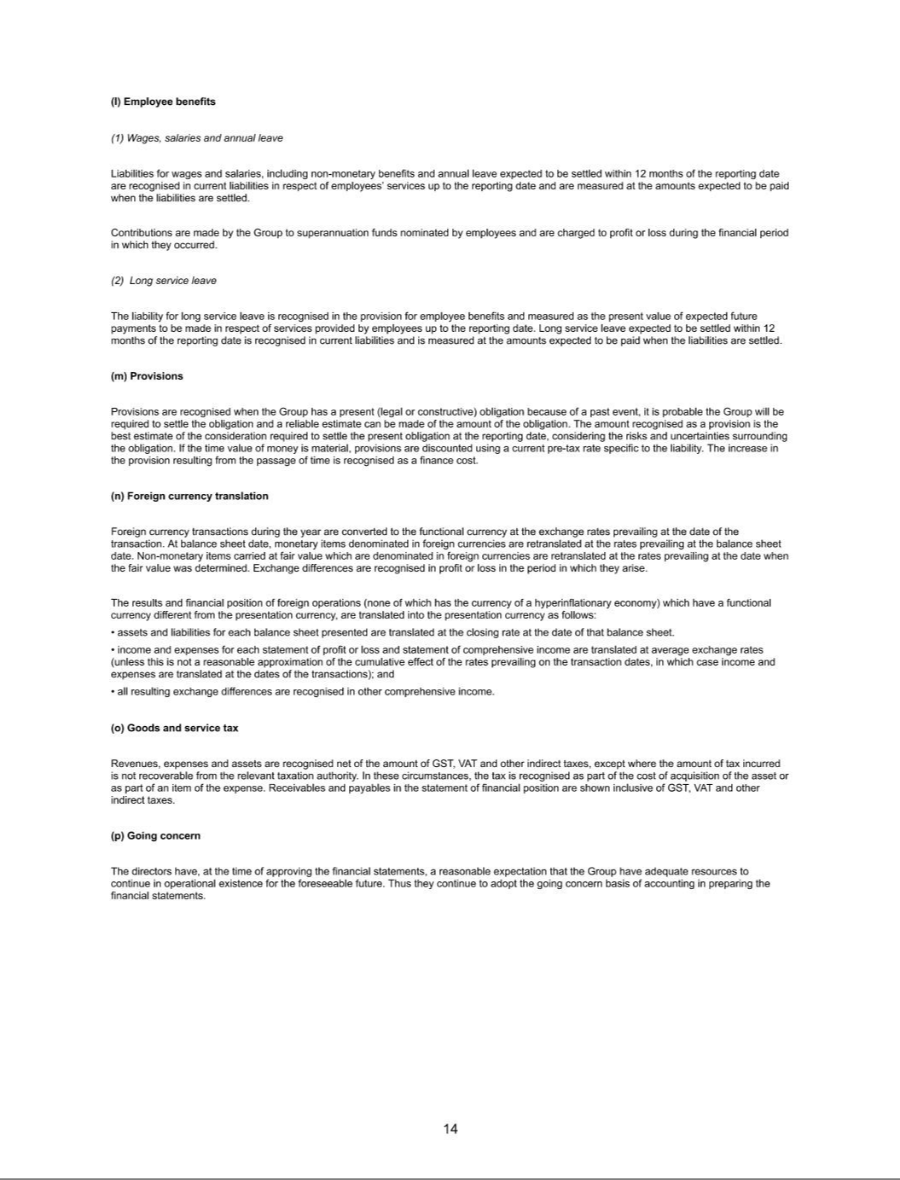

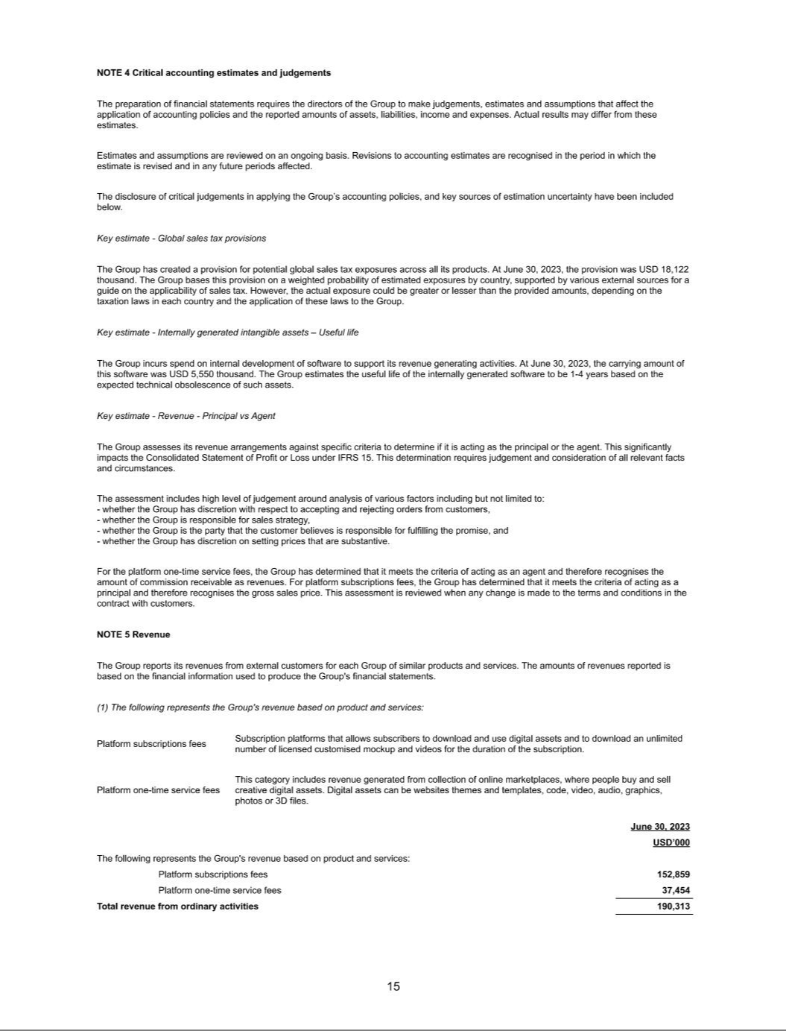

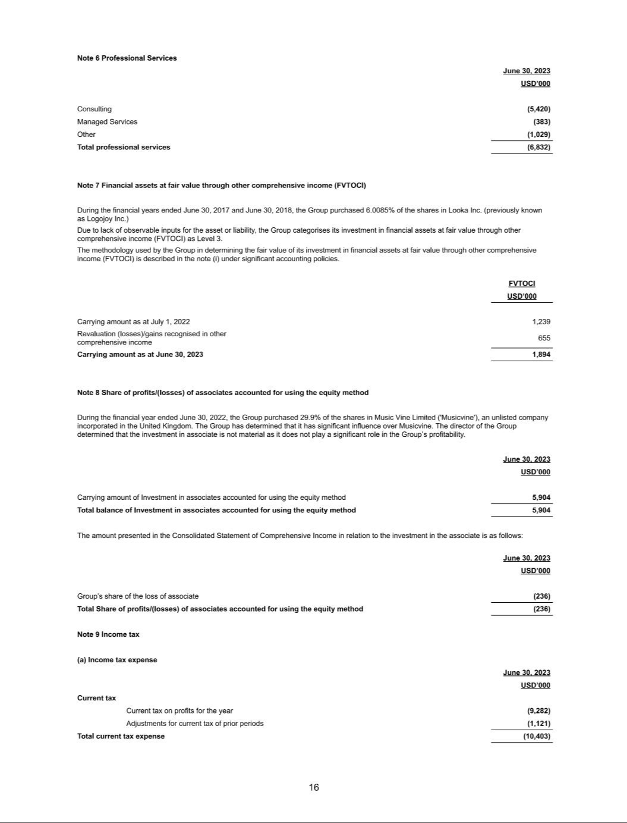

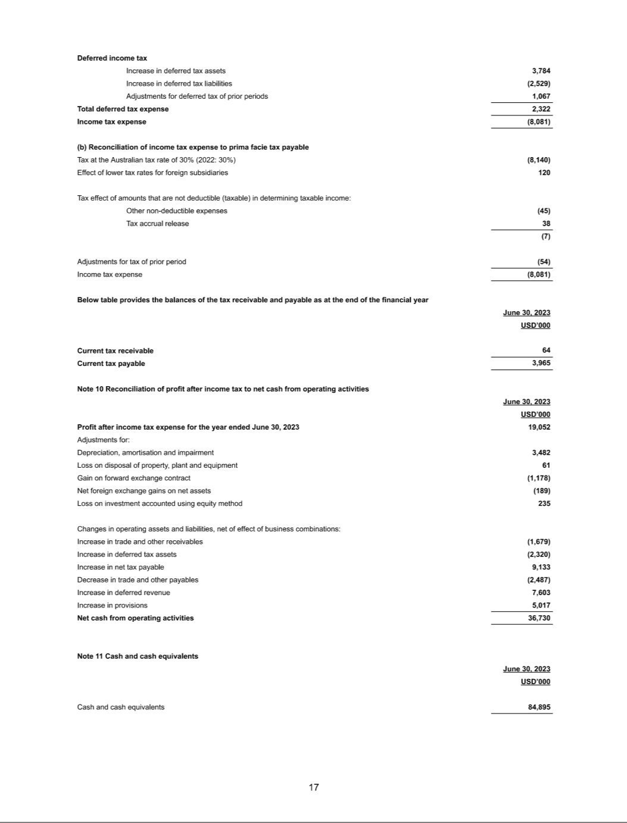

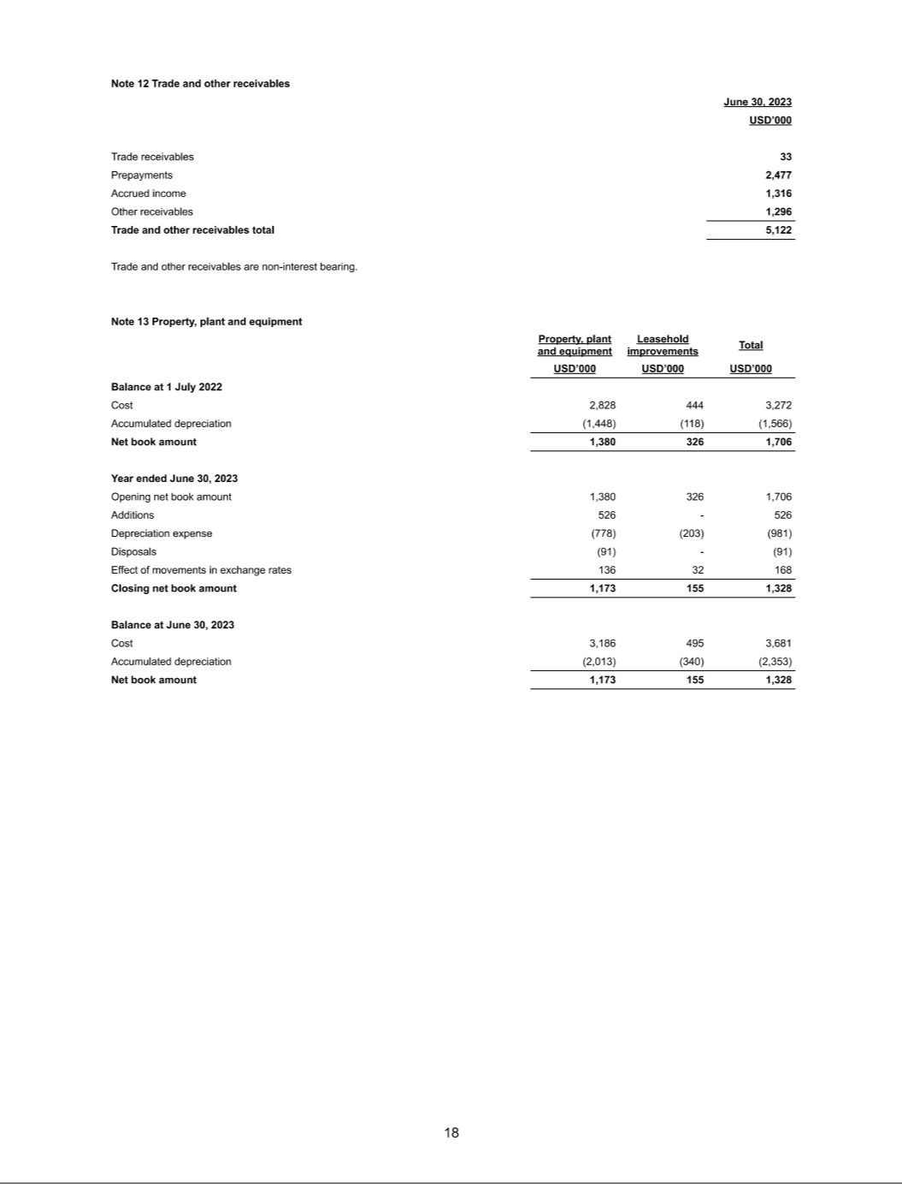

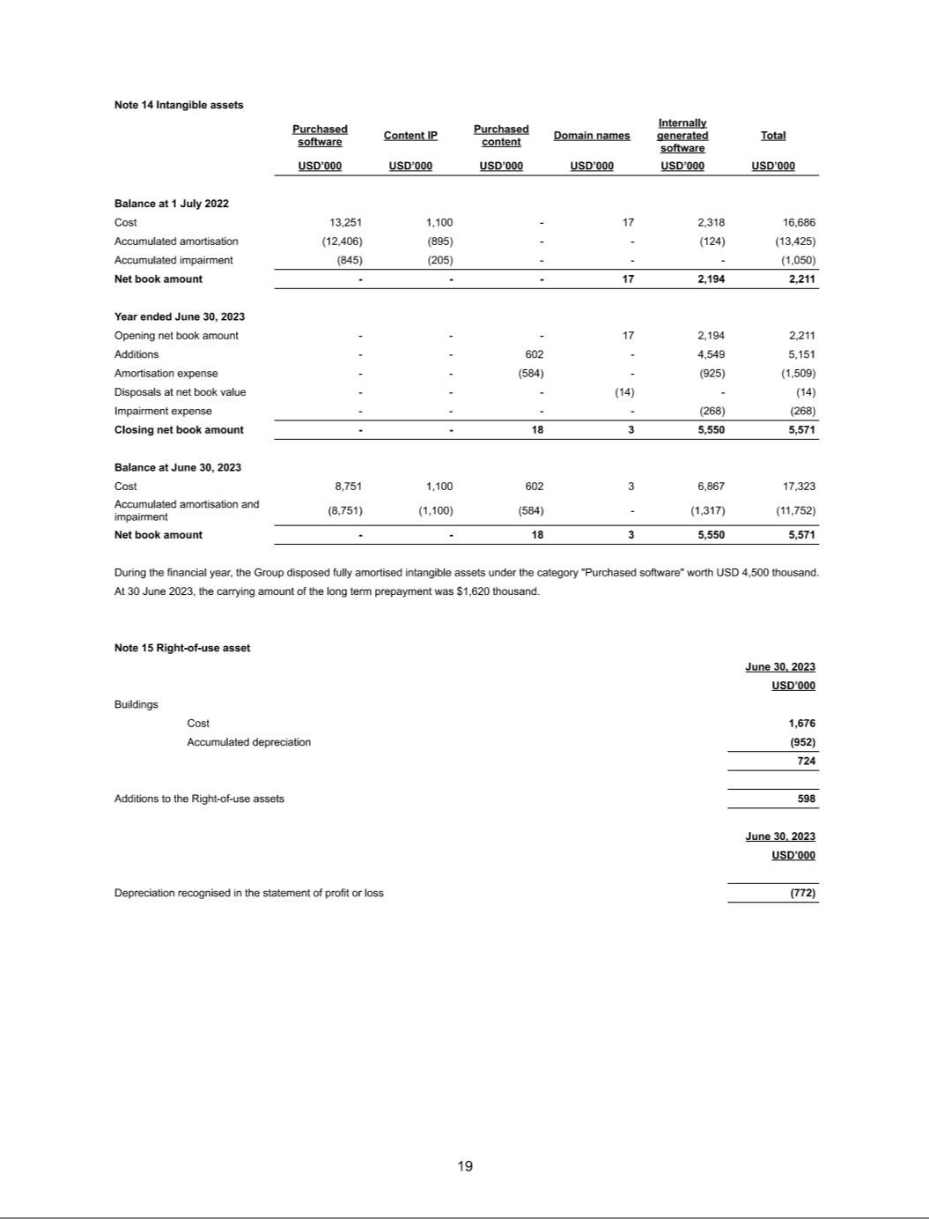

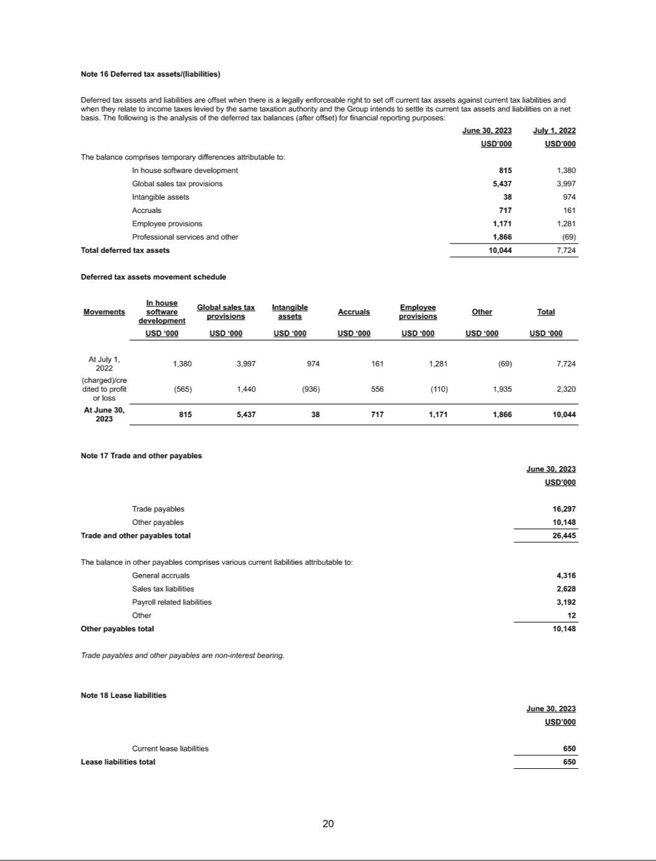

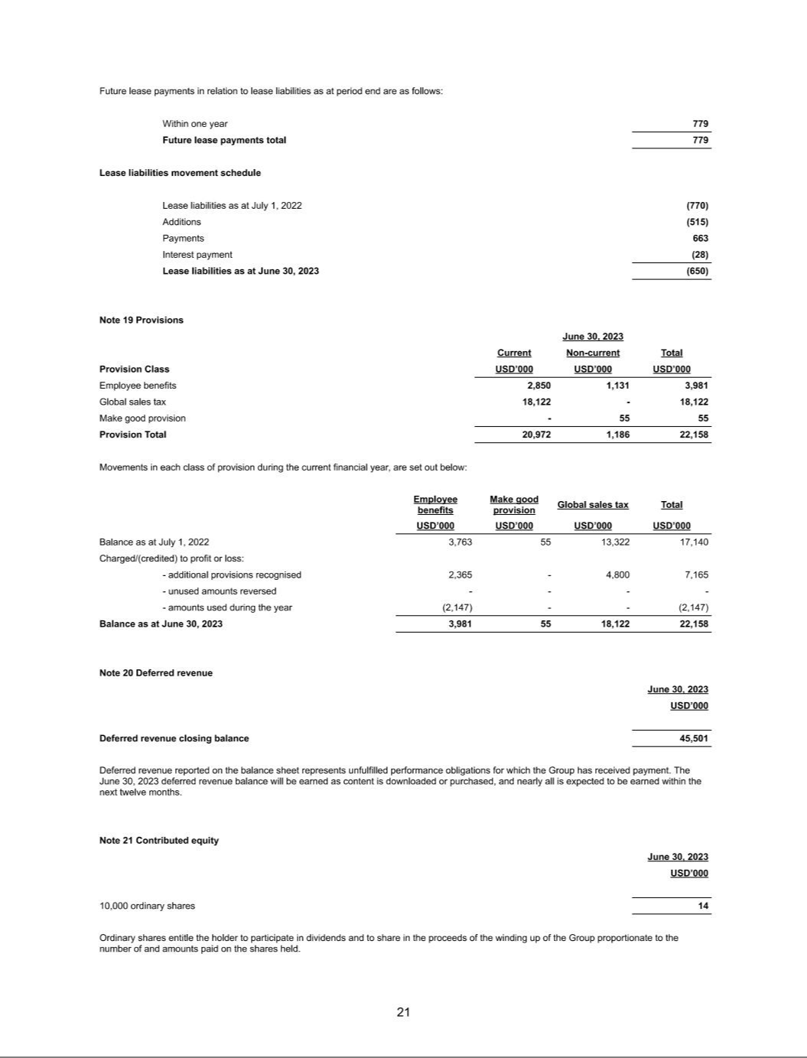

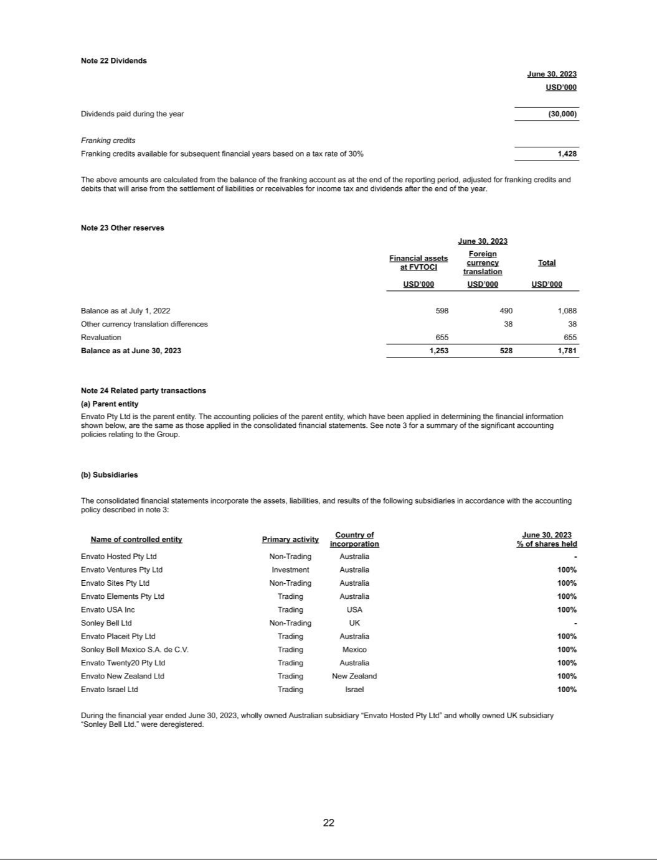

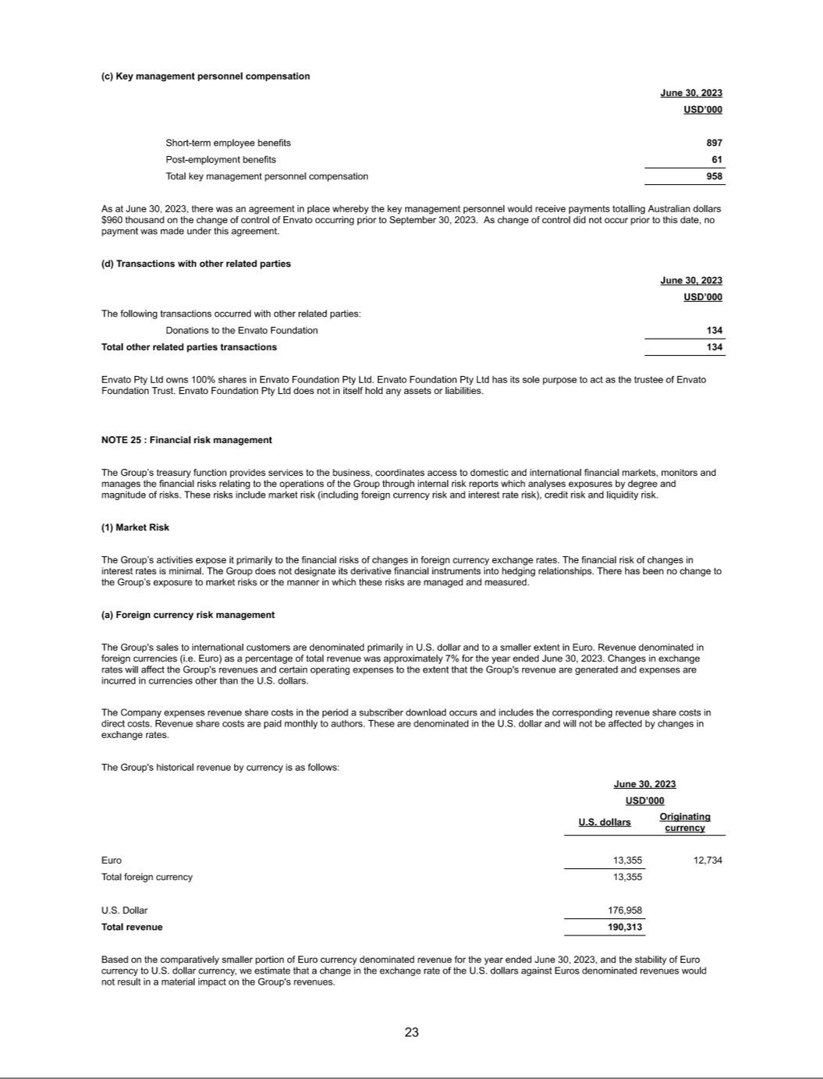

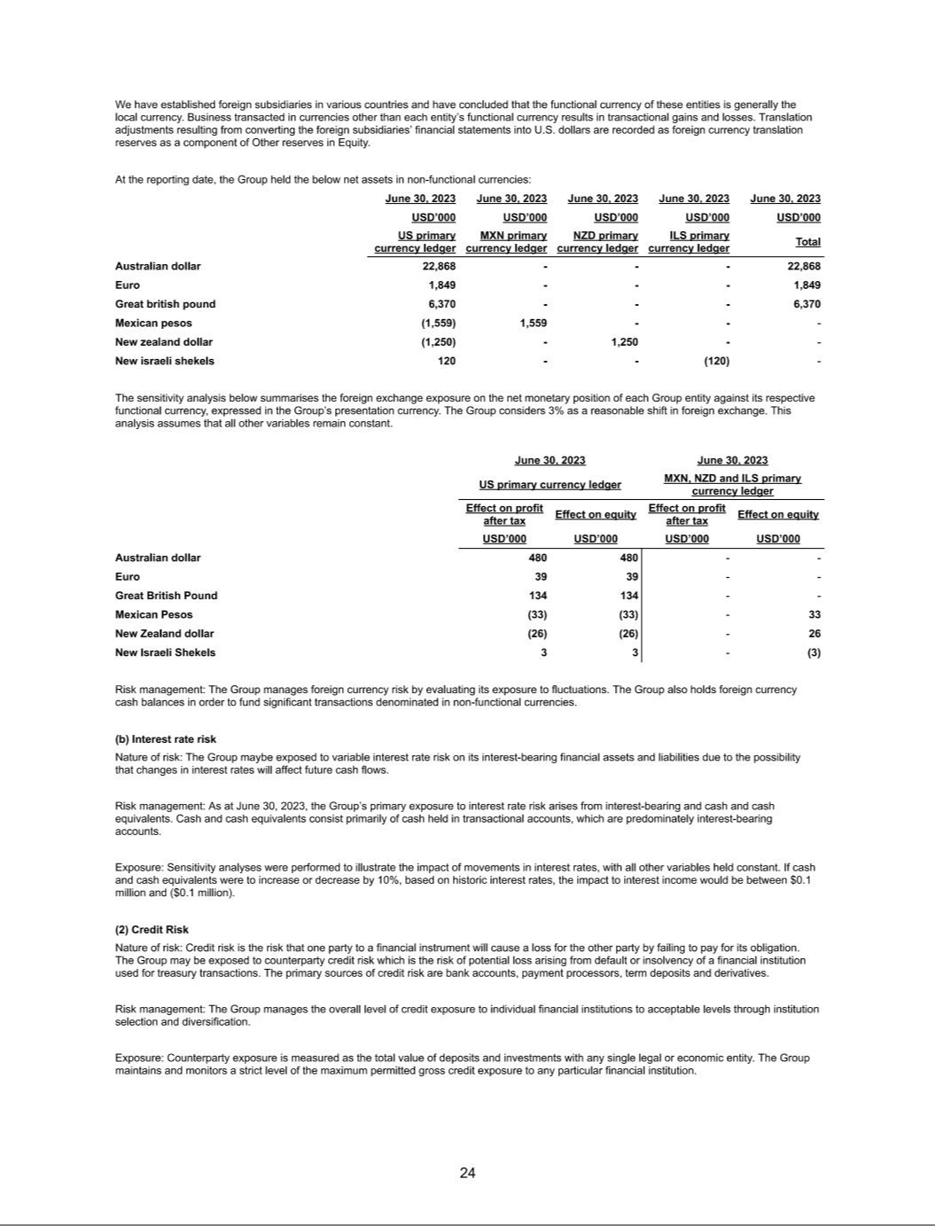

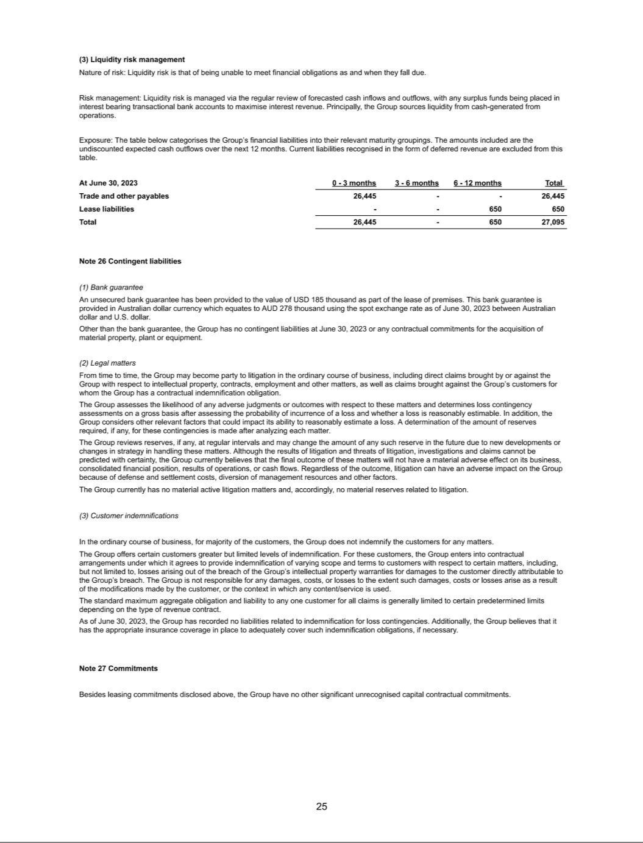

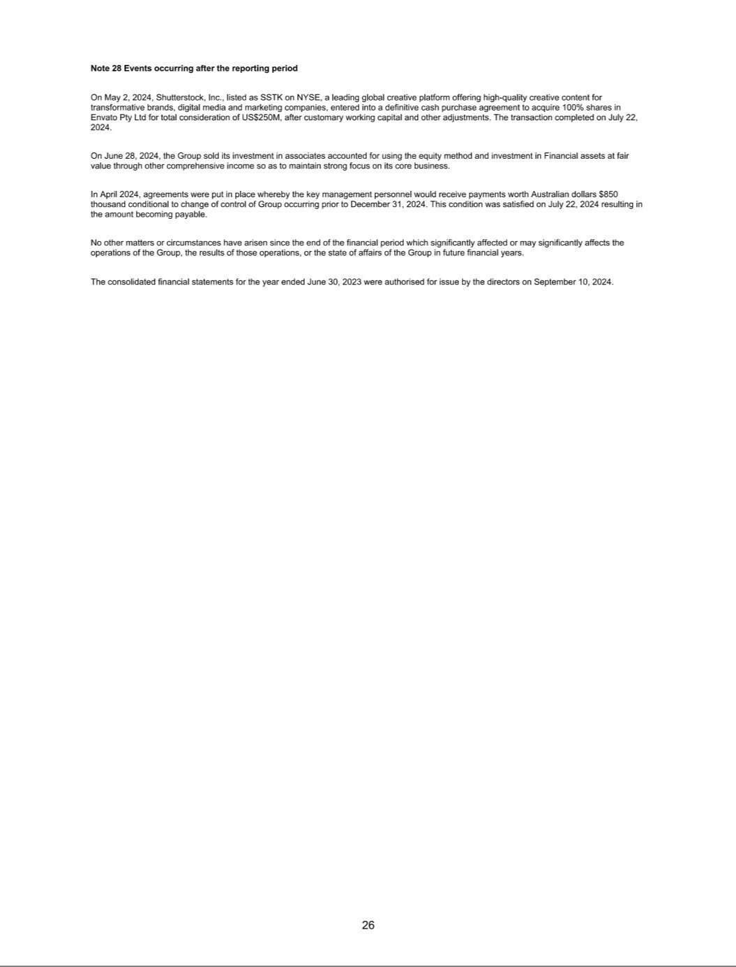

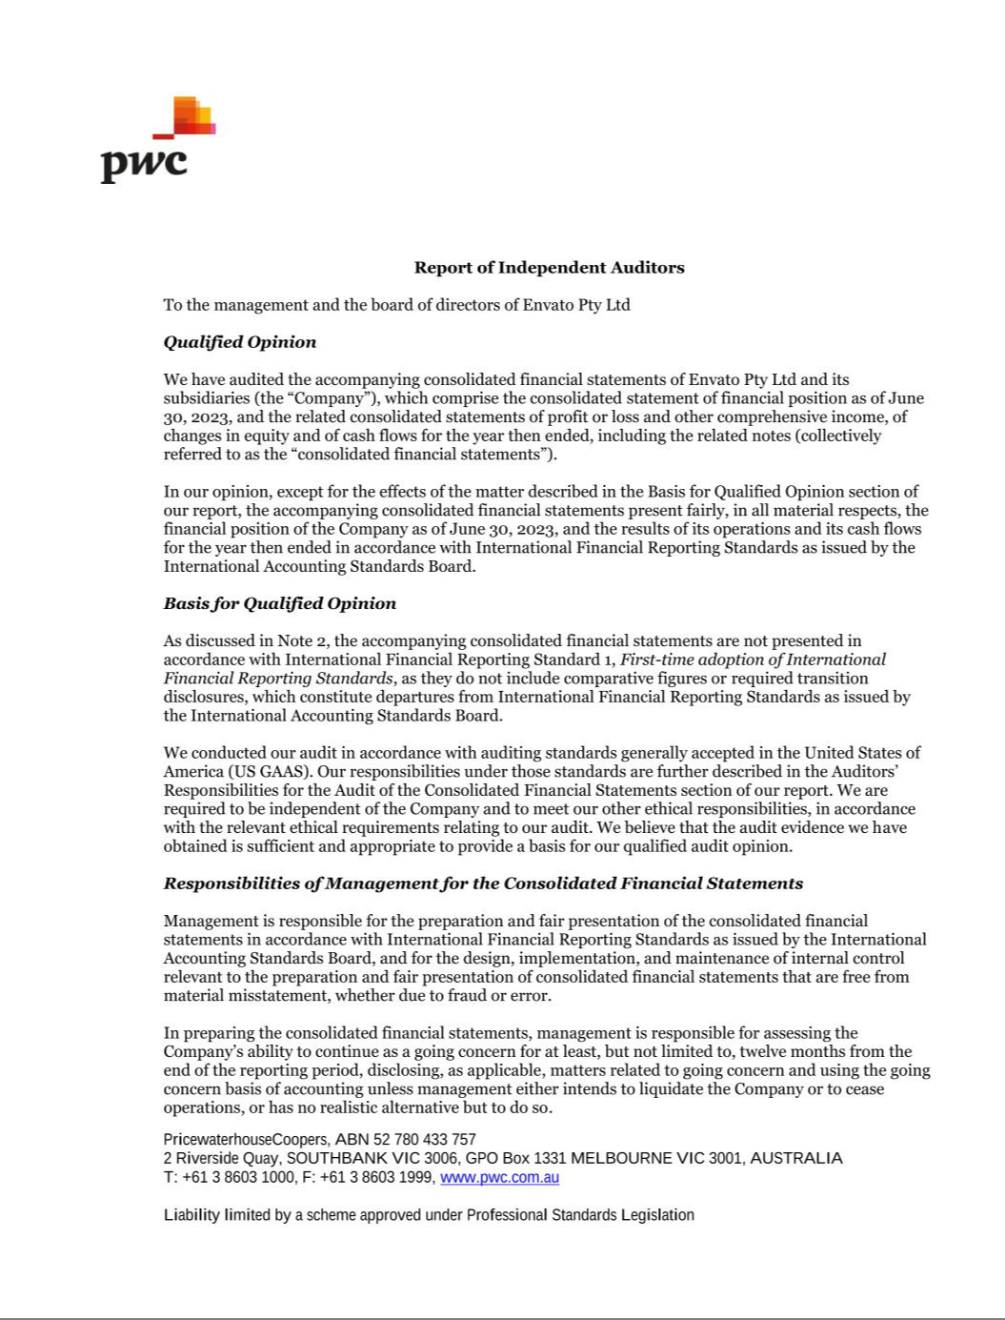

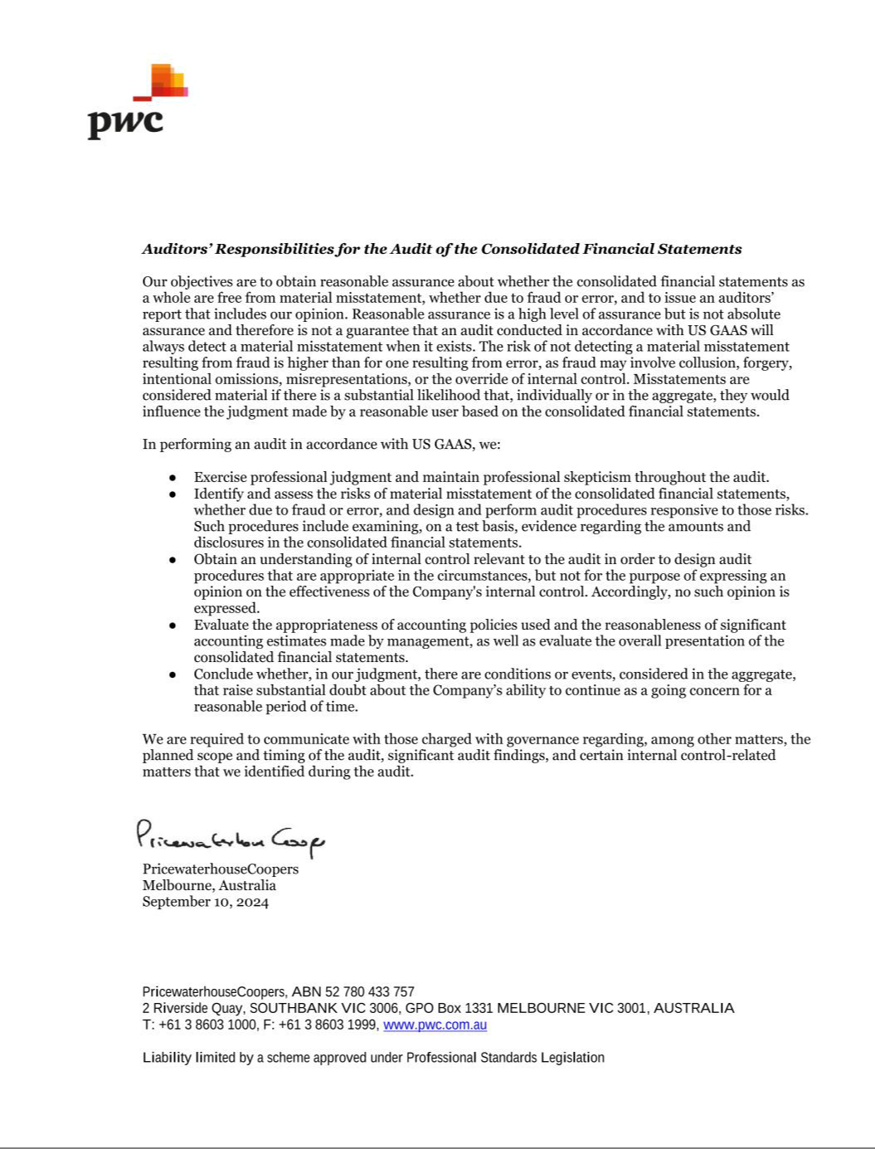





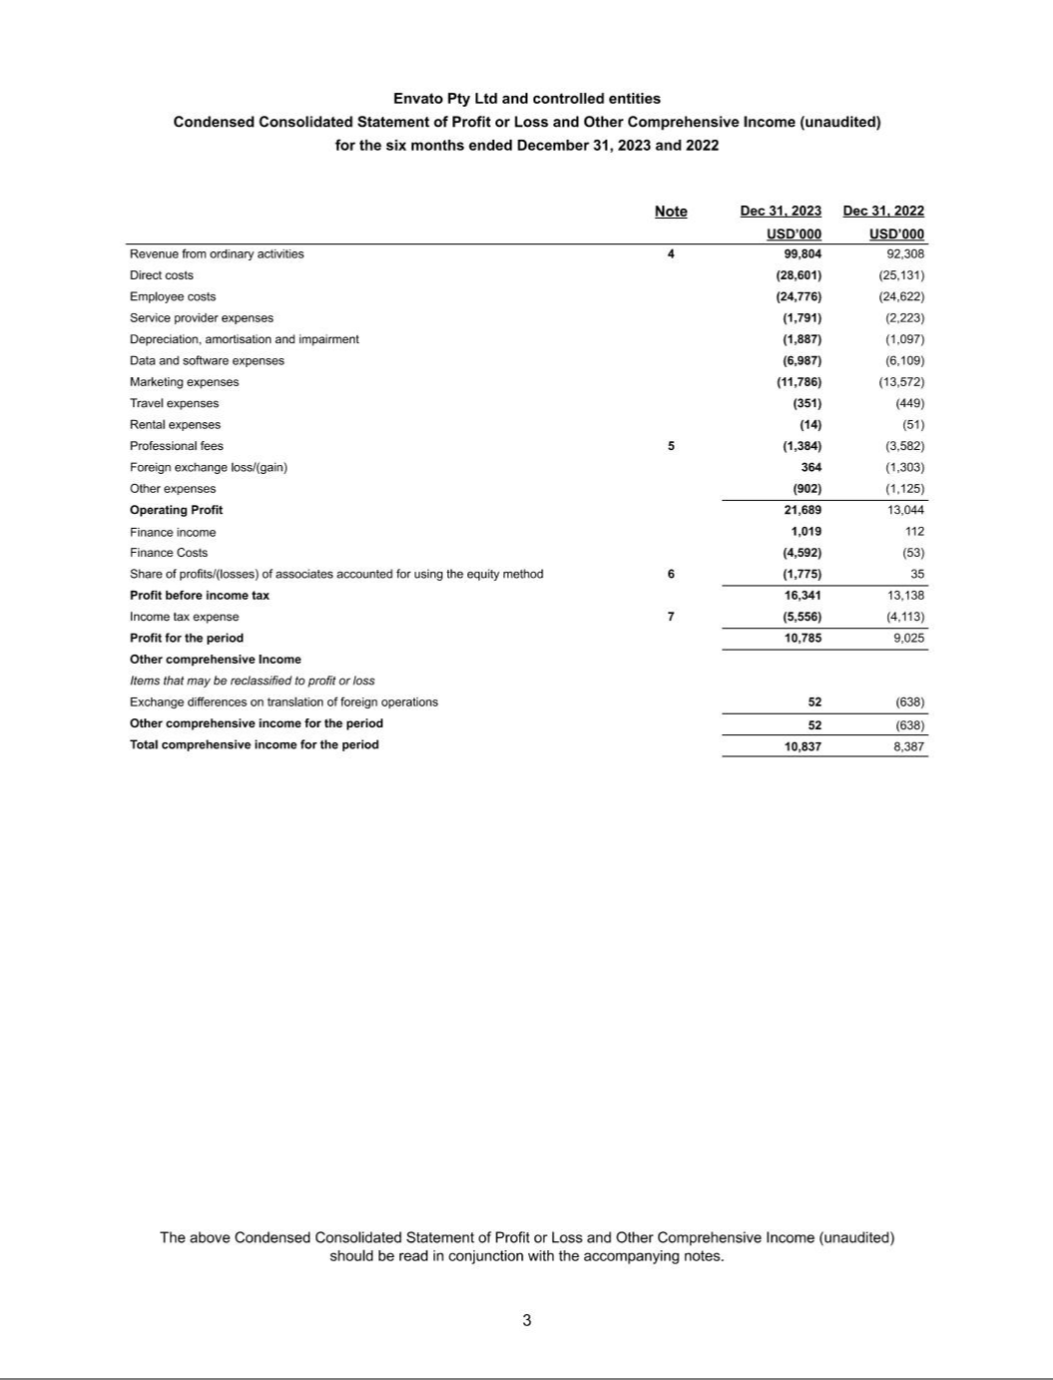

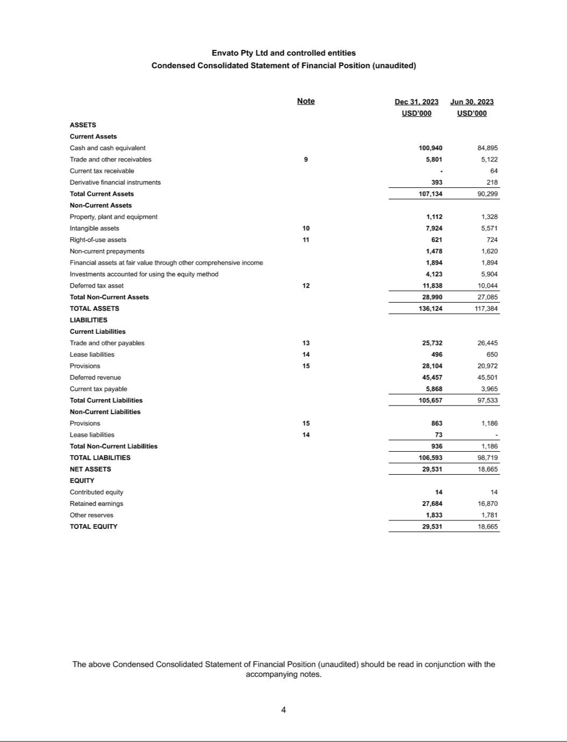

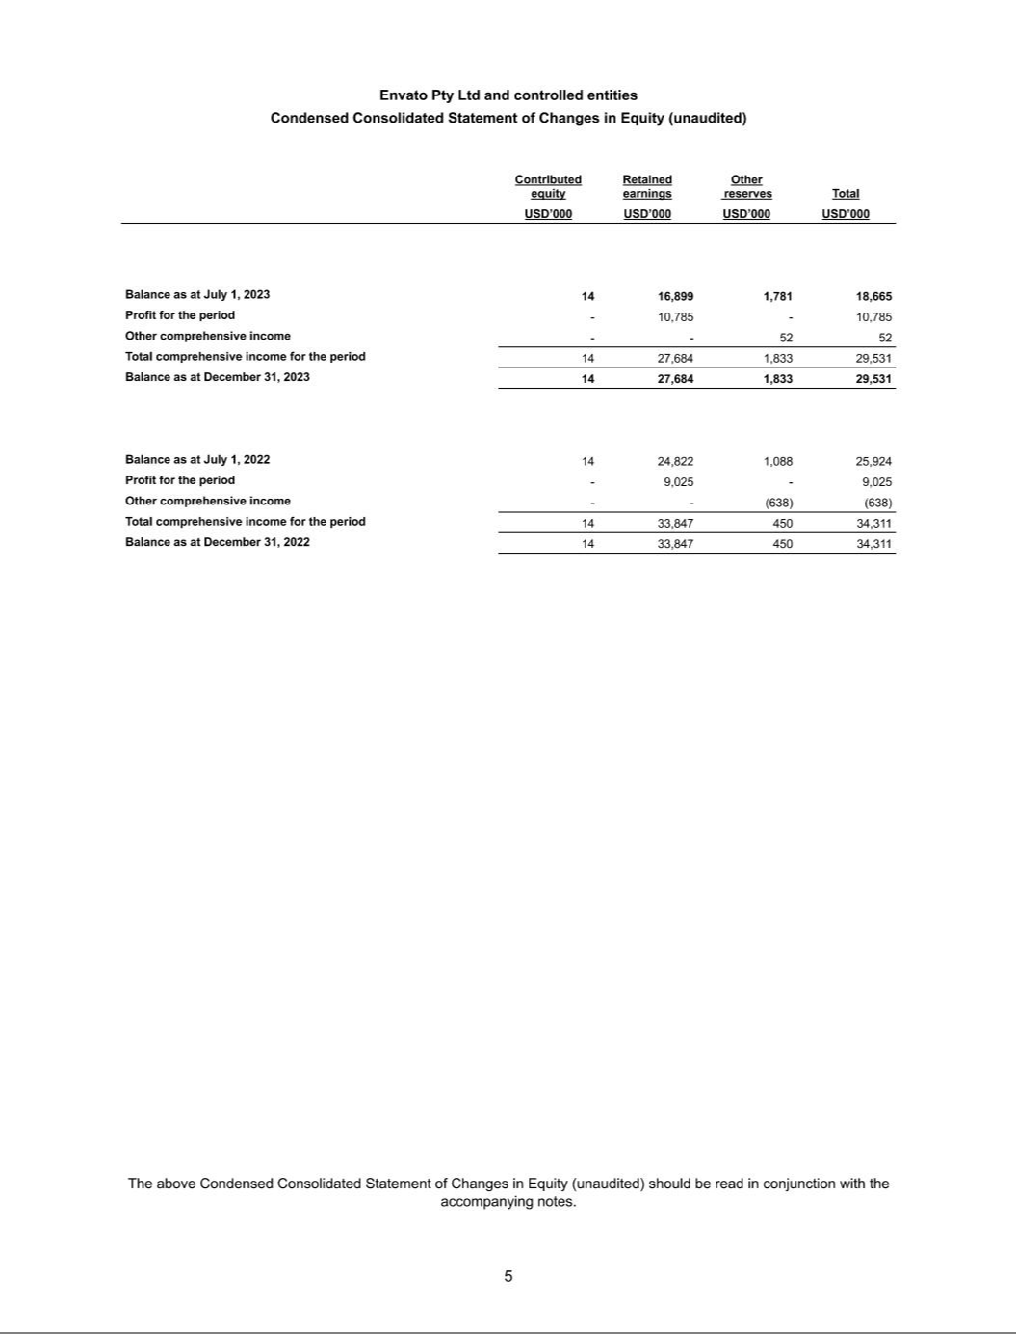

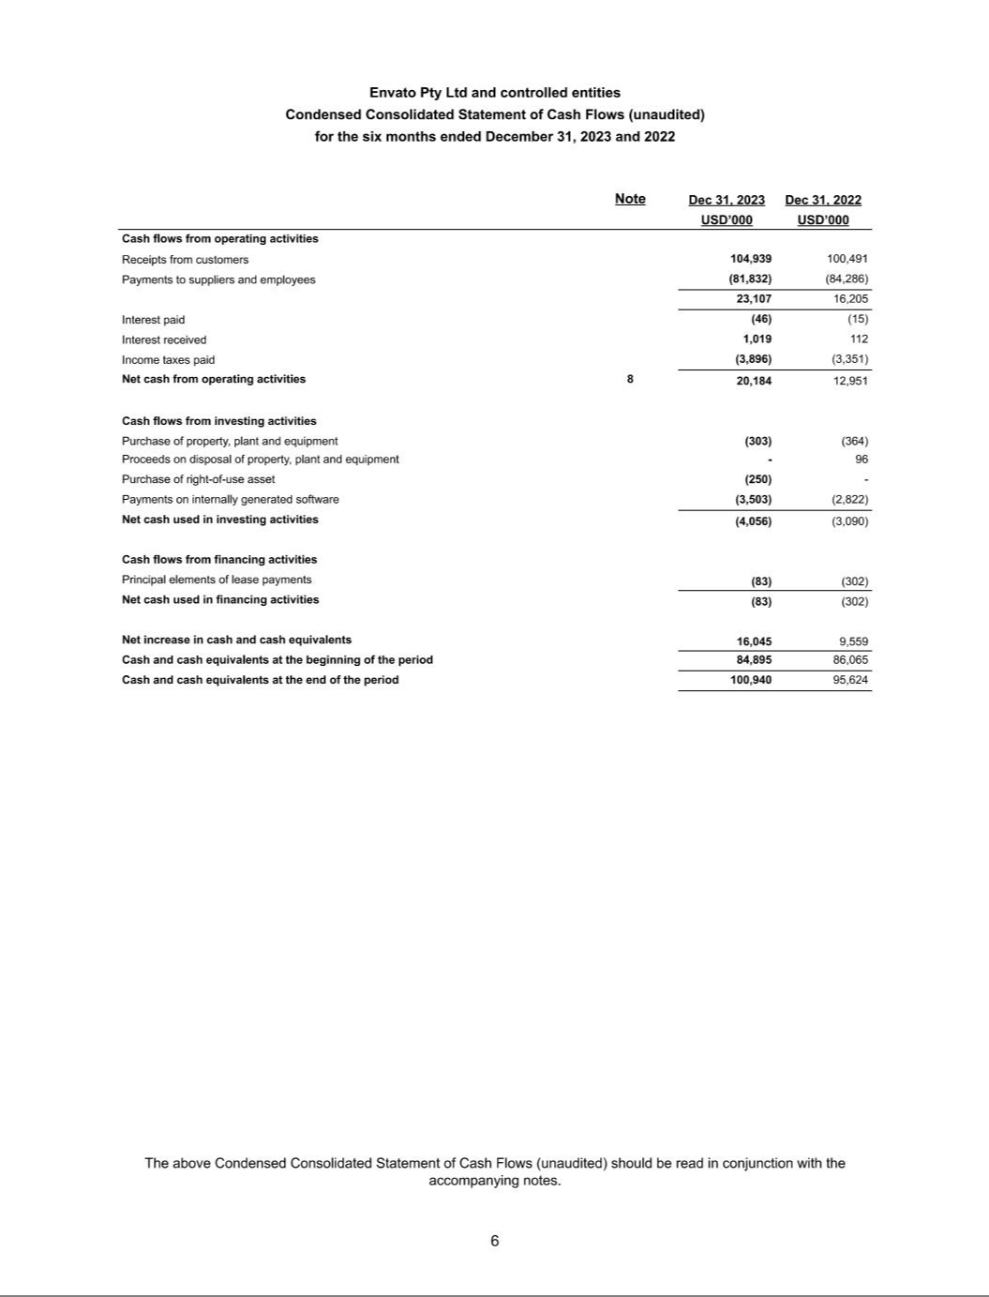

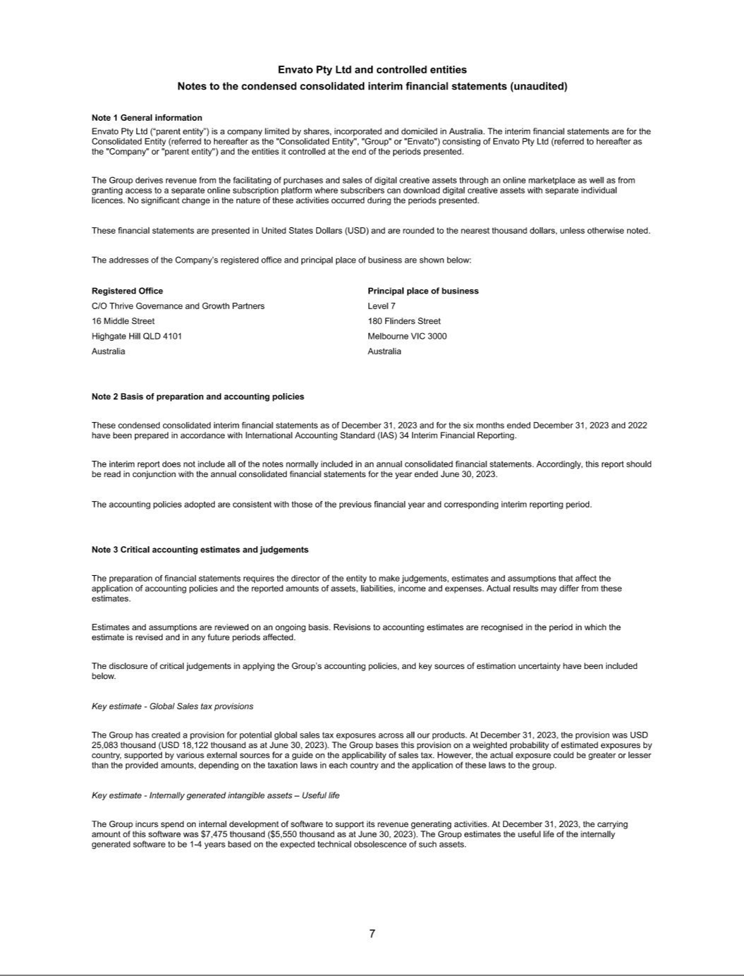

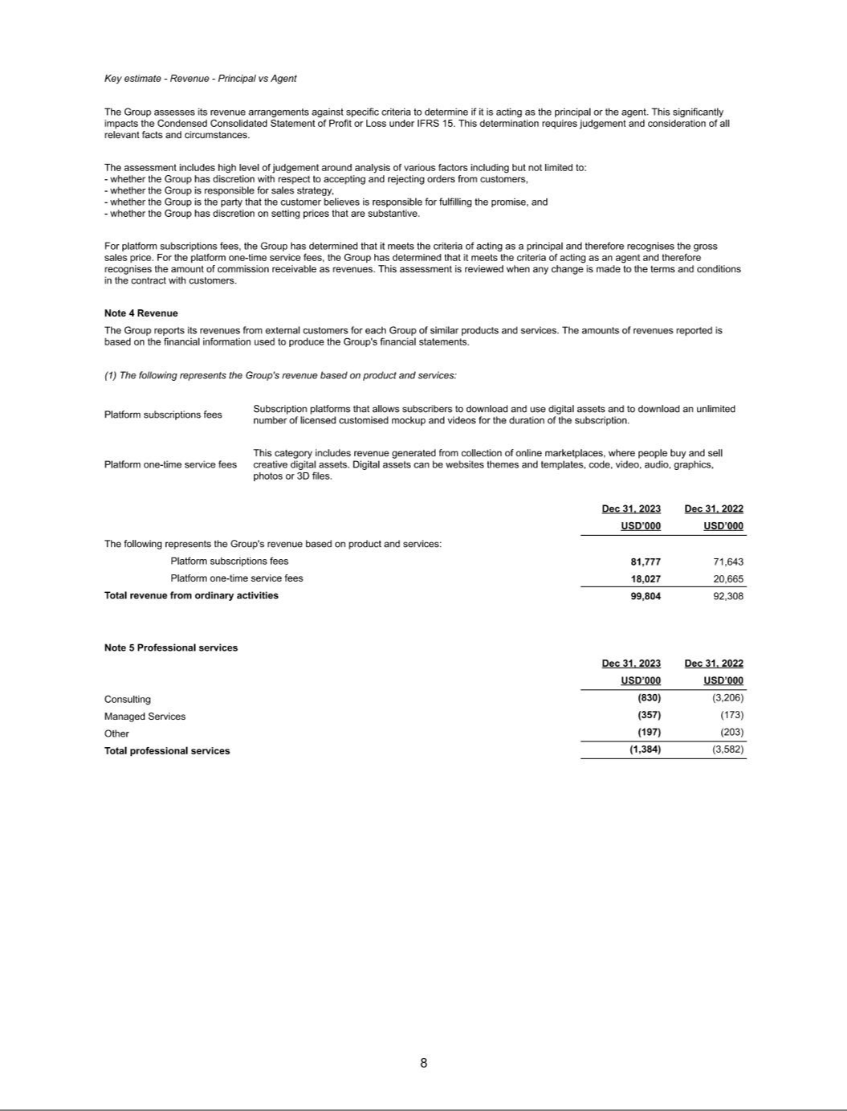

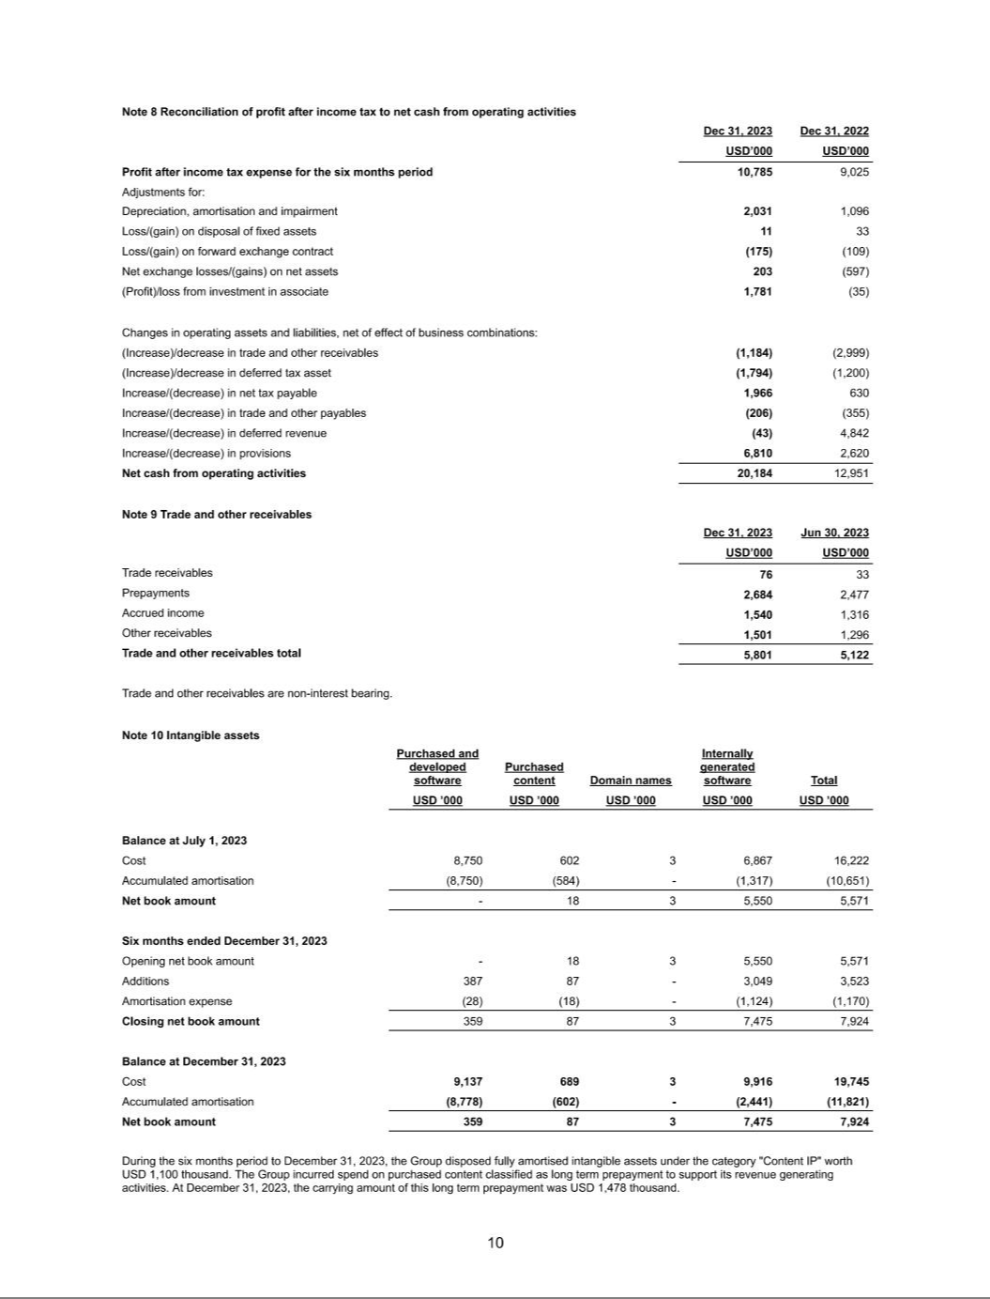

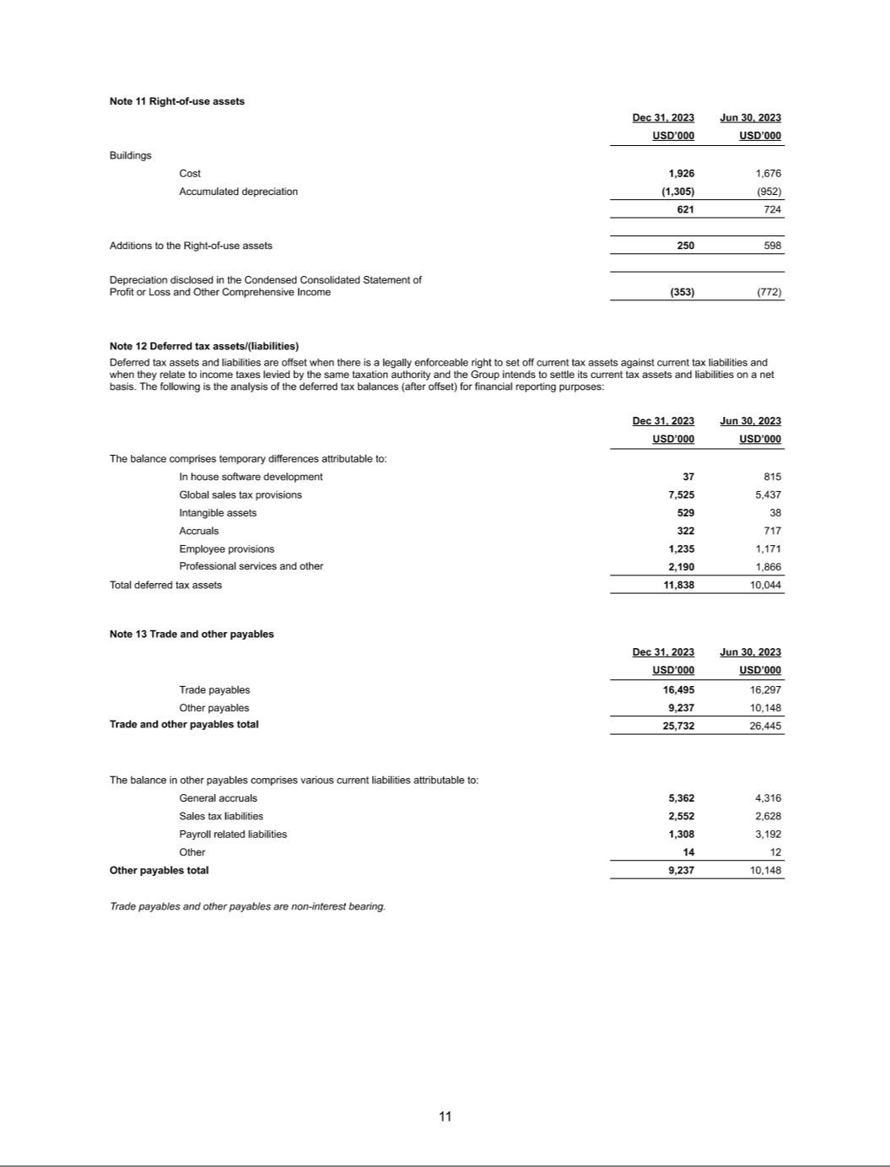

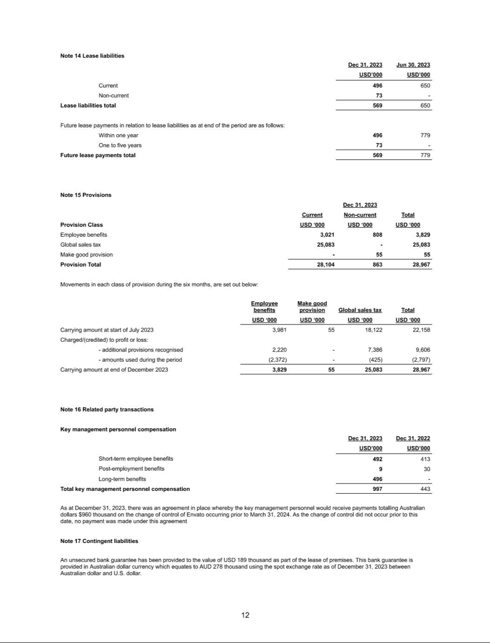

EXHIBIT 99.3

UNAUDITED PRO FORMA CONDENSED COMBINED FINANCIAL INFORMATION

On July 22, 2024, the Company completed its previously announced acquisition of Envato Pty Ltd. (“Envato”) pursuant to a Share Purchase Agreement (the “Purchase Agreement”) entered into on May 1, 2024, to acquire all of the issued and outstanding capital stock of Envato (the "Envato Acquisition"). The aggregate consideration paid by the Company, after customary working capital and other adjustments in accordance with the terms of the Purchase Agreement, was $250 million.

The Envato acquisition was funded through an amended and restated credit agreement (the “A&R Credit Agreement”), which was entered into among the Company, as borrower, certain direct and indirect subsidiaries of the Company as guarantors, the lenders party thereto, and Bank of America, N.A., as Administrative Agent for the lenders. The A&R Credit Agreement provides for a five-year (i) senior unsecured term loan facility (the “Term Loan”) in an aggregate principal amount of $125 million and (ii) senior unsecured revolving credit facility (the “Revolver”) in an aggregate principal amount of $250 million. The A&R Credit Agreement provides for a letter of credit subfacility and a swingline facility.

The Envato Acquisition was accounted for using the acquisition method of accounting for business combinations under the provisions of Financial Accounting Standards Board (“FASB”) Accounting Standard Codification (“ASC”) Topic 805, Business Combinations (“ASC 805”).

In addition, on June 23, 2023, the Company completed its acquisition of Giphy, Inc. (“Giphy”) pursuant to a stock purchase agreement entered into with Meta Platforms, Inc. (“Meta”) on May 22, 2023, to acquire all the outstanding shares of Giphy (the “Giphy Acquisition”). The consideration paid by the Company was $53 million in net cash, in addition to cash acquired and other working capital adjustments. The Giphy Acquisition was accounted for using the acquisition method of accounting for business combinations under the provisions of ASC 805.

The unaudited pro forma condensed combined financial statements were prepared in accordance with Article 11 of Regulation S-X, as amended by SEC Final Rule Release No. 33-10786, Amendments to Financial Disclosures About Acquired and Disposed Businesses and are presented to illustrate the estimated effects of the Envato Acquisition and the Giphy Acquisition.
The unaudited pro forma condensed combined balance sheet was prepared as if the Envato Acquisition had occurred on March 31, 2024. The unaudited pro forma condensed combined statements of operations for the year ended December 31, 2023, and for the three months ended March 31, 2024 were prepared as if the Envato Acquisition and Giphy Acquisition had occurred on January 1, 2023. For all periods after June 23, 2023, Giphy’s results were included in the Shutterstock consolidated financial statements.

The following unaudited pro forma condensed combined financial information is derived from the historical financial statements of Shutterstock, Envato and Giphy, and should be read in conjunction with:

- Shutterstock, Inc.’s consolidated financial statements included in its Annual Report on Form 10-K filed with the Securities and Exchange Commission (“SEC”) on February 26, 2024, and incorporated herein by reference.

- Shutterstock, Inc.’s consolidated financial statements included in its Quarterly Report on Form 10-Q filed with the SEC on May 2, 2024, and incorporated herein by reference.

- Envato’s audited consolidated financial statements for the year ended June 30, 2023, that are included as Exhibit 99.1 in the Company’s Report on Form 8-K/A filed with the SEC on October 3, 2024 to which this unaudited pro forma condensed combined financial information is being filed as an exhibit.

- Envato’s unaudited condensed consolidated financial statements for the six months ended December 31, 2023 and 2022, that are included as Exhibit 99.2 in the Company’s Report on Form 8-K/A filed with the SEC on October 3, 2024 to which this unaudited pro forma condensed combined financial information is being filed as an exhibit.

1

- Envato's statement of profit or loss for the three months ended March 31, 2024, and the statement of financial position as of March 31, 2024 derived from the books and records of Envato.

- Giphy’s unaudited condensed consolidated financial statements for the quarterly period ended March 31, 2023, which are included in the Company’s Current Report on Form 8-K/A filed with the SEC on August 31, 2023.

- Giphy's statement of operations for the period from April 1, 2023 through June 23, 2023 derived from the books and records of Giphy.

The unaudited pro forma condensed combined financial information has been prepared for illustrative purposes only and are not necessarily indicative of the financial condition or results of operations of future periods or the financial condition or results of operations that would have been realized had the entities been a single entity as of or for the periods presented.

Assumptions underlying the pro forma adjustments are described in the accompanying notes, which should be read in conjunction with the unaudited pro forma condensed combined financial information. The transaction accounting adjustments are based on available information and assumptions that the Company’s management believes are reasonable. Such adjustments are estimates and actual experience may differ from expectations.

The unaudited pro forma condensed combined financial statements are subject to Envato Acquisition closing adjustments that have not yet been finalized. Accordingly, the pro forma adjustments are preliminary and have been made solely for the purpose of providing unaudited pro forma condensed combined financial information as required by SEC rules. Differences between these preliminary estimates and the final combination accounting may be material.

2

UNAUDITED PRO FORMA CONDENSED COMBINED BALANCE SHEET

AS OF MARCH 31, 2024

(In thousands)

 |  | Historical
 |  |  |  |  |  |  |  |  |  |  | Debt Financing
 |  |  |  |  | Envato |  | Transaction Accounting |  |  |  | Transaction |  |  | Pro Forma
 |  | Shutterstock |  |  | (Note 5) |  |  | Adjustments | Note |  | Adjustments | Note |  | Combined
ASSETS
Current assets:
Cash and cash equivalents | $ | 71,811 |  | $ | 101,291 |  | $ | (250,213) | 6B | $ | 247,519 | 6A | $ | 170,408
Accounts receivable, net |  | 93,993 |  |  | 3,484 |  |  | — |  |  | — |  |  | 97,477
Prepaid expenses and other current assets |  | 93,095 |  |  | 3,507 |  |  | — |  |  | 479 | 6A |  | 97,081
Total current assets |  | 258,899 |  |  | 108,282 |  |  | (250,213) |  |  | 247,998 |  |  | 364,966
Property and equipment, net |  | 63,430 |  |  | 1,070 |  |  | — |  |  | — |  |  | 64,500
Right-of-use asset |  | 16,482 |  |  | 451 |  |  | (451) | 6C |  | — |  |  | 16,482
Intangibles, net |  | 174,868 |  |  | 8,368 |  |  | 82,032 | 6C |  | — |  |  | 265,268
Goodwill |  | 402,787 |  |  | — |  |  | 201,189 | 6D |  | — |  |  | 603,976
Deferred tax assets, net |  | 28,156 |  |  | 11,686 |  |  | 10,822 | 6F |  | — |  |  | 50,664
Other assets |  | 83,881 |  |  | 1,336 |  |  | — |  |  | 1,917 | 6A |  | 87,134
Total assets | $ | 1,028,503 |  | $ | 131,193 |  | $ | 43,379 |  | $ | 249,915 |  | $ | 1,452,990
LIABILITIES AND STOCKHOLDERS' EQUITY
Current liabilities
Accounts payable | $ | 9,373 |  | $ | 2,439 |  | $ | — |  | $ | — |  | $ | 11,812
Accrued expenses |  | 99,212 |  |  | 10,126 |  |  | 6,575 | 6E |  | (85) | 6A |  | 115,828
Contributor royalties payable |  | 61,392 |  |  | 15,269 |  |  | — |  |  | — |  |  | 76,661
Deferred revenue |  | 198,041 |  |  | 47,338 |  |  | — |  |  | — |  |  | 245,379
Debt |  | 30,000 |  |  | — |  |  | — |  |  | 125,000 | 6A |  | 155,000
Other current liabilities |  | 34,959 |  |  | 35,534 |  |  | 62,996 | 6C, 6F |  | — |  |  | 133,489
Total current liabilities |  | 432,977 |  |  | 110,706 |  |  | 69,571 |  |  | 124,915 |  |  | 738,169
Deferred tax liability, net |  | 3,795 |  |  | — |  |  | — |  |  | — |  |  | 3,795
Long term debt |  | — |  |  | — |  |  | — |  |  | 125,000 | 6A |  | 125,000
Lease liabilities |  | 28,745 |  |  | — |  |  | — |  |  | — |  |  | 28,745
Other non-current liabilities |  | 21,711 |  |  | 870 |  |  | — |  |  | — |  |  | 22,581
Total liabilities |  | 487,228 |  |  | 111,576 |  |  | 69,571 |  |  | 249,915 |  |  | 918,290
Stockholders equity:
Common Stock |  | 399 |  |  | — |  |  | — |  |  | — |  |  | 399
Treasury stock |  | (228,213) |  |  | — |  |  | — |  |  | — |  |  | (228,213)
Additional paid-in capital |  | 434,416 |  |  | 14 |  |  | (14) | 6G |  | — |  |  | 434,416
Accumulated other comprehensive loss |  | (13,438) |  |  | — |  |  | — |  |  | — |  |  | (13,438)
Retained earnings |  | 348,111 |  |  | 19,603 |  |  | (26,178) | 6E, 6G |  | — |  |  | 341,536
Total stockholders' equity |  | 541,275 |  |  | 19,617 |  |  | (26,192) |  |  | — |  |  | 534,700
Total liabilities and stockholders' equity | $ | 1,028,503 |  | $ | 131,193 |  | $ | 43,379 |  | $ | 249,915 |  | $ | 1,452,990

3

UNAUDITED PRO FORMA CONDENSED COMBINED STATEMENT OF OPERATIONS FOR THE YEAR ENDED DECEMBER 31, 2023

(In thousands, except per share data)

 |  | Historical |  |  |  |  |  |  |  |  |  |  |  |  |  | Historical
 |  |  |  |  |  |  |  | Giphy
 |  |  |  |  |  |  |  | Acquisition |  |  |  |  | Pro forma |  |  |  |  |  | Envato
 |  |  |  |  |  |  | Transaction |  |  |  |  |  | Combined |  |  |  |  |  | Acquisition |  |  | Debt
 |  |  |  |  |  |  |  | Accounting |  |  |  | (adjusted for Giphy |  |  |  |  |  |  | Transaction |  |  | Financing
 |  |  |  |  | Giphy |  | Adjustments |  |  |  |  |  | Acquisition |  |  | Envato |  |  | Accounting |  |  | Transaction |  |  | Pro Forma
 | Shutterstock |  |  |  | (Note 3) |  |  | (Note 3) |  | Note |  |  | Transaction) |  |  | (Note 5) |  |  | Adjustments | Note |  | Adjustments | Note |  | Combined
Revenue | $ | 874,587 | $ |  | — |  | $ | 7,151 |  | 3A |  | $ | 881,738 |  | $ | 197,809 |  | $ | — |  | $ | — | $ |  | 1,079,547
Operating expenses:
Cost of revenue |  | 352,630 |  |  | — |  |  | 2,538 |  | 3B |  |  | 355,168 |  |  | 72,784 |  |  | 10,731 | 6H, 6I |  | — |  |  | 438,683
Sales and marketing |  | 214,749 |  |  | 11,148 |  |  | — |  |  |  |  | 225,897 |  |  | 33,845 |  |  | — |  |  | — |  |  | 259,742
Product development |  | 96,162 |  |  | 27,108 |  |  | — |  |  |  |  | 123,270 |  |  | 25,550 |  |  | — |  |  | — |  |  | 148,820
General and administrative |  | 142,646 |  |  | 11,874 |  |  | 692 |  | 3B |  |  | 155,212 |  |  | 30,483 |  |  | 9,675 | 6I, 6J |  | — |  |  | 195,370
Total operating expenses |  | 806,187 |  |  | 50,130 |  |  | 3,230 |  |  |  |  | 859,547 |  |  | 162,662 |  |  | 20,406 |  |  | — |  |  | 1,042,615
Income / (loss) from operations |  | 68,400 |  |  | (50,130) |  |  | 3,921 |  |  |  |  | 22,191 |  |  | 35,147 |  |  | (20,406) |  |  | — |  |  | 36,932
Bargain purchase gain |  | 50,261 |  |  | — |  |  | — |  |  |  |  | 50,261 |  |  | — |  |  | — |  |  | — |  |  | 50,261
Other income / (expense), net |  | 3,807 |  |  | 78 |  |  | — |  |  |  |  | 3,885 |  |  | (2,765) |  |  | — |  |  | (18,575) | 6K |  | (17,455)
Income / (loss) before income taxes |  | 122,468 |  |  | (50,052) |  |  | 3,921 |  |  |  |  | 76,337 |  |  | 32,382 |  |  | (20,406) |  |  | (18,575) |  |  | 69,738
Provision (benefit) for income taxes |  | 12,199 |  |  | — |  |  | 862 |  | 3C |  |  | 13,061 |  |  | 9,524 |  |  | (4,370) | 6I |  | (4,365) | 6L |  | 13,850
Net income / (loss) | $ | 110,269 |  | $ | (50,052) |  | $ | 3,059 |  |  |  | $ | 63,276 |  | $ | 22,858 |  | $ | (16,036) |  | $ | (14,210) |  | $ | 55,888
Earnings per share:
Basic | $ | 3.07 |  |  |  |  |  |  |  |  |  |  |  |  |  |  |  |  |  |  |  |  |  | $ | 1.56
Diluted | $ | 3.04 |  |  |  |  |  |  |  |  |  |  |  |  |  |  |  |  |  |  |  |  | $ |  | 1.54
Basic |  | 35,878 |  |  |  |  |  |  |  |  |  |  |  |  |  |  |  |  |  |  |  |  |  |  | 35,878
Diluted |  | 36,242 |  |  |  |  |  |  |  |  |  |  |  |  |  |  |  |  |  |  |  |  |  |  | 36,242

4

UNAUDITED PRO FORMA CONDENSED COMBINED STATEMENT OF OPERATIONS

FOR THE THREE MONTHS ENDED MARCH 31, 2024

(In thousands, except per share data)

 |  | Historical
 |  |  |  |  | Envato |  |  | Transaction |  |  | Debt Financing
 |  |  |  |  | Reclassified |  |  | Accounting |  |  | Transaction |  |  | Pro Forma
 |  | Shutterstock |  |  | (Note 5) |  |  | Adjustments | Note |  | Adjustments | Note |  | Combined
Revenue | $ | 214,315 | $ |  | 49,698 |  | $ | — |  | $ | — | $ |  | 264,013
Operating expenses:
Cost of revenue |  | 88,204 |  |  | 18,243 |  |  | 2,689 | 6H, 6I |  | — |  |  | 109,136
Sales and marketing |  | 56,236 |  |  | 7,960 |  |  | — |  |  | — |  |  | 64,196
Product development |  | 21,051 |  |  | 5,988 |  |  | — |  |  | — |  |  | 27,039
General and administrative |  | 32,078 |  |  | 7,442 |  |  | 7,350 | 6I, 6J |  | — |  |  | 46,870
Total operating expenses |  | 197,569 |  |  | 39,633 |  |  | 10,039 |  |  | — |  |  | 247,241
Income / (loss) from operations |  | 16,746 |  |  | 10,065 |  |  | (10,039) |  |  | — |  |  | 16,772
Other income / (expense), net |  | 3,644 |  |  | (630) |  |  | — |  |  | (4,644) | 6K |  | (1,630)
Income / (loss) before income taxes |  | 20,390 |  |  | 9,435 |  |  | (10,039) |  |  | (4,644) |  |  | 15,142
Provision (benefit) for income taxes |  | 4,269 |  |  | 1,679 |  |  | (1,093) | 6I |  | (1,091) | 6L |  | 3,764
Net income / (loss) | $ | 16,121 | $ |  | 7,756 |  | $ | (8,946) |  | $ | (3,553) | $ |  | 11,378
Earnings per share:
Basic | $ | 0.45 |  |  |  |  |  |  |  |  |  | $ |  | 0.32
Diluted | $ | 0.45 |  |  |  |  |  |  |  |  |  | $ |  | 0.32
Weighted average shares outstanding:
Basic |  | 35,591 |  |  |  |  |  |  |  |  |  |  |  | 35,591
Diluted |  | 36,066 |  |  |  |  |  |  |  |  |  |  |  | 36,066

5

Notes to Unaudited Pro Forma Condensed Combined Financial Information

Note 1 – Basis of Pro Forma Presentation

On July 22, 2024, the Company completed its previously announced acquisition of Envato Pty Ltd. (“Envato”) pursuant to a Share Purchase Agreement (the “Purchase Agreement”) entered into on May 1, 2024, to acquire all of the issued and outstanding capital stock of Envato (the "Envato Acquisition"). The aggregate consideration paid by the Company, after customary working capital and other adjustments in accordance with the terms of the Purchase Agreement, was $250 million.

The Envato acquisition was funded through an amended and restated credit agreement (the “A&R Credit Agreement”), which was entered into among the Company, as borrower, certain direct and indirect subsidiaries of the Company as guarantors, the lenders party thereto, and Bank of America, N.A., as Administrative Agent for the lenders. The A&R Credit Agreement provides for a five-year (i) senior unsecured term loan facility (the “Term Loan”) in an aggregate principal amount of $125 million and (ii) senior unsecured revolving credit facility (the “Revolver”) in an aggregate principal amount of $250 million. The A&R Credit Agreement provides for a letter of credit subfacility and a swingline facility.
The Envato Acquisition was accounted for using the acquisition method of accounting for business combinations under the provisions of Financial Accounting Standards Board (“FASB”) Accounting Standard Codification (“ASC”) Topic 805, Business Combinations (“ASC 805”).

In addition, on June 23, 2023, the Company completed its acquisition of Giphy, Inc. (“Giphy”) pursuant to a stock purchase agreement entered into with Meta Platforms, Inc. (“Meta”) on May 22, 2023, to acquire all the outstanding shares of Giphy (the “Giphy Acquisition”). The consideration paid by the Company was $53 million in net cash, in addition to cash acquired and other working capital adjustments. The Giphy Acquisition was accounted for using the acquisition method of accounting for business combinations under the provisions of ASC 805.

The unaudited pro forma condensed combined financial statements were prepared in accordance with Article 11 of Regulation S-X, as amended by SEC Final Rule Release No. 33-10786, Amendments to Financial Disclosures About Acquired and Disposed Businesses and are presented to illustrate the estimated effects of the Envato Acquisition and the Giphy Acquisition.
The unaudited pro forma condensed combined balance sheet was prepared as if the Envato Acquisition had occurred on March 31, 2024. The unaudited pro forma condensed combined statements of operations for the year ended December 31, 2023, and for the three months ended March 31, 2024 were prepared as if the Envato Acquisition and Giphy Acquisition had occurred on January 1, 2023. For all periods after June 23, 2023, Giphy’s results were included in the Shutterstock consolidated financial statements.

The following unaudited pro forma condensed combined financial information is derived from the historical financial statements of Shutterstock, Envato and Giphy, and should be read in conjunction with:

- Shutterstock, Inc.’s consolidated financial statements included in its Annual Report on Form 10-K filed with the Securities and Exchange Commission (“SEC”) on February 26, 2024, and incorporated herein by reference.

- Shutterstock, Inc.’s consolidated financial statements included in its Quarterly Report on Form 10-Q filed with the SEC on May 2, 2024, and incorporated herein by reference.

- Envato’s audited consolidated financial statements for the year ended June 30, 2023, that are included as Exhibit 99.1 in the Company’s Report on Form 8-K/A filed with the SEC on October 3, 2024 to which this unaudited pro forma condensed combined financial information is being filed as an exhibit.

6

- Envato’s unaudited condensed consolidated financial statements for the six months ended December 31, 2023 and 2022, that are included as Exhibit 99.2 in the Company’s Report on Form 8-K/A filed with the SEC on October 3, 2024 to which this unaudited pro forma condensed combined financial information is being filed as an exhibit.
- Envato's statement of profit or loss for the three months ended March 31, 2024, and the statement of financial position as of March 31, 2024 derived from the books and records of Envato.

- Giphy’s unaudited condensed consolidated financial statements for the quarterly period ended March 31, 2023, which are included in the Company’s Current Report on Form 8-K/A filed with the SEC on August 31, 2023.

- Giphy's statement of operations for the period from April 1, 2023 through June 23, 2023 derived from the books and records of Giphy.

The unaudited pro forma condensed combined financial information is not necessarily indicative of what Shutterstock’s results of operations would have been had the Envato Acquisition and Giphy Acquisition occurred on the dates indicated, nor is it necessarily indicative of what the financial position or results of operations of the combined company will be in future periods. The historical financial information has been adjusted to reflect transaction related adjustments that management believes are necessary to present fairly Shutterstock’s pro forma results of operations following the closing of the Envato Acquisition and Giphy Acquisition for the periods indicated. Additionally, the unaudited pro forma condensed combined statement of operations does not reflect any benefits that may result from potential revenue enhancements, anticipated cost savings and expense efficiencies or other synergies that may be achieved from the transaction.
The pro forma adjustments are based on certain estimates and assumptions, including the Envato preliminary purchase price allocation. The actual adjustments and the allocation of the final purchase price will depend on several factors, including additional financial information and completion of the determination of fair value of assets and liabilities of Envato as of the purchase date. Therefore, the actual adjustments will differ from the pro forma adjustments, and it is possible that the differences may be material.

The combination is subject to Envato Acquisition closing adjustments that have not yet been finalized. Accordingly, the pro forma adjustments are preliminary and have been made solely for the purpose of providing unaudited pro forma condensed combined financial information as required by SEC rules. Differences between these preliminary estimates and the final combination accounting may be material.

Envato's financial statements were prepared in accordance with International Financial Reporting Standards ("IFRS") issued by the International Accounting Standards Board ("IASB"). There were no material adjustments required to convert these financial statements to United States generally accepted accounting principles (“U.S. GAAP”). The pro forma adjustments include certain reclassifications to conform Envato’s historical accounting presentation to Shutterstock’s accounting presentation. Shutterstock’s management believes that its assumptions provide a reasonable basis for presenting all of the significant effects of the transactions and that the pro forma adjustments give appropriate effect to those assumptions and are properly applied in the unaudited pro forma condensed combined financial information.

7

Note 2 – Preliminary Fair Value Allocation of Assets Acquired and Liabilities Assumed

For purposes of these pro forma financial statements, the estimated purchase price is as follows (in thousands):

 | Purchase Price
Preliminary purchase consideration | 250,213
Acquired cash | (101,291)
Preliminary purchase consideration, net of acquired cash | 148,922

The allocation of the purchase price to assets acquired and liabilities assumed is as follows, as though the transaction closed on March 31, 2024 (in thousands):

Fair value of assets acquired and liabilities assumed: |  | As of March 31, 2024
Cash and cash equivalents | $ | 101,291
Accounts receivable, net |  | 3,484
Prepaid expenses and other current assets |  | 3,507
Property and equipment, net |  | 1,070
Intangible assets:
Trademark |  | 31,000
Software |  | 47,000
Customer Relationships |  | 12,400
Intangible assets, net |  | 90,400
Deferred tax assets |  | 22,508
Other assets |  | 1,336
Total assets acquired |  | 223,596
Accounts payable |  | 2,439
Accrued expenses |  | 10,126
Contributor royalties payable |  | 15,269
Deferred revenue |  | 47,338
Other current liabilities |  | 98,530
Other non-current liabilities |  | 870
Total liabilities assumed |  | 174,572
Net assets acquired |  | 49,024
Preliminary purchase consideration |  | 250,213
Preliminary Goodwill |  | 201,189

The excess of preliminary purchase consideration over total net assets was recorded as goodwill. The goodwill arising from the transaction is primarily attributable to expected operational synergies and is not deductible for income tax purposes. The fair value adjustments are preliminary and based on estimates of the fair value of the assets and liabilities assumed on March 31, 2024 and have been prepared to illustrate the effect of the Envato Acquisition. Accordingly, the pro forma purchase price allocation may be subject to further adjustments as additional information becomes available and as additional analyses and final valuations are completed. The final adjustments could be materially different from those reflected herein. The identifiable intangible assets, which include trademark, software, customer relationships have weighted average useful lives of approximately 10 years, 5 years and 6 years, respectively. The fair value of the trademark and software was determined using the relief-from-royalty method, and the fair value of the customer relationships was determined using the excess of earnings method. The identifiable intangible assets of this acquisition are amortized on a straight-line basis.

8

Note 3 – Giphy Acquisition Pro Forma Adjustments

On June 23, 2023, the Company completed the Giphy Acquisition. In connection with the closing of the Giphy Acquisition, the Company and Meta entered into a transitional services agreement (the “TSA”) pursuant to which Meta is responsible for certain costs related to retention of Giphy employees, including (i) recurring salary, bonus, and benefits through August 2024, which would be $35.6 million if all employees are retained through August 2024, and (ii) nonrecurring items, totaling $87.9 million, comprised of one-time employment inducement bonuses and the cash value of unvested Meta equity awards (the “Giphy Retention Compensation”).

The results of Giphy are included in the actual consolidated results of the Company from June 23, 2023. Adjustments have been made to the unaudited pro forma condensed combined statement of operations for the year ended December 31, 2023 to include the results of Giphy from January 1, 2023 to June 23, 2023, such that the unaudited pro forma condensed combined statement of operations for the year ended December 31, 2023 also reflects the result of Giphy as if the Company had acquired Giphy on January 1, 2023.

 |  | Historical
 |  |  |  | Giphy Accounting Transaction Accounting
 |  | Giphy |  |  | Adjustments |  | Note |  |  | Giphy As Reclassified
Revenue | $ | — |  | $ | 7,151 |  | 3A |  | $ | 7,151
Operating expenses:
Cost of revenue |  | — |  |  | 2,538 |  | 3B |  |  | 2,538
Sales and marketing |  | 11,148 |  |  | — |  |  |  |  | 11,148
Product development |  | 27,108 |  |  | — |  |  |  |  | 27,108
General and administrative |  | 11,874 |  |  | 692 |  | 3B |  |  | 12,566
Total operating expenses |  | 50,130 |  |  | 3,230 |  |  |  |  | 53,360
Income / (loss) from operations |  | (50,130) |  |  | 3,921 |  |  |  |  | (46,209)
Other income / (expense), net |  | 78 |  |  | — |  |  |  |  | 78
Income / (loss) before income taxes |  | (50,052) |  |  | 3,921 |  |  |  |  | (46,131)
Provision for income taxes |  | — |  |  | 862 |  | 3C |  |  | 862
Net income / (loss) |  | (50,052) |  |  | 3,059 |  |  |  |  | (46,993)

- To record $7.2 million for the period from January 1, 2023 through June 23, 2023 representing the allocation of the $30 million of consideration to an API services agreement, which was deferred on the date of acquisition and will be recorded as revenue over two years.
- Amortization of intangible assets recorded in connection with purchase accounting adjustments.

 | Period from January 1, 2023
(in thousands) | through June 23, 2023
Cost of revenue | 2,538
General and administrative | 692

C. Estimated income tax impact of the Giphy transaction accounting adjustments, using the statutory tax rate.

9

Note 4 – Envato’s Statement of Operations Reconciliation for Twelve Months Ended December 31, 2023

For purposes of preparing the unaudited condensed combined statement of operations for the year-ended December 31, 2023, Envato's historical audited statement of profit and loss and other comprehensive income for the twelve months ended June 30, 2023 was adjusted using Envato's unaudited statements of profit and loss and other comprehensive income for the six-month periods ended December 31, 2022 and 2023.

 |  | Twelve months ended |  | Six months ended December 31, |  |  | Six months ended December 31, |  |  |  | Fiscal Year 2023 Results
 |  | June 30, 2023 |  |  | 2022 |  |  | 2023 |  |  | through December 31, 2023
(in thousands) |  | (A) |  |  | (B) |  |  | (C) |  |  | (A - B + C)
Revenue from ordinary activities | $ | 190,313 |  | $ | 92,308 |  | $ | 99,804 |  | $ | 197,809
Direct costs |  | 52,302 |  |  | 25,131 |  |  | 28,601 |  |  | 55,772
Employee costs |  | 54,878 |  |  | 24,622 |  |  | 24,776 |  |  | 55,032
Service provider expenses |  | 4,666 |  |  | 2,223 |  |  | 1,791 |  |  | 4,234
Depreciation, amortization and impairment |  | 2,843 |  |  | 1,097 |  |  | 1,887 |  |  | 3,633
Data and software expenses |  | 12,467 |  |  | 6,109 |  |  | 6,987 |  |  | 13,345
Marketing expenses |  | 25,790 |  |  | 13,572 |  |  | 11,786 |  |  | 24,004
Travel expenses |  | 653 |  |  | 449 |  |  | 351 |  |  | 555
Rental expenses |  | 77 |  |  | 51 |  |  | 14 |  |  | 40
Professional fees |  | 6,832 |  |  | 3,582 |  |  | 1,384 |  |  | 4,634
Foreign exchange loss |  | 1,537 |  |  | 1,303 |  |  | (364) |  |  | (130)
Other expenses |  | 1,636 |  |  | 1,125 |  |  | 902 |  |  | 1,413
Operating profit |  | 26,632 |  |  | 13,044 |  |  | 21,689 |  |  | 35,277
Finance income |  | 842 |  |  | 112 |  |  | 1,019 |  |  | 1,749
Finance costs |  | (105) |  |  | (53) |  |  | (4,592) |  |  | (4,644)
Share of profits/(losses) of associates accounted for using the equity method |  | (236) |  |  | 35 |  |  | (1,775) |  |  | (2,046)
Profit before income tax |  | 27,133 |  |  | 13,138 |  |  | 16,341 |  |  | 30,336
Income tax expense |  | 8,081 |  |  | 4,113 |  |  | 5,556 |  |  | 9,524
Profit for the period |  | 19,052 |  |  | 9,025 |  |  | 10,785 |  |  | 20,812

10

Note 5 – Envato Statement of Profit or Loss and Statement of Financial Position Adjustments and Reclassification

Certain pre-acquisition adjustments and reclassifications for the year ended December 31, 2023, for the three months ended March 31, 2024, and as of March 31, 2024 have been made in the historical presentation of Envato's statement of financial position and statement of operations, as follows.

 |  |  |  |  |  | Year ended December 31, 2023
 |  |  |  |  |  |  | (In thousands)
Envato caption | Shutterstock caption |  | Envato Historical |  | Pre-acquisition |  | Ref. |  | Reclassification | Ref. |  | Envato As
Envato caption | Shutterstock caption |  | (Note 4) |  | adjustments |  |  |  | Reclassification |  |  | Reclassified
Revenue from ordinary activities | Revenue | $ | 197,809 |  | $ | — | $ |  | — | $ |  | 197,809
Direct cost |  |  | 55,772 |  |  | — |  |  | (55,772) | (ii) |  | —
 | Cost of revenue |  |  |  |  | — |  |  | 50,429 | (ii) |  | 50,429
 | General and administrative |  |  |  |  | — |  |  | 5,343 | (ii) |  | 5,343
Employee cost |  |  | 55,032 |  |  | — |  |  | (55,032) | (iii) |  | —
 | Cost of revenue |  |  |  |  | — |  |  | 7,573 | (iii) |  | 7,573
 | Sales and marketing |  |  |  |  | — |  |  | 8,022 | (iii) |  | 8,022
 | Product development |  |  |  |  | — |  |  | 23,606 | (iii) |  | 23,606
 | General and administrative |  |  |  |  | — |  |  | 15,831 | (iii) |  | 15,831
Service provider expenses |  |  | 4,234 |  |  | — |  |  | (4,234) | (iv) |  | —
 | Cost of revenue |  |  |  |  | — |  |  | 2,451 | (iv) |  | 2,451
 | Sales and marketing |  |  |  |  | — |  |  | 1,295 | (iv) |  | 1,295
 | Product development |  |  |  |  | — |  |  | 488 | (iv) |  | 488
Depreciation, amortization and impairment |  |  | 3,633 |  |  | — |  |  | (3,633) | (v) |  | —
 | Cost of revenue |  |  |  |  | — |  |  | 3,507 | (v) |  | 3,507
 | General and administrative |  |  |  |  | — |  |  | 126 | (v) |  | 126
Data and software expenses |  |  | 13,345 |  |  | — |  |  | (13,345) | (vi) |  | —
 | Cost of revenue |  |  |  |  | — |  |  | 8,824 | (vi) |  | 8,824
 | Sales and marketing |  |  |  |  | — |  |  | 524 | (vi) |  | 524
 | Product development |  |  |  |  | — |  |  | 1,456 | (vi) |  | 1,456
 | General and administrative |  |  |  |  | — |  |  | 2,541 | (vi) |  | 2,541
Marketing expenses | Sales and marketing |  | 24,004 |  |  | — |  |  | — |  |  | 24,004
Travel expenses | General and administrative |  | 555 |  |  | — |  |  | — |  |  | 555
Rental expenses | General and administrative |  | 40 |  |  | — |  |  | — |  |  | 40
Professional fees | General and administrative |  | 4,634 |  |  | — |  |  | — |  |  | 4,634
Foreign exchange loss / (income) | Other income, net |  | (130) |  |  | — |  |  | — |  |  | (130)
Other expenses | General and administrative |  | 1,413 |  |  | — |  |  | — |  |  | 1,413
Operating profit | Income before income taxes |  | 35,277 |  |  | — |  |  | — |  |  | 35,277
Finance income | Other income, net |  | 1,749 |  |  | — |  |  | — |  |  | 1,749
Finance costs | Other income, net |  | (4,644) |  |  | — |  |  | — |  |  | (4,644)
Share of losses of associates accounted for using the equity method |  |  | (2,046) |  |  | 2,046 | (i) |  | — |  |  | —
Profit before income tax | Income before income taxes |  | 30,336 |  |  | 2,046 |  |  | — |  |  | 32,382
Income tax expense | Provision for income taxes |  | 9,524 |  |  | — |  |  | — |  |  | 9,524
Profit for the period | Net income | $ | 20,812 |  | $ | 2,046 |  | $ | — |  | $ | 22,858

- Adjustment reflecting the change in the fair value of equity method investment that was disposed of prior to Shutterstock's acquisition of Envato.

- Represents the reclassification of "Direct cost" on Envato's statement of profit or loss into "Cost of revenue" and "General and administrative" to conform to the Company's statement of operations presentation.

- Represents the reclassification of "Employee cost" on Envato's statement of profit or loss into "Cost of revenue", "Sales and marketing", "Product development" and "General and administrative" to conform to the Company's statement of operations presentation.
- Represents the reclassification of "Service provider expenses" on Envato's statement of profit or loss into "Cost of revenue", "Sales and marketing" and "Product development" to conform to the Company's statement of operations presentation.
- Represents the reclassification of "Depreciation, amortization and impairment" on Envato's statement of profit or loss into "Cost of revenue" and "General and administrative" to conform to the Company's statement of operations presentation.
- Represents the reclassification of "Data and software expenses" on Envato's statement of profit or loss into "Cost of revenue", "Sales and marketing", "Product development" and "General and administrative" to conform to the Company's statement of operations presentation.

11

 |  |  |  |  |  | Three Months Ended March 31, 2024
 |  |  |  |  |  | (In thousands)
Envato caption | Shutterstock caption |  | Envato Historical (*) |  |  | Pre-acquisition adjustments | Ref. |  | Reclassification | Ref. |  | Envato As
Envato caption | Shutterstock caption |  |  |  |  |  |  |  |  |  |  | Reclassified
Revenue from ordinary activities | Revenue | $ | 49,698 |  | $ | — | $ |  | — | $ |  | 49,698
Direct cost |  |  | 13,309 |  |  | — |  |  | (13,309) | (ii) |  | —
 | Cost of revenue |  |  |  |  | — |  |  | 12,711 | (ii) |  | 12,711
 | General and administrative |  |  |  |  | — |  |  | 598 | (ii) |  | 598
Employee cost |  |  | 12,737 |  |  | — |  |  | (12,737) | (iii) |  | —
 | Cost of revenue |  |  |  |  | — |  |  | 1,753 | (iii) |  | 1,753
 | Sales and marketing |  |  |  |  | — |  |  | 1,857 | (iii) |  | 1,857
 | Product development |  |  |  |  | — |  |  | 5,462 | (iii) |  | 5,462
 | General and administrative |  |  |  |  | — |  |  | 3,665 | (iii) |  | 3,665
Service provider expenses |  |  | 737 |  |  | — |  |  | (737) | (iv) |  | —
 | Cost of revenue |  |  |  |  | — |  |  | 428 | (iv) |  | 428
 | Sales and marketing |  |  |  |  | — |  |  | 225 | (iv) |  | 225
 | Product development |  |  |  |  | — |  |  | 84 | (iv) |  | 84
Depreciation, amortization and impairment |  |  | 948 |  |  | — |  |  | (948) | (v) |  | —
 | Cost of revenue |  |  |  |  | — |  |  | 931 | (v) |  | 931
 | General and administrative |  |  |  |  | — |  |  | 17 | (v) |  | 17
Data and software expenses |  |  | 3,664 |  |  | — |  |  | (3,664) | (vi) |  | —
 | Cost of revenue |  |  |  |  | — |  |  | 2,420 | (vi) |  | 2,420
 | Sales and marketing |  |  |  |  | — |  |  | 168 | (vi) |  | 168
 | Product development |  |  |  |  | — |  |  | 442 | (vi) |  | 442
 | General and administrative |  |  |  |  | — |  |  | 634 | (vi) |  | 634
Marketing expenses | Sales and marketing |  | 5,710 |  |  | — |  |  | — |  |  | 5,710
Travel expenses | General and administrative |  | 149 |  |  | — |  |  | — |  |  | 149
Rental expenses | General and administrative |  | 24 |  |  | — |  |  | — |  |  | 24
Professional fees | General and administrative |  | 2,086 |  |  | — |  |  | — |  |  | 2,086
Foreign exchange loss / (income) | Other income, net |  | 1,450 |  |  | — |  |  | — |  |  | 1,450
Other expenses | General and administrative |  | 269 |  |  | — |  |  | — |  |  | 269
Operating profit | Income before income taxes |  | 8,615 |  |  | — |  |  | — |  |  | 8,615
Finance income | Other income, net |  | 1,195 |  |  | — |  |  | — |  |  | 1,195
Finance costs | Other income, net |  | (375) |  |  | — |  |  | — |  |  | (375)
Share of losses of associates accounted for using the equity method |  |  | 29 |  |  | (29) | (i) |  | — |  |  | —
Profit before income tax | Income before income taxes |  | 9,464 |  |  | (29) |  |  | — |  |  | 9,435
Income tax expense | Provision for income taxes |  | 1,679 |  |  | — |  |  | — |  |  | 1,679
Profit for the period | Net income | $ | 7,785 |  | $ | (29) |  | $ | — |  | $ | 7,756

- Envato's statement of profit or loss for the three months ended March 31, 2024 derived from the books and records of Envato.

  - Adjustment reflecting the change in the fair value of equity method investment that was disposed of prior to Shutterstock's acquisition of Envato.

  - Represents the reclassification of "Direct cost" on Envato's statement of profit or loss into "Cost of revenue" and "General and administrative" to conform to the Company's statement of operations presentation.

  - Represents the reclassification of "Employee cost" on Envato's statement of profit or loss into "Cost of revenue", "Sales and marketing", "Product development" and "General and administrative" to conform to the Company's statement of operations presentation.
  - Represents the reclassification of "Service provider expenses" on Envato's statement of profit or loss into "Cost of revenue", "Sales and marketing" and "Product development" to conform to the Company's statement of operations presentation.
  - Represents the reclassification of "Depreciation, amortization and impairment" on Envato's statement of profit or loss into "Cost of revenue" and "General and administrative" to conform to the Company's statement of operations presentation.
  - Represents the reclassification of "Data and software expenses" on Envato's statement of profit or loss into "Cost of revenue", "Sales and marketing", "Product development" and "General and administrative" to conform to the Company's statement of operations presentation.

12

 |  |  |  |  |  |  | As of March 31, 2024
 |  |  |  |  |  |  | (In thousands)
 |  |  |  |  |  | Pre-acquisition |  |  |  |  |  | Envato As
Envato caption | Shutterstock caption | Envato Historical (*) |  |  |  | adjustments | Ref. |  | Reclassification | Ref. |  | Reclassified
Current assets: | Current assets:
Cash and cash equivalents | Cash and cash equivalents | $ | 101,291 |  | $ | — | $ |  | — |  | $ | 101,291
Trade and other receivables | Accounts receivable, net |  | 6,991 |  |  | — |  |  | (3,507) | (ii) |  | 3,484
 | Prepaid expenses and other current assets |  | — |  |  | — |  |  | 3,507 | (ii) |  | 3,507
Total current assets | Total current assets |  | 108,282 |  |  | — |  |  | — |  |  | 108,282
Property, plant and equipment | Property and equipment, net |  | 1,070 |  |  | — |  |  | — |  |  | 1,070
Intangibles | Intangibles, net |  | 8,368 |  |  | — |  |  | — |  |  | 8,368
Deferred tax asset | Deferred tax assets, net |  | 11,686 |  |  | — |  |  | — |  |  | 11,686
Right of use assets | Right-of-use asset |  | 451 |  |  | — |  |  | — |  |  | 451
Non current prepayments |  |  | 1,336 |  |  | — |  |  | — |  |  | 1,336
Financial assets at fair value through other comprehensive income |  |  | 1,832 |  |  | (1,832) | (i) |  | — |  |  | —
Investments accounted for using the equity method |  |  | 4,151 |  |  | (4,151) | (i) |  | — |  |  | —
Total assets | Total assets |  | 137,176 |  |  | (5,983) |  |  | — |  |  | 131,193
Trade and other payables | Accounts Payable |  | 28,223 |  |  | — |  |  | (25,784) | (iii) |  | 2,439
 | Accrued expenses |  | — |  |  | — |  |  | 10,126 | (iii) |  | 10,126
 | Contributor royalties payable |  | — |  |  | — |  |  | 15,269 | (iii) |  | 15,269
Lease liabilities |  |  | 404 |  |  | — |  |  | (404) | (iv) |  | —
Provisions |  |  | 28,824 |  |  | — |  |  | (28,824) | (iv) |  | —
Current tax payable |  |  | 5,917 |  |  | — |  |  | (5,917) | (iv) |  | —
Deferred revenue | Deferred revenue |  | 47,338 |  |  | — |  |  | — |  |  | 47,338
Deferred tax liability | Deferred tax liability |  | — |  |  | — |  |  | — |  |  | —
 | Other current liabilities |  | — |  |  | — |  |  | 35,534 | (iii), (iv) |  | 35,534
Total current liabilities | Total current liabilities |  | 110,706 |  |  | — |  |  | — |  |  | 110,706
Provisions |  |  | 870 |  |  | — |  |  | (870) | (v) |  | —
 | Other non-current liabilities |  | — |  |  | — |  |  | 870 | (v) |  | 870
Total liabilities | Total liabilities |  | 111,576 |  |  | — |  |  | — |  |  | 111,576
Issued Capital | Common Stock |  | 14 |  |  | — |  |  | (14) | (vi) |  | —
 | Additional paid-in capital |  | — |  |  | — |  |  | 14 | (vi) |  | 14
Other reserves |  |  | 1,820 |  |  | (1,820) | (i) |  | — |  |  | —
 | Accumulated other comprehensive loss |  | — |  |  | — |  |  | — |  |  | —
Retained earnings | Retained earnings |  | 23,766 |  |  | (4,163) | (i) |  | — |  |  | 19,603
Total stockholders equity | Total stockholders equity |  | 25,600 |  |  | (5,983) |  |  | — |  |  | 19,617
Total liabilities and stockholders equity | Total liabilities and stockholders equity |  | 137,176 |  |  | (5,983) |  |  | — |  |  | 131,193

- Envato's statement of financial position as of March 31, 2024 derived from the books and records of Envato.

  - Adjustment reflecting the fair value of equity method investments and financial assets that were disposed of prior to Shutterstock's acquisition of Envato.

  - Represents the reclassification of "Trade and other receivables" on Envato's statement of financial position into "Prepaid and other current assets" to conform to the Company's balance sheet presentation.

  - Represents the reclassification of "Trade and other payables" on Envato's statement of financial position into "Accrued expenses", "Contributor royalties payable" and "Other current liabilities", respectively to conform to the Company's balance sheet presentation.
  - Represents the reclassification of "Lease liabilities", "Provisions" and "Current tax payable" on Envato's statement of financial position into "Other current liabilities" to conform to the Company's balance sheet presentation.

  - Represents the reclassification of non current "Provisions" on Envato's statement of financial position into "Other non-current liabilities" to conform to the Company's balance sheet presentation.

  - Represents the reclassification of "Issued Capital" on Envato's statement of financial position into "Additional paid-in capital" to conform to the Company's balance sheet presentation.

13

Note 6 – Envato Acquisition Pro Forma Adjustments

The following pro forma adjustments result from the Envato Acquisition.

Pro Forma Condensed Combined Balance Sheet adjustments as of March 31, 2024:

- The company borrowed $280 million under the A&R Credit Agreement, consisting of $125 million from the Term Loan and $155 million from the Revolver of which $30 million was used to repay the extinguished unsecured revolving loan facility. The Term Loan has a term of 5 years and is classified as non-current. The debt issue cost of $2.4 million related to the borrowings is recorded as $0.5 million in Prepaid expenses and other current assets and $1.9 million in Other assets. These amounts are amortized over the repayment term of the borrowings.

(in thousands) | As of March 31, 2024
Term Loan Credit Facility | 125,000
Revolver loan facility | 155,000
Deferred financing cost and payment of accrued interest related the extinguished loan facility | (2,481)
Paydown of the extinguished unsecured revolving loan facility | (30,000)
Total | 247,519

- Reflects the acquisition consideration of $250 million transferred on the date of acquisition.

- Preliminary adjustment to record the acquired assets and assumed liabilities at estimated fair value.

(in thousands) | As of March 31, 2024
Right-of-use asset | (451)
Intangibles, net | 82,032
Other current liabilities | 404

- Adjustment represents the goodwill recorded which is calculated as the fair value of consideration transferred in excess of the preliminary fair value of the assets acquired and liabilities assumed from the Envato Acquisition. Refer to Note 2 for allocation to goodwill.
- Represents $6.6 million of accrued expenses primarily related to the Envato Acquisition transaction costs. This reflects a reduction in retained earnings.

- Represents $63.4 million of Envato obligations that were triggered upon the closing of the acquisition. The deferred tax effect of the these obligations is $10.8 million.

- Reflects the elimination of Envato’s stockholders' equity, comprised of 10,000 ordinary shares, par value of $1.4 and retained earnings of $19.6 million.

Pro Forma Condensed Combined Statement of Operations adjustments for the year ended December 31, 2023 and for the three-months ended March 31, 2024:

H. Reversal of depreciation of right-of-use asset recorded on Envato's historical financial statements to reflect the fair value adjustments.

 | Three months ended |  | Year ended
(in thousands) | March 31, 2024 |  | December 31, 2023
Cost of revenue |  | (178) | (736)

14

- Amortization of intangible assets recorded in connection with purchase accounting adjustments.

(in thousands) | Three months ended March 31, 2024 | Year ended December 31, 2023
Cost of revenue | 2,867 | 11,467
General and administrative | 775 | 3,100
Provision (benefit) for income taxes | (1,093) | (4,370)

Fair value of intangible assets acquired are as follows:

(in thousands) | Useful Life (in years) |  | Amount
Trademark | 10 | $ | 31,000
Software | 5 |  | 47,000
Customer Relationships | 6 |  | 12,400
Total |  |  | 90,400

- Adjustment to include $6.6 million transaction costs related to the Envato Acquisition.

- The adjustment to record interest expense and issuance costs amortization assumes the loans were obtained on January 1, 2023. The interest rate for this pro forma adjustment is 7.07% for the Senior Term Loan and 7.07% for Revolving Credit Facility. An increase or decrease in the interest rate on loans of one-eighth of one percent would result in a change in interest expense of approximately $0.4 million and $0.1 million for the year ended December 31, 2023 and three months ended March 31, 2024.

(in thousands) | Three months ended March 31, 2024 | Year ended December 31, 2023
Interest expense | (4,524) | (18,096)
Amortization of deferred issuance cost | (120) | (479)

- Estimated income tax impact of the Debt Financing Accounting Adjustments, using the statutory tax rate.

15

