UNITED STATES

SECURITIES AND EXCHANGE COMMISSION
WASHINGTON, D.C. 20549

FORM 8-K

CURRENT REPORT

Pursuant to Section 13 or 15(d)

of the Securities Exchange Act of 1934

Date of Report (Date of earliest event reported): January 7, 2025

Getty Images Holdings, Inc.

(Exact name of registrant as specified in its charter)

Delaware | 001-41453 | 87-3764229
(State or other jurisdiction of | (Commission | (IRS Employer
incorporation) | File Number) | Identification No.)
 | 605 5th Ave S. Suite 400
 | Seattle, WA 98104
 | (Address of Principal Executive Offices, including Zip Code)
 | Registrant’s telephone number, including area code: (206) 925-5000
 | Not Applicable
 | (Former name or former address, if changed since last report)

Check the appropriate box below if the Form 8-K filing is intended to simultaneously satisfy the filing obligation of the registrant under any of the following provisions (see General Instruction A.2. below):

- Written communications pursuant to Rule 425 under the Securities Act (17 CFR 230.425)

- Soliciting material pursuant to Rule 14a-12 under the Exchange Act (17 CFR 240.14a-12)

- Pre-commencement communications pursuant to Rule 14d-2(b) under the Exchange Act (17 CFR 240.14d-2(b))

- Pre-commencement communications pursuant to Rule 13e-4(c) under the Exchange Act (17 CFR 240.13e 4(c)) Securities registered pursuant to Section 12(b) of the Act:

 |  |  |  | Name of each exchange
Title of each class |  | Trading Symbol(s) |  | on which registered
Class A Common Stock |  | GETY |  | New York Stock Exchange

Indicate by check mark whether the registrant is an emerging growth company as defined in Rule 405 of the Securities Act of 1933 (§230.405 of this chapter) or Rule 12b-2 of the Securities Exchange Act of 1934 (§240.12b-2 of this chapter).

Emerging growth company x

If an emerging growth company, indicate by check mark if the registrant has elected not to use the extended transition period for complying with any new or revised financial accounting standards provided pursuant to Section 13(a) of the Exchange Act. ☐

Item 7.01 Regulation FD Disclosure.

On January 6, 2025, Getty Images Holdings, Inc., a Delaware corporation (“Getty Images”), entered into an Agreement and Plan of Merger, dated as of January 6, 2025 (the “Merger Agreement”), by and among Getty Images, Grammy Merger Sub 2, Inc., a Delaware corporation and wholly owned subsidiary of Getty Images, Grammy Merger Sub 3, LLC, a Delaware limited liability company and a direct wholly owned subsidiary of Getty Images, Shutterstock, Inc., a Delaware corporation (“Shutterstock”), Grammy HoldCo, Inc., a Delaware corporation and a direct wholly owned subsidiary of Shutterstock (“HoldCo”), and Grammy Merger Sub One, Inc., Delaware corporation and a direct wholly owned subsidiary of HoldCo.

On January 7, 2025, copies of the documents furnished as Exhibits 99.1, 99.2, 99.3, 99.4, 99.5, 99.6, 99.7, 99.8, 99.9, 99.10 and 99.11 were disseminated by the Company in connection with the announcement of the Transactions.

The information in this report furnished pursuant to Item 7.01 (including the Exhibits referenced herein), are being furnished and shall not be deemed “filed” for the purposes of Section 18 of the Securities Exchange Act of 1934, as amended (the “Exchange Act”), or otherwise subject to the liabilities of that section. Such information shall not be incorporated by reference into any registration statement or other document pursuant to the Securities Act of 1933, as amended, or the Exchange Act, except as shall be expressly set forth by specific reference in any such filing.

Additional Information about the Acquisition and Where to Find It

In connection with the proposed transaction, Getty Images intends to file with the Securities and Exchange Commission (the “SEC”) a registration statement on Form S-4 that will include an information statement of Getty Images and a proxy statement of Shutterstock and that also will constitute a prospectus with respect to shares of Getty Images’ common stock to be issued in the transactions (the “joint proxy and information statement/prospectus”). Each of Getty Images and Shutterstock may also file with or furnish to the SEC other relevant documents regarding the proposed transaction. This press release is not a substitute for the joint proxy and information statement/prospectus or any other document that Getty Images or Shutterstock may file with or furnish to the SEC. The definitive joint proxy and information statement/prospectus (if and when available) will be mailed to stockholders of Getty Images and Shutterstock. BEFORE MAKING ANY VOTING OR INVESTMENT DECISION, INVESTORS AND SECURITY HOLDERS ARE URGED TO READ THE JOINT PROXY AND INFORMATION STATEMENT/PROSPECTUS (WHEN AVAILABLE) AND ALL OTHER RELEVANT DOCUMENTS THAT ARE OR WILL BE FILED WITH OR FURNISHED TO THE SEC, AS WELL AS ANY AMENDMENTS OR SUPPLEMENTS TO THESE DOCUMENTS, CAREFULLY AND IN THEIR ENTIRETY BECAUSE THEY CONTAIN OR WILL CONTAIN IMPORTANT INFORMATION ABOUT THE PROPOSED TRANSACTION AND RELATED MATTERS. Investors and security holders will be able to obtain free copies of the joint proxy and information statement/prospectus (if and when available) and other documents containing important information about Getty Images, Shutterstock and the proposed transaction, once such documents are filed with or furnished to the SEC through the website maintained by the SEC at www.sec.gov. Copies of the documents filed with or furnished to the SEC by Getty Images will be available free of charge on Getty Images’ website at investors.gettyimages.com or by contacting Getty Images’ Investor Relations department by email at investorrelations@gettyimages.com. Copies of the documents filed with or furnished to the SEC by Shutterstock will be available free of charge on Shutterstock’s website at investor. shutterstock.com or by contacting Shutterstock’s Investor Relations department by email at IR@Shutterstock.com.

Participants in the Solicitation

This communication is not a solicitation of proxies in connection with the proposed transaction. Getty Images, Shutterstock and certain of their respective directors and executive officers and other members of their respective management and employees may be deemed to be participants in the solicitation of proxies in respect of the proposed transaction. Information about the directors and executive officers of Getty Images, including a description of their direct or indirect interests, by security holdings or otherwise, is set forth in Getty Images’ proxy statement for its 2024 annual meeting of stockholders, which was filed with or furnished to the SEC on April 24, 2024. Information about the directors and executive officers of Shutterstock, including a description of their direct or indirect interests, by security holdings or otherwise, is set forth in Shutterstock’s proxy statement for its 2024 annual meeting of stockholders, which was filed with the SEC on April 26, 2024. Other information regarding the participants in the proxy solicitations and a description of their direct and indirect interests, by security holdings or otherwise, will be contained in the joint proxy and information statement/prospectus and other relevant materials to be filed with or furnished to the SEC regarding the proposed transaction. You may obtain free copies of these documents using the sources indicated above.

No Offer or Solicitation

This communication is not intended to and shall not constitute an offer to buy or sell or the solicitation of an offer to buy or sell any securities, or a solicitation of any vote or approval, nor shall there be any sale of securities in any jurisdiction in which such offer, solicitation or sale would be unlawful prior to registration or qualification under the securities laws of any such jurisdiction. No offer of securities shall be made, except by means of a prospectus meeting the requirements of Section 10 of the Securities Act of 1933, as amended.

Forward-Looking Statements

The statements in this communication, and any related oral statements, include forward-looking statements concerning Getty Images, Shutterstock, the proposed transaction described herein and other matters. All statements, other than historical facts, are forward-looking statements. Forward-looking statements may discuss goals, intentions and expectations as to future plans, trends, events, results of operations or financial condition, financings or otherwise, based on current beliefs and involve numerous risks and uncertainties that could cause actual results to differ materially from expectations. Forward-looking statements speak only as of the date they are made or as of the dates indicated in the statements and should not be relied upon as predictions of future events, as there can be no assurance that the events or circumstances reflected in these statements will be achieved or will occur or the timing thereof. Forward-looking statements can often, but not always, be identified by the use of forward-looking terminology including “believes,” “expects,” “may,” “will,” “should,” “could,” “might,” “seeks,” “intends,” “plans,” “pro forma,” “estimates,” “anticipates,” “designed,” or the negative of these words and phrases, other variations of these words and phrases or comparable terminology, but not all forward-looking statements include such identifying words. Forward-looking statements are based upon current plans, estimates and expectations that are subject to risks, uncertainties and assumptions. Should one or more of these risks or uncertainties materialize, or should underlying assumptions prove incorrect, actual results may vary. The forward-looking statements in this communication relate to, among other things, obtaining applicable regulatory and stockholder approvals on a timely basis or otherwise, satisfying other closing conditions to the proposed transaction, on a timely basis or otherwise, the expected tax treatment of the transaction, the expected timing of the transaction, and the integration of the businesses and the expected benefits, cost savings, accretion, synergies and growth to result therefrom. Important factors that could cause actual results to differ materially from such forward-looking statements include, among other things: failure to obtain applicable regulatory or stockholder approvals in a timely manner or otherwise; interloper risk; failure to satisfy other closing conditions to the transaction or to complete the transaction on anticipated terms and timing (or at all); negative effects of the announcement of the transaction on the ability of Shutterstock or Getty Images to retain and hire key personnel and maintain relationships with customers, suppliers and others who Shutterstock or Getty Images does business, or on Shutterstock or Getty Images’ operating results and business generally; risks that the businesses will not be integrated successfully or that the combined company will not realize expected benefits, cost savings, accretion, synergies and/or growth as expected (or at all), or that such benefits may take longer to realize or may be more costly to achieve than expected; the risk that disruptions from the transaction will harm business plans and operations; risks relating to unanticipated costs of integration; significant transaction and/or integration costs, or difficulties in connection with the transaction and/or unknown or inestimable liabilities; restrictions during the pendency of the transaction that may impact the ability to pursue certain business opportunities or strategic transactions; potential litigation associated with the transaction; the potential impact of the announcement or consummation of the transaction on Getty Images’, Shutterstock’s or the combined company’s relationships with suppliers, customers, employers and regulators; demand for the combined company’s products; potential changes in the price for Getty Images Common Stock that could negatively impact the value of the consideration offered to the Shutterstock stockholders; the occurrence of any event that could give rise to the termination of the proposed transaction; and Getty Images’ ability to complete any refinancing of its debt or new debt financing on a timely basis, on favorable terms or at all. A more fulsome discussion of the risks related to the proposed transaction will be included in the joint proxy and information statement/prospectus. For a discussion of factors that could cause actual results to differ materially from those contemplated by forward-looking statements, see the section captioned “Risk Factors” in each of Getty Images’ and Shutterstock’s Annual Report on Form 10-K for the fiscal year ended December 31, 2023, subsequent Quarterly Reports on Form 10-Q and other filings with the SEC. Should one or more of these risks or uncertainties materialize, or should underlying assumptions prove incorrect, actual results may vary materially from those indicated or anticipated by such forward looking statements. While the list of factors presented here is, and the list of factors presented in the joint proxy and information statement/prospectus will be, considered representative, no such list should be considered to be a complete statement of all potential risks and uncertainties. Unlisted factors may present significant additional obstacles to the realization of forward looking statements. Neither Getty Images nor Shutterstock assumes, and each hereby disclaims, any obligation to update forward-looking statements, except as may be required by law.

Item 9.01 Financial Statements and Exhibits.

- Exhibits.

Exhibit No. |  |  | Description of Exhibit
99.1 |  |  | Investor Presentation, dated January 7, 2025
99.2 |  |  | Investor Presentation Conference Call Transcript, dated January 7, 2025
99.3 |  |  | Question & Answer (Leadership), dated January 7, 2025
99.4 |  |  | Transaction Notice (Employees), dated January 7, 2025
99.5 |  |  | Intranet Question & Answer (Employees), dated January 7, 2025
99.6 |  |  | Transaction Notice (Content Partners), dated January 7, 2025
99.7 |  |  | Question & Answer (Content Partners), dated January 7, 2025
99.8 |  |  | Transaction Notice (Contributors), dated January 7, 2025
99.9 |  |  | Question & Answer (Contributors), dated January 7, 2025
99.10 |  |  | Transaction Notice (Customers), dated January 7, 2025
99.11 |  |  | Question & Answer (Customers), dated January 7, 2025
104 |  |  | Cover Page Interactive Data File (embedded within the Inline XBRL document)

SIGNATURES

Pursuant to the requirements of the Securities Exchange Act of 1934, the registrant has duly caused this report to be signed on its behalf by the undersigned hereunto duly authorized.

Date: January 7, 2025 Getty Images Holdings, Inc.

By: | /s/ Kjelti Kellough
Name: | Kjelti Kellough
Title: | Senior Vice President, General Counsel, and Corporate Secretary

Exhibit 99.1


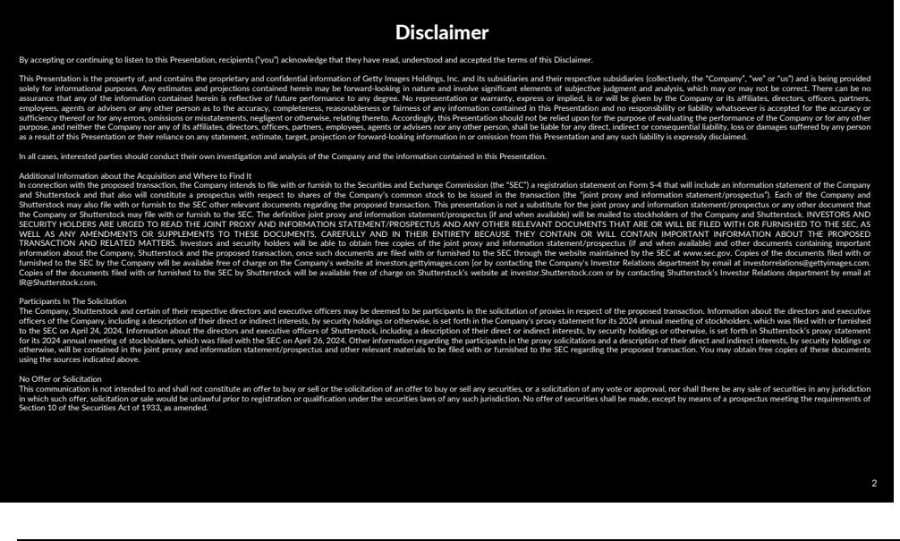

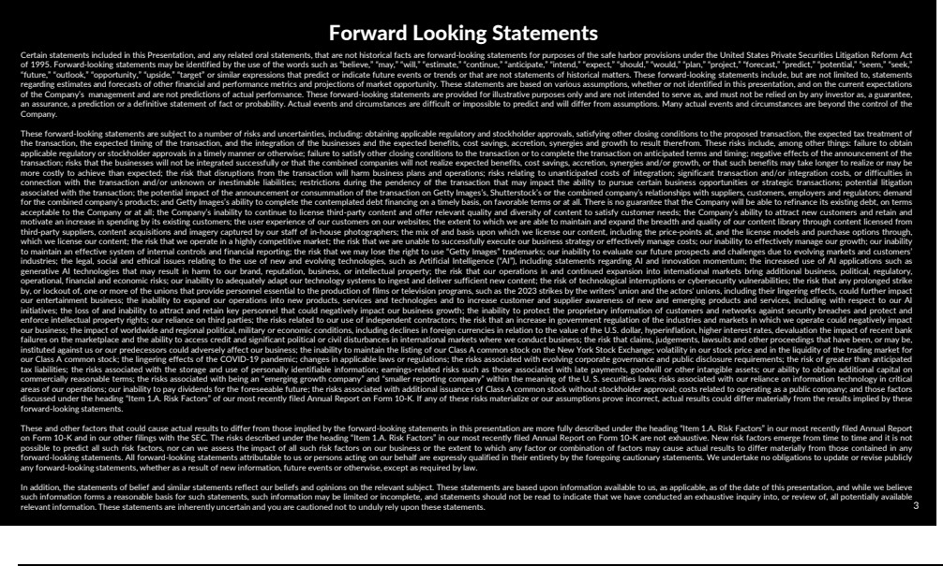

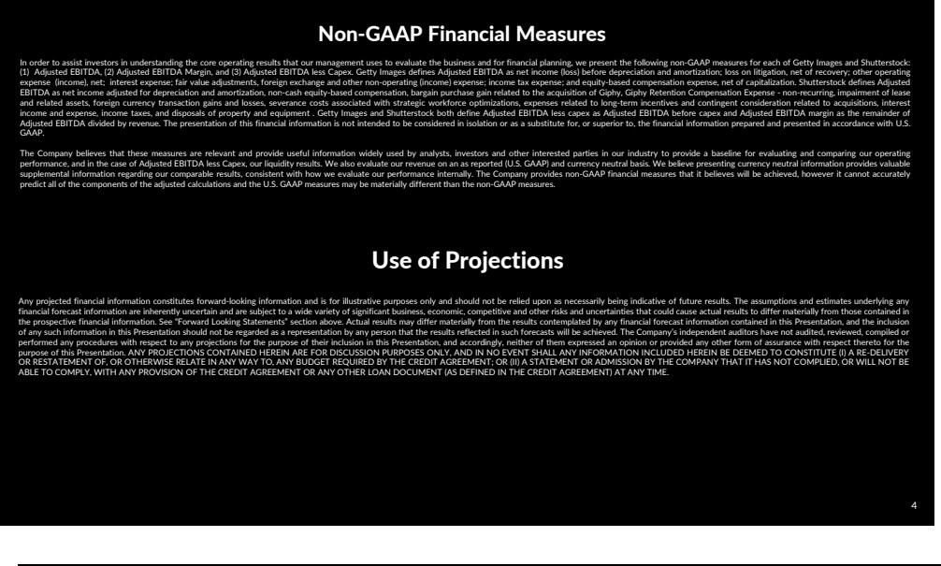

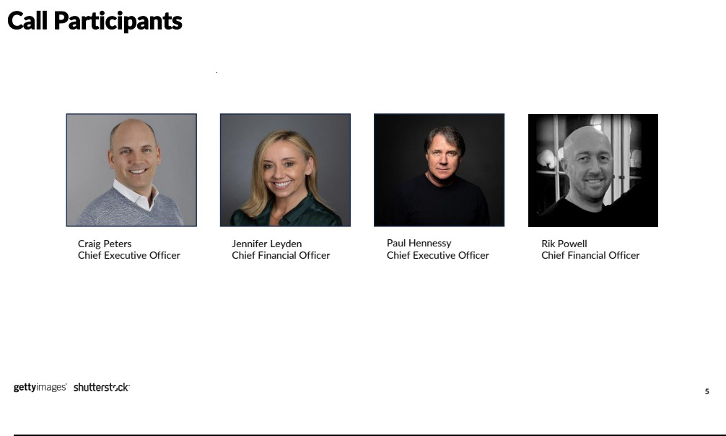

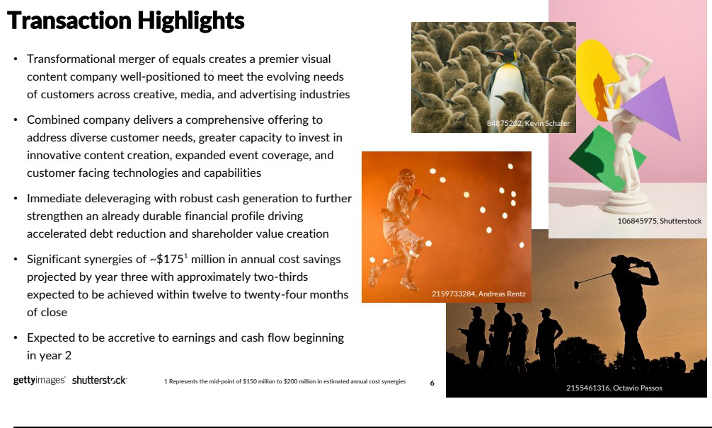

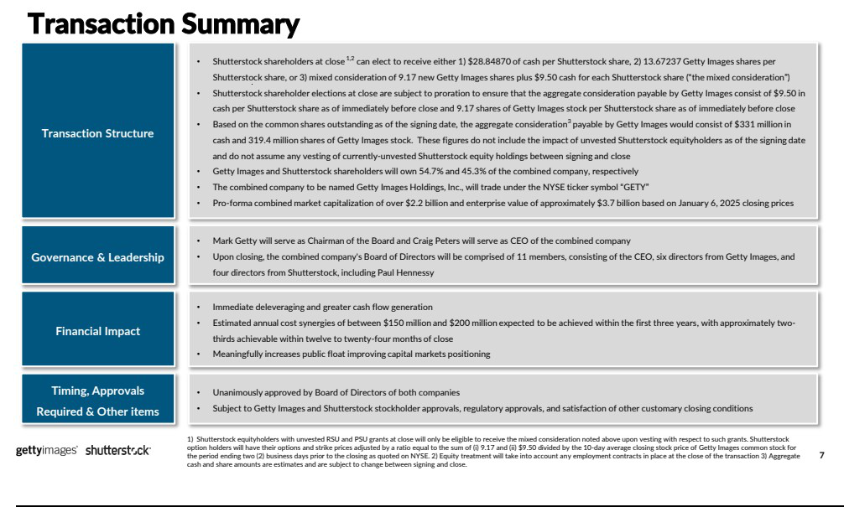

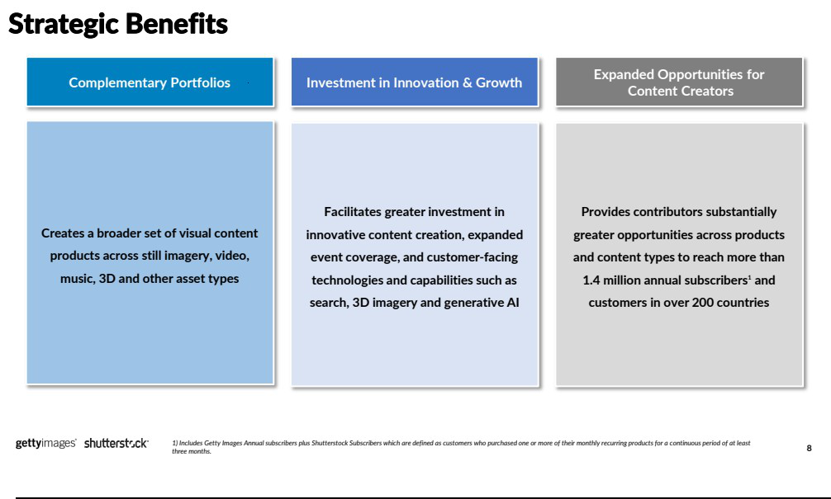

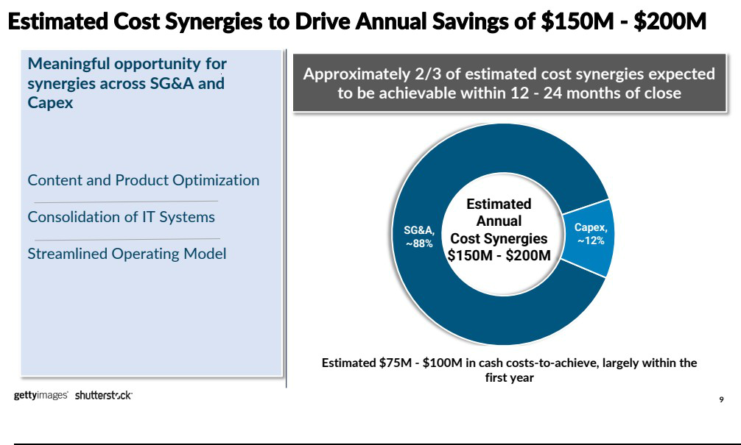

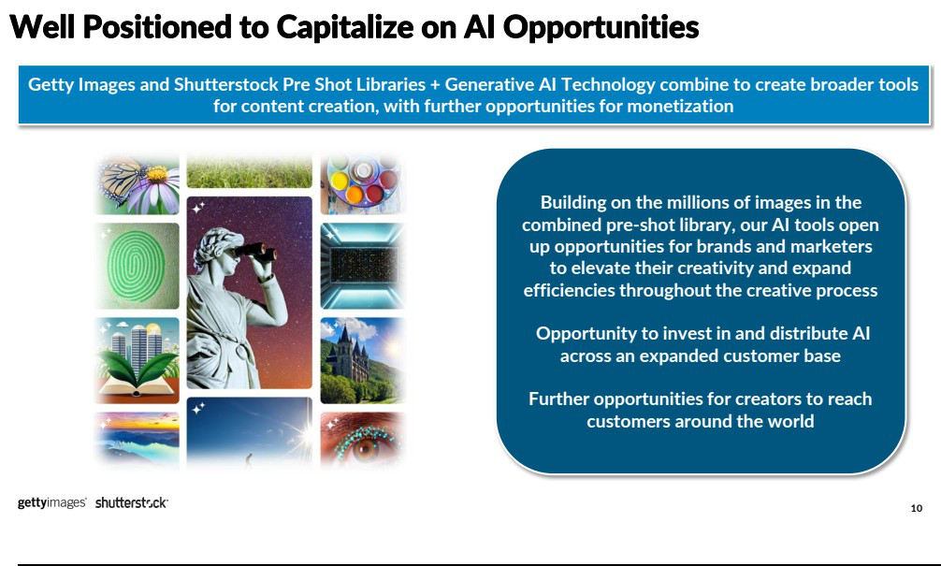

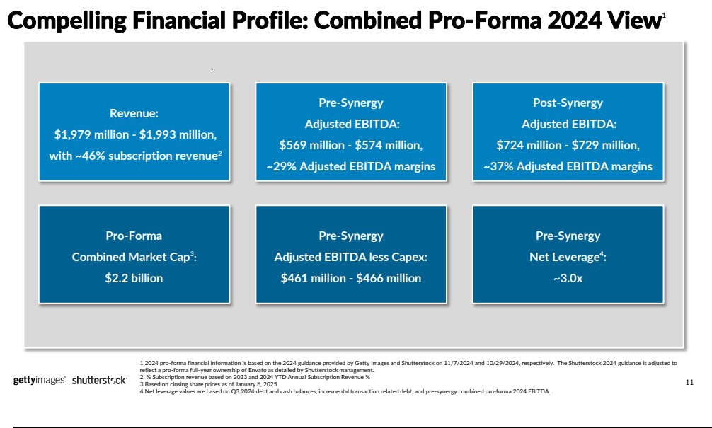

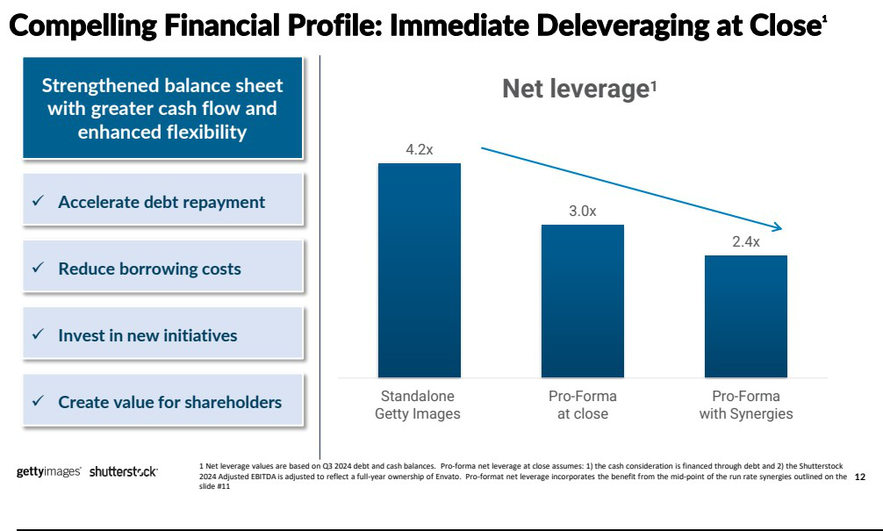

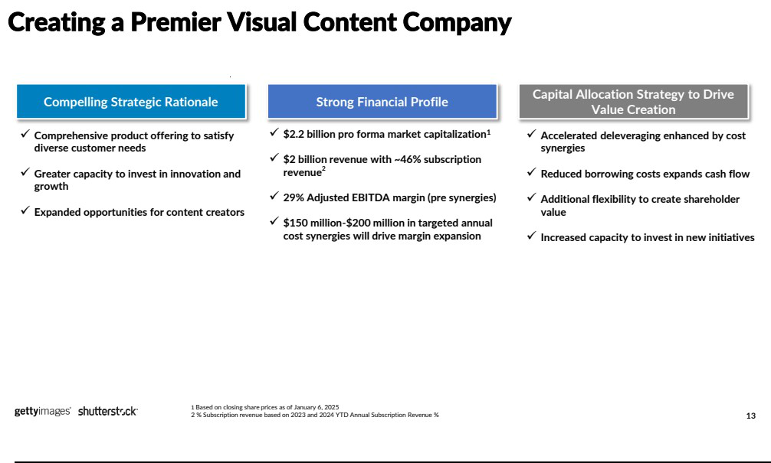



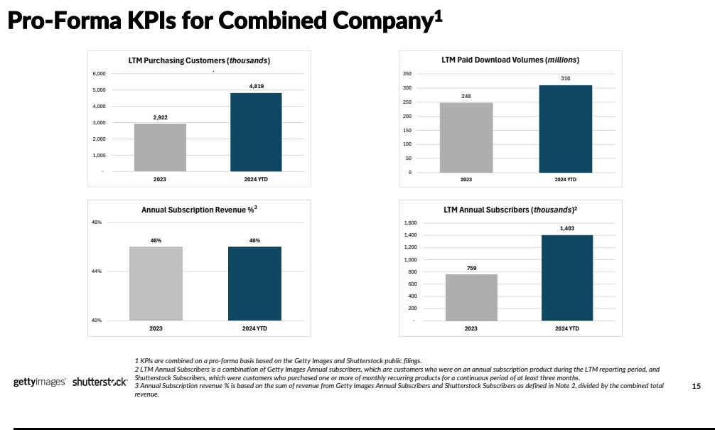

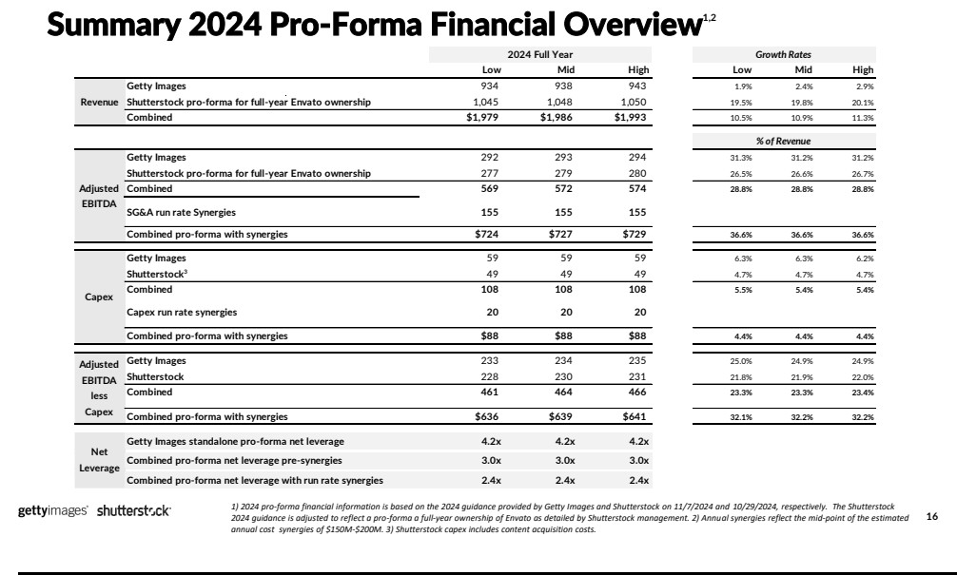

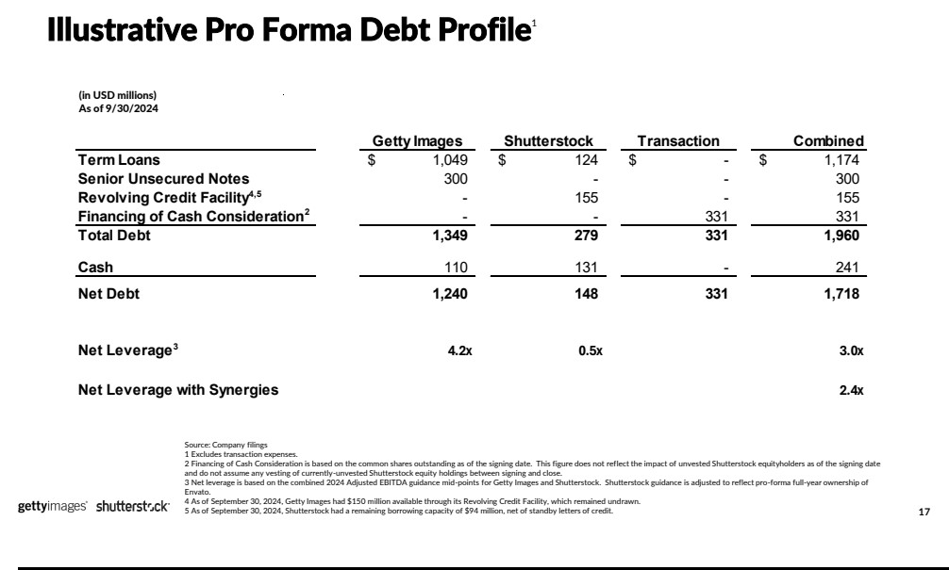



Exhibit 99.2

The following is a transcript of the January 7, 2025 investor call with Getty Images Holdings, Inc. and Shutterstock, Inc.

Company Participants

- Craig Peters, Chief Executive Officer

- Paul Hennessy, Chief Executive Officer

- Steven Kanner, Vice President of Investor Relations and Treasury

Other Participants

- Andrew Boone, Analyst, Citizens

- Bernard McTernan, Analyst, Needham

- Cory Carpenter, Analyst, JPMorgan

- Unidentified Participant, Analyst, Unknown

- Youssef Squali, Analyst, Truist Securities

Presentation

Operator

Good morning. Welcome to the Getty Images and Shutterstock Merger Announcement. Today's call is being recorded. (Operator Instructions)

At this time, I'd like to turn the conference over to Steven Kanner, Vice President of Investor Relations and Treasury at Getty Images. Thank you. You may begin.

Steven Kanner

Thank you for joining our call today to discuss the merger of Getty Images and Shutterstock. The press release and presentation are available on each company's Investor Relations site at investors.gettyimages.com, and investor.shutterstock.com. The press release and presentation have also been filed with the SEC.

Our remarks will include forward-looking statements and refer to non-GAAP financial measures. Actual results could differ materially from those statements. Please see our legal disclosures on Pages 2, 3 and 4 of the presentation referencing forward-looking statements, non-GAAP financial measures, and where to find important additional information regarding the transaction.

I will now hand the call over to Craig Peters, Chief Executive Officer of Getty Images.

Craig Peters

Thank you, Steven. Thank you, to everyone for joining us today. I'm (technical difficulty) Shutterstock's CEO, Paul Hennessy, and CFO, Rick Powell. We're excited to speak to what we believe to be a truly transformational merger that will result in a company with a strong financial foundation and opportunities for superior value creation for customers, creators and our combined shareholder base.

We're thrilled about the potential to partner with the Shutterstock team at a time when Getty Images has been building positive organic performance momentum as evidenced by our third quarter results. And we're confident that together we'll be able to carry that momentum forward with additional financial flexibility to grow in a dynamic digital content market.

We prepared a few slides about the transaction, which I'll walk through, and then open it up to your questions. But before doing so, I'd like to offer my thanks to Paul Hennessy for his partnership in making this happen and turn it over to him to share any thoughts on the transaction from his perspective.

Paul Hennessy

Thanks so much, Craig, and thanks to the teams from both Shutterstock and Getty Images who have worked collaboratively and diligently to get us to this point. At Shutterstock, our purpose is to empower the world to tell their stories by bridging the gap between idea and execution, and this merger only expands our ability to achieve this.

Providing the best and most diverse content has been at the heart of Shutterstock's business since day one. In addition to this philosophy, we have also shown

tremendous agility in evolving our offerings to meet the ever-changing needs of our customers, most recently through the strategic acquisition of the unlimited

subscription-based and volatile [ph] content business and our ongoing investments in our rapidly growing data, distribution, and services business.

This merger unlocks many opportunities for the Shutterstock contributors and

customers through expanded distribution channels and increased availability of new and exclusive content and creates immediate value for shareholders of both

companies. We're excited at the prospect of what the combination of these two great companies can achieve in a world where content is more widely consumed than ever before.

With that, I'll hand back to Craig.

Craig Peters

Thanks, Paul. That's a nice segue to pick up on Slide 6 of the presentation and address the major question on all your minds. Why come together now? As a combined business, simply put, we believe we can offer our media, corporate and agency customers of all sizes and across all regions a comprehensive suite of solutions to meet any of their visual content needs. Given the rapidly evolving landscape, as a combined company we will have far greater resources to continue to

innovate for our customers.

This transaction will immediately increase our financial flexibility. Getty Images has consistently focused on the importance of deleveraging our balance sheet. We've made some great strides over the past several years on this front, and the transaction will deliver our stated goal of leverage below 3x EBITDA and enhance our liquidity to continue to delever evaluate returns to shareholders and invest in opportunities.

The transaction is expected to be highly accretive to the company's earnings and cash flow. We're forecasting between $150 million and $200 million in cost synergies by year 3, with just under two-thirds expected to be delivered within the first 12 to 24 months. In short, for shareholders of both companies, we expect to unlock significant value to reduce leverage levels, cost synergies, operational efficiencies and the pursuit of new revenue opportunities.

Taking a step back, and looking at Slide 7, I'd like to run through some of the transaction details, and there are a few key points we'd like you to take away from this slide. First, this is a mixed offering where Shutterstock shareholders will have the opportunity to receive cash value at close and participate in the equity upside we expect to generate as a combined company. Each Shutterstock shareholder can elect to receive either cash, stock or a combination of cash and stock, up to an aggregate maximum amount of $331 million in cash with no more than 319.4 million shares of Getty Images stock and subject to proration [ph]. Following the close, existing Getty Images shareholders will own approximately 54.7% of the combined company and Shutterstock shareholders will own approximately 45.3%.

I will continue leading the combined company as CEO and Mark Getty will remain as Chairman of our 11-member Board, which will include four directors appointed by Shutterstock, including Paul Hennessy. While it would take some time to obtain the customary regulatory and shareholder approvals, we are hopeful the transaction will close sometime in the second half of 2025.

Moving to Slide 8. Strategically, this merger is a great fit fora number of reasons. Focusing on the top three: one, both companies bring highly complementary strengths to the table. By matching Getty Images premier exclusive content with Shutterstock's strong brands and leadership in categories such as 3D, Music and GIFY, we expect to go to market with a more extensive and diverse set of solutions for customers.

Second, both companies understand the importance of investing for growth and together, we have greater capacity for sustained investment. The combined business will aim to invest in continued innovation, expanding content and coverage and in technologies, inclusive of AI, which I'll touch on in more detail momentarily.

Third and final, we're looking forward to being able to offer content creators who sit at the very heart of what we do expanded reach. Our contributors want and need to get their visuals in front of the right audience and now they'll have many more opportunities to do so. The combined business will have more than 1.4 million annual subscribers, will serve small and medium-sized businesses in addition to large enterprises with a presence in more than 200 countries.

Moving to Slide 9. I already touched on the estimated annual cost synergies of between $150 million and $200 million we believe we have the potential to achieve. But to give you more color, the vast majority of these savings, nearly 90% will be in SG&A, with [ph] the remainder coming in CapEx. Both Getty Images and Shutterstock have a long track record of integrating businesses and realizing synergies we are confident we can deliver these. With that said, while we unify our technology

platform as part of this delivering those synergies, I also want to be very clear that we fully expect Shutterstock to continue as a brand and a website based on the

incredible brand equity built by John, Paul, and the team.

Moving to Slide 10. Paul and I firmly believe Al represents significant opportunities. We've been investing in it and through the merger, we are better poised to capitalize on them. Getty Images continues to see customer adoption grow for our custom fine-tuned, commercially safe generative Al model, and Shutterstock is also starting to see positive traction with its generative-plus [ph] offering. We know customers want to leverage Al as part of their creative process and offering Al services, alongside our combined pre shot and custom solutions will be an incredibly powerful offer.

Given the strategic and financial benefits I spoke to earlier, we are well positioned to continue investing in Al capabilities and distributing those capabilities across a combined customer base. We're going to continue to do so in a responsible way that ensures human creativity continues to flourish, fair use rights are respected and co-creators [ph] are appropriately rewarded for their immense contributions.

Moving to Slide 11. You can double-click on our pro forma financials, and you can see the value creation we're expecting to achieve here. On a pro forma basis, the combined business approaches $2 billion in annual revenue, with nearly half of that from annual subscriptions. At Getty Images, we've been on a journey over the past few years to shift our revenue model towards subscriptions, and it's working. In the third quarter of 2024, we announced our ninth consecutive quarter with annual subscriber growth of approximately 50% or more on an LTM basis. Subscribers are increasingly drawn to our unique and differentiated [ph] content, and we expect this combination to only deepen our customer commitment to our product.

Our combined pro forma adjusted EBITDA is expected to be just over $570 million in 2024 at the midpoint of our respective guidance rates. That translates to a roughly 29% margin and more importantly, these figures do not include any of the estimated $175 million midpoint of our annual run rate cost synergies, and we expect to achieve, again, at the midpoint of that range. Once you factor in those synergies, our adjusted EBITDA increases to $727 million, which translates to an expanded, incredibly strong margin of approximately 37%. Unlevered pretax free cash flow or EBITDA-less CapEx is a similar story, where even before accounting for synergies, we expect

approximately $464 million in 2024.

Slide 12. As I mentioned earlier, one of the key benefits of this transaction is that it facilitates immediate deleveraging. It will put us squarely within our stated target of net leverage between 2.5x and 3x EBITDA. On a standalone basis, as of September 30, 2024, we were just over 4x leverage. Upon closing, we expect to reach below -marks below 3x on a combined pro forma basis. And again, when considering synergies and liquidity expansion, we are confident we can continue to delever this business further.

As a combined business with stronger balance sheet and cash flows, we expect to have much greater capital allocation flexibility. We'd be able to further expedite debt repayment to reduce our borrowing costs, have greater capacity to invest in growth initiatives, and of course remain opportunistic in exploring other ways we can potentially create value for shareholders.

Before I wrap up, I'd like to hand it back to Paul for his closing remarks.

Paul Hennessy

Thanks, Craig. We truly believe that the combination of Getty Images and Shutterstock is great news for the industry. The resulting depth and breadth of content, as well as our complementary offerings, will ensure that the combined entities are ideally positioned to serve all our stakeholders for years to come, and we look forward to working with Getty Images team to build a transformative combined business.

Craig Peters

Thanks, Paul. So we'll take your questions here in a bit. But to close, we're confident this major milestone for both our companies will establish a stronger business to the benefit of our combined customers, contributors, shareholders and employees. We expect to have a very attractive financial profile, with nearly $2 billion in revenue, strong EBITDA margins even before considering the approximately $175 million in estimated annual run rate synergies, and incredibly robust cash flow. With a stronger financial foundation, we'll have enhanced capital flexibility to further invest in growth and create value for shareholders.

We'll now turn this back to the operator to take your questions. Thank you.

Questions And Answers

Operator

(Operator Instructions) We'll take our first question from Bernie McTernan with Needham.

Q - Bernard McTernan

Great. I had two. First, just wanted to ask about data licensing deals. I believe both companies have broad set or at least some data licensing deals. Are there any top line synergies just from flowing through each other's content through those existing relationships? Is there a way to think about it?

Then secondly, tangentially [ph] also on Gen AI, there's a big debate in the industry in terms of just the competitive threat from Gen Al more broadly against stock image companies or stock content companies. How will the larger combined company better compete against those competitors and just competition more broadly as well?

A - Craig Peters

Thanks, Bernie. I'll take this and then Paul can add in over the top. On the data licensing side of things, both companies have done some level of data licensing. We expect that that'll continue post-close, but I wouldn't read into it any top line synergies on that basis. Again, we're really from a transactional standpoint, this is really more about the operational and cost synergies.

On the Gen Al front, both Paul and I have talked to this in prior calls, our businesses have not seen any impact as a result of Gen Al. We think our preshot offering and our custom offerings stand on the merits of its own value. We think when you combine that with AI, there is upside on the Al front, not downside.

So Paul, I don't know if you want to add anything there?

A - Paul Hennessy

I think -- I think you've covered that, Craig. We see increased usage in our stock content from our Al customers, and we're seeing new customers coming into the franchise for our Al product. So we think there's a one plus one equaling three on that front.

Q - Bernard McTernan

Congrats on getting the deal done.

Operator

(Operator Instructions) We'll go next to Youssef Squali with Truist Securities.

Q - Youssef Squali

All right. Yes, congrats on the deal, it makes a lot of sense to us. Maybe can you talk about the valuation basically on what basis get to the 55-45 split for Shutterstock to shareholders; in particular, what was kind of the logic of that 28-84 share offer for stock that closed up [ph] (inaudible) and then second, can you talk about the regulatory approval process in the U.S. and Europe as well? And just your level of confidence that the deal will go through?

A - Craig Peters

Thank you, Youssef. Appreciate the sign of confidence on the transaction. With respect to the valuation, look, it's one that obviously is highly negotiated. But we believe that we arrived at a fair place based off the respective equity valuations and enterprise valuations of these businesses on a 30-, 60-, 90-day VF [ph]. And so we believe it's a fair deal that is fair to both sides in terms of shareholders and stakeholders. So that's really how we wound up where we wound up.

With respect to the regulatory front, clearly, we have processes that we go through, but this is -- we are in a large visual content market. Customers have so many opportunities to produce their own content or to source that content freely across a wide variety of services. And certainly Al now being one of those. So we're pretty confident that ultimately this transaction will get approval. Again, we don't control the exact timing of that, but we have a high confidence. This has never been a situation where customers have not had choice. They've always had choice. We believe we're an excellent choice. We'd like to be their choice more often than not. But there are a lot of options for customers in the market, and that's only expanding. So I appreciate the question and the support.

Operator

Our next question will come from Cory Carpenter with JPMorgan.

Q - Cory Carpenter

had two as well. First, understanding you're not committing to specific revenue synergies, but maybe you could paint the picture just around the potential

opportunities on cross-selling over time. Then secondly, you mentioned a few times being able to invest more as a combined company. What are the priorities on the investment side where you feel like maybe you've been constrained before that you'll now be able to invest more in?

A - Craig Peters

Thanks, Cory. So let me -- I mean on the crossing [ph] -- one of the things that the Shutterstock team has done is they've built really a great combination of assets across a variety of asset types. So whether that's GIFY or whether that's 3D assets through TurboSquid, or whether that's Music through Premium Beat, those are things that Getty Images has not brought to the table historically. And so we do see opportunities to bring those to market across an expanded customer base. So certainly we do see those types of opportunities. It's going to take us a bit to get there. We're really pleased that Envato was now part of the Shutterstock portfolio. They fit very well with our subscription strategy, and they bring a wide range of assets to the table. So those will be things that we work through, and certainly we expect those to produce opportunities for the business over the long haul.

Paul, I don't know if you want to add anything or?

A - Paul Hennessy

Craig, I think you answered it well. In an ecommerce world, we've got a diverse set of customers that are looking for unique and specific things. When you combine the assets of the two companies, conversion goes north. So this is just a great

opportunity for our -- both our customers and our contributors. I think that just

naturally leads to revenue opportunities.

A - Craig Peters

And Cory, I think you had a second part of your question, if you could just repeat that for me, that - I'd appreciate it.

Q - Cory Carpenter

So you mentioned a lot about this deal allowing you to invest more as a combined company. Just maybe if you could just go over what your priorities are on the investment side where perhaps you were constrained before but now you'll be more free to pursue?

A - Craig Peters

I think without getting into too much detail for competitive reason, I mean there are so many technology opportunities presenting themselves across whether that's search or whether that's how we service our customers or whether that's how we embrace generative Al. The companies have been investing in that. But clearly, we can reduce the duplication of investment, and that's going to allow us to accelerate delivery of what we've already collectively been investing in. Both companies again are making significant investments in surge [ph] in delivery and whole variety of items, but what we're going to be able to do is do that with a combined resource base. So it's really acceleration.

Now we'll also have opportunities to look at M&A. It's not that -- the companies haven't been looking at opportunities. And clearly, the Shutterstock team has been more active than not. And we've been more focused in on debt pay down, but those will be opportunities we can also look at as well.

Operator

Our next question will come from Andrew Boone with Citizens.

Q - Andrew Boone

Editorial was a strength of the Getty platform. Can you guys just talk about the opportunity in terms of combining that asset with Shutterstock and what you guys can do and bring with greater scale [ph]? Then secondly, capital allocation significantly different between the two companies, right? Shutterstock has been returning capital with the dividend. How do we think about that aspect as Getty does delever? And how do you guys think about capital allocation the balance sheet moves towards (inaudible)?

A - Craig Peters

Thank you, Andrew. I think I've got your question. So look, we are incredibly proud of our editorial business at Getty Images. It is an amazing business. It has amazing assets. It represents an amazing archive. There are going to be opportunities that present themselves around how we can leverage that capability across the

Shutterstock customer base and platform, but ultimately to say it's just -- it continues to be a very important part of our overall business and a very important part of why customers choose Getty Images, and we deliver a lot of value back to our customers through that service.

With respect to capital allocation, I think it's a bit early, but clearly this gives us opportunities to evaluate potential, whether that's stock buyback or dividends, as we continue to delever. So those will be things that we'll be able to make those

decisions as we close and move forward.

Paul, I don't know if you want to speak to anything in the interim or?

A - Paul Hennessy

Nothing more to add.

Operator

Our next question will come from Tim Nollen with Macquarie [ph].

Q - Unidentified Participant

Can I ask the revenue synergy question other way around [ph]? Can you talk a bit as to how much overlap there may be between your business, given you've been competing on in terms of content base, in terms of customers? How much is there overlap versus how much is their complementarity between the two?

A - Craig Peters

Thanks, Tim. I've said this from -- in many, many conversations and in many times, these businesses are much more complementary than people ever think or give credit to. We at Getty Images have a very different business and a very different composition. It's a business that's built on exclusive content. It's a business that is oriented through our primary brand at Getty Images towards the enterprise. The Shutterstock businesses have a broader reach across small and midsized businesses, a different geographic reach, as we referenced in some of our calls prior. So these are highly complementary businesses. We don't go into most of our sales engagements and find that we've got shutter stock on the competitive side or vice versa. This is -- these are very complementary assets, and I expect that we'll be able to leverage that complementary in nature in order to drive to new revenue

opportunities.

Paul?

A - Paul Hennessy

Yes. I'd echo that. It's complementary on people, it's complementary on distribution channels, it's complementary on asset types, complementary on platform types. I think there is real opportunities for revenue growth because the businesses are different.

Q - Unidentified Participant

And if I can I add a follow-up, which is kind of related, which is about the Gen Al opportunity. I know, Craig, you been very vocal about this and done a lot of work establishing efforts there. Just wondering how much you can combine those efforts and what that would entail?

A - Craig Peters

Look, our efforts have been very similar, very complementary, right? We've both been investing in order [ph] producing generative Al that is respectful of creators, that is commercially safe, and combining that with the power of our pre shot libraries and our asset capabilities. I think that will just continue going forward. But again, we'll be able to reduce the duplication of that effort. So we're excited for that. We should see acceleration in terms of delivery as a result of it [ph].

Operator

Thank you. At this time it appears there are no further questions in queue. I would like to turn the call back to Craig Peters for any additional or closing remarks.

A - Craig Peters

Well I just really want to thank Paul and the Shutterstock team for all the work that went into this. We're excited about this opportunity and the value that we can unlock across all stakeholder -- stakeholders. And I appreciate your time early in this

morning. Thank you.

Operator

Thank you. This does conclude today's Getty Images and Shutterstock merger announcement call. You may disconnect your line at this time. And have a wonderful day. Thanks.

Additional Information about the Acquisition and Where to Find It

In connection with the proposed transaction, Getty Images intends to file with the Securities and Exchange Commission (the “SEC”) a registration statement on Form S-4 that will include an information statement of Getty Images and a proxy statement of Shutterstock and that also will constitute a prospectus with respect to shares of Getty Images’ common stock to be issued in the transactions (the “joint proxy and information statement/prospectus”). Each of Getty Images and Shutterstock may also file with or furnish to the SEC other relevant documents regarding the proposed transaction. This communication is not a substitute for the joint proxy and information statement/prospectus or any other document that Getty Images or Shutterstock may file with or furnish to the SEC. The definitive joint proxy and information statement/prospectus (if and when available) will be mailed to stockholders of Getty Images and Shutterstock. BEFORE MAKING ANY VOTING OR INVESTMENT DECISION, INVESTORS AND SECURITY HOLDERS ARE URGED TO READ THE JOINT PROXY AND INFORMATION STATEMENT/PROSPECTUS (WHEN AVAILABLE) AND ALL OTHER RELEVANT DOCUMENTS THAT ARE OR WILL BE FILED WITH OR FURNISHED TO THE SEC, AS WELL AS ANY AMENDMENTS OR SUPPLEMENTS TO THESE DOCUMENTS, CAREFULLY AND IN THEIR ENTIRETY BECAUSE THEY CONTAIN OR WILL CONTAIN IMPORTANT INFORMATION ABOUT THE PROPOSED TRANSACTION AND RELATED MATTERS. Investors and security holders will be able to obtain free copies of the joint proxy and information statement/prospectus (if and when available) and other documents containing important information about Getty Images, Shutterstock and the proposed transaction, once such documents are filed with or furnished to the SEC through the website maintained by the SEC at www.sec.gov. Copies of the documents filed with or furnished to the SEC by Getty Images will be available free of charge on Getty Images’ website at investors.gettyimages.com or by contacting Getty Images’ Investor Relations department by email at investorrelations@gettyimages.com. Copies of the documents filed with or furnished to the SEC by Shutterstock will be available free of charge on Shutterstock’s website at investor. shutterstock.com or by contacting Shutterstock’s Investor Relations department by email at IR@Shutterstock.com.

Participants in the Solicitation

This communication is not a solicitation of proxies in connection with the proposed transaction. Getty Images, Shutterstock and certain of their respective directors and executive officers and other members of their respective management and employees may be deemed to be participants in the solicitation of proxies in respect of the proposed transaction. Information about the directors and executive officers of Getty Images, including a description of their direct or indirect interests, by security holdings or otherwise, is set forth in Getty Images’ proxy statement for its 2024 annual meeting of stockholders, which was filed with or furnished to the SEC on April 24, 2024. Information about the directors and executive officers of Shutterstock, including a description of their direct or indirect interests, by security holdings or otherwise, is set forth in Shutterstock’s proxy statement for its 2024 annual meeting of stockholders, which was filed with the SEC on April 26, 2024. Other information regarding the participants in the proxy solicitations and a description of their direct and indirect interests, by security holdings or otherwise, will be contained in the joint proxy and information statement/prospectus and other relevant materials to be filed with or furnished to the SEC regarding the proposed transaction. You may obtain free copies of these documents using the sources indicated above.

No Offer or Solicitation

This communication is not intended to and shall not constitute an offer to buy or sell or the solicitation of an offer to buy or sell any securities, or a solicitation of any vote or approval, nor shall there be any sale of securities in any jurisdiction in which such offer, solicitation or sale would be unlawful prior to registration or qualification under the securities laws of any such jurisdiction. No offer of securities shall be made, except by means of a prospectus meeting the requirements of Section 10 of the Securities Act of 1933, as amended.

Forward-Looking Statements

The statements in this communication, and any related oral statements, include forward-looking statements concerning Getty Images, Shutterstock, the proposed transaction described herein and other matters. All statements, other than historical facts, are forward-looking statements. Forward-looking statements may discuss goals, intentions and expectations as to future plans, trends, events, results of operations or financial condition, financings or otherwise, based on current beliefs and involve numerous risks and uncertainties that could cause actual results to differ materially from expectations. Forward-looking statements speak only as of the date they are made or as of the dates indicated in the statements and should not be relied upon as predictions of future events, as there can be no assurance that the events or circumstances reflected in these statements will be achieved or will occur or the timing thereof. Forward-looking statements can often, but not always, be identified by the use of forward-looking terminology including “believes,” “expects,” “may,” “will,” “should,” “could,” “might,” “seeks,” “intends,” “plans,” “pro forma,” “estimates,” “anticipates,” “designed,” or the negative of these words and phrases, other variations of these words and phrases or comparable terminology, but not all forward-looking statements include such identifying words. Forward-looking statements are based upon current plans, estimates and expectations that are subject to risks, uncertainties and assumptions. Should one or more of these risks or uncertainties materialize, or should underlying assumptions prove incorrect, actual results may vary. The forward-looking statements in this communication relate to, among other things, obtaining applicable regulatory and stockholder approvals on a timely basis or otherwise, satisfying other closing conditions to the proposed transaction, on a timely basis or otherwise, the expected tax treatment of the transaction, the expected timing of the transaction, and the integration of the businesses and the expected benefits, cost savings, accretion, synergies and growth to result therefrom. Important factors that could cause actual results to differ materially from such forward-looking statements include, among other things: failure to obtain applicable regulatory or stockholder approvals in a timely manner or otherwise; interloper risk; failure to satisfy other closing conditions to the transaction or to complete the transaction on anticipated terms and timing (or at all); negative effects of the announcement of the transaction on the ability of Shutterstock or Getty Images to retain and hire key personnel and maintain relationships with customers, suppliers and others who Shutterstock or Getty Images does business, or on Shutterstock or Getty Images’ operating results and business generally; risks that the businesses will not be integrated successfully or that the combined company will not realize expected benefits, cost savings, accretion, synergies and/or growth, as expected (or at all), or that such benefits may take longer to realize or may be more costly to achieve than expected; the risk that disruptions from the transaction will harm business plans and operations; risks relating to unanticipated costs of integration; significant transaction and/or integration costs, or difficulties in connection with the transaction and/or unknown or inestimable liabilities; restrictions during the pendency of the transaction that may impact the ability to pursue certain business opportunities or strategic transactions; potential litigation associated with the transaction; the potential impact of the announcement or consummation of the transaction on Getty Images’, Shutterstock’s or the combined company’s relationships with suppliers, customers, employers and regulators; demand for the combined company’s products; potential changes in the Getty Images stock price that could negatively impact the value of the consideration offered to the Shutterstock stockholders; the occurrence of any event that could give rise to the termination of the proposed transaction; and Getty Images’ ability to complete any refinancing of its debt or new debt financing on a timely basis, on favorable terms or at all. A more fulsome discussion of the risks related to the proposed transaction will be included in the joint proxy and information statement/prospectus. For a discussion of factors that could cause actual results to differ materially from those contemplated by forward-looking statements, see the section captioned “Risk Factors” in each of Getty Images’ and Shutterstock’s Annual Report on Form 10-K for the fiscal year ended December 31, 2023, subsequent Quarterly Reports on Form 10-Q and other filings with the SEC. Should one or more of these risks or uncertainties materialize, or should underlying assumptions prove incorrect, actual results may vary materially from those indicated or anticipated by such forward looking statements. While the list of factors presented here is, and the list of factors presented in the joint proxy and information statement/prospectus will be, considered representative, no such list should be considered to be a complete statement of all potential risks and uncertainties. Unlisted factors may present significant additional obstacles to the realization of forward looking statements. Neither Getty Images nor Shutterstock assumes, and each hereby disclaims, any obligation to update forward-looking statements, except as may be required by law.

Exhibit 99.3

Q&A – reactive only

Why are you merging with Shutterstock?

By combining the complementary strengths of both companies, we will be better positioned to address evolving customer needs and provide tremendous value across industries. The combined company will have greater capacity to invest in innovative content creation, expanded event coverage and cutting-edge customer-facing technologies and capabilities such as search and emerging formats like 3D and generative AI.

Why now? Were there financial pressures driving this decision?

The timing reflects market opportunities and the potential for long-term growth. This is a proactive step to position ourselves as a leader in the industry and meet the growing demand for our offerings. At the same time, we have discussed many times that our debt levels remain too high, and this transaction is expected to immediately help address that and strengthen our financial profile.

Isn’t this merger just an attempt to stabilize a business that’s been struggling since going public via a SPAC?

Not at all. Going public was an important step for our company. Merging with Shutterstock will allow us to take the next step towards achieving our long-term growth potential, while further strengthening our balance sheet, expanding our publicly traded float, and allowing the company to better manage market risks and capitalize on opportunities.

Isn’t this merger just a way to prop up the weaker Getty Images’ struggling stock?

We are entering this transaction because we believe it is in the best long-term interests of all Getty Images stakeholders as it allows the company to further reduce our debt below target range and to better manage to market risks and opportunities. The transaction also expands the float in our stock which should allow for more balanced trading.

Why would you acquire a company with declining revenue?

Shutterstock has built a significant business serving a broad base of customers across an array of brands, and as one company we will meaningfully expand our presence with smaller and mid-market customers. We believe there are opportunities to improve Shutterstock performance as we have done with our own brands and there is significant synergy potential between the companies.

Why would you acquire a company with less of an emphasis on premium content? Won’t this just dilute the quality of your library?

Shutterstock has built a significant business that is highly complementary to our own by serving a broad base of customers across an array of brands with a more meaningful presence in certain geographic markets, across small and medium businesses and in certain content categories like 3D and music. We expect to keep the Shutterstock brands positioned as they are today, and Shutterstock has proven there is demand for these offerings at this positioning. We also expect to maintain the target positioning of our brands.

Is this because of the impact of AI on your businesses?

Merging with Shutterstock strengthens our financial profile, providing greater resources to weather market risks and to invest in opportunities, inclusive of AI. We also continue to see upside in offering AI services alongside our pre-shot and custom offerings.

How can you integrate when Shutterstock has such differing views on AI and data licensing?

Unlike Shutterstock, our business is largely based on exclusive content and partners. As a result, we have not pursued licenses to the same degree; however, we have licensed nonexclusive content, and we believe the combination will be even more compelling to entities looking to train models with permissioned content.

It is important to recognize, however, that we already have much in common in this area. And while we have been more active in our views on responsible AI; we do not think we hold different positions. While we have taken different approaches to licensing AI content and the acceptance of AI content on our platforms, we will have a dedicated workstream focus on optimizing those approaches as part of the integration planning.

Is this merger just about cutting costs and layoffs?

We see significant synergies between the businesses and, while this will result in cost cuts, we still have a long period to undergo thoughtful integration planning before we close. With that said, we see this combination just as much about the opportunity to capitalize on exciting growth opportunities ahead and to further strengthen our financial profile.

Does this signal that one or both companies were failing?

Not at all, this is about the benefits of bringing two companies together.

Will this merger hurt competition in the industry?

Absolutely not. The combined company will still be a small part of the highly fragmented and competitive market for imagery. There are many other companies across the pre-shot creative and editorial landscape, including free, but there are also platforms to crowdsource imagery, hire freelance production, engage agencies, source via social media, access via software platforms, go direct to photographers and now a broad range of generative AI. We do not see this impacting customer choice in any shape or form.

Do you anticipate any regulatory hurdles?

The transaction is subject to customary regulatory review, but it’s important to recognize the combined company will still be a small part of the highly fragmented and competitive market for imagery. There are many other companies across the pre-shot creative and editorial landscape, including free, but there are also platforms to crowdsource imagery, hire freelance production, engage agencies, source via social media, access via software platforms, go direct to photographers and now a broad range of generative AI. We do not see this impacting customer choice and, to the contrary, we believe it will benefit all of our stakeholders, including by providing expanded reach for contributors.

Is this merger a sign that your business model isn’t working?

We have established a high-quality recurring revenue model that is increasingly focused on subscriptions. We believe our model provides a time and cost-efficient basis for customers to access imagery absent legal risk. This is proven by our customer acquisition and retention. We have no plans to change our business model in connection with this transaction.

How many jobs will be lost as a result of this merger?

As we continue to operate as stand-alone companies until we receive the required approvals, we cannot speak to specifics, but we do see opportunities to operate more efficiently. This creates a more durable company and the additional resources to apply to new opportunities where we see them.

What happens if this merger fails?

We will continue to stay focused on our Formula for Sustained Success and our Principles which have served us well.

What’s your plan to compete with other major players in the industry?

We do not expect major shifts in how the respective brands are positioned or compete in the market, although we do believe the merger will benefit all of our stakeholders, including customers, through enhanced innovation and improved offerings.

What’s your plan to address your debt levels if this transaction does not get approved?

We have made great strides in reducing our leverage, including by becoming a publicly traded company a few years ago. We also have very supportive large shareholders in Getty Images and Koch Equity Development. We are entering a process to refinance our existing stand-alone debt. We continue to paydown debt with our free cash flow and we can evaluate a range of other options to accelerate debt paydown, including a potential equity offering.

Additional Information about the Acquisition and Where to Find It

In connection with the proposed transaction, Getty Images intends to file with the Securities and Exchange Commission (the “SEC”) a registration statement on Form S-4 that will include an information statement of Getty Images and a proxy statement of Shutterstock and that also will constitute a prospectus with respect to shares of Getty Images’ common stock to be issued in the transaction (the “joint proxy and information statement/prospectus”). Each of Getty Images and Shutterstock may also file with or furnish to the SEC other relevant documents regarding the proposed transaction. This press release is not a substitute for the joint proxy and information statement/prospectus or any other document that Getty Images or Shutterstock may file with or furnish to the SEC. The joint proxy and information statement/prospectus (if and when available) will be mailed to stockholders of Getty Images and Shutterstock. BEFORE MAKING ANY VOTING OR INVESTMENT DECISION, INVESTORS AND SECURITY HOLDERS ARE URGED TO READ THE JOINT PROXY AND INFORMATION STATEMENT/PROSPECTUS (WHEN AVAILABLE) AND ALL OTHER RELEVANT DOCUMENTS THAT ARE OR WILL BE FILED WITH OR FURNISHED TO THE SEC, AS WELL AS ANY AMENDMENTS OR SUPPLEMENTS TO THESE DOCUMENTS, CAREFULLY AND IN THEIR ENTIRETY BECAUSE THEY CONTAIN OR WILL CONTAIN IMPORTANT INFORMATION ABOUT THE PROPOSED TRANSACTION AND RELATED MATTERS. Investors and security holders will be able to obtain free copies of the joint proxy and information statement/prospectus (if and when available) and other documents containing important information about Getty Images, Shutterstock and the proposed transaction, once such documents are filed with or furnished to the SEC through the website maintained by the SEC at www.sec.gov. Copies of the documents filed with or furnished to the SEC by Getty Images will be available free of charge on Getty Images’ website at investors.gettyimages.com or by contacting Getty Images’ Investor Relations department by email at investorrelations@gettyimages.com. Copies of the documents filed with or furnished to the SEC by Shutterstock will be available free of charge on Shutterstock’s website at investor. shutterstock.com or by contacting Shutterstock’s Investor Relations department by email at IR@Shutterstock.com.

Participants in the Solicitation

This communication is not a solicitation of proxies in connection with the proposed transaction. Getty Images, Shutterstock and certain of their respective directors and executive officers and other members of their respective management and employees may be deemed to be participants in the solicitation of proxies in respect of the proposed transaction. Information about the directors and executive officers of Getty Images, including a description of their direct or indirect interests, by security holdings or otherwise, is set forth in Getty Images’ proxy statement for its 2024 annual meeting of stockholders, which was filed with or furnished to the SEC on April 24, 2024. Information about the directors and executive officers of Shutterstock, including a description of their direct or indirect interests, by security holdings or otherwise, is set forth in Shutterstock’s proxy statement for its 2024 annual meeting of stockholders, which was filed with the SEC on April 26, 2024. Other information regarding the participants in the proxy solicitations and a description of their direct and indirect interests, by security holdings or otherwise, will be contained in the joint proxy and information statement/prospectus and other relevant materials to be filed with or furnished to the SEC regarding the proposed transaction. You may obtain free copies of these documents using the sources indicated above.

No Offer or Solicitation

This communication is not intended to and shall not constitute an offer to buy or sell or the solicitation of an offer to buy or sell any securities, or a solicitation of any vote or approval, nor shall there be any sale of securities in any jurisdiction in which such offer, solicitation or sale would be unlawful prior to registration or qualification under the securities laws of any such jurisdiction. No offer of securities shall be made, except by means of a prospectus meeting the requirements of Section 10 of the Securities Act of 1933, as amended.

Forward-Looking Statements

The statements in this communication, and any related oral statements, include forward-looking statements concerning Getty Images, Shutterstock, the proposed transaction described herein and other matters. All statements, other than historical facts, are forward-looking statements. Forward-looking statements may discuss goals, intentions and expectations as to future plans, trends, events, results of operations or financial condition, financings or otherwise, based on current beliefs and involve numerous risks and uncertainties that could cause actual results to differ materially from expectations. Forward-looking statements speak only as of the date they are made or as of the dates indicated in the statements and should not be relied upon as predictions of future events, as there can be no assurance that the events or circumstances reflected in these statements will be achieved or will occur or the timing thereof. Forward-looking statements can often, but not always, be identified by the use of forward-looking terminology including “believes,” “expects,” “may,” “will,” “should,” “could,” “might,” “seeks,” “intends,” “plans,” “pro forma,” “estimates,” “anticipates,” “designed,” or the negative of these words and phrases, other variations of these words and phrases or comparable terminology, but not all forward-looking statements include such identifying words. Forward-looking statements are based upon current plans, estimates and expectations that are subject to risks, uncertainties and assumptions. Should one or more of these risks or uncertainties materialize, or should underlying assumptions prove incorrect, actual results may vary. The forward-looking statements in this communication relate to, among other things, obtaining applicable regulatory and stockholder approvals on a timely basis or otherwise, satisfying other closing conditions to the proposed transaction, on a timely basis or otherwise, the expected tax treatment of the transaction, the expected timing of the transaction, and the integration of the businesses and the expected benefits, cost savings, accretion, synergies and growth to result therefrom. Important factors that could cause actual results to differ materially from such forward-looking statements include, among other things: failure to obtain applicable regulatory or stockholder approvals in a timely manner or otherwise; interloper risk; failure to satisfy other closing conditions to the transaction or to complete the transaction on anticipated terms and timing (or at all); negative effects of the announcement of the transaction on the ability of Shutterstock or Getty Images to retain and hire key personnel and maintain relationships with customers, suppliers and others who Shutterstock or Getty Images does business, or on Shutterstock or Getty Images’ operating results and business generally; risks that the businesses will not be integrated successfully or that the combined company will not realize expected benefits, cost savings, accretion, synergies and/or growth, as expected (or at all), or that such benefits may take longer to realize or may be more costly to achieve than expected; the risk that disruptions from the transaction will harm business plans and operations; risks relating to unanticipated costs of integration; significant transaction and/or integration costs, or difficulties in connection with the transaction and/or unknown or inestimable liabilities; restrictions during the pendency of the transaction that may impact the ability to pursue certain business opportunities or strategic transactions; potential litigation associated with the transaction; the potential impact of the announcement or consummation of the transaction on Getty Images’, Shutterstock’s or the combined company’s relationships with suppliers, customers, employers and regulators; demand for the combined company’s products; potential changes in the Getty Images stock price that could negatively impact the value of the consideration offered to the Shutterstock stockholders; the occurrence of any event that could give rise to the termination of the proposed transaction; and Getty Images’ ability to complete any refinancing of its debt or new debt financing on a timely basis, on favorable terms or at all. A more fulsome discussion of the risks related to the proposed transaction will be included in the joint proxy and information statement/prospectus. For a discussion of factors that could cause actual results to differ materially from those contemplated by forward-looking statements, see the section captioned “Risk Factors” in each of Getty Images’ and Shutterstock’s Annual Report on Form 10-K for the fiscal year ended December 31, 2023, subsequent Quarterly Reports on Form 10-Q and other filings with the SEC. Should one or more of these risks or uncertainties materialize, or should underlying assumptions prove incorrect, actual results may vary materially from those indicated or anticipated by such forward looking statements. While the list of factors presented here is, and the list of factors presented in the joint proxy and information statement/prospectus will be, considered representative, no such list should be considered to be a complete statement of all potential risks and uncertainties. Unlisted factors may present significant additional obstacles to the realization of forward looking statements. Neither Getty Images nor Shutterstock assumes, and each hereby disclaims, any obligation to update forward-looking statements, except as may be required by law.

Exhibit 99.4

Employee Memo

Team,

Today, I’m thrilled to share some exciting news that marks a significant milestone in our company’s 30-year journey. We entered into an agreement to merge with Shutterstock, a transformative step that unlocks additional opportunities to strengthen our financial foundation and invest in the future growth of the company.

The combined company will be named Getty Images Holdings, Inc and I will continue in my role as CEO, with Mark Getty staying on as Chairman of the combined entity. You can read more in the public announcement here.

While this announcement signals an exciting future, it’s important to emphasize that the merger is subject to the satisfaction of customary closing conditions, including the receipt of required regulatory approvals, the process for which could take more than a year, and the approval of Getty Images and Shutterstock stockholders. As a result, there are no immediate changes to our focus or plans, and we need to stay focused on execution of our existing plans and operate as separate companies.

There will be many questions to answer over the coming days, months, and quarters, but I want to start with the question of “Why merge?” Importantly, this agreement will meaningfully strengthen our financial foundation. Getty Images continues to maintain leverage (i.e., debt) at higher levels than we would like. While we have made great strides in reducing our leverage, including through the capital we raised in going public a few years ago, we still have more work to do. By merging with Shutterstock, we will reach our target debt levels and have increased flexibility and resources to invest in opportunities to the benefit of all stakeholders, including our shareholders, our customers, our partners, our contributors and you, our employees.

There will be significant work to merge our companies after the transaction closes. And while any combination of this magnitude means there will certainly be future changes in the way we work, as the named CEO of the merged entity, I commit that we will be transparent throughout the process, that we will maintain a commitment to the mission of Getty Images, and that we will always adhere to the Principles that define the culture of Getty Images.

We scheduled an All Hands call for later today to review more detail on the announcement and answer any questions. A list of prepared FAQs can also be found on Mixer, and your managers and HR business partners are always available to discuss any concerns. We have also prepared messaging for our customers, partners, and contributors. If you are directly contacted by the media, analysts, or investors, please contact investorrelations@gettyimages.com.

Many of our colleagues have gone above and beyond their usual responsibilities, working through holidays, to contribute to this process, and I know their efforts will continue in the months ahead. On behalf of the Board, the leadership team, and the entire company, I want to extend my heartfelt thanks to everyone who played a part in getting us to this important milestone. Your commitment, sacrifice and hard work are sincerely appreciated.

As we approach our 30th anniversary, I am really excited to announce what I believe can be a foundational transaction for our future.

Thank you,

Craig

Additional Information about the Acquisition and Where to Find It

In connection with the proposed transaction, Getty Images intends to file with the Securities and Exchange Commission (the “SEC”) a registration statement on Form S-4 that will include an information statement of Getty Images and a proxy statement of Shutterstock and that also will constitute a prospectus with respect to shares of Getty Images’ common stock to be issued in the transaction (the “proxy statement/prospectus”). Each of Getty Images and Shutterstock may also file with or furnish to the SEC other relevant documents regarding the proposed transaction. This press release is not a substitute for the proxy statement/prospectus or any other document that Getty Images or Shutterstock may file with or furnish to the SEC. The definitive proxy statement/prospectus (if and when available) will be mailed to stockholders of Getty Images and Shutterstock. BEFORE MAKING ANY VOTING OR INVESTMENT DECISION, INVESTORS AND SECURITY HOLDERS ARE URGED TO READ THE PROXY STATEMENT/PROSPECTUS (WHEN AVAILABLE) AND ALL OTHER RELEVANT DOCUMENTS THAT ARE OR WILL BE FILED WITH OR FURNISHED TO THE SEC, AS WELL AS ANY AMENDMENTS OR SUPPLEMENTS TO THESE DOCUMENTS, CAREFULLY AND IN THEIR ENTIRETY BECAUSE THEY CONTAIN OR WILL CONTAIN IMPORTANT INFORMATION ABOUT THE PROPOSED TRANSACTION AND RELATED MATTERS. Investors and security holders will be able to obtain free copies of the proxy statement/prospectus (if and when available) and other documents containing important information about Getty Images, Shutterstock and the proposed transaction, once such documents are filed with or furnished to the SEC through the website maintained by the SEC at www.sec.gov. Copies of the documents filed with or furnished to the SEC by Getty Images will be available free of charge on Getty Images’ website at investors.gettyimages.com [or by contacting Getty Images’ Investor Relations department by email at investorrelations@gettyimages.com]. Copies of the documents filed with or furnished to the SEC by Shutterstock will be available free of charge on Shutterstock’s website at investor. shutterstock.com [or by contacting Shutterstock’s Investor Relations department by email at IR@Shutterstock.com].

Participants in the Solicitation

This communication is not a solicitation of proxies in connection with the proposed transaction. Getty Images, Shutterstock and certain of their respective directors and executive officers and other members of their respective management and employees may be deemed to be participants in the solicitation of proxies in respect of the proposed transaction. Information about the directors and executive officers of Getty Images, including a description of their direct or indirect interests, by security holdings or otherwise, is set forth in Getty Images’ proxy statement for its 2024 annual meeting of stockholders, which was filed with the SEC on April 24, 2024. Information about the directors and executive officers of Shutterstock, including a description of their direct or indirect interests, by security holdings or otherwise, is set forth in Shutterstock’s proxy statement for its 2024 annual meeting of stockholders, which was filed with the SEC on April 26, 2024. Other information regarding the participants in the proxy solicitations and a description of their direct and indirect interests, by security holdings or otherwise, will be contained in the proxy statement/prospectus and other relevant materials to be filed with or furnished to the SEC regarding the proposed transaction. You may obtain free copies of these documents using the sources indicated above.

No Offer or Solicitation

This communication is not intended to and shall not constitute an offer to buy or sell or the solicitation of an offer to buy or sell any securities, or a solicitation of any vote or approval, nor shall there be any sale of securities in any jurisdiction in which such offer, solicitation or sale would be unlawful prior to registration or qualification under the securities laws of any such jurisdiction. No offer of securities shall be made, except by means of a prospectus meeting the requirements of Section 10 of the Securities Act of 1933, as amended.

Forward Looking Statements

The statements in this press release, and any related oral statements, include forward-looking statements concerning Getty Images, Shutterstock, the proposed transaction described herein and other matters. All statements, other than historical facts, are forward-looking statements. Forward-looking statements may discuss goals, intentions and expectations as to future plans, trends, events, results of operations or financial condition, financings or otherwise, based on current beliefs and involve numerous risks and uncertainties that could cause actual results to differ materially from expectations. Forward-looking statements speak only as of the date they are made or as of the dates indicated in the statements and should not be relied upon as predictions of future events, as there can be no assurance that the events or circumstances reflected in these statements will be achieved or will occur or the timing thereof. Forward-looking statements can often, but not always, be identified by the use of forward-looking terminology including “believes,” “expects,” “may,” “will,” “should,” “could,” “might,” “seeks,” “intends,” “plans,” “pro forma,” “estimates,” “anticipates,” “designed,” or the negative of these words and phrases, other variations of these words and phrases or comparable terminology, but not all forward-looking statements include such identifying words. Forward-looking statements are based upon current plans, estimates and expectations that are subject to risks, uncertainties and assumptions. Should one or more of these risks or uncertainties materialize, or should underlying assumptions prove incorrect, actual results may vary. The forward-looking statements in this press release relate to, among other things, obtaining applicable regulatory and stockholder approvals on a timely basis or otherwise, satisfying other closing conditions to the proposed transaction, on a timely basis or otherwise, the expected tax treatment of the transaction, the expected timing of the transaction, and the integration of the businesses and the expected benefits, cost savings, accretion, synergies and growth to result therefrom. Important factors that could cause actual results to differ materially from such forward-looking statements include, among other things: failure to obtain applicable regulatory or stockholder approvals in a timely manner or otherwise; interloper risk; failure to satisfy other closing conditions to the transaction or to complete the transaction on anticipated terms and timing (or at all); negative effects of the announcement of the transaction on the ability of Shutterstock or Getty Images to retain and hire key personnel and maintain relationships with customers, suppliers and others who Shutterstock or Getty Images does business, or on Shutterstock or Getty Images’ operating results and business generally; risks that the businesses will not be integrated successfully or that the combined company will not realize expected benefits, cost savings, accretion, synergies and/or growth, as expected (or at all), or that such benefits may take longer to realize or may be more costly to achieve than expected; the risk that disruptions from the transaction will harm business plans and operations; risks relating to unanticipated costs of integration; significant transaction and/or integration costs, or difficulties in connection with the transaction and/or unknown or inestimable liabilities; restrictions during the pendency of the transaction that may impact the ability to pursue certain business opportunities or strategic transactions; potential litigation associated with the transaction; the potential impact of the announcement or consummation of the transaction on Getty Images’, Shutterstock’s or the combined company’s relationships with suppliers, customers, employers and regulators; demand for the combined company’s products; potential changes in the Getty Images stock price that could negatively impact the value of the consideration offered to the Shutterstock stockholders; the occurrence of any event that could give rise to the termination of the proposed transaction; and Getty Images’ ability to complete any refinancing of its debt or new debt financing on a timely basis, on favorable terms or at all. A more fulsome discussion of the risks related to the proposed transaction will be included in the proxy statement/prospectus. For a discussion of factors that could cause actual results to differ materially from those contemplated by forward-looking statements, see the section captioned “Risk Factors” in each of Getty Images’ and Shutterstock’s Annual Report on Form 10-K for the fiscal year ended December 31, 2023, subsequent Quarterly Reports on Form 10-Q and other filings with the SEC. Should one or more of these risks or uncertainties materialize, or should underlying assumptions prove incorrect, actual results may vary materially from those indicated or anticipated by such forward looking statements. While the list of factors presented here is, and the list of factors presented in the proxy statement/prospectus will be, considered representative, no such list should be considered to be a complete statement of all potential risks and uncertainties. Unlisted factors may present significant additional obstacles to the realization of forward looking statements. Neither Getty Images nor Shutterstock assumes, and each hereby disclaims, any obligation to update forward-looking statements, except as may be required by law.

Exhibit 99.5

The level of outside interest in our business is likely to increase significantly as a result of this announcement. Prospective investors, current business partners, and vendors may inquire about our current business trends, our growth strategy, and our financial results. Analysts and reporters will also be looking for information. Even your friends and family may be more curious about Getty Images’ plans and growth prospects now that we have announced the combination with Shutterstock.

As a reminder all employees have an obligation to maintain confidentiality. Please do not share any non-public information about the company, including speculation about the merger, with anyone outside of the organization, including friends and family. For more information please visit our Equity and Insider Trading Resources Mixer site.

Why are we combining with Shutterstock?

By combining the complementary strengths of both companies, we will be better positioned to address evolving customer needs and provide much greater value across industries. Importantly it will meaningfully strengthen our financial foundation.

How will this merger benefit our company and employees?

By merging with Shutterstock, we will reach our target debt levels and have increased flexibility and resources to invest in opportunities to the benefit of all stakeholders. We expect our employees to benefit from more enriching and challenging roles as well as additional professional development paths as part of a larger combined organization.

Is this transaction a reaction to generative AI threats?

Merging with Shutterstock will lower our debt levels below our target, providing greater resources to weather market risks and to invest in opportunities, inclusive of AI. We also continue to see upside in offering AI services alongside our pre-shot and custom offerings

What are the key milestones or timelines for the merger process?

The merger is expected to close in 12-18 months. During this time, we’ll focus on careful planning to ensure a smooth transition. Updates will be shared as more details become available.

Why is the process that long?

The merger is subject to the satisfaction of customary closing conditions, including the receipt of required regulatory approvals and the approval of Getty Images and Shutterstock stockholders.

Will there be layoffs or restructuring as part of the merger?

We see significant synergies between the businesses and a major component of our integration planning will include identifying opportunities to operate more efficiently. We are committed to communicating transparently as we undertake those planning efforts. Importantly, it will take time to obtain regulatory approvals to close the transaction and the most important thing for us all to focus on at this time is continuing to execute our business plan.

How will my role be impacted? Will my job responsibilities or reporting line change?

There is a significant period between now and close. During that time, there are no changes in our focus or plans. We cannot speak to specific potential impacts following close, but we are committed to being transparent. With that said, our Formula for Sustained Success has People, Culture and Execution are core variables and we fully expect to retain those individuals who are aligned to our Culture and driving our Execution.

Will our Leadership change?

Craig Peters will remain CEO and Mark Getty will continue as Chairman of the combined business. As part of the integration planning process, the full executive leadership team will be determined and communicated well in advance of closing.

How will leadership ensure transparency and keep employees informed throughout the process?

We are committed to open and transparent communication. Regular updates will be shared via All Hands, emails, and our Mixer page.

What is expected of employees during this transition?

There are no immediate changes to our focus or plans, and we are relying on all of you to stay focused on execution. Now more than ever it’s critically important that everyone remain focused on delivering upon our core drivers and 2025 priorities.

Some employees may be asked to contribute to specific processes related to integration planning for the merger, and we will ensure guidance and support are provided to any employees this applies to. To be clear, you should not reach out to anyone at Shutterstock regarding the merger unless you have been specifically approved to do so

When can we expect more detailed information about the merger?

More information will be shared as it becomes available, with key updates expected closer to the merger date.

Will office locations or work arrangements change?

We will have a dedicated integration team to work through such questions as we progress through the process. No decisions have been made regarding office locations or work arrangements, but we remain committed to our Flexible Work Principles. Any updates will be shared with ample notice.

Will my salary, bonus, or benefits change because of the merger?

We are committed to ensuring clarity and fairness in this process. At this time, there are no known changes to salary, bonuses, or benefits. These matters will be reviewed as part of the integration process, and any updates will be communicated in a timely manner.

What happens to my current stock options or equity plans?

We are committed to ensuring clarity and fairness in this process. Details regarding equity plans will be reviewed as part of the integration process, and any updates will be communicated in a timely fashion.

How will the merger impact our individual and team goals?

There are no immediate changes to your goals or priorities. Now more than ever it’s critically important that everyone remain focused on delivering upon our core drivers and 2025 functional plans.

What should we tell customers or partners who ask about the merger?

Direct them to the official press announcement or refer to the customer communications that was distributed today. Assure them that we remain focused on delivering high-quality service and be clear that Getty Images and Shutterstock remain separate companies until the merger closes.

Will there be any changes to the products or services we offer?

This merger is expected to unlock opportunities to expand and diversify our content library and invest in cutting-edge customer facing technologies and capabilities such as search and emerging formats like 3D and generative AI. For now, it’s business as usual. As plans develop, we’ll share updates on how the merger may enhance our offerings.

How will the merger enhance our ability to serve customers?

The merger is expected to allow us to combine resources and expertise to better anticipate and meet customer needs, creating additional value across industries.

Can I speak about the merger with customers, partners, or contributors?

We have sent email communications to our customers, partners and contributors. If you are contacted about this announcement, please direct them to the official press release. If there are specific questions to be answered please contact your Sales, Business Development or Contributor leadership.

What if you get calls from analysts, reporters or investors?

Our Communications and Investor Relations teams will be serving as the gatekeepers with the investment community and media. Please refer all calls you get from analysts, investors, or the media to investorrelations@gettyimages.com.

Additional Information about the Acquisition and Where to Find It

In connection with the proposed transaction, Getty Images intends to file with the Securities and Exchange Commission (the “SEC”) a registration statement on Form S-4 that will include an information statement of Getty Images and a proxy statement of Shutterstock and that also will constitute a prospectus with respect to shares of Getty Images’ common stock to be issued in the transaction (the “joint proxy and information statement/prospectus”). Each of Getty Images and Shutterstock may also file with or furnish to the SEC other relevant documents regarding the proposed transaction. This press release is not a substitute for the joint proxy and information statement/prospectus or any other document that Getty Images or Shutterstock may file with or furnish to the SEC. The joint proxy and information statement/prospectus (if and when available) will be mailed to stockholders of Getty Images and Shutterstock. BEFORE MAKING ANY VOTING OR INVESTMENT DECISION, INVESTORS AND SECURITY HOLDERS ARE URGED TO READ THE JOINT PROXY AND INFORMATION STATEMENT/PROSPECTUS (WHEN AVAILABLE) AND ALL OTHER RELEVANT DOCUMENTS THAT ARE OR WILL BE FILED WITH OR FURNISHED TO THE SEC, AS WELL AS ANY AMENDMENTS OR SUPPLEMENTS TO THESE DOCUMENTS, CAREFULLY AND IN THEIR ENTIRETY BECAUSE THEY CONTAIN OR WILL CONTAIN IMPORTANT INFORMATION ABOUT THE PROPOSED TRANSACTION AND RELATED MATTERS. Investors and security holders will be able to obtain free copies of the joint proxy and information statement/prospectus (if and when available) and other documents containing important information about Getty Images, Shutterstock and the proposed transaction, once such documents are filed with or furnished to the SEC through the website maintained by the SEC at www.sec.gov. Copies of the documents filed with or furnished to the SEC by Getty Images will be available free of charge on Getty Images’ website at investors.gettyimages.com or by contacting Getty Images’ Investor Relations department by email at investorrelations@gettyimages.com. Copies of the documents filed with or furnished to the SEC by Shutterstock will be available free of charge on Shutterstock’s website at investor. shutterstock.com or by contacting Shutterstock’s Investor Relations department by email at IR@Shutterstock.com.

Participants in the Solicitation

This communication is not a solicitation of proxies in connection with the proposed transaction. Getty Images, Shutterstock and certain of their respective directors and executive officers and other members of their respective management and employees may be deemed to be participants in the solicitation of proxies in respect of the proposed transaction. Information about the directors and executive officers of Getty Images, including a description of their direct or indirect interests, by security holdings or otherwise, is set forth in Getty Images’ proxy statement for its 2024 annual meeting of stockholders, which was filed with the SEC on April 24, 2024. Information about the directors and executive officers of Shutterstock, including a description of their direct or indirect interests, by security holdings or otherwise, is set forth in Shutterstock’s proxy statement for its 2024 annual meeting of stockholders, which was filed with the SEC on April 26, 2024. Other information regarding the participants in the proxy solicitations and a description of their direct and indirect interests, by security holdings or otherwise, will be contained in the proxy statement/prospectus and other relevant materials to be filed with or furnished to the SEC regarding the proposed transaction. You may obtain free copies of these documents using the sources indicated above.

No Offer or Solicitation

This communication is not intended to and shall not constitute an offer to buy or sell or the solicitation of an offer to buy or sell any securities, or a solicitation of any vote or approval, nor shall there be any sale of securities in any jurisdiction in which such offer, solicitation or sale would be unlawful prior to registration or qualification under the securities laws of any such jurisdiction. No offer of securities shall be made, except by means of a prospectus meeting the requirements of Section 10 of the Securities Act of 1933, as amended.

Forward Looking Statements

The statements in this press release, and any related oral statements, include forward-looking statements concerning Getty Images, Shutterstock, the proposed transaction described herein and other matters. All statements, other than historical facts, are forward-looking statements. Forward-looking statements may discuss goals, intentions and expectations as to future plans, trends, events, results of operations or financial condition, financings or otherwise, based on current beliefs and involve numerous risks and uncertainties that could cause actual results to differ materially from expectations. Forward-looking statements speak only as of the date they are made or as of the dates indicated in the statements and should not be relied upon as predictions of future events, as there can be no assurance that the events or circumstances reflected in these statements will be achieved or will occur or the timing thereof. Forward-looking statements can often, but not always, be identified by the use of forward-looking terminology including “believes,” “expects,” “may,” “will,” “should,” “could,” “might,” “seeks,” “intends,” “plans,” “pro forma,” “estimates,” “anticipates,” “designed,” or the negative of these words and phrases, other variations of these words and phrases or comparable terminology, but not all forward-looking statements include such identifying words. Forward-looking statements are based upon current plans, estimates and expectations that are subject to risks, uncertainties and assumptions. Should one or more of these risks or uncertainties materialize, or should underlying assumptions prove incorrect, actual results may vary. The forward-looking statements in this press release relate to, among other things, obtaining applicable regulatory and stockholder approvals on a timely basis or otherwise, satisfying other closing conditions to the proposed transaction, on a timely basis or otherwise, the expected tax treatment of the transaction, the expected timing of the transaction, and the integration of the businesses and the expected benefits, cost savings, accretion, synergies and growth to result therefrom. Important factors that could cause actual results to differ materially from such forward-looking statements include, among other things: failure to obtain applicable regulatory or stockholder approvals in a timely manner or otherwise; interloper risk; failure to satisfy other closing conditions to the transaction or to complete the transaction on anticipated terms and timing (or at all); negative effects of the announcement of the transaction on the ability of Shutterstock or Getty Images to retain and hire key personnel and maintain relationships with customers, suppliers and others who Shutterstock or Getty Images does business, or on Shutterstock or Getty Images’ operating results and business generally; risks that the businesses will not be integrated successfully or that the combined company will not realize expected benefits, cost savings, accretion, synergies and/or growth, as expected (or at all), or that such benefits may take longer to realize or may be more costly to achieve than expected; the risk that disruptions from the transaction will harm business plans and operations; risks relating to unanticipated costs of integration; significant transaction and/or integration costs, or difficulties in connection with the transaction and/or unknown or inestimable liabilities; restrictions during the pendency of the transaction that may impact the ability to pursue certain business opportunities or strategic transactions; potential litigation associated with the transaction; the potential impact of the announcement or consummation of the transaction on Getty Images’, Shutterstock’s or the combined company’s relationships with suppliers, customers, employers and regulators; demand for the combined company’s products; potential changes in the Getty Images stock price that could negatively impact the value of the consideration offered to the Shutterstock stockholders; the occurrence of any event that could give rise to the termination of the proposed transaction; and Getty Images’ ability to complete any refinancing of its debt or new debt financing on a timely basis, on favorable terms or at all. A more fulsome discussion of the risks related to the proposed transaction will be included in the proxy statement/prospectus. For a discussion of factors that could cause actual results to differ materially from those contemplated by forward-looking statements, see the section captioned “Risk Factors” in each of Getty Images’ and Shutterstock’s Annual Report on Form 10-K for the fiscal year ended December 31, 2023, subsequent Quarterly Reports on Form 10-Q and other filings with the SEC. Should one or more of these risks or uncertainties materialize, or should underlying assumptions prove incorrect, actual results may vary materially from those indicated or anticipated by such forward looking statements. While the list of factors presented here is, and the list of factors presented in the proxy statement/prospectus will be, considered representative, no such list should be considered to be a complete statement of all potential risks and uncertainties. Unlisted factors may present significant additional obstacles to the realization of forward looking statements. Neither Getty Images nor Shutterstock assumes, and each hereby disclaims, any obligation to update forward-looking statements, except as may be required by law.

Exhibit 99.6

Project Grammy content partner communications

Email:

Subject Line: Getty Images and Shutterstock Announce Plans to Merge

Dear valued partner,

As Getty Images approaches its 30th anniversary, we are excited to share some news regarding the future of our business. After careful consideration and strategic planning, we are announcing that Getty Images and Shutterstock plan to merge under the corporate name of Getty Images Holdings, Inc. with Mark Getty as Chairman and Craig Peters as CEO.

The merger is subject to the satisfaction of customary closing conditions, including receipt of required regulatory approvals and the approval of Getty Images and Shutterstock stockholders. As a result, the merger is not closed, and each company will continue to operate independently in the interim, and it will be business as usual with respect to your relationship with Getty Images.

Once closed, we expect this merger has the potential to expand the market opportunity for your content.

As we work through the review processes over the next several months, we will be transparent in sharing any updates.

Thank you for your ongoing trust and collaboration. We look forward to an even brighter future together as we enter our fourth decade.

Warm regards,

xxxx,

Additional Information about the Acquisition and Where to Find It

In connection with the proposed transaction, Getty Images intends to file with the Securities and Exchange Commission (the “SEC”) a registration statement on Form S-4 that will include an information statement of Getty Images and a proxy statement of Shutterstock and that also will constitute a prospectus with respect to shares of Getty Images’ common stock to be issued in the transaction (the “proxy statement/prospectus”). Each of Getty Images and Shutterstock may also file with or furnish to the SEC other relevant documents regarding the proposed transaction. This press release is not a substitute for the proxy statement/prospectus or any other document that Getty Images or Shutterstock may file with or furnish to the SEC. The definitive proxy statement/prospectus (if and when available) will be mailed to stockholders of Getty Images and Shutterstock. BEFORE MAKING ANY VOTING OR INVESTMENT DECISION, INVESTORS AND SECURITY HOLDERS ARE URGED TO READ THE PROXY STATEMENT/PROSPECTUS (WHEN AVAILABLE) AND ALL OTHER RELEVANT DOCUMENTS THAT ARE OR WILL BE FILED WITH OR FURNISHED TO THE SEC, AS WELL AS ANY AMENDMENTS OR SUPPLEMENTS TO THESE DOCUMENTS, CAREFULLY AND IN THEIR ENTIRETY BECAUSE THEY CONTAIN OR WILL CONTAIN IMPORTANT INFORMATION ABOUT THE PROPOSED TRANSACTION AND RELATED MATTERS. Investors and security holders will be able to obtain free copies of the proxy statement/prospectus (if and when available) and other documents containing important information about Getty Images, Shutterstock and the proposed transaction, once such documents are filed with or furnished to the SEC through the website maintained by the SEC at www.sec.gov. Copies of the documents filed with or furnished to the SEC by Getty Images will be available free of charge on Getty Images’ website at investors.gettyimages.com [or by contacting Getty Images’ Investor Relations department by email at investorrelations@gettyimages.com]. Copies of the documents filed with or furnished to the SEC by Shutterstock will be available free of charge on Shutterstock’s website at investor. shutterstock.com [or by contacting Shutterstock’s Investor Relations department by email at IR@Shutterstock.com].

Participants in the Solicitation

This communication is not a solicitation of proxies in connection with the proposed transaction. Getty Images, Shutterstock and certain of their respective directors and executive officers and other members of their respective management and employees may be deemed to be participants in the solicitation of proxies in respect of the proposed transaction. Information about the directors and executive officers of Getty Images, including a description of their direct or indirect interests, by security holdings or otherwise, is set forth in Getty Images’ proxy statement for its 2024 annual meeting of stockholders, which was filed with the SEC on April 24, 2024. Information about the directors and executive officers of Shutterstock, including a description of their direct or indirect interests, by security holdings or otherwise, is set forth in Shutterstock’s proxy statement for its 2024 annual meeting of stockholders, which was filed with the SEC on April 26, 2024. Other information regarding the participants in the proxy solicitations and a description of their direct and indirect interests, by security holdings or otherwise, will be contained in the proxy statement/prospectus and other relevant materials to be filed with or furnished to the SEC regarding the proposed transaction. You may obtain free copies of these documents using the sources indicated above.

No Offer or Solicitation

This communication is not intended to and shall not constitute an offer to buy or sell or the solicitation of an offer to buy or sell any securities, or a solicitation of any vote or approval, nor shall there be any sale of securities in any jurisdiction in which such offer, solicitation or sale would be unlawful prior to registration or qualification under the securities laws of any such jurisdiction. No offer of securities shall be made, except by means of a prospectus meeting the requirements of Section 10 of the Securities Act of 1933, as amended.

Forward Looking Statements

The statements in this press release, and any related oral statements, include forward-looking statements concerning Getty Images, Shutterstock, the proposed transaction described herein and other matters. All statements, other than historical facts, are forward-looking statements. Forward-looking statements may discuss goals, intentions and expectations as to future plans, trends, events, results of operations or financial condition, financings or otherwise, based on current beliefs and involve numerous risks and uncertainties that could cause actual results to differ materially from expectations. Forward-looking statements speak only as of the date they are made or as of the dates indicated in the statements and should not be relied upon as predictions of future events, as there can be no assurance that the events or circumstances reflected in these statements will be achieved or will occur or the timing thereof. Forward-looking statements can often, but not always, be identified by the use of forward-looking terminology including “believes,” “expects,” “may,” “will,” “should,” “could,” “might,” “seeks,” “intends,” “plans,” “pro forma,” “estimates,” “anticipates,” “designed,” or the negative of these words and phrases, other variations of these words and phrases or comparable terminology, but not all forward-looking statements include such identifying words. Forward-looking statements are based upon current plans, estimates and expectations that are subject to risks, uncertainties and assumptions. Should one or more of these risks or uncertainties materialize, or should underlying assumptions prove incorrect, actual results may vary. The forward-looking statements in this press release relate to, among other things, obtaining applicable regulatory and stockholder approvals on a timely basis or otherwise, satisfying other closing conditions to the proposed transaction, on a timely basis or otherwise, the expected tax treatment of the transaction, the expected timing of the transaction, and the integration of the businesses and the expected benefits, cost savings, accretion, synergies and growth to result therefrom. Important factors that could cause actual results to differ materially from such forward-looking statements include, among other things: failure to obtain applicable regulatory or stockholder approvals in a timely manner or otherwise; interloper risk; failure to satisfy other closing conditions to the transaction or to complete the transaction on anticipated terms and timing (or at all); negative effects of the announcement of the transaction on the ability of Shutterstock or Getty Images to retain and hire key personnel and maintain relationships with customers, suppliers and others who Shutterstock or Getty Images does business, or on Shutterstock or Getty Images’ operating results and business generally; risks that the businesses will not be integrated successfully or that the combined company will not realize expected benefits, cost savings, accretion, synergies and/or growth, as expected (or at all), or that such benefits may take longer to realize or may be more costly to achieve than expected; the risk that disruptions from the transaction will harm business plans and operations; risks relating to unanticipated costs of integration; significant transaction and/or integration costs, or difficulties in connection with the transaction and/or unknown or inestimable liabilities; restrictions during the pendency of the transaction that may impact the ability to pursue certain business opportunities or strategic transactions; potential litigation associated with the transaction; the potential impact of the announcement or consummation of the transaction on Getty Images’, Shutterstock’s or the combined company’s relationships with suppliers, customers, employers and regulators; demand for the combined company’s products; potential changes in the Getty Images stock price that could negatively impact the value of the consideration offered to the Shutterstock stockholders; the occurrence of any event that could give rise to the termination of the proposed transaction; and Getty Images’ ability to complete any refinancing of its debt or new debt financing on a timely basis, on favorable terms or at all. A more fulsome discussion of the risks related to the proposed transaction will be included in the proxy statement/prospectus. For a discussion of factors that could cause actual results to differ materially from those contemplated by forward-looking statements, see the section captioned “Risk Factors” in each of Getty Images’ and Shutterstock’s Annual Report on Form 10-K for the fiscal year ended December 31, 2023, subsequent Quarterly Reports on Form 10-Q and other filings with the SEC. Should one or more of these risks or uncertainties materialize, or should underlying assumptions prove incorrect, actual results may vary materially from those indicated or anticipated by such forward looking statements. While the list of factors presented here is, and the list of factors presented in the proxy statement/prospectus will be, considered representative, no such list should be considered to be a complete statement of all potential risks and uncertainties. Unlisted factors may present significant additional obstacles to the realization of forward looking statements. Neither Getty Images nor Shutterstock assumes, and each hereby disclaims, any obligation to update forward-looking statements, except as may be required by law.

Exhibit 99.7

Reactive content partner Q&A for staff

Why is this merger happening now?

We see this merger as unlocking benefits of simplified access across our combined offerings and increased investment in new content and coverage, in new asset types, in customer service and support and in new technologies and capabilities. All of this with the aim of providing our customers with the contents they need in a time and budget efficient manner and absent intellectual property risks.

What does this merger mean for my current relationship with your company?

As the merger is not yet closed, there is no change to your relationship with Getty Images. Once closed, we will communicate any changes and we remain fully committed to serving your needs and maintaining the highest levels of service and support you’ve come to expect from Getty Images.

Will our contract terms or agreements change because of this merger?

As the merger is not yet closed, there is no change to your relationship with Getty Images. Once closed, we do not expect any changes to your agreement.

How will this merger benefit me as a partner?

The merger creates an opportunity for us to offer you more resources, better technologies, and expanded distribution channels, which can lead to greater exposure and more opportunities for monetization of your content. We are committed to investing in innovative tools and platforms that will help you grow and succeed.

Will I still have the same point of contact?

Yes, your Getty Images point of contact will remain the same for the foreseeable future. If there are any changes, we’ll ensure a smooth transition and keep you informed every step of the way.

Will your level of service be impacted during the transition?

No, maintaining exceptional service is a priority for us. Our teams are fully equipped to ensure continuity during this transition, and you can expect business as usual.

What happens if I need support during this time?

Our support teams remain available to assist you as always across Getty Images services. The channels you currently use for support will not change, and you can continue to rely on us to meet your needs.

Does this merger mean you're moving away from [specific product/service]?

No, this merger is about expanding and improving our capabilities, not eliminating them. We remain committed to our suite of products and services, and we’ll continue to enhance them to better serve our customers.

Is there any risk to our existing business relationship with you as a result of the merger?

There is no risk to our relationship. In fact, we are confident that this merger will lead to stronger, more fruitful partnerships as we invest in new solutions, reach new audiences, and offer more opportunities for content partners.

Will the merger result in any product or service discontinuations?

At this stage, no changes are planned for any products or services. As we integrate post-closing, we will carefully evaluate our offerings to ensure they align with customer needs and deliver the best value. Any changes will be communicated well in advance, with a focus on providing improved alternatives or solutions that meet or exceed your current expectations.

Can we expect pricing increases for partners as a result of the merger?

Absolutely not. This merger is driven by the desire to improve customer experiences, expand our capabilities, and drive innovation—not to increase pricing. Our goal is to provide better, more efficient, and more comprehensive solutions while maintaining competitive and fair pricing. We believe this combination will create new opportunities for delivering greater value to our partners and our customers in a highly competitive marketplace.

Will this have any impact on your approach to generative AI?

We have been clear and purposeful in our approach to leveraging responsible generative AI as a tool for content creation. We believe AI continues to represent a significant opportunity for our business and the businesses of our partners when paired with human creativity. As a combined business, we are committed to harnessing that opportunity while ensuring fair use rights are respected and creators are appropriately rewarded for their immense contributions to society.

Additional Information about the Acquisition and Where to Find It

In connection with the proposed transaction, Getty Images intends to file with the Securities and Exchange Commission (the “SEC”) a registration statement on Form S-4 that will include an information statement of Getty Images and a proxy statement of Shutterstock and that also will constitute a prospectus with respect to shares of Getty Images’ common stock to be issued in the transaction (the “joint proxy and information statement/prospectus”). Each of Getty Images and Shutterstock may also file with or furnish to the SEC other relevant documents regarding the proposed transaction. This press release is not a substitute for the joint proxy and information statement/prospectus or any other document that Getty Images or Shutterstock may file with or furnish to the SEC. The joint proxy and information statement/prospectus (if and when available) will be mailed to stockholders of Getty Images and Shutterstock. BEFORE MAKING ANY VOTING OR INVESTMENT DECISION, INVESTORS AND SECURITY HOLDERS ARE URGED TO READ THE JOINT PROXY AND INFORMATION STATEMENT/PROSPECTUS (WHEN AVAILABLE) AND ALL OTHER RELEVANT DOCUMENTS THAT ARE OR WILL BE FILED WITH OR FURNISHED TO THE SEC, AS WELL AS ANY AMENDMENTS OR SUPPLEMENTS TO THESE DOCUMENTS, CAREFULLY AND IN THEIR ENTIRETY BECAUSE THEY CONTAIN OR WILL CONTAIN IMPORTANT INFORMATION ABOUT THE PROPOSED TRANSACTION AND RELATED MATTERS. Investors and security holders will be able to obtain free copies of the joint proxy and information statement/prospectus (if and when available) and other documents containing important information about Getty Images, Shutterstock and the proposed transaction, once such documents are filed with or furnished to the SEC through the website maintained by the SEC at www.sec.gov. Copies of the documents filed with or furnished to the SEC by Getty Images will be available free of charge on Getty Images’ website at investors.gettyimages.com or by contacting Getty Images’ Investor Relations department by email at investorrelations@gettyimages.com. Copies of the documents filed with or furnished to the SEC by Shutterstock will be available free of charge on Shutterstock’s website at investor. shutterstock.com or by contacting Shutterstock’s Investor Relations department by email at IR@Shutterstock.com.

Participants in the Solicitation

This communication is not a solicitation of proxies in connection with the proposed transaction. Getty Images, Shutterstock and certain of their respective directors and executive officers and other members of their respective management and employees may be deemed to be participants in the solicitation of proxies in respect of the proposed transaction. Information about the directors and executive officers of Getty Images, including a description of their direct or indirect interests, by security holdings or otherwise, is set forth in Getty Images’ proxy statement for its 2024 annual meeting of stockholders, which was filed with or furnished to the SEC on April 24, 2024. Information about the directors and executive officers of Shutterstock, including a description of their direct or indirect interests, by security holdings or otherwise, is set forth in Shutterstock’s proxy statement for its 2024 annual meeting of stockholders, which was filed with the SEC on April 26, 2024. Other information regarding the participants in the proxy solicitations and a description of their direct and indirect interests, by security holdings or otherwise, will be contained in the joint proxy and information statement/prospectus and other relevant materials to be filed with or furnished to the SEC regarding the proposed transaction. You may obtain free copies of these documents using the sources indicated above.

No Offer or Solicitation

This communication is not intended to and shall not constitute an offer to buy or sell or the solicitation of an offer to buy or sell any securities, or a solicitation of any vote or approval, nor shall there be any sale of securities in any jurisdiction in which such offer, solicitation or sale would be unlawful prior to registration or qualification under the securities laws of any such jurisdiction. No offer of securities shall be made, except by means of a prospectus meeting the requirements of Section 10 of the Securities Act of 1933, as amended.

Forward-Looking Statements

The statements in this communication, and any related oral statements, include forward-looking statements concerning Getty Images, Shutterstock, the proposed transaction described herein and other matters. All statements, other than historical facts, are forward-looking statements. Forward-looking statements may discuss goals, intentions and expectations as to future plans, trends, events, results of operations or financial condition, financings or otherwise, based on current beliefs and involve numerous risks and uncertainties that could cause actual results to differ materially from expectations. Forward-looking statements speak only as of the date they are made or as of the dates indicated in the statements and should not be relied upon as predictions of future events, as there can be no assurance that the events or circumstances reflected in these statements will be achieved or will occur or the timing thereof. Forward-looking statements can often, but not always, be identified by the use of forward-looking terminology including “believes,” “expects,” “may,” “will,” “should,” “could,” “might,” “seeks,” “intends,” “plans,” “pro forma,” “estimates,” “anticipates,” “designed,” or the negative of these words and phrases, other variations of these words and phrases or comparable terminology, but not all forward-looking statements include such identifying words. Forward-looking statements are based upon current plans, estimates and expectations that are subject to risks, uncertainties and assumptions. Should one or more of these risks or uncertainties materialize, or should underlying assumptions prove incorrect, actual results may vary. The forward-looking statements in this communication relate to, among other things, obtaining applicable regulatory and stockholder approvals on a timely basis or otherwise, satisfying other closing conditions to the proposed transaction, on a timely basis or otherwise, the expected tax treatment of the transaction, the expected timing of the transaction, and the integration of the businesses and the expected benefits, cost savings, accretion, synergies and growth to result therefrom. Important factors that could cause actual results to differ materially from such forward-looking statements include, among other things: failure to obtain applicable regulatory or stockholder approvals in a timely manner or otherwise; interloper risk; failure to satisfy other closing conditions to the transaction or to complete the transaction on anticipated terms and timing (or at all); negative effects of the announcement of the transaction on the ability of Shutterstock or Getty Images to retain and hire key personnel and maintain relationships with customers, suppliers and others who Shutterstock or Getty Images does business, or on Shutterstock or Getty Images’ operating results and business generally; risks that the businesses will not be integrated successfully or that the combined company will not realize expected benefits, cost savings, accretion, synergies and/or growth, as expected (or at all), or that such benefits may take longer to realize or may be more costly to achieve than expected; the risk that disruptions from the transaction will harm business plans and operations; risks relating to unanticipated costs of integration; significant transaction and/or integration costs, or difficulties in connection with the transaction and/or unknown or inestimable liabilities; restrictions during the pendency of the transaction that may impact the ability to pursue certain business opportunities or strategic transactions; potential litigation associated with the transaction; the potential impact of the announcement or consummation of the transaction on Getty Images’, Shutterstock’s or the combined company’s relationships with suppliers, customers, employers and regulators; demand for the combined company’s products; potential changes in the Getty Images stock price that could negatively impact the value of the consideration offered to the Shutterstock stockholders; the occurrence of any event that could give rise to the termination of the proposed transaction; and Getty Images’ ability to complete any refinancing of its debt or new debt financing on a timely basis, on favorable terms or at all. A more fulsome discussion of the risks related to the proposed transaction will be included in the joint proxy and information statement/prospectus. For a discussion of factors that could cause actual results to differ materially from those contemplated by forward-looking statements, see the section captioned “Risk Factors” in each of Getty Images’ and Shutterstock’s Annual Report on Form 10-K for the fiscal year ended December 31, 2023, subsequent Quarterly Reports on Form 10-Q and other filings with the SEC. Should one or more of these risks or uncertainties materialize, or should underlying assumptions prove incorrect, actual results may vary materially from those indicated or anticipated by such forward looking statements. While the list of factors presented here is, and the list of factors presented in the joint proxy and information statement/prospectus will be, considered representative, no such list should be considered to be a complete statement of all potential risks and uncertainties. Unlisted factors may present significant additional obstacles to the realization of forward looking statements. Neither Getty Images nor Shutterstock assumes, and each hereby disclaims, any obligation to update forward-looking statements, except as may be required by law.

Exhibit 99.8

Project Grammy contributor comms

Email/article:

Subject: The Merging of Getty Images and Shutterstock

Dear Creator/Contributor,

As Getty Images approaches our 30th anniversary, we are excited to share the news that Getty Images and Shutterstock have announced an agreement to merge. The company will operate under Getty Images Holdings, Inc. The official press announcement can be found here.

It’s important to note that it will take time for the transaction to close. The merger is subject to the satisfaction of customary closing conditions, including receipt of required regulatory approvals and the approval of Getty Images and Shutterstock stockholders. As a result, the merger is not closed, and each company will continue to operate independently in the interim, and it will be business as usual with respect to your relationship with Getty Images.

We are undertaking this merger in large part because we expect it to provide expanded reach for your content, support for new asset types and formats and enhanced support and tools to manage your work.

We believe in creativity. We believe in the power of imagery. We believe pre-shot solutions represent an efficient and powerful tool for our customers. We believe in the opportunity of AI, but the need to compensate creators for the use of their work. These beliefs will not change with the transaction.

Over the coming months, as we move to close, we are committed to sharing updates.

We thank you for sharing your talent, content and trust with Getty Images and we look forward to providing expanded opportunities and capabilities going forward.

Best wishes,

Craig Peters

CEO, Getty Images

Additional Information about the Acquisition and Where to Find It

In connection with the proposed transaction, Getty Images intends to file with the Securities and Exchange Commission (the “SEC”) a registration statement on Form S-4 that will include an information statement of Getty Images and a proxy statement of Shutterstock and that also will constitute a prospectus with respect to shares of Getty Images’ common stock to be issued in the transaction (the “proxy statement/prospectus”). Each of Getty Images and Shutterstock may also file with or furnish to the SEC other relevant documents regarding the proposed transaction. This press release is not a substitute for the proxy statement/prospectus or any other document that Getty Images or Shutterstock may file with or furnish to the SEC. The definitive proxy statement/prospectus (if and when available) will be mailed to stockholders of Getty Images and Shutterstock. BEFORE MAKING ANY VOTING OR INVESTMENT DECISION, INVESTORS AND SECURITY HOLDERS ARE URGED TO READ THE PROXY STATEMENT/PROSPECTUS (WHEN AVAILABLE) AND ALL OTHER RELEVANT DOCUMENTS THAT ARE OR WILL BE FILED WITH OR FURNISHED TO THE SEC, AS WELL AS ANY AMENDMENTS OR SUPPLEMENTS TO THESE DOCUMENTS, CAREFULLY AND IN THEIR ENTIRETY BECAUSE THEY CONTAIN OR WILL CONTAIN IMPORTANT INFORMATION ABOUT THE PROPOSED TRANSACTION AND RELATED MATTERS. Investors and security holders will be able to obtain free copies of the proxy statement/prospectus (if and when available) and other documents containing important information about Getty Images, Shutterstock and the proposed transaction, once such documents are filed with or furnished to the SEC through the website maintained by the SEC at www.sec.gov. Copies of the documents filed with or furnished to the SEC by Getty Images will be available free of charge on Getty Images’ website at investors.gettyimages.com [or by contacting Getty Images’ Investor Relations department by email at investorrelations@gettyimages.com]. Copies of the documents filed with or furnished to the SEC by Shutterstock will be available free of charge on Shutterstock’s website at investor. shutterstock.com [or by contacting Shutterstock’s Investor Relations department by email at IR@Shutterstock.com].

Participants in the Solicitation

This communication is not a solicitation of proxies in connection with the proposed transaction. Getty Images, Shutterstock and certain of their respective directors and executive officers and other members of their respective management and employees may be deemed to be participants in the solicitation of proxies in respect of the proposed transaction. Information about the directors and executive officers of Getty Images, including a description of their direct or indirect interests, by security holdings or otherwise, is set forth in Getty Images’ proxy statement for its 2024 annual meeting of stockholders, which was filed with the SEC on April 24, 2024. Information about the directors and executive officers of Shutterstock, including a description of their direct or indirect interests, by security holdings or otherwise, is set forth in Shutterstock’s proxy statement for its 2024 annual meeting of stockholders, which was filed with the SEC on April 26, 2024. Other information regarding the participants in the proxy solicitations and a description of their direct and indirect interests, by security holdings or otherwise, will be contained in the proxy statement/prospectus and other relevant materials to be filed with or furnished to the SEC regarding the proposed transaction. You may obtain free copies of these documents using the sources indicated above.

No Offer or Solicitation

This communication is not intended to and shall not constitute an offer to buy or sell or the solicitation of an offer to buy or sell any securities, or a solicitation of any vote or approval, nor shall there be any sale of securities in any jurisdiction in which such offer, solicitation or sale would be unlawful prior to registration or qualification under the securities laws of any such jurisdiction. No offer of securities shall be made, except by means of a prospectus meeting the requirements of Section 10 of the Securities Act of 1933, as amended.

Forward Looking Statements

The statements in this press release, and any related oral statements, include forward-looking statements concerning Getty Images, Shutterstock, the proposed transaction described herein and other matters. All statements, other than historical facts, are forward-looking statements. Forward-looking statements may discuss goals, intentions and expectations as to future plans, trends, events, results of operations or financial condition, financings or otherwise, based on current beliefs and involve numerous risks and uncertainties that could cause actual results to differ materially from expectations. Forward-looking statements speak only as of the date they are made or as of the dates indicated in the statements and should not be relied upon as predictions of future events, as there can be no assurance that the events or circumstances reflected in these statements will be achieved or will occur or the timing thereof. Forward-looking statements can often, but not always, be identified by the use of forward-looking terminology including “believes,” “expects,” “may,” “will,” “should,” “could,” “might,” “seeks,” “intends,” “plans,” “pro forma,” “estimates,” “anticipates,” “designed,” or the negative of these words and phrases, other variations of these words and phrases or comparable terminology, but not all forward-looking statements include such identifying words. Forward-looking statements are based upon current plans, estimates and expectations that are subject to risks, uncertainties and assumptions. Should one or more of these risks or uncertainties materialize, or should underlying assumptions prove incorrect, actual results may vary. The forward-looking statements in this press release relate to, among other things, obtaining applicable regulatory and stockholder approvals on a timely basis or otherwise, satisfying other closing conditions to the proposed transaction, on a timely basis or otherwise, the expected tax treatment of the transaction, the expected timing of the transaction, and the integration of the businesses and the expected benefits, cost savings, accretion, synergies and growth to result therefrom. Important factors that could cause actual results to differ materially from such forward-looking statements include, among other things: failure to obtain applicable regulatory or stockholder approvals in a timely manner or otherwise; interloper risk; failure to satisfy other closing conditions to the transaction or to complete the transaction on anticipated terms and timing (or at all); negative effects of the announcement of the transaction on the ability of Shutterstock or Getty Images to retain and hire key personnel and maintain relationships with customers, suppliers and others who Shutterstock or Getty Images does business, or on Shutterstock or Getty Images’ operating results and business generally; risks that the businesses will not be integrated successfully or that the combined company will not realize expected benefits, cost savings, accretion, synergies and/or growth, as expected (or at all), or that such benefits may take longer to realize or may be more costly to achieve than expected; the risk that disruptions from the transaction will harm business plans and operations; risks relating to unanticipated costs of integration; significant transaction and/or integration costs, or difficulties in connection with the transaction and/or unknown or inestimable liabilities; restrictions during the pendency of the transaction that may impact the ability to pursue certain business opportunities or strategic transactions; potential litigation associated with the transaction; the potential impact of the announcement or consummation of the transaction on Getty Images’, Shutterstock’s or the combined company’s relationships with suppliers, customers, employers and regulators; demand for the combined company’s products; potential changes in the Getty Images stock price that could negatively impact the value of the consideration offered to the Shutterstock stockholders; the occurrence of any event that could give rise to the termination of the proposed transaction; and Getty Images’ ability to complete any refinancing of its debt or new debt financing on a timely basis, on favorable terms or at all. A more fulsome discussion of the risks related to the proposed transaction will be included in the proxy statement/prospectus. For a discussion of factors that could cause actual results to differ materially from those contemplated by forward-looking statements, see the section captioned “Risk Factors” in each of Getty Images’ and Shutterstock’s Annual Report on Form 10-K for the fiscal year ended December 31, 2023, subsequent Quarterly Reports on Form 10-Q and other filings with the SEC. Should one or more of these risks or uncertainties materialize, or should underlying assumptions prove incorrect, actual results may vary materially from those indicated or anticipated by such forward looking statements. While the list of factors presented here is, and the list of factors presented in the proxy statement/prospectus will be, considered representative, no such list should be considered to be a complete statement of all potential risks and uncertainties. Unlisted factors may present significant additional obstacles to the realization of forward looking statements. Neither Getty Images nor Shutterstock assumes, and each hereby disclaims, any obligation to update forward-looking statements, except as may be required by law.

Exhibit 99.9

Reactive FAQ

Why are you merging?

By combining the complementary strengths of both companies, we will be better positioned to address evolving customer needs ensure creators have the opportunity to reach audiences around the world. The combined company will enable greater capacity to invest in innovative content creation, expanded event coverage and cutting-edge customer-facing technologies and capabilities such as search and emerging formats like 3D and generative AI.

How will this merger benefit the creator community?

This merger is about simplification, growth and opportunity. Together, we can invest in unified tools and services, reach a wider audience, and offer new ways for creators to maximize the value of their work.

What changes can I expect to see in the near future?

Until the transaction closes, it’s business as usual. You can continue to use the platforms and tools as you do today. Once the transaction closes, we will communicate any changes, including potential enhancements to tools, features, or opportunities, and ensure you’re informed every step of the way.

Will my existing agreements or licensing terms change?

No, your existing agreements and licensing terms will remain unchanged as we work through the integration process. If there are any future updates, we will communicate them transparently and provide ample notice.

Will my rights to my work be affected by this merger?

Absolutely not. Your rights to your work remain the same. The merger does not change the ownership or protection of your intellectual property.

If I’m currently signed with both companies, what happens to my contracts?

Nothing changes between now and closing as a result of the proposed merger. If you have contracts with both companies, we will review them as part of the integration process and ensure there is no disruption post-closing. To the extent necessary, we will notify you with clear guidance on next steps.

Will there be changes to the way royalties are calculated or paid?

There are no changes to royalty calculations or payment schedules. If updates are made in the future, we are committed to transparency and will provide detailed information well in advance.

Will my royalty payments be impacted during the transition?

No, royalty payments will not be impacted during the transition. You will continue to receive payments on the same schedule and under the same terms as before.

Does this merger mean you'll be reducing royalties or cutting payments to creators to increase profits?

There are no plans to reduce royalties or cut payments. Our priority remains fair compensation for your work, and we will continue to ensure that creators are paid appropriately. This merger is about creating efficiencies and opportunities that can lead to greater value for creators and customers in the long term.

Won’t this merger reduce competition and reduce the value of my work?

Absolutely not. Our goal is to create a platform where creators have access to more opportunities and better tools to succeed. We are focused on building a thriving, competitive marketplace that benefits creators by driving innovation and value and providing an expanded set of options for creators to monetize their content.

How will the combined business approach content exclusivity?

Your existing agreements and licensing terms will remain unchanged between now and closing as we work through the integration process. If there are any future updates, we will communicate them transparently and provide ample notice.

Does this mean more of my work will be used to train AI models?

We have been clear and purposeful in our approach to leveraging responsible generative AI and ensuring it continues to be paired with human creativity. We do not train AI models using any editorial content and we have established clear parameters for sharing revenue with creators for use of permissioned content. As a combined business, we are committed to harnessing the opportunity of AI while ensuring fair use rights are respected and creators are appropriately rewarded for their immense contributions to society.

Additional Information about the Acquisition and Where to Find It

In connection with the proposed transaction, Getty Images intends to file with the Securities and Exchange Commission (the “SEC”) a registration statement on Form S-4 that will include an information statement of Getty Images and a proxy statement of Shutterstock and that also will constitute a prospectus with respect to shares of Getty Images’ common stock to be issued in the transaction (the “joint proxy and information statement/prospectus”). Each of Getty Images and Shutterstock may also file with or furnish to the SEC other relevant documents regarding the proposed transaction. This press release is not a substitute for the joint proxy and information statement/prospectus or any other document that Getty Images or Shutterstock may file with or furnish to the SEC. The joint proxy and information statement/prospectus (if and when available) will be mailed to stockholders of Getty Images and Shutterstock. BEFORE MAKING ANY VOTING OR INVESTMENT DECISION, INVESTORS AND SECURITY HOLDERS ARE URGED TO READ THE JOINT PROXY AND INFORMATION STATEMENT/PROSPECTUS (WHEN AVAILABLE) AND ALL OTHER RELEVANT DOCUMENTS THAT ARE OR WILL BE FILED WITH OR FURNISHED TO THE SEC, AS WELL AS ANY AMENDMENTS OR SUPPLEMENTS TO THESE DOCUMENTS, CAREFULLY AND IN THEIR ENTIRETY BECAUSE THEY CONTAIN OR WILL CONTAIN IMPORTANT INFORMATION ABOUT THE PROPOSED TRANSACTION AND RELATED MATTERS. Investors and security holders will be able to obtain free copies of the joint proxy and information statement/prospectus (if and when available) and other documents containing important information about Getty Images, Shutterstock and the proposed transaction, once such documents are filed with or furnished to the SEC through the website maintained by the SEC at www.sec.gov. Copies of the documents filed with or furnished to the SEC by Getty Images will be available free of charge on Getty Images’ website at investors.gettyimages.com or by contacting Getty Images’ Investor Relations department by email at investorrelations@gettyimages.com. Copies of the documents filed with or furnished to the SEC by Shutterstock will be available free of charge on Shutterstock’s website at investor. shutterstock.com or by contacting Shutterstock’s Investor Relations department by email at IR@Shutterstock.com.

Participants in the Solicitation

This communication is not a solicitation of proxies in connection with the proposed transaction. Getty Images, Shutterstock and certain of their respective directors and executive officers and other members of their respective management and employees may be deemed to be participants in the solicitation of proxies in respect of the proposed transaction. Information about the directors and executive officers of Getty Images, including a description of their direct or indirect interests, by security holdings or otherwise, is set forth in Getty Images’ proxy statement for its 2024 annual meeting of stockholders, which was filed with or furnished to the SEC on April 24, 2024. Information about the directors and executive officers of Shutterstock, including a description of their direct or indirect interests, by security holdings or otherwise, is set forth in Shutterstock’s proxy statement for its 2024 annual meeting of stockholders, which was filed with the SEC on April 26, 2024. Other information regarding the participants in the proxy solicitations and a description of their direct and indirect interests, by security holdings or otherwise, will be contained in the joint proxy and information statement/prospectus and other relevant materials to be filed with or furnished to the SEC regarding the proposed transaction. You may obtain free copies of these documents using the sources indicated above.

No Offer or Solicitation

This communication is not intended to and shall not constitute an offer to buy or sell or the solicitation of an offer to buy or sell any securities, or a solicitation of any vote or approval, nor shall there be any sale of securities in any jurisdiction in which such offer, solicitation or sale would be unlawful prior to registration or qualification under the securities laws of any such jurisdiction. No offer of securities shall be made, except by means of a prospectus meeting the requirements of Section 10 of the Securities Act of 1933, as amended.

Forward-Looking Statements

The statements in this communication, and any related oral statements, include forward-looking statements concerning Getty Images, Shutterstock, the proposed transaction described herein and other matters. All statements, other than historical facts, are forward-looking statements. Forward-looking statements may discuss goals, intentions and expectations as to future plans, trends, events, results of operations or financial condition, financings or otherwise, based on current beliefs and involve numerous risks and uncertainties that could cause actual results to differ materially from expectations. Forward-looking statements speak only as of the date they are made or as of the dates indicated in the statements and should not be relied upon as predictions of future events, as there can be no assurance that the events or circumstances reflected in these statements will be achieved or will occur or the timing thereof. Forward-looking statements can often, but not always, be identified by the use of forward-looking terminology including “believes,” “expects,” “may,” “will,” “should,” “could,” “might,” “seeks,” “intends,” “plans,” “pro forma,” “estimates,” “anticipates,” “designed,” or the negative of these words and phrases, other variations of these words and phrases or comparable terminology, but not all forward-looking statements include such identifying words. Forward-looking statements are based upon current plans, estimates and expectations that are subject to risks, uncertainties and assumptions. Should one or more of these risks or uncertainties materialize, or should underlying assumptions prove incorrect, actual results may vary. The forward-looking statements in this communication relate to, among other things, obtaining applicable regulatory and stockholder approvals on a timely basis or otherwise, satisfying other closing conditions to the proposed transaction, on a timely basis or otherwise, the expected tax treatment of the transaction, the expected timing of the transaction, and the integration of the businesses and the expected benefits, cost savings, accretion, synergies and growth to result therefrom. Important factors that could cause actual results to differ materially from such forward-looking statements include, among other things: failure to obtain applicable regulatory or stockholder approvals in a timely manner or otherwise; interloper risk; failure to satisfy other closing conditions to the transaction or to complete the transaction on anticipated terms and timing (or at all); negative effects of the announcement of the transaction on the ability of Shutterstock or Getty Images to retain and hire key personnel and maintain relationships with customers, suppliers and others who Shutterstock or Getty Images does business, or on Shutterstock or Getty Images’ operating results and business generally; risks that the businesses will not be integrated successfully or that the combined company will not realize expected benefits, cost savings, accretion, synergies and/or growth, as expected (or at all), or that such benefits may take longer to realize or may be more costly to achieve than expected; the risk that disruptions from the transaction will harm business plans and operations; risks relating to unanticipated costs of integration; significant transaction and/or integration costs, or difficulties in connection with the transaction and/or unknown or inestimable liabilities; restrictions during the pendency of the transaction that may impact the ability to pursue certain business opportunities or strategic transactions; potential litigation associated with the transaction; the potential impact of the announcement or consummation of the transaction on Getty Images’, Shutterstock’s or the combined company’s relationships with suppliers, customers, employers and regulators; demand for the combined company’s products; potential changes in the Getty Images stock price that could negatively impact the value of the consideration offered to the Shutterstock stockholders; the occurrence of any event that could give rise to the termination of the proposed transaction; and Getty Images’ ability to complete any refinancing of its debt or new debt financing on a timely basis, on favorable terms or at all. A more fulsome discussion of the risks related to the proposed transaction will be included in the joint proxy and information statement/prospectus. For a discussion of factors that could cause actual results to differ materially from those contemplated by forward-looking statements, see the section captioned “Risk Factors” in each of Getty Images’ and Shutterstock’s Annual Report on Form 10-K for the fiscal year ended December 31, 2023, subsequent Quarterly Reports on Form 10-Q and other filings with the SEC. Should one or more of these risks or uncertainties materialize, or should underlying assumptions prove incorrect, actual results may vary materially from those indicated or anticipated by such forward looking statements. While the list of factors presented here is, and the list of factors presented in the joint proxy and information statement/prospectus will be, considered representative, no such list should be considered to be a complete statement of all potential risks and uncertainties. Unlisted factors may present significant additional obstacles to the realization of forward looking statements. Neither Getty Images nor Shutterstock assumes, and each hereby disclaims, any obligation to update forward-looking statements, except as may be required by law.

Exhibit 99.10

Project Grammy customer communications

EMAIL:

Subject Line: Getty Images and Shutterstock Announce Plans to Merge

Dear valued customer,

As Getty Images approaches its 30th anniversary, we are excited to share some news with you: Getty Images and Shutterstock announced plans to merge under the corporate name of Getty Images Holdings, Inc.

The merger is subject to the satisfaction of customary closing conditions, including receipt of required regulatory approvals and the approval of Getty Images and Shutterstock stockholders. As a result, the merger is not closed, and each company will continue to operate independently in the interim, and it will be business as usual with respect to your relationship with Getty Images.

Once closed, we expect this merger to allow for simplified access across our combined offerings and increased investment in new content and coverage, in new asset types, in enhanced customer service and support and in new technologies and capabilities. All of this with the aim of providing you with the contents you need in a time and budget efficient manner and absent intellectual property risks.

In this period prior to close, nothing about your business relationship with Getty Images will change and you can continue to rely on the same high-quality service and partnership you’ve come to expect from Getty Images. We are committed to keeping you informed throughout this process and ensuring a smooth transition. If you have any questions, please don’t hesitate to reach out to your usual sales contact.

Thank you for your continued trust and support. We are excited about the opportunities this merger brings to help you succeed and look forward to embarking on this next chapter together.

Warm regards,

Craig Peters,

CEO

Getty Images

Additional Information about the Acquisition and Where to Find It

In connection with the proposed transaction, Getty Images intends to file with the Securities and Exchange Commission (the “SEC”) a registration statement on Form S-4 that will include an information statement of Getty Images and a proxy statement of Shutterstock and that also will constitute a prospectus with respect to shares of Getty Images’ common stock to be issued in the transaction (the “proxy statement/prospectus”). Each of Getty Images and Shutterstock may also file with or furnish to the SEC other relevant documents regarding the proposed transaction. This press release is not a substitute for the proxy statement/prospectus or any other document that Getty Images or Shutterstock may file with or furnish to the SEC. The definitive proxy statement/prospectus (if and when available) will be mailed to stockholders of Getty Images and Shutterstock. BEFORE MAKING ANY VOTING OR INVESTMENT DECISION, INVESTORS AND SECURITY HOLDERS ARE URGED TO READ THE PROXY STATEMENT/PROSPECTUS (WHEN AVAILABLE) AND ALL OTHER RELEVANT DOCUMENTS THAT ARE OR WILL BE FILED WITH OR FURNISHED TO THE SEC, AS WELL AS ANY AMENDMENTS OR SUPPLEMENTS TO THESE DOCUMENTS, CAREFULLY AND IN THEIR ENTIRETY BECAUSE THEY CONTAIN OR WILL CONTAIN IMPORTANT INFORMATION ABOUT THE PROPOSED TRANSACTION AND RELATED MATTERS. Investors and security holders will be able to obtain free copies of the proxy statement/prospectus (if and when available) and other documents containing important information about Getty Images, Shutterstock and the proposed transaction, once such documents are filed with or furnished to the SEC through the website maintained by the SEC at www.sec.gov. Copies of the documents filed with or furnished to the SEC by Getty Images will be available free of charge on Getty Images’ website at investors.gettyimages.com [or by contacting Getty Images’ Investor Relations department by email at investorrelations@gettyimages.com]. Copies of the documents filed with or furnished to the SEC by Shutterstock will be available free of charge on Shutterstock’s website at investor. shutterstock.com [or by contacting Shutterstock’s Investor Relations department by email at IR@Shutterstock.com].

Participants in the Solicitation

This communication is not a solicitation of proxies in connection with the proposed transaction. Getty Images, Shutterstock and certain of their respective directors and executive officers and other members of their respective management and employees may be deemed to be participants in the solicitation of proxies in respect of the proposed transaction. Information about the directors and executive officers of Getty Images, including a description of their direct or indirect interests, by security holdings or otherwise, is set forth in Getty Images’ proxy statement for its 2024 annual meeting of stockholders, which was filed with the SEC on April 24, 2024. Information about the directors and executive officers of Shutterstock, including a description of their direct or indirect interests, by security holdings or otherwise, is set forth in Shutterstock’s proxy statement for its 2024 annual meeting of stockholders, which was filed with the SEC on April 26, 2024. Other information regarding the participants in the proxy solicitations and a description of their direct and indirect interests, by security holdings or otherwise, will be contained in the proxy statement/prospectus and other relevant materials to be filed with or furnished to the SEC regarding the proposed transaction. You may obtain free copies of these documents using the sources indicated above.

No Offer or Solicitation

This communication is not intended to and shall not constitute an offer to buy or sell or the solicitation of an offer to buy or sell any securities, or a solicitation of any vote or approval, nor shall there be any sale of securities in any jurisdiction in which such offer, solicitation or sale would be unlawful prior to registration or qualification under the securities laws of any such jurisdiction. No offer of securities shall be made, except by means of a prospectus meeting the requirements of Section 10 of the Securities Act of 1933, as amended.

Forward Looking Statements

The statements in this press release, and any related oral statements, include forward-looking statements concerning Getty Images, Shutterstock, the proposed transaction described herein and other matters. All statements, other than historical facts, are forward-looking statements. Forward-looking statements may discuss goals, intentions and expectations as to future plans, trends, events, results of operations or financial condition, financings or otherwise, based on current beliefs and involve numerous risks and uncertainties that could cause actual results to differ materially from expectations. Forward-looking statements speak only as of the date they are made or as of the dates indicated in the statements and should not be relied upon as predictions of future events, as there can be no assurance that the events or circumstances reflected in these statements will be achieved or will occur or the timing thereof. Forward-looking statements can often, but not always, be identified by the use of forward-looking terminology including “believes,” “expects,” “may,” “will,” “should,” “could,” “might,” “seeks,” “intends,” “plans,” “pro forma,” “estimates,” “anticipates,” “designed,” or the negative of these words and phrases, other variations of these words and phrases or comparable terminology, but not all forward-looking statements include such identifying words. Forward-looking statements are based upon current plans, estimates and expectations that are subject to risks, uncertainties and assumptions. Should one or more of these risks or uncertainties materialize, or should underlying assumptions prove incorrect, actual results may vary. The forward-looking statements in this press release relate to, among other things, obtaining applicable regulatory and stockholder approvals on a timely basis or otherwise, satisfying other closing conditions to the proposed transaction, on a timely basis or otherwise, the expected tax treatment of the transaction, the expected timing of the transaction, and the integration of the businesses and the expected benefits, cost savings, accretion, synergies and growth to result therefrom. Important factors that could cause actual results to differ materially from such forward-looking statements include, among other things: failure to obtain applicable regulatory or stockholder approvals in a timely manner or otherwise; interloper risk; failure to satisfy other closing conditions to the transaction or to complete the transaction on anticipated terms and timing (or at all); negative effects of the announcement of the transaction on the ability of Shutterstock or Getty Images to retain and hire key personnel and maintain relationships with customers, suppliers and others who Shutterstock or Getty Images does business, or on Shutterstock or Getty Images’ operating results and business generally; risks that the businesses will not be integrated successfully or that the combined company will not realize expected benefits, cost savings, accretion, synergies and/or growth, as expected (or at all), or that such benefits may take longer to realize or may be more costly to achieve than expected; the risk that disruptions from the transaction will harm business plans and operations; risks relating to unanticipated costs of integration; significant transaction and/or integration costs, or difficulties in connection with the transaction and/or unknown or inestimable liabilities; restrictions during the pendency of the transaction that may impact the ability to pursue certain business opportunities or strategic transactions; potential litigation associated with the transaction; the potential impact of the announcement or consummation of the transaction on Getty Images’, Shutterstock’s or the combined company’s relationships with suppliers, customers, employers and regulators; demand for the combined company’s products; potential changes in the Getty Images stock price that could negatively impact the value of the consideration offered to the Shutterstock stockholders; the occurrence of any event that could give rise to the termination of the proposed transaction; and Getty Images’ ability to complete any refinancing of its debt or new debt financing on a timely basis, on favorable terms or at all. A more fulsome discussion of the risks related to the proposed transaction will be included in the proxy statement/prospectus. For a discussion of factors that could cause actual results to differ materially from those contemplated by forward-looking statements, see the section captioned “Risk Factors” in each of Getty Images’ and Shutterstock’s Annual Report on Form 10-K for the fiscal year ended December 31, 2023, subsequent Quarterly Reports on Form 10-Q and other filings with the SEC. Should one or more of these risks or uncertainties materialize, or should underlying assumptions prove incorrect, actual results may vary materially from those indicated or anticipated by such forward looking statements. While the list of factors presented here is, and the list of factors presented in the proxy statement/prospectus will be, considered representative, no such list should be considered to be a complete statement of all potential risks and uncertainties. Unlisted factors may present significant additional obstacles to the realization of forward looking statements. Neither Getty Images nor Shutterstock assumes, and each hereby disclaims, any obligation to update forward-looking statements, except as may be required by law.

Exhibit 99.11

Reactive customer Q&A for staff

Why is this merger happening now?

This merger is expected to simplify access across our combined offerings and facilitate greater increased investment in new content and coverage, in new asset types, in enhanced customer service and support and in new technologies and capabilities. All of this with the aim of providing you with the contents you need in a time and budget efficient manner and absent intellectual property risks.

What does this merger mean for my current relationship with your company?

As the merger is not yet closed, there are no changes to your relationship with Getty Images. Once closed, we will communicate any changes, and we remain fully committed to serving your needs and maintaining the highest levels of service and support you’ve come to expect from Getty Images.

Will my contract or pricing change because of this merger?

As the merger is not yet closed, there are no changes to your relationship with Getty Images. Once closed, we do not expect any changes to pricing as a result of the merger. We are excited about the potential to provide you simplified access to expanded content, offerings and capabilities over time.

What do I do if I have a subscription to both companies?

As the merger is not yet closed, your subscriptions will remain separate, and you can continue using them as you always have. As we integrate our businesses post-closing, we’ll work toward simplified access to expanded content, offerings and capabilities over time. If any changes or opportunities arise, we’ll communicate them clearly and ensure you’re supported throughout the process.

How will this merger improve the products/services I receive?

The combined company will enable greater capacity to invest in innovative content creation, expanded event coverage, cutting-edge customer-facing technologies and capabilities such as search and emerging formats like 3D and generative AI.

Will I still have the same account manager or point of contact?

Yes, your Getty Images point of contact will remain the same for the foreseeable future. If there are any changes, we’ll ensure a smooth transition and keep you informed every step of the way.

Will your level of service be impacted during the transition?

No, maintaining exceptional service is a priority for us. Our teams are fully equipped to ensure continuity during this transition, and you can expect business as usual.

What happens if I need support during this time?

Our support teams remain available to assist you as always across the Getty Images products and services. The channels you currently use for support will not change, and you can continue to rely on us to meet your needs.

Does this merger mean you're moving away from [specific product/service]?

No, this merger is about strengthening our capabilities, not eliminating them. We remain committed to our suite of products and services, and we’ll continue to enhance them to better serve our customers.

Will this merger affect my pricing or discounts?

No changes are planned for pricing or discounts. We value your business and will maintain our commitment to delivering cost-effective solutions.

Will this merger reduce competition in the market?

Absolutely not. This merger is about enhancing our ability to serve you as a customer, not reducing competition. Both companies bring complementary strengths to the table, and by combining resources, we aim to deliver greater value and innovation to the market. We remain committed to fostering a competitive landscape and adhering to all regulatory guidelines to ensure fairness and transparency.

Will the merger result in any product or service discontinuations?

At this stage, no changes are planned for any products or services. As we integrate, we will carefully evaluate our offerings to ensure they align with customer needs and deliver the best value.

Any changes will be communicated well in advance, with a focus on providing improved alternatives or solutions that meet or exceed your current expectations.

Can we expect pricing increases for customers as a result of the merger?

Absolutely not. This merger is driven by the desire to improve customer experiences, expand our capabilities, and drive innovation—not to increase pricing. Our goal is to provide better, more efficient, and more comprehensive solutions while maintaining competitive and fair pricing. We believe this combination will create new opportunities for delivering greater value to our customers in a highly competitive marketplace.

Will this have any impact on your approach to generative AI?

We have been clear and purposeful in our approach to leveraging responsible generative AI as a tool for content creation. We believe AI continues to represent a meaningful opportunity for our business and our customers when paired with human creativity. As a combined business, we are committed to harnessing that opportunity while ensuring fair use rights are respected and creators are appropriately rewarded for their immense contributions to society.

Additional Information about the Acquisition and Where to Find It

In connection with the proposed transaction, Getty Images intends to file with the Securities and Exchange Commission (the “SEC”) a registration statement on Form S-4 that will include an information statement of Getty Images and a proxy statement of Shutterstock and that also will constitute a prospectus with respect to shares of Getty Images’ common stock to be issued in the transaction (the “joint proxy and information statement/prospectus”). Each of Getty Images and Shutterstock may also file with or furnish to the SEC other relevant documents regarding the proposed transaction. This press release is not a substitute for the joint proxy and information statement/prospectus or any other document that Getty Images or Shutterstock may file with or furnish to the SEC. The joint proxy and information statement/prospectus (if and when available) will be mailed to stockholders of Getty Images and Shutterstock. BEFORE MAKING ANY VOTING OR INVESTMENT DECISION, INVESTORS AND SECURITY HOLDERS ARE URGED TO READ THE JOINT PROXY AND INFORMATION STATEMENT/PROSPECTUS (WHEN AVAILABLE) AND ALL OTHER RELEVANT DOCUMENTS THAT ARE OR WILL BE FILED WITH OR FURNISHED TO THE SEC, AS WELL AS ANY AMENDMENTS OR SUPPLEMENTS TO THESE DOCUMENTS, CAREFULLY AND IN THEIR ENTIRETY BECAUSE THEY CONTAIN OR WILL CONTAIN IMPORTANT INFORMATION ABOUT THE PROPOSED TRANSACTION AND RELATED MATTERS. Investors and security holders will be able to obtain free copies of the joint proxy and information statement/prospectus (if and when available) and other documents containing important information about Getty Images, Shutterstock and the proposed transaction, once such documents are filed with or furnished to the SEC through the website maintained by the SEC at www.sec.gov. Copies of the documents filed with or furnished to the SEC by Getty Images will be available free of charge on Getty Images’ website at investors.gettyimages.com or by contacting Getty Images’ Investor Relations department by email at investorrelations@gettyimages.com. Copies of the documents filed with or furnished to the SEC by Shutterstock will be available free of charge on Shutterstock’s website at investor. shutterstock.com or by contacting Shutterstock’s Investor Relations department by email at IR@Shutterstock.com.

Participants in the Solicitation

This communication is not a solicitation of proxies in connection with the proposed transaction. Getty Images, Shutterstock and certain of their respective directors and executive officers and other members of their respective management and employees may be deemed to be participants in the solicitation of proxies in respect of the proposed transaction. Information about the directors and executive officers of Getty Images, including a description of their direct or indirect interests, by security holdings or otherwise, is set forth in Getty Images’ proxy statement for its 2024 annual meeting of stockholders, which was filed with or furnished to the SEC on April 24, 2024. Information about the directors and executive officers of Shutterstock, including a description of their direct or indirect interests, by security holdings or otherwise, is set forth in Shutterstock’s proxy statement for its 2024 annual meeting of stockholders, which was filed with the SEC on April 26, 2024. Other information regarding the participants in the proxy solicitations and a description of their direct and indirect interests, by security holdings or otherwise, will be contained in the joint proxy and information statement/prospectus and other relevant materials to be filed with or furnished to the SEC regarding the proposed transaction. You may obtain free copies of these documents using the sources indicated above.

No Offer or Solicitation

This communication is not intended to and shall not constitute an offer to buy or sell or the solicitation of an offer to buy or sell any securities, or a solicitation of any vote or approval, nor shall there be any sale of securities in any jurisdiction in which such offer, solicitation or sale would be unlawful prior to registration or qualification under the securities laws of any such jurisdiction. No offer of securities shall be made, except by means of a prospectus meeting the requirements of Section 10 of the Securities Act of 1933, as amended.

Forward-Looking Statements

The statements in this communication, and any related oral statements, include forward-looking statements concerning Getty Images, Shutterstock, the proposed transaction described herein and other matters. All statements, other than historical facts, are forward-looking statements. Forward-looking statements may discuss goals, intentions and expectations as to future plans, trends, events, results of operations or financial condition, financings or otherwise, based on current beliefs and involve numerous risks and uncertainties that could cause actual results to differ materially from expectations. Forward-looking statements speak only as of the date they are made or as of the dates indicated in the statements and should not be relied upon as predictions of future events, as there can be no assurance that the events or circumstances reflected in these statements will be achieved or will occur or the timing thereof. Forward-looking statements can often, but not always, be identified by the use of forward-looking terminology including “believes,” “expects,” “may,” “will,” “should,” “could,” “might,” “seeks,” “intends,” “plans,” “pro forma,” “estimates,” “anticipates,” “designed,” or the negative of these words and phrases, other variations of these words and phrases or comparable terminology, but not all forward-looking statements include such identifying words. Forward-looking statements are based upon current plans, estimates and expectations that are subject to risks, uncertainties and assumptions. Should one or more of these risks or uncertainties materialize, or should underlying assumptions prove incorrect, actual results may vary. The forward-looking statements in this communication relate to, among other things, obtaining applicable regulatory and stockholder approvals on a timely basis or otherwise, satisfying other closing conditions to the proposed transaction, on a timely basis or otherwise, the expected tax treatment of the transaction, the expected timing of the transaction, and the integration of the businesses and the expected benefits, cost savings, accretion, synergies and growth to result therefrom. Important factors that could cause actual results to differ materially from such forward-looking statements include, among other things: failure to obtain applicable regulatory or stockholder approvals in a timely manner or otherwise; interloper risk; failure to satisfy other closing conditions to the transaction or to complete the transaction on anticipated terms and timing (or at all); negative effects of the announcement of the transaction on the ability of Shutterstock or Getty Images to retain and hire key personnel and maintain relationships with customers, suppliers and others who Shutterstock or Getty Images does business, or on Shutterstock or Getty Images’ operating results and business generally; risks that the businesses will not be integrated successfully or that the combined company will not realize expected benefits, cost savings, accretion, synergies and/or growth, as expected (or at all), or that such benefits may take longer to realize or may be more costly to achieve than expected; the risk that disruptions from the transaction will harm business plans and operations; risks relating to unanticipated costs of integration; significant transaction and/or integration costs, or difficulties in connection with the transaction and/or unknown or inestimable liabilities; restrictions during the pendency of the transaction that may impact the ability to pursue certain business opportunities or strategic transactions; potential litigation associated with the transaction; the potential impact of the announcement or consummation of the transaction on Getty Images’, Shutterstock’s or the combined company’s relationships with suppliers, customers, employers and regulators; demand for the combined company’s products; potential changes in the Getty Images stock price that could negatively impact the value of the consideration offered to the Shutterstock stockholders; the occurrence of any event that could give rise to the termination of the proposed transaction; and Getty Images’ ability to complete any refinancing of its debt or new debt financing on a timely basis, on favorable terms or at all. A more fulsome discussion of the risks related to the proposed transaction will be included in the joint proxy and information statement/prospectus. For a discussion of factors that could cause actual results to differ materially from those contemplated by forward-looking statements, see the section captioned “Risk Factors” in each of Getty Images’ and Shutterstock’s Annual Report on Form 10-K for the fiscal year ended December 31, 2023, subsequent Quarterly Reports on Form 10-Q and other filings with the SEC. Should one or more of these risks or uncertainties materialize, or should underlying assumptions prove incorrect, actual results may vary materially from those indicated or anticipated by such forward looking statements. While the list of factors presented here is, and the list of factors presented in the joint proxy and information statement/prospectus will be, considered representative, no such list should be considered to be a complete statement of all potential risks and uncertainties. Unlisted factors may present significant additional obstacles to the realization of forward looking statements. Neither Getty Images nor Shutterstock assumes, and each hereby disclaims, any obligation to update forward-looking statements, except as may be required by law.

